**1.2 Game Coding: Character Movement**

**Introduction**

How are video games made? Why it in computer of code of course! In this lesson you will learn the Professional Greeting and how to make your game character move.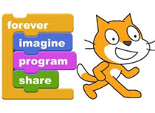

**Equipment**

✦ Computer with Internet

✦ Scratch™ account (see lesson 1.1)

**Vocabulary**

✦ Sprites – Objects that perform actions

✦ Scripts – Computer Code

✦ Costumes – a sprites appearance

✦ Pair programing – two programmers working one program on one computer

✦ Algorithm – set of rules to be followed by a computer

✦ Iterate – do over and over

**Procedure**

Now that you have completed the Tutorial in last lesson let’s start programing your own game. In Scratch you create graphic **sprites** that move on the **stage**. Each sprite in Scratch has its own **scripts**, **costumes**, and **sounds** . The stage also has its own script, backgrounds, and sounds.

In this activity you will program your Wizard sprite to move around a game board. You will learn how to use “if-then” blocks to make branches in an **algorithm**. You will also learn how to make a program **iterate**.

1. Launch a Web browser and navigate to the Scratch website at [**http://scratch.mit.edu**](http://scratch.mit.edu) and login into Scratch.

2. Start building a Scratch program by clicking the Create Tab.

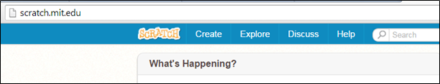

3. Now you will be able to build a game! Give your game a name like **My First Game** .

Scratch will automatically save your game as you code; you can always click on save now .

Scratch starts you out in the Scripts view, notice these five parts of the Scripts view.

|  |
| --- |
|  |

|  |
| --- |
|  |

4. Now let’s program the Scratch cat to move. In the categories box click on and drag into the Script Area.

5. In the categories box click on and drag into the if-then script .

6. In the categories box click on and drag into the if-then script.

7. Change the space to right arrow and 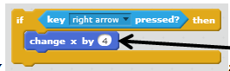 the x by 4.

8. Now here is a great skill! Right click on the code and choose duplicate 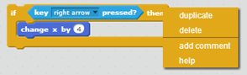 and connect the blocks together 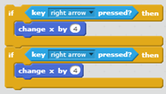.

9. Change the bottom space to left arrow and the y by -4 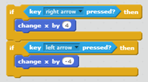.

10. In the categories box click on  and drag  around the if-then block 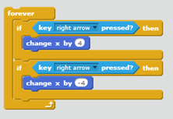.

11. Let’s test it out. In the categories box click on  and drag  on to the top of the code 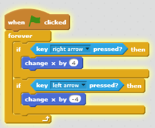.

12. Now click on  and test the left and right arrow. Scratch Cat moves!

13. Duplicate the two if-then statements and add them on to the bottom. Change the arrows to up and down. Remove the change x by and replace them with change y by  and finally change the 10 to 4 and -4.

14. Your final code should look this this 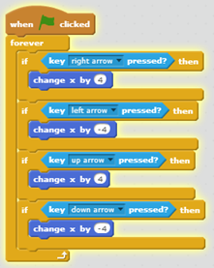.

15. When you press the up, down, left and right arrows Scratch Cat will move around the game board.

16. In the next lesson we will change the characters look and add grass to the background.