**1.3 Game Coding: Visual Design**

**Introduction**

In the world of video games looks matter and in this lesson you will learn how to change the look of your character and the background.

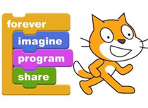

**Equipment**

✦ Computer with internet

✦ Scratch™ account

**Vocabulary**

✦ Sprites – Objects that perform actions

✦ Scripts – Computer Code

✦ Costumes – a sprites appearance

✦ Pair programing – two programmers working one program on one computer

✦ Algorithm – set of rules to be followed by a computer

✦ Iterate – do over and over

**Procedure**

Now that you have your game started let’s make it look cool. Scratch lets you create graphic **sprites** that move on the **stage**. You will change your character from Scratch Cat to a wizard and the background of the stage from white to green.

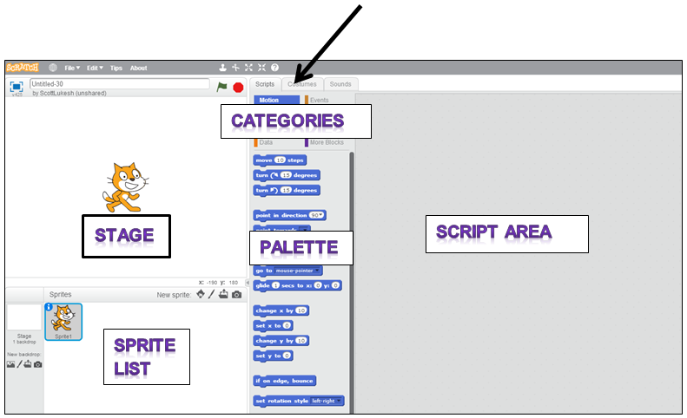

1. Click the Costumes tab and we

will change your sprites look.

2. Click on Choose Costume from Library  and choose the Wizard Girl  now delete the two Scratch Cats with the X in the upper right hand corner 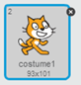.

3. Right click on the wizard girl sprite  and select info. Change the sprites name to wizard  and click the blue arrow.

4. Click on the Wizard Girl 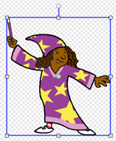 and using one of the corner buttons, reduce her to approximately ¼ her original size .

5. Right click on the costume 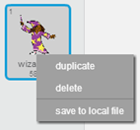 and duplicate it.

6. Select the Flip left-right button.

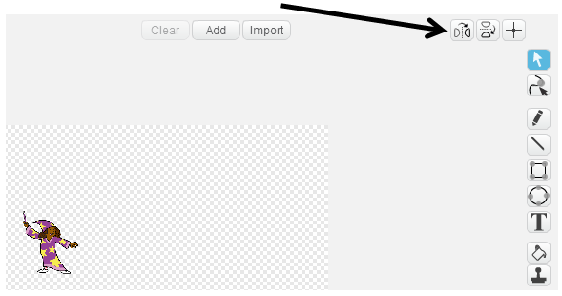

Now your costumes will look like this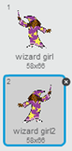.

7. Let’s program the new costumes. Click on Scripts and choose Looks , drag and drop  into the right and left arrow if-then blocks. Your code will look like this 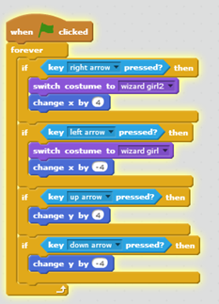. Now when you click on the  your Wizard will point her wand in the direction she is moving.

8. Time to make the background of the Stage green. Click on Paint New Backdrop.

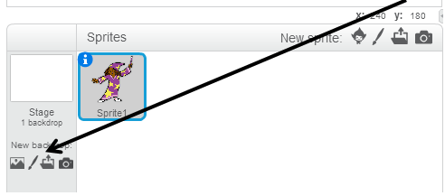

9. Select green 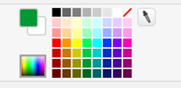 and click the Paint Bucket, click the Stage and it will turn green.

10. Test out your program, your Wizard now has grass to play on! In the next lesson you will add some fruit and some sounds.