**1.4 Game Coding: Graphics and Sound**

**Introduction**

Games are boring without interesting graphics and sounds, in this lesson you will learn how to add both.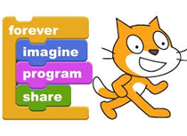

**Equipment**

✦ Computer with internet

✦ Scratch™ account

**Vocabulary**

✦ Sprites – Objects that perform actions

✦ Scripts – Computer Code

✦ Costumes – a sprites appearance

✦ Pair programing – two programmers working one program on one computer

✦ Algorithm – set of rules to be followed by a computer

✦ Iterate – do over and over

**Procedure**

1. Click on Choose Sprite from the Library . Choose Things and double click on the apple .

2. You will see the apple on the stage let resize the apple. Click on the apple in the sprite list 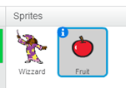 select Costumes  click on the  and using one of the corner buttons, reduce it to approximately 50% the size of the wizard.

3. Right click on the costume 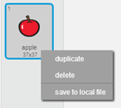 and duplicate it.

4. Select the Flip left-right button . Now your costumes will look like this 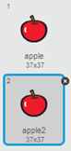.

5. Continue this process adding the watermelons and oranges until your Costumes look like this; the order down the page is important!

.

6. Resize each piece of fruit to the same size as the apple .

7. Click on the Scripts tab  and build this code in the Script Area 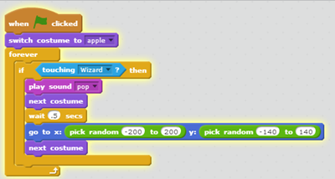.

8. Now when the wizard touches a piece of fruit five things happen:

1. a pop sound is plays

2. the fruit changes costumes to a cut piece of fruit

3. there is a one half of a second pause

4. two random numbers are selected

5. and the fruit costume changes again and is move to the random numbers!