Rube Goldberg Contest

# What is a Rube Goldberg Machine???

A Rube Goldberg machine is a contraption that is meant to produce a complicated chain reaction of events to produce a simple task. See the image below. The child's end goal is to turn on the t.v.

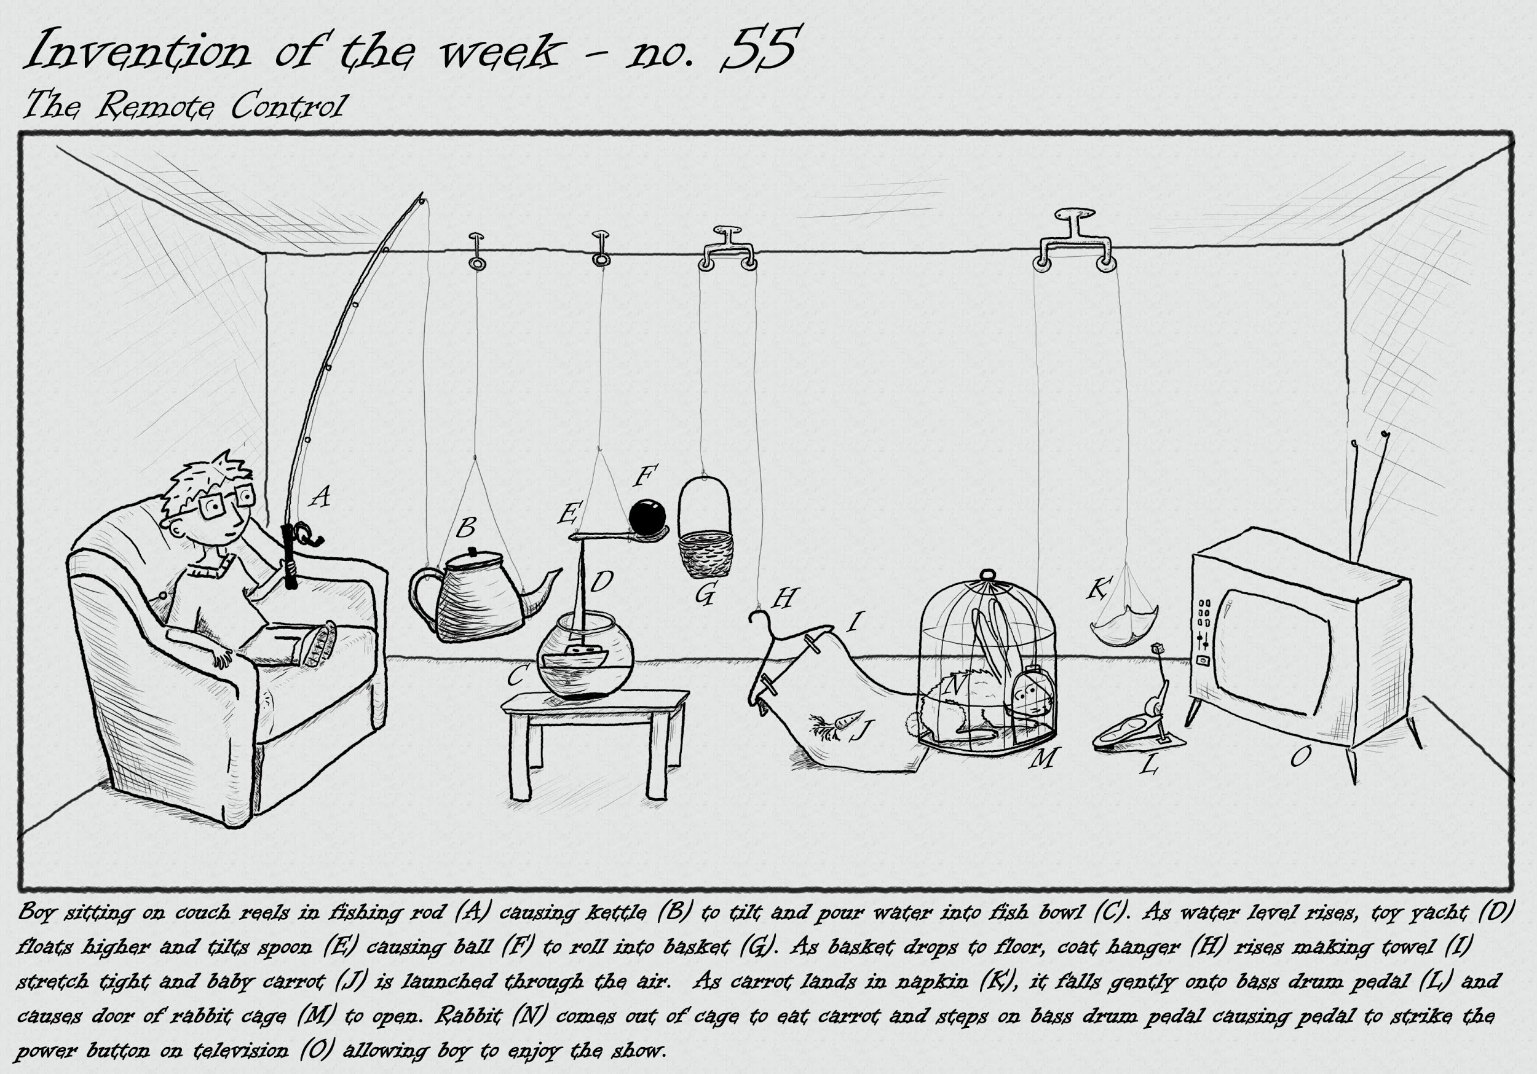

**Requirements:**

**Have 6 steps or more**

**Have a Teacher sponsor and team of 2-4 students**

**Must complete an end goal (examples seen below):**

* **Filling a bowl**
* **Revealing a message**
* **Crush a can**
* **Popping a balloon**
* **Turn on a light**
* **Turn a page**

The due date will be **February 23, 2017** by **5:00 pm**. There will be a top three. The winners will receive a prize along with sponsor teacher. Best of luck to all who compete and may the odds be in your favor.

1. Provide an illustration, drawing or photo of your Rube Goldberg machine on a separate piece of paper.
2. What is the end goal of your Rube Goldberg? ____________________________________________________________________________________________________________________________________________
3. What are some simple machines that you used through out your design.(e.i pulleys, levers, ramps/inclined or declined planes, or seesaws)
4. How many steps does your machine have? List each step and describe what it achieves.