Frame Analysis Tool

Using biarc approximation for frame representation of ship lines

A mathematical description of the frames of a wide variety of hull forms is challenging, because of, sometimes, not only numerous changes of radii of curvature along the frame, but a reversed direction of curvature as well. But such a description is needed for CAD models of ship hulls. Fortunately the proper tools for the job have been developed quite some time ago, in the 1960ies of the last century, as far as I know. The technique is called biarc approximation which means that the frames are divided into sections which are then approximated by two arc segments. Using two arc segments allows to connect points along the frame prescribing also the tangent at the start and endpoint. This allows to generate a smooth contour along even the most tortuous of frames. FrameAnalysisTool (= FAT) uses this technique. To analyze your own frames you have to generate an input file with pairs of coordinates, either in spread sheet csv format or in SVG format. See FAT use section.

Requirements
You need python 3 to run the program. If you use the anaconda distribution you have all that is required, including the integrated development environment spyder, from which you can run FAT.
To run the program from the command line use an ASCII editor to change the path for the data (variable wkDir in line 105) and enter:
>> python FrameAnalysisTool.py
on the command line. Omit the chevrons, these represent your system prompt.
You can download anaconda from here:
https://www.anaconda.com/download

Content in Package
- FrameAnalsysisTool.py main program, as mentioned FrameAnalysisTool is abbreviated FAT
- utilPY.py various functions, e.g. plotting and circle fitting
- BiarcM.py program for biarc calculation
- BiarcDraw.py standalone program for plotting biarc sequence. The program uses binary data generated by FAT
- FrameAnalysisTool.pdf this documentation

Biarc basics

To get an understanding of how biarcs work we first use the program BiarcM.py, which generates a single segment consisting of two arcs which share a common tangent a the point where they meet. Note that for two arcs to form a smooth curve without change in tangent (i.e. having a kink) the center points of the arcs and the point where they touch must all three lay on a straight line.
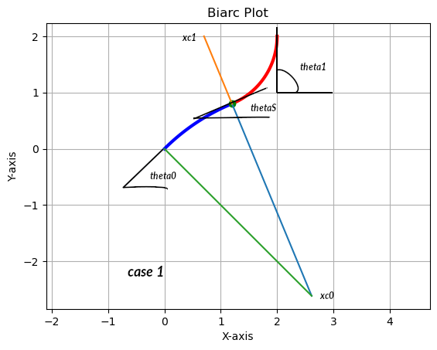

This can be seen in the picture case 1, above. The light blue radius vector of the blue arc and the orange radius vector of the red arc form a straight line which passes through the green point where they meet. The angles, theta0 equal to 45° and theta1 equal 90°, are prescribed in the program as well as the start (p= 0,0) and endpoint (p= 2,2) of the two arcs. The routine biarc then calculates all the parameters describing the two arcs. These are the curvatures (kappa = 1/radius, i.e. the inverse of the radius) the location of the two center points xc0, xc1, of the arcs and the location of the point xs (green dot) where the arcs touch as well as the angle thetaS of the tangent at xs. Using these values it should be straight forward to generate the arcs in a CAD program. At some point in the future I will do this using FreeCAD since it uses python as a script language, so the Frame Analysis Tool can be integrated as a FreeCAD macro.
Change the variable jCase in line 75 of BiarcM to 2 for the second example. Here the start angle theta0 is smaller, 22.5° , thus the two arcs now have the same direction of curvature. Note how again the center points of the arcs and xs line up.

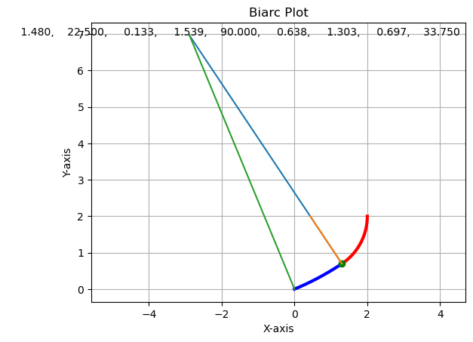

Next we will take a look at three examples of frames that have been approximated. The first one is of a 1950ies yacht, with the S-shape typical at the time. To run this example change the value of the variable useCsv in line 90 of FrameAnalysisTool to 1, i.e. remove the minus sign. This example uses data from a csv file. As mentioned above this is just a list of x,y point pairs. This method is not recommended, see below.
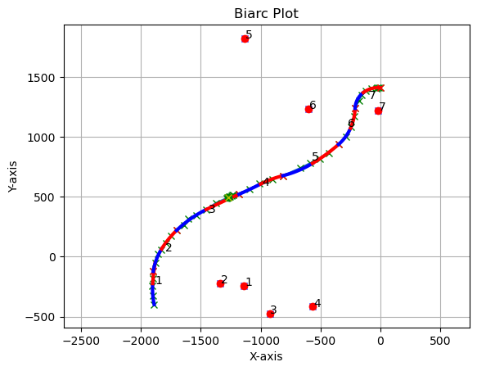
The lines of yachts from the beginning to roughly the 1960ies of the last century had a curved transition from the keel to the hull, often called S shape. The red dots in the picture are the locations of the segment arc center points, with numbers corresponding to the section numbers. Here the values for the length of the segments is k_p = [4, 6, 14, 4, 5, 4]. The red crosses along the frame are the endpoints of the segments and, of course, the starting point of the next section. The green circle with the yellow cross is one distinct point, to give you an idea where a certain point is located along the frame. You can set the number of this point at the end of the program file. For an explanation of the use of the segmentation list k_p please read the chapter on the use of FrameAnalysisTool a bit further in this file. The above frame actually is distorted, the width to hight ratio is not correct. See about using scale factors to correct this below.

The next example is a frame from the stern section of a dutch 17th century ship.
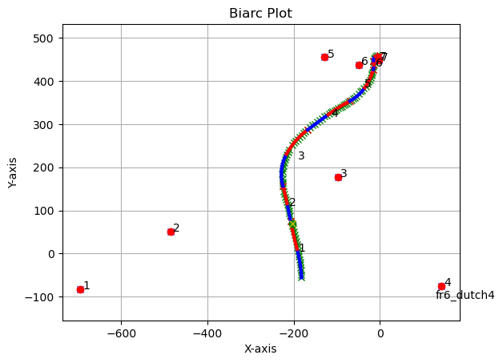

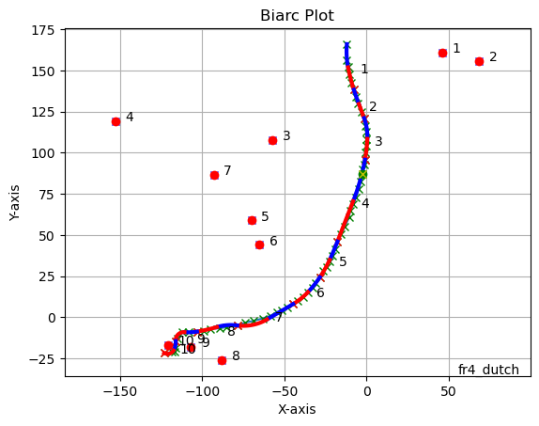
Note that here the keel has been approximated by a small arc. The next picture shows a frame from the forward part of the same vessel.

The same frame as before but this time keel has been cut off. Note how the approximation is poor in the garboards. The number and length of segments is crucial to a good approximation. This will be explained further in the section of how to use FAT, below.
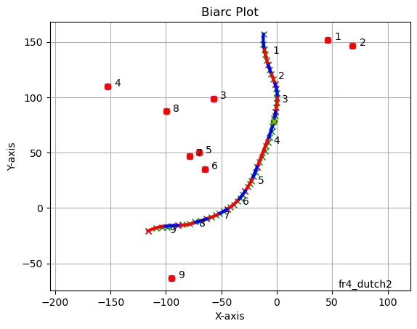

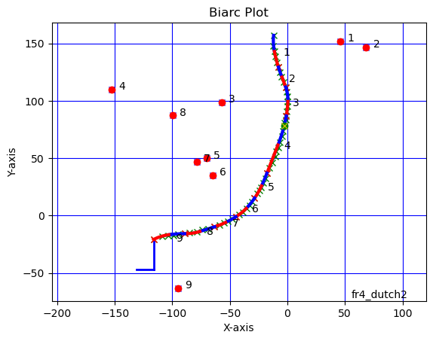
Modeling the keel with a large radius is not realistic for this type of vessel, so it is better digitized. without the keel, but there is an option to add a rectangular keel, like below

The Keel Option

Drawings have, in most cases, the keel included but, as we have seen, the rectangular keels of many ships have to be modeled by other means than biarcs. I have therefore included an option to model a rectangular keel. The example of this is in frm4_dutch2.svg:
<usr kp="5 4 6 12 6 6 5 5"
keel="-15,-26.2,-1" />
The keel data are in the section tagged usr, the keyword is keel. The last number is an index, which indicates whether the keel starts from the first or the last station of the frame data, since this simply depends on which way you digitized the frame. The first two numbers are, from left to right, the half width of the keel and the depth of the keel from the frame station where is starts. The signs depend on the orientation of the frame. If the first number, the half width, is zero, a vertcal line is drawn from the last data point befor the start of the keel, down by the amount indicated by the second number. From the end of this line a horizontal line is drawn which ends in the plane of symmetry. The keel data are entered in the usr section, see below.

How to use FrameAnalysisTool
FAT needs a file with coordinate pairs describing points along the lines of the frames to be approximated. This may either be a csv file, as used in spread sheets, or an SVG file. SVG means Scalable Vector Graphics and is a very common file format. It is very convenient, even essential, to be able to store additional information in the data file, especially in a project with a large number of frames. Here SVG files offer a tremendous advantage, since SVG is a markup language, so you can add any number of additional information to the file and use the very straight forward methods to retrieve them. Python comes with an SVG module so you can rely on a well thought out and tested processing mechanism.

Digitization
The best way to generate the frame data would probably be to use a vectorization software. Unfortunately I have so far not found any program that would make a good job of digitizing the very poor quality frame pictures which you usually have for input.
I use the free graphics program gimp for manually digitizing the frames. The path tool (TOOLS → PATH) allows you to click on the curve and generate a sequence of data points.
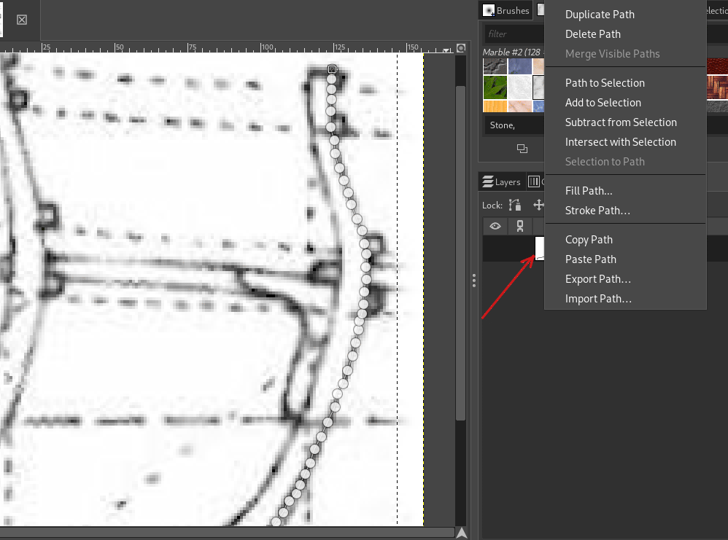
In the above picture the data points are the small circles connected via thin lines on the outer frame contour. It takes probably less than five minutes to generate about 100 data points. The exact location of the data points is not that important, since a smoothing step is used in the program but of course the points should not be too far off the frame contour. After you started the path tool via TOOLS → Path from the gimp menu a panel opens on the right hand side of the program. After you click the first point a small white icon appears, indicated by the red arrow. Once you finished generating points, you want to save them to a file. To do this right click on the small white icon, whereupon the menu, which is visible in the picture, pops up. Select the option “Export Path”, second at the bottom of the menu, enter a file name and an extension of .svg (dot svg). If you want to add information to the SVG file you need an ASCII editor, i.e. an editor which writes pure ASCII files. I use gvim, since it is free ware and available across all platforms but it is sort of a nerd tool, its great but takes some time do get accustomed to. Copy and paste the three lines belonging to the usr tag to the svg file.

Defining Segments
The next step is, to define the segments used to approximate the frame. This is done by creating the list k_p, which contains the number of points used in each segment. Currently this list is the result of some educated guess work, since so far I have not found an algorithm that would generate a proper list. Examples of a k_p list are found in lines 100 through 103 in FAT. Line 103 looks like this:
k_p = [4, 6, 14, 4, 5, 4]
Thus the first segment has four points, the second one 6 and so on. The last segment is calculated by adding up all elements in the list and than subtracting that sum from the number of available data points in the x,z data. Since a circle requires at least 3 points the program stops with an error message if there are less than three points left for the last segment, so that this condition is not met. To facilitate the process, the sum of the k_p list and the number of data points is printed to the screen, like so:
number stations in curve 61 number stations required by k_p 59
Note that the number is sufficient, since that last data point in a segment is also used as the first one in the next segment, thus the last segment has three points.
The goal should perhaps be to use as few segments as possible. A segment can not contain a part of the frame where the curvature changes more than once. This is sometimes difficult, because the data points are a bit randomly offset left and right so if a part of the curve has a very large radius that leads to some weird behaviour. If that happens you have three options.
- Change the segment length. One or two points more or less in a segment may change the curve to become acceptable
- Insert additional points in the SVG file, by manually interpolating linearly between adjacent points.
- Perform a new digitization of the curve.

Two Step Approximation
FAT uses two steps to generate segments: first a circle approximation is calculated for the segment to find the tangents at the endpoints. This step uses a minimization technique to find a best circle fit for the input points. The tangent vectors of adjacent segments are then averaged and a biarc approximation is calculated.

SVG File Structure
Next we will have a brief look at an SVG file. These are the first lines in the file fr4_dutch.svg . The data points start after the upper case C.

<svg xmlns="http://www.w3.org/2000/svg"
width="19.8146mm" height="28.8327mm"
viewBox="0 0 156 227">
<path id="Unnamed"
fill="none" stroke="black" stroke-width="1"
d="M 20.00,207.75
C 21.00,205.75 27.75,205.00 27.75,205.00
23.00,205.5 27.75,205.00 27.75,205.00
“
“
124.25,26.50 124.25,23.00 124.25,23.00
124.35,23.00 124.50,19.75 124.50,19.75" />
</svg>
The digitized data points are all only in the first column of the list, the other points are generated by gimp to calculate a spline for the curve, theses points are not used by FAT. As you see, fortunately, a markup language is used. Since the segmentation is crucial for a frame the information must be stored together with the data, it would be a nightmare to keep track of which segmentation k_p corresponds to which the data set.
You can easily add items to a file in a markup language. Items are designated by a tag. In the file below the tag usr, for user data, has been added. An item starts with a left chevron and the tag and ends with a slash followed by a right chevron. All data in a tag are strings, starting and ending with a double upper quote. The user section contains the list k_p and two scaling factors cX, cZ which allows you to modify the frame size right from the beginning. If the digitized frames are distorted, the ratio of width to height not being the correct one, use different cX, cZ values to correct the error.
Examples of how the information is read from the SVG file are found around line 120 and in the function getSvgItm, line 64 in FAT. If you want to store different k_p lists in a file you can add a dummy tag like <cmnt below. This tag is not used in the program. It is required so that the SVG reader does not hick up.

<svg xmlns="http://www.w3.org/2000/svg"
width="19.8146mm" height="28.8327mm"
viewBox="0 0 156 227">
<cmnt kp ="5 4 6 12 12 8 5 4" />
<usr kp="5 4 6 12 6 6 5 5"
cX = "1.0"
cZ = "1.0" />
<path id="Unnamed"
fill="none" stroke="black" stroke-width="1"
d="M 20.00,207.75
C 21.00,205.75 27.75,205.00 27.75,205.00
23.00,205.5 27.75,205.00 27.75,205.00
“
“
124.25,26.50 124.25,23.00 124.25,23.00
124.35,23.00 124.50,19.75 124.50,19.75" />
</svg>
The next picture shows a nice example of a faulty segmentation. Both cases use the same input data from file inpFname='frm6_strm2'. Using a segmentation list k_p of:
k_p = [8, 9, 7, 6, 6]
gives the funny loop below
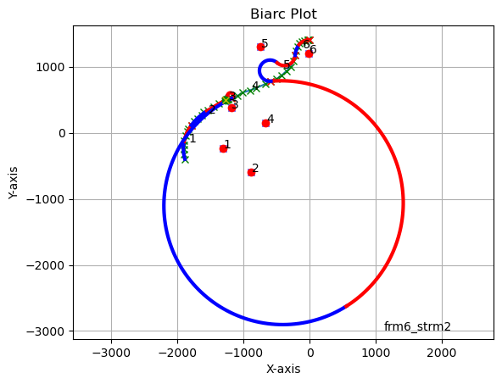
a fairly good approximation is achieved, using the k_p list
k_p = [4, 6, 14, 4, 5, 4]
Let me reiterate that the picture below uses the exact same data points as the one above, only the segmentation is different, here it is k_p = [8, 9, 3, 4, 6, 6], line 122 in FAT. The problem with the previous segmentation is, in my opinion, the fact, that segment 4 uses to few data points.
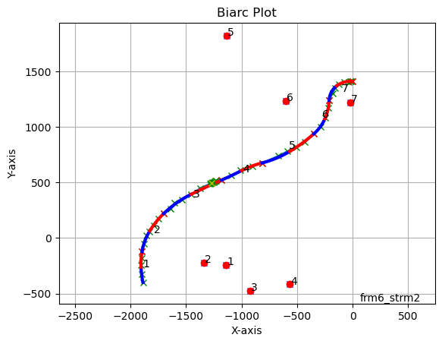

Data Interface
FAT writes a binary file that contains all the data necessary to generate a plot. The file name starts with the input file name and adds _bac.dat, the bac stands for bi arc. These data could be used to transfer information from FAT to a CAD progrm.

CAD integration
As mentioned before I would like to incorporate FAT into FreeCAD but it should also be possible to use other CAD programs, so whoever uses it in a CAD program is kindly requested to share a how to with the rest of the community.

Automatic Segmentation
A robust algorithm that generates an acceptable segmentation would be helpful, but currently I have no idea of how to handle the various cases, e.g. small to medium circles and nearly straight lines.

Legal Notes

This file is part of FrameAnalysisTool

FrameAnalysisTool, is free software: you can redistribute it and/or modify
it under the terms of the GNU General Public License as published by the
Free Software Foundation, either version 3 of the License or any later
version.

FrameAnalysisTool is distributed in the hope that it will be useful,
but WITHOUT ANY WARRANTY; without even the implied warranty of
MERCHANTABILITY or FITNESS FOR A PARTICULAR PURPOSE. See the
GNU General Public License for more details.

You should have received a copy of the GNU General Public License along
with FrameAnalysisTool. If not, see <http://www.gnu.org/licenses/>.

Copyright 2025 Juergen Humt

Credits

FrameAnalysisTool uses the following programs, please see the licenses of those programs in their respective sub folders. Both programs have been converted from Matlab® to Python.
a) circle_fit Copyright (c) 1981, Izhak Bucher. Circle fit takes a set of x,y data and fits a circle to these points
b). Biarc calculates all necessarey parameters for a segment consisting of two circular arcs between given end points and given tangent angles at start and end point. Biarc_Plot plots the curves.

