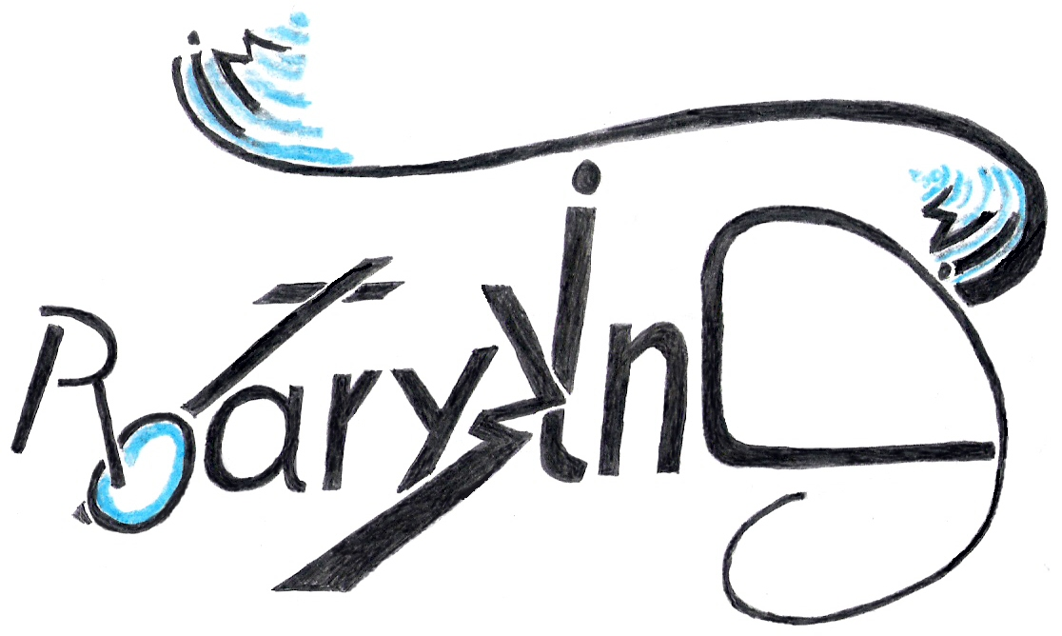

RotaryWingSim

Version 2.0

User Guide

11/2013

Table of contents
About RotaryWingSim 3
Some Remarks on the Purpose of the Program 4
General Program Description 5
Program Features 5
Installing Octave and the GUI 6
Getting Started with RotaryWingSim 6
Octave from the command line 7
Configuring the Octave GUI 7
Octave from the GUI 8
Matlab GUI 8
Static Simulation 9
Performance Estimates 9
The Simulink Model 9
Program Structure 10
Primary Program Modules 10
The Force and Moment Modules 10
Secondary Program Modules 10
Read Modules 11
Evaluation Modules 11
The Simulink Module 11
Trim Routine 12
Data Input 13
Alternative input 14
Aircraft Data 14
Flight Data 15
Controller Data 15
Fuselage Force and Moment and Reference Data 15
Things to improve 16
Things to Do 16
Comparison of stability values 18
References 20
Disclaimer 21

About RotaryWingSim
RotaryWingSim is ultimately to become a program framework for the dynamic simulation of rotary wing aircraft. To this end the program will be developed into a highly modular application for the simulation of helicopters, compound helicopters and autogyros. It is also planned to port the program from the proprietary platform (Matlab/Simulink) which is used right now to an open source platform. GNU Octave, SciLab or a stand alone version in C++ are under consideration.
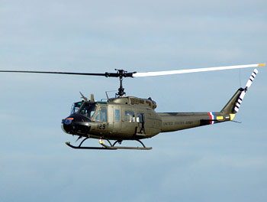
In version 1.0 of RotaryWingSim a linear – non modular – model of a Bell UH1-H helicopter had been imple-mented. The formulae describing the helicopter are presented in a NASA report from 1977. This report is unique in that it also provides all physical constants of the model, including time constants for the Bell bar and for the transfer functions of the aircraft controls. A complete simulation was implemented by adding several vital parts which are not found in the report, such as the six degree of freedom (6DOF) equations of motion for an aircraft, transformations between earth and body coordinates, an iterative inflow calculation for the rotor and last but not least a trim routine. Currently for inflow calculation the schme proposed by Garath D. Padfield is used while the trim routine is essentially the one published by Marc E. Dreier.
Programming started in March 2010 and took about four months, work being carried out at night and on most every weekend. After this time the program delivered the first results, which were rubbish throughout. More than two months of painful and painstaking debugging followed. Many bugs from inverted signs to missing parts in formulae or logical errors were eliminated. Most computer programs, and especially very complex ones like this, are rendered useless by the minutest of errors and almost no intermediate results were available to check the calculations against. Finding an error sometimes even seemed to deteriorate the results rather than advancing work towards the final goal. One can easily imagine how the author's expression changed from disbelieving to doubtful to joyful when on the 19th of September after one last small change the angular rate plots started to resemble those in the report. If you want to obtain the source code please contact kolibri282 at www.rotaryforum.com

I hope you will enjoy working with this program.

Happy simming!

Juergen Humt
Duesseldorf, November 2013

RotaryWingSim Version 2.0 User Guide
Copyright 2013 Juergen Humt

Some Remarks on the Purpose of the Program
First and foremost the program will be useful if you want to acquaint yourself with the basics of rotor craft design. You can very quickly explore the effects of configuration changes and thus get a feeling for how things interact. Just by reading the code you can follow the steps required to finally arrive at the stability parameters calculated by the program. From that point on you are only limited by your own ambitions and your perserverance. While successful helicopters like the Sikorsky R4-B the S-51 or the Bristol Sycamore have been developed based on the theory presented in the reports used in this program one must keep in mind that those who did it were professionals who had spent theire entire lives learning how to use the tools now made available in RotaryWingSim, so you would be aiming quite high if you tried to do the same as someone lacking that experience. Please also read the disclaimer at the end of this document. I should perhaps add that trying to get to grips with the flight dynamics of rotary wing aircraft is a serious health hazard, it might cause depressed feelings, sleepless nights and in general is not for the faint of heart....plus your blood pressure may rise beyond critical levesl …..when you feel you've made another step ahead...;-)

General Program Description
RotaryWingSim is a modular simulation program which allows to find trim solutions to various configurations of rotary wing aircraft. The program also calculates the stability derivatives and a solution to the stability quartic. This solution gives the characteristics of the aircraft for the so called phugoid and short period response. The program is based on technology that has been developed beginning in the 1930th up to about the 1960th of the last century. I have compiled a documentation package consisting of a fairly large number of reports which were used in writing and testing the program. A very good introduction to the basics of rotary wing aircraft flight stability is in the report: “Calculation of the Longitudinal Stability Derivatives and Modes of Motion for Helicopter Aircraft”. The author starts with a brief overview of the required mathematical “tools of the trade” and goes on to explain basics of stability calculations starting from force and moment equilibrium equations. The chapter on the different stability derivatives is probably one of the best you can find on the topic. Currently the stability derivatives calculatedb by RotaryWingSim are valid only in helicopter mode (see next chapter) since rotor speed variation, a major factor for autogyros, is not taken into account.

Program Features
a) Helicopter Mode
- Performance Calculation: Rate of Climb, Power to Hover
- Trim Calculation:
Prescribed Rotational Speed → Cyclic, Collective Pitch, Engine
power to trim
- Stability: Stability Derivatives, Solution of Stability Quartic

b) Autogyro Mode
- Trim Calculation 1:
Prescribed Rotational Speed → Cyclic, Collective Pitch, Engine
power to trim
- Trim Calculation 2:
Prescribed Collective Pitch,→ Cyclic Pitch, Rotational Speed,
Engine power to trim

c) Helicopter- and Autogyro Mode
- Investigation of winged or wingless configurations
- Linear geometric blade twist can be included
- Rotor state calculation method a: formulae of naca 716 for rectangular
blades are used. The blades are considered rigid, no cyclic twist
considered
- Rotor state calculation method b: formulae of naca 600 for rectangular
blades are used. Cyclic twist as exhibited e.g. by the Cierva C-30 is
included
- Especially for helicopters the horizontal stabilizer is sometimes connected
to the cyclic via a linkage that changes the angle of attack in conjunction
with cyclic input. Such so called gearing curves can be entered as
polynomials.
- Rotor downwash on the horizontal stabilizer is included using the values
from Heyson and Katzoff

The stability derivatives in autogyro mode are currently not deemed correct since rotor speed does not change during the perturbation steps used to calculate them.

Installing Octave and the GUI

To run RotaryWingSim you need either Matlab or a free Matlab clone called Octave. Installing Matlab is straightforward and not covered here. To install Octave download the current (3.6.2 as of 11/2013) version from here: http://sourceforge.net/projects/octave/files/Octave%20Windows%20binaries/
Usually you might want to install to a separate directory called e.g. programs. It is recommended to use a directory where the whole path does not contain any special chracters except an underscore: _
Thus “C:\Programs\flight_sim” would be ok, but “C:\Program Files\flight” might get you into trouble. Create the required folders before you start the installation, you can then select the folder during the installation process.
Octave can be run from the command line (see getting started below) but today most users feel more comfortable with a GUI. There is a separate GUI for Octave which you can download here: http://www.outsch.org/2011/01/29/qtoctave-0-10-1-for-windows/
Click on the build for windows link, indicated by the red arrow in the picture below:
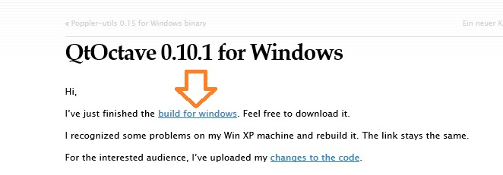

Getting Started with RotaryWingSim
Unzip the program files to a folder of your choice.

Octave from the command line
- open a command window via :
Startbutton->All Programs->Accessories->Command Prompt
- change to the RotaryWingSim directory usin the cd command
- start octave by typing e.g. C:\applics\octave3.6\octave.exe
- run RotaryWingSimStart.m to initialize all variables in the workspace and calculate the state variables for trimmed flight. After initializing the work space you can – if you are using Matlab - start the Simulink model to calculate the dynamic response.

Configuring the Octave GUI
If you start the GUI for the first time the path to the Octave executable has to be entered. In the GUI menu line click “Config” and the “General Configuration”. In the pop up windwo (see picturer below) use the select button to find your octave executable to enter it in the “Ocatve Path” line.
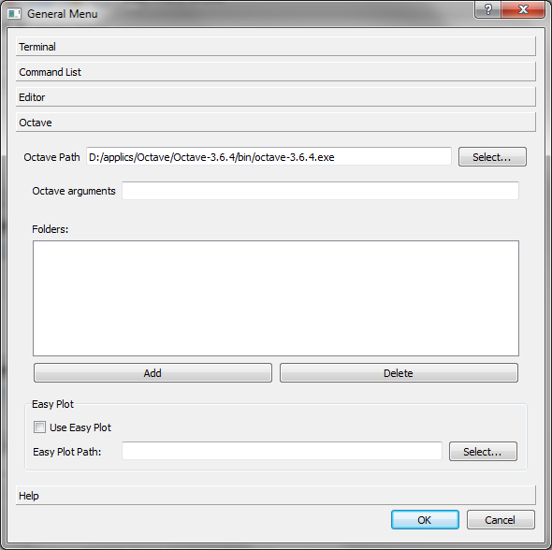

Octave from the GUI
- Start the GUI by clicking on the qtoctave shortcut on the desktop. If there is none, create one to qtoctave.exe.
- The GUI constists of two windows, a debug and an editor window which is also used to launch the application. The editor window is depicted below. Load the program via the “File” → “Open” buttons and then select “Run” from the menue

Matlab and GUI
Unfortunately there is a slight syntax difference so that you have to manually change two files when switching from Octave to Matlab. You have to change three lines in two files:
- in helideriv3104.m line 137 ff you find:
% Matlab:
% out2= fsolve(@clcAlfa,alfaD,options,mu,oM,thtaN,xNN,cTReq);
%
% Octave
out2= fsolve(@(alfaD) clcAlfa (alfaD ,mu,oM,thtaN,xNN,cTReq), alfaD, options);
Place a comment character (percent sign) in front of the second line beginning with out2 (line 141) and remove the comment character from the frist line beginning with out2 so that the lines afterwards look like this:
% Matlab:
out2= fsolve(@clcAlfa,alfaD,options,mu,oM,thtaN,xNN,cTReq);
%
% Octave
% out2= fsolve(@(alfaD) clcAlfa (alfaD ,mu,oM,thtaN,xNN,cTReq), alfaD, options);
Now save helideriv3104.m
- in helicopterPerformance.m change lines 43 ff and 58 ff in the same way and save the file.
- use the directory select line which is located on the upper edge in the middle of the control panel to change to the RotaryWingSim directory.
- and the button to open a file menue to the left on the upper edge
- Run RotaryWingSimStart.m to initialize all variables in the workspace and calculate the state variables for trimmed flight. After initializing the work space you can – if you are using Matlab - start the Simulink model to calculate the dynamic response.

Static Simulation
First the program calculates a steady state trim solution for the given fligth state, i.e. forces and moments are reduced to near zero. Based on this trim solution small perturbations are applied to find the stability derivatives. The matrix of stability derivatives looks like this:
RotaryWingSim
u w q
x -0.064057 -0.007607 0.700494
z -0.019035 -0.967900 -0.341502
m 0.007966 0.003318 -0.331469
A similar matrix follows immediately afterwards and displays the values from measured data which have been entered via the flight state input file *.flt. This allows to quickly compare the trim results from RotaryWingSim with fligth test data.

Performance Estimates
In helicopter mode (itrType = 2) the program performes a preliminary helicopter performance calculation based on the paper by Petrovi/Stupar/Kosti/Simonovi, title:
"Determination of Light Helicopter Flight Performance at the Preliminary Design Stage"
The output consists of diagrams showing rates of climb and descents, flight envelope (i.e. maximum attainable hight over the speed range) and rotor torque. The two pictures below show the rate of climb and flight envelope plot:
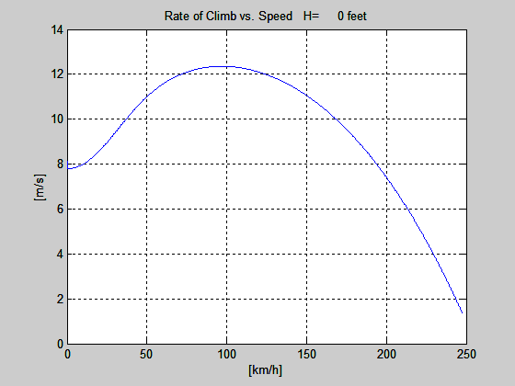

The Simulink Model
You need Matlab Version 6.1 release 12.1 or newer for this part of the simulation.
Currently the Simulink model is can not be used. The points below which require Simulink version 4.0 or a later had been implemented in version 1.2 of RotaryWingSim. These can currently not be used out of the box, you will have to update them yourselfe. Please let me know if you devise an implementation that works. The features were:
- the system response with different controller gains for the four PID controllers
currently implemented or with another controller you devised
- the dynamic response to step inputs on one or more controls

Program Structure
The program consists of two major parts, the first consisting of some seventy Matlab m files which implement all formulae needed for the mathematical model and handling of the Program, the other one is the Simulink model
A major part of the program documentation can be found inside the Matlab m files. Each m file contains a header that describes what the routine is for and the input and output parameters. At the end of some program lines you will find the number of the formula implemented in this line and the page on which it can be found in the report naca-73254. Sometimes the values of the program variables which are calculated when using the reference input file RotDatUH1H.dat are added as comments at the end of the line where the variable is calculated. Stepping through the file you can verify whether the program calculates the correct values with respect to the aforementioned reference data file.

Primary Program Modules

The Force and Moment Modules
The aircraft model consists of m files as stated above. Seven major subroutines, each of which calculates forces and moments for one aircraft sub assembly, are the core of the aircraft model. These are:
- main rotor
- tail rotor
- fuselage
- horizontal stabilizer
- vertical stabilizer (fin)
- wing
- engine
Besides forces and moments several other routines calculate control quantities such as e.g. angles. One control routine is entirely dedicated to the main rotor and provides input to other routines.

Secondary Program Modules
There are a lot of routines that perform auxiliary tasks like:
- performing preliminary performance calculation
- reading data in various formats
- evaluating polynomials
- calculating certain data groups like e.g. derivatives
- converting values from one unit system to another

Read Modules
The read modules perform data input from various file. The major read modules are explained in chapter “Data Input”

Evaluation Modules
The evaluation modules work mainly on special data structures like airfoil data or fuselage coefficients.

The Simulink Module
(Currently not operational)
The Simulink model ties together all the different parts to form the differential equation that is ultimately solved to yield the transient solution. The Simulink model is the graphical representation of this differential equation. To facilitate porting the program to non proprietary platforms the programming in Simulink was kept to a minimum. Only aircraft parts that have to be represented as first order systems (PT1) like Bell bar or controller dynamics have been implemented using Simulink blocks. For all routines implemented in the *.m files which are needed for the Simulink model, wrapper functions have been written so that all necessary evaluation of the formulae takes place in m files. Not only will this greatly facilitate porting the program to other platforms but it also makes it possible to use the same functions in the trim routine that were used in the Simulink model. The wrapper routines have a capital S in their name, apart from which the names are the same as those of the routines being wrapped. So the function for the fin forces and moments is in the file FinFrcMmtFunc.m while the wrapper is in the file FinFrcMmtSFunc.m. As for the structure of the wrapper functions you may want to read the Simulink documentation.
After initializing the work space (see: Getting Started) you can – if you are using Matlab - start the Simulink model to calculate the dynamic response. At the end of RotaryWingSimStart, around line 420, you will find a block that allows to select the step input you want to simulate. It looks like this:
%
% Step function values for Simulink:
% tStp : step time at which the step function
% is activated in the simulink model
% dTstp : time after which the step input is
% set back to start value
% dleStp: longitudinal cyclic step value
% dlcStp: collective step value
% dlpStp: tail rotor collective step value
%

dleStp= 2.54;
dlaStp= 0.0; % 2.54;
% The amplitudes in the report were bigger than the
% ones I calculated. I therefore measured the step
% amplitude and it seemed to be something like:
dlcStp= 0.0; % 3.47;
% For pedal step amplitudes were smaller. Step value
% was measured to be:
dlpStp= 0.0; % 1.5566;

In this case you simulate a longitudinal cyclic step input of one inch expressed as 2.54 centimeters. Note that all control movements are given in a non consitent unit of centimeters! The step starts at 0.1 seconds simulation time and will last 10 seconds after which it is returned to the previous state. If you want to simulate a collective step input the block would look like this:

dleStp= 0.0; % 2.54;
dlaStp= 0.0; % 2.54;
% The amplitudes in the report were bigger than the
% ones I calculated. I therefore measured the step
% amplitude and it seemed to be something like:
dlcStp= 3.47;
% For pedal step amplitudes were smaller. Step value
% was measured to be:
dlpStp= 0.0; % 1.5566;

Trim Routine
The calculation of the transient aircraft response starts from a trimmed flight state. Currently this means that the aircraft is flying at constant speed and all angular rates are zero. This is equivalent to finding a set of trim variables that will make all forces and moments acting on the aircraft cancel such that the sum of forces and moments is zero. Suboutines were written that calculate the forces and moments for the different aircraft modules, another one to carry out the summation. This routine is in file AcFrcMmtSummation.m (Aircraft Force and Moment Summation). The trim routine (file acTrim3D.m) uses a Newton search algorithm as proposed by Mark E. Dreier. Depending on the flight mode under investigation different sets of trim variables are used. Two flight modes, helicopter mode and autogyro mode, are supported. In autogyro mode the user can either prescribe a value for collective pitch and find the rotor speed in trimmed flight or vice versa. In helicopter mode the rotational speed of the rotor is fixed and the required rotor torque is calculated. The flight mode is set in the *.flt (see below) in line 5.

Trim variables are the four aircraft controls which are:
- longitudinal cyclic
- lateral cyclic
- rotor collective pitch
- pedal (tail rotor collective)
and two attitude angles:
- roll angle phi
- pitch angle theta
in autogyro mode either collective pitch or rotational speed is fixed,
the trimvariable then is the other one i.e.:
- rotor speed or collective pitch
The yaw angle may be set to an arbitrary value, well, within reasonable boundaries that is. Small perturbations are added to the trim variables in turn and a Jacobi matrix is calculated. Using the inverted Jacobi matrix an improved value for the trim state is calculated. The routine continues until the error norm is small enough.

Data Input
All data are in sub directory data of the program folder. Data input has been split into five parts with separate files for each one. These are:
- Aircraft data, describing the physical properties of the aircraft. There is a comment
behind every number in the file explaining which data item is in that line.
File extension *.dat.
The data are read by readAcData.m
- Flight data, describing the current flight state of the aircraft. Again there is a comment behind every number in the file explaining which data item is in this line
File extension *.flt
The data are read by readFligtData.m
- Wing section (polar) data, Wing data are in x-foil format
File extension *.pol.
The data are read by readAirfoilData.m
- Fuselage lift, drag and moment coefficients and measured values from flight tests,
converted to polynomials.
File extension *.cff
The data are read by cXstrct.m
- Controller data, describing the settings for the controllers, these are used with the
Simulink model
File extension is *.cnt.
The data are read by cXstrct.m

This divided input was designed so as to easily allow calculation of different combinations of the data groups, e.g. analyzing the behaviour for different center of gravity positions, flight states or controller configurations.
Currently some of the variables in the aircraft data section are not used. They have been incorpo-rated with a view to future program development. Some values may be entered with a unit string in the comment begind the figure, which is a character sequence enclosed in square brackets.
Only one has to be provided since for example the flight speed, advance ratio and tip speed are all related by rotor rpm so when anyone of the three is given the other two are calculated.

Alternative input
Some input values are optional, some may be entered in different units and some assume a different meaning depending on the sign they carry. These are described in the chapters below.

Aircraft Data
The aircraft data file contains all physical properties including time constants for the Bell bar. A reference input file can be found in the data directory of RotaryWingSim. The file RotDatUH1H contains the numbers which will yield the simulation results for 60 knot straight and level flight of the UH1-H helicopter which is the case presented in the report naca 73254. Currently the file format of the aircraft data file is static, i.e. the number of lines and the sequence in which they appear can only be modified if the file readAcData.m is also modified. There are two exceptions to this rule, where optional lines can be entered in the aircraft data file. The first one is at the end of the fuselage section. After the fuselage moment coefficient cmNfus a line with a file name may be entered. If this line is present, fuselage coefficients will be read from the file otherwise coefficients are read from the default file set in line 353 of RotaryWingSimStart. If the formulae including blade twist from naca 591/600 are to be used three lines have to be added at the end of the main rotor section in the aircraft data file. In these lines offset between aerodynamic center and wing spar, torsional rigidity and moment coefficient of the blade profile are provided. If these lines are not present the formulae of naca 716 are used for rotor calculation. An example file including blade twist data is KelletKD1tws.dat. The alternative inputs in the aircraft data file (*.dat) may be summed up like this:

- a line with a filename (string) may be entered right after the fuselage section. If present all fuselage coefficients are read from this file.
- rotor speed may be entered as tip speed in feet per second, shaft speed in revolutions per minute or circular frequency in rad/s. The correct unit is placed in square brackets in the data line behind a comment character ( a percent sign % ). See previous paragraph. The possible input units are: [rpm] = revolutions per minute, [revs/sec] = revolutions per second [fps] = tip speed in feet per second.
- if rotor twist is to be included values for twist characteristics are entered behind the main rotor section. If no additional lines are found there twist is not included in the calculation. An example can be found in file KelletKD1tws.dat

Flight Data
The flight data file contains all information about the current state of the aircraft, like flight speed in three coordinate directions, flight attitude and angular rates. To explore different configurations of a basic aircraft file an offset for the center of gravity position may be entered as well as an added mass. For helicopters an initial value for rotor torque should be entered since the trim routine might not converge without a good guess for that value

Alternative input in the flight state variable file (*.flt):
- if current hight above ground is entered air density is calculated based on that value. Alternatively a negative number may be entered here which then is used as a ratio of actual air density to standard air density at zero feet. If e.g. a value of -0.98 is entered air densiy is 0.98 of standard density.

Controller Data
The controller data file contains gain values of the four PID controllers which are currently in the Simulink model. These gain values have been set by guess and by golly, so here is ample room for improvement. To switch the controllers on or off set the variable cKp around line 370 in RotaryWingSimStart to 1.0 or 0.0:
% use cKp to switch on and off the pid controlers
cKp= 0.0;

Fuselage Force and Moment as well as Reference Data
Data of fuselage forces and moments and other data are read into the program as coefficients of a power series. The structure of such a data set looks like this:
# Cm
0.0 gradient of extension from left most curve point to minus infinity
0.0 gradient of extension from right most curve point to plus infinity
7 highest power in the series
5.93929606e-012 coefficient of highest power in the series
2.07807372e-010
-3.10924842e-010
-6.70930963e-008
-3.11535033e-007
8.80512533e-006
1.13863323e-004
-4.56325908e-004 coefficient of x⁰, the linear term of the power series
-1.31079137e+001 left boundary of power series approximation
1.15000000e+001 right boundary of power series approximation
377 scalefactor for x values
0.0 dummy, currently not used

Each data section in a flight data file file begins with a hash followed by a string. The routine that reads the coefficient data searches for this string and starts reading in the first line after the string was found. The next two lines contain values for the gradient at wich the curve is extended from the left boundary to minus infinity and from the right boundary to plus inifinity. If these values are zero the gradient is calculated based as the gradient of the derivative in the respective curve point. The next line is the hightest power that appears in the power series followed by the coefficients of the series. Note that the number of coefficients is one more than the number of the series since we have a coefficient for x to the power of zero, thus e.g. for n=3 in the third line of a data set we have four coefficients following that line. The first one is the multiplier for the highest power in the series the last one is the multiplier for x to the power of zero , x⁰ (=1.0)
There is a set of auxilary programs available to prepare and visualize these coefficient files. The first step is to generate a list of data pairs from the curves which you want to convert to a power series. In the first line of this file enter the maximum x and y values for the curve. In the second line offset values may be entered if for x and/or y the zero point of the coordinate system was not on the graph. In program curveUtil.m enter the path to the file and the filename plus the highest power to be used for the polynomila. The latter will usually be closer to three, the maximum should be 6 or 7.

Major Influences on Stability Derivatives
Mq:
- blade mass and hinge offset
- horizontal stabilizer (size, lever arm, lift curve slope)

Example Calculations
The first step in getting accquainted with the program could be just to rerun some of the sample calculations and compare the output to the listings below.

S-51
The data for this example are in the directory ./data/S-51a/. The configuration does not exactly represent the aircraft, since the distance from center of gravity to the horizontal tail is about ten feet larger than physically possible. Nevertheless some basics can be demonstrated with this model.
The advance ratio of the example is mu= 0,2. The resultant values of the stability derivatives and the quartic solutions are:
RotaryWingSim
u w q
x -0.079416 -0.025428 0.899270
z -0.010968 -0.926226 -0.096007
m 0.006731 0.004997 -0.175507
Measured Data
u w q
x -0.087000 0.030000 0.105000
z -0.020000 -1.070000 -1.100000
m 0.007300 0.030000 -0.025000

Solution of stability quartic RotaryWingSim:
z1 -1.08774 0.00000j
z2 -0.39875 0.00000j
z3 0.15405 0.33191j
z4 0.15405 -0.33191j
Routh D -0.076

Solution of stability quartic of measured data:
z1 -1.61149 0.00000j
z2 0.35134 0.19299j
z3 0.35134 -0.19299j
z4 -0.27319 0.00000j
Routh D -0.093
The negative value of Routh's discriminant and the positive real part of the quartic solution indicate that the aircraft is unstable. Well this is, where fun begins. It is generally accepted that a horizontal stabilizer will improve stability, so let's see. The stabilizer value of 2.3 square feet is a wild guess and was introduced to represent the closed rear fuselage that has a certain damping effect. If the stabilizer is increased to 32 square feet the stability quartic looks like this:
z1 -0.77701 0.63730j
z2 -0.77701 -0.63730j
z3 -0.00440 0.34690j
z4 -0.00440 -0.34690j
Routh D 0.015
The positive Routh's discriminant and the negative values of the real parts of the stability quartic solution indicate that the aircraft is now stable for this flight speed. Testing a few values one finds that the stability boundarie is somewhere aroung an area of 31.3 sqft. Note that the stabilizer is downloded a bit, with a negative value of -4°. Changing this value to -2 degrees results in an unstable configuration with Routh's discriminant equal to -0.030.

Things to improve
The model currently calculates the dynamic response quite good yet other values are quite off the mark and some things are currently not well understood. These are:
- stability derivatives for some models all have the sign of the measured values but especially the q derivatives differ vastly in magnitude. (See appendix B for a comparison between stability derivatives calculated by the program with values from naca report 3144)
- main rotor control angles A1S and B1S calculated by the program are much
larger than the values in naca 3144
- collective pitch is off by one degree or a bit more
- In the Horizontal stabilizer routine two terms are currently omitted that are
given in the report. The formula looks like this in the program:
wH= vB(3) + vqAux + vB(1)*dls; % + wC + lamNf/R7; % (54) p.9
It is not clear why incorporating the terms after the % sign destabilize the
result as is the case right now.
You will probably find more things to improve while working with the program and of course any improvement is highly appreciated. Send your modified code to the RotaryWingSim thread in the “Theory of Flight” section at www.rotaryforum.com.

Future Program Development
The program currently shows several deviations from measured values. The author hopes that by publishing the code as an open source project others will take part in the effort to improve simulation fidelity and thus speed up the process of providing the community of rotary wing aircraft afficionados some day with a semi professional tool.

Things to Do
- Verify that data can be read in US or SI units using the switch usUnits
- Modularize the program such that different main rotor configurations can be incorporated, perhaps using object oriented programming.
- Find better values for the PID controller settings or implement a new controller.
- Incorporate a numerical integration routine for the main rotor using two dimensional profile data from wind tunnel tests.
- Implement a Peters He inflow model for the main rotor
- Incorporate rotor blade elasticity
- Add a propeller thrust model
- Review results for the case of a climbing or descending helicopter.
- Add gusts to the possible step inputs.
- Calculate stability derivatives dZw/dt and dMw/dt.
- Verify model for backwards flight
- Improve model accuracy in hover
- Add jet and piston engine models
- Add a pilot model

Comparison of stability values

Nasa CR 3144 RotaryWingSim UH1H Model
Xu -0.024400 -68.16 Xu -0.057761 -161.34
Xw 0.066500 185.75 Xw 0.065817 183.84
Xq 0.498100 7312.11 Xq 0.752905 11052.89
Zu 0.012300 34.36 Zu 0.028887 80.69
Zw -0.875700 -2446.07 Zw -0.866506 -2420.38
Zwd 0.000000 0.00 Zwd 0.000000 0.00
Zq -0.492900 -7235.77 Zq -0.101653 -1492.30
Mu 0.010600 29.61 Mu 0.016749 46.78
Mw -0.008800 -24.58 Mw -0.023493 -65.62
Mwd 0.000000 0.00 Mwd 0.000000 0.00
Mq -0.523000 -7677.64 Mq -0.468711 -6880.83

### SP and PH mode approx ### ### SP and PH mode approx ###
Short Period Mode Short Period Mode
omega SP 0.8476 omega SP 1.0538
zeta SP 0.8251 zeta SP 0.6335

re -0.6994 + 0.4788j re -0.6676 + 0.8153j
re -0.6994 - 0.4788 re -0.6676 - 0.8153j
Phugoid Mode Phugoid Mode
omega PH 0.3510 omega PH 0.3490
zeta PH 0.1904 zeta PH 0.2425

re -0.0669 + 0.3446j re -0.0846 + 0.3386j
re -0.0669 - 0.3446j re -0.0846 - 0.3386j

A 1.0000 A 1.0000
B 1.5324 B 1.5045
C 1.0286 C 1.4583
D 0.2684 D 0.3506
E 0.0885 E 0.1353
### SP and PH mode from quartic # ### SP and PH mode from quartic
M thta 0.000 M thta 0.000

A 1.0000 A 1.0000
B 1.4231 B 1.3930
C 0.7464 C 1.1731
D 0.0957 D 0.1841
E 0.0900 E 0.1357

Routh D -0.090 Routh D 0.004

z = z =

-0.7619 + 0.4524i -0.6953 + 0.7455i
-0.7619 – 0.4524i -0.6953 - 0.7455i
0.0503 + 0.3348i -0.0012 + 0.3614i
0.0503 – 0.3348i -0.0012 - 0.3614i

Short Period Mode Short Period Mode
omega SP 0.8861 omega SP 1.0194
zeta SP 0.8598 zeta SP 0.6821
period SP 13.8880 period SP 8.4283
tHalf SP 0.9098 tHalf SP 0.9969
N half SP 0.0655 N half SP 0.1183

Phugoid Mode Phugoid Mode
omega PH 0.3386 omega PH 0.3614
zeta PH -0.1486 zeta PH 0.0033
period PH 18.7663 period PH 17.3865
tHalf PH 13.7761 tHalf PH 580.2046
N half PH 0.7341 N half PH 33.3711

References
[1] Baiyley, F. J. Jr., A Simplified Theoretical method of Determining the Characteristics of a Lifting Rotor in Forward Flight. National Advisory Committee for Aeronautics, Langley Field, Va., March 17, 1941
[2] Wheatley, John B., An Analysis of the Factors that Determine the Periodic Twist of an Autogiro Rotor Blade, With a Comparison of Predicted and Measured Results. National Advisory Committee for Aeronautics, Langley Field, Va., April 14, 1937
[3] Talbot, Peter. D. and Corliss , Lloyd D., NASA TM 73254, A Mathematical Force and Moment Model of a UH1-H Helicopter for Flight Dynamcis Simulations, Ames Research Center, NASA 1977
[4] Heffley, Robert K., Jewell, Wayne F., Lehman, John M. and Van Winkel, Richard A. NASA CR 3144, A Compilation and Analysis of Helicopter Handling Qualities Data, Ames Research Center, NASA 1977
[5] Welch, Arthur J. and Warren, Edward L., USAAMRDL Technical Report 71-66, Comparison of UH-1C Flight Test Data with MOSTAB-C Small Perturbation Math Model, USAAMRDL Fort Eustis, Virgina 1971
[6] Prouty, Raymond, Helicopter Performance Stability and Control, PWS Publisher, 1986
[7] Padfield, Gareth D. Helicopter Flight Dynamcis: The Theory and Applications of Flying Qualities and Simulation Modeling, AIAA 1996
[8] Dreier, Mark E., Introduction to Helicopter and Tiltrotor Simulation, AIAA 2007

Disclaimer
This file is part of RotaryWingSim.
%
RotaryWingSim, is free software: you can redistribute it and/or modify it under the terms of the GNU General Public License as published by the Free Software Foundation, either version 3 of the License or any later version.
RotaryWingSim is distributed in the hope that it will be useful, but WITHOUT ANY WARRANTY; without even the implied warranty of MERCHANTABILITY or FITNESS FOR A PARTICULAR PURPOSE. See the GNU General Public License for more details.
You should have received a copy of the GNU General Public License along with RotaryWingSim. If not, see <http://www.gnu.org/licenses/>.

Не надо изобретать нового!Все уже изобретено до нас! Главная задача - найти и собрать все это новое по частям в реальный аппарат

