Integrated Web Server in DASH SDK
For WINDOWS
Configuration File
- Need to have configuration file in which we can provide settings to the WEB Server.
- Add the system environmental variable name MONGOOSE_CONF and map the path of configuration file
MONGOOSE_CONF = <drive> :\< folders>\<configuration file>
Example:
MONGOOSE_CONF = c:\mongoose.conf
- In configuration file we can mention the port(s) to listen ,Folder to map etc.,
- If no configuration file found, default settings will be applicable.
For Example ,Web server listens on 8080 port.
Sample Configuration File

USB redirection connect
- Asks whether to use default integrated web server.
- If yes then asks to provide file path as in Fig 1
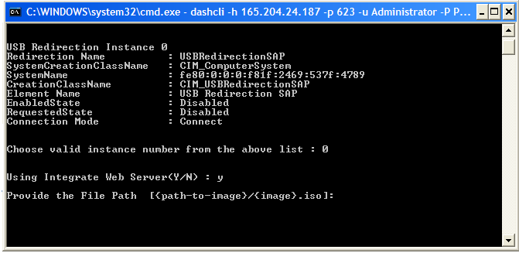
Fig 1
Path can be for example:
D:\isoimagefolder\subfolder\someimage.iso

Windows Service

- When we are using default web server there will be a service running in background
- Service with name “DASHWebServer”, which starts running automatic.
- We can start, stop the “DASHWebServer” service
- To Stop the Service from command prompt
webserver -s
- To Uninstall the service
webserver -u

For Linux

Configuration File
- Need to have configuration file in which we can provide settings to the WEB Server.
- Add the system environmental variable name MONGOOSE_CONF and map the path of configuration file
MONGOOSE_CONF = <drive> :\< folders>\<configuration file>
Example:
MONGOOSE_CONF = home/nrayi/mongoose.conf
- In configuration file we can mention the port(s) to listen ,Folder to map etc.,
- If no configuration file found, default settings will be applicable.
For Example ,Web server listens on 8080 port.

USB redirection connect
- Asks whether to use default integrated web server.
- If yes then asks to provide file path as in Fig 2
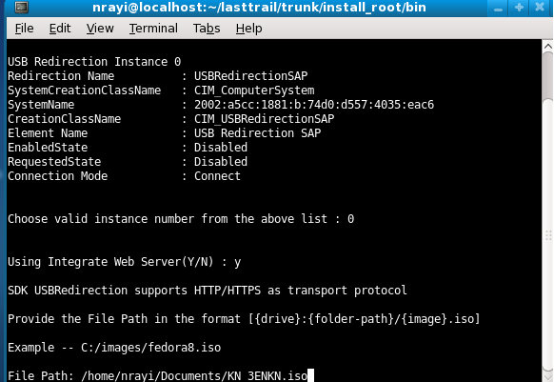
Fig 2

- Path can be for example:
/home/userid/someimage.iso

Daemon

- Daemon process gets created and starts running on the port.
- We can stop the service manually
ps –eaf | grep webserver (to find the process running)
kill -9 <pid> (to kill the process)

