Google — Year in Search 2020
Source URL: https://www.youtube.com/watch?v=rokGy0huYEA

Video Description
In times of uncertainty, people seek understanding and meaning. This year, the world searched “why” more than ever. This film features the questions we asked this year, with words and narration by Kofi Lost. Explore more trends from the year at https://google.com/yearinsearch
#YearinSearch
Mira este video en español: https://www.youtube.com/watch?v=d5ZzM-4mF8w
Audio described version here: https://www.youtube.com/watch?v=2oVrUv-w3Oo
C R E D I T S:
Google Brand Studio
Words/Narration: Kofi Lost
Editor: Scott Butzer - Cabin Editing Company
Sound Design: John Bolen - Formosa Group
VFX/Color/Finish: Shape + Light
Original Music: Peter CottonTale - “Together”
Featured Artists: Chicago Children’s Choir, Cynthia Erivo, and The Matt Jones (Re-Collective Orchestra) - https://music.youtube.com/watch?v=95Id8XdUegE
SELECT FOOTAGE COURTESY OF:
@RMG News
Getty Images / NBC News Archives
Tom Fuller, Tom Wilkinson, and the University of Oxford
Seán Doran
Photo by Stephanie Maze
Footage from the “World Surf Weekly” provided through the courtesy of the World Surf League
Meged Gozani, Haaretz
The Real Neal’s
Breonna Taylor Mural by Future History Now
Breonna Taylor Mural photo courtesy of Maurice Taylor
Academy Awards® Clip
Copyright © Academy of Motion Pictures Arts and Sciences
WNBA/NBA footage courtesy of the National Basketball Association
Jimmy Fallon footage courtesy of NBC Universal
Estate of Breonna Taylor
Trayvon Martin Foundation
The estate of George Floyd
Mamba & Mambacita Sports Foundation
Photo copyright courtesy of NBC Archives
Footage copyright courtesy of Alyza Enriquez
Richner Communications, Inc /Long Island Herald
Story to Spectacle
Nandi Bushell
Eddie VanHalen music video footage courtesy of Rhino Records, a Warner Music Group company
Canal OFF
XOS Digital
Mural Credit -Dom Whitehurst
Photo courtesy of Nate Palmer
Photography by PABLO MARTINEZ MONSIVAIS/AP
Commencement speech courtesy of Howard University
Mural Artist Nikkolas Smith
Footage courtesy US Tennis Association
JaVale McGee, https://www.youtube.com/javalemcgee
Subscribe to our Channel: https://www.youtube.com/google
Tweet with us on Twitter: https://twitter.com/google
Follow us on Instagram: https://www.instagram.com/google
Join us on Facebook: https://www.facebook.com/Google

Transcript & Screenshots
--- Screenshot at 00:00:00 ---

[00:00:00] [Music]
[00:00:02] the most human trait
[00:00:03] [Music]
[00:00:04] is to want to know why and in a year
[00:00:08] that tested
[00:00:09] everyone around the world why was
[00:00:11] searched more than ever
[00:00:17] the spread of the coronavirus has passed
[00:00:20] a significant milestone
[00:00:22] and while we didn't find all the answers
[00:00:24] we kept asking
[00:00:27] some questions inspired jordan
--- Screenshot at 00:00:30 ---
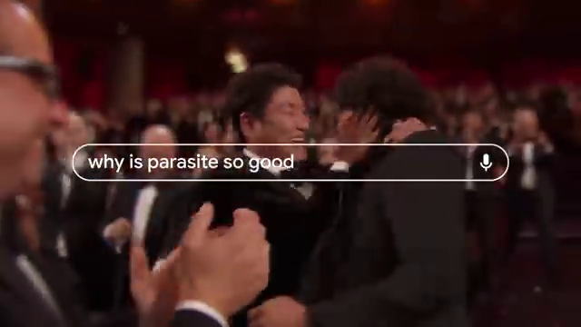
[00:00:30] others excitement
[00:00:32] [Music]
[00:00:36] yes yes
[00:00:40] yes i don't know what an improper
[00:00:42] fraction is
[00:00:43] keep all of those distractions out of
[00:00:45] the way
[00:00:48] oh my god put it on there and start it
[00:00:50] up for me what are y'all doing
[00:00:53] it's still march how many days
[00:00:56] in march some questions made us cry
--- Screenshot at 00:01:00 ---
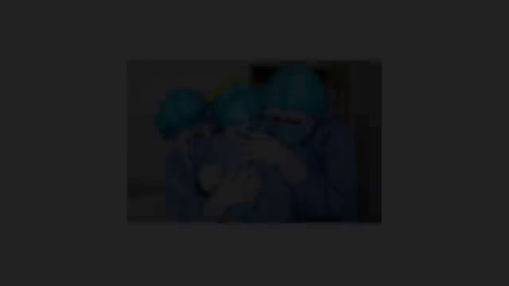
[00:01:00] you know we've been through our ups and
[00:01:01] been through our downs i think the most
[00:01:03] important part is that we all stay
[00:01:04] together throughout
[00:01:06] i love you guys
[00:01:08] [Applause]
[00:01:10] some made us worry about this spinning
[00:01:12] rock we call home fires were detected in
[00:01:14] the amazon rainforest
[00:01:18] why were so many lives lost almost 1.5
[00:01:21] million people have now died of covet 19
[00:01:24] worldwide
[00:01:26] why are we still asking the same
[00:01:27] questions
[00:01:29] george floyd repeatedly told the
--- Screenshot at 00:01:30 ---
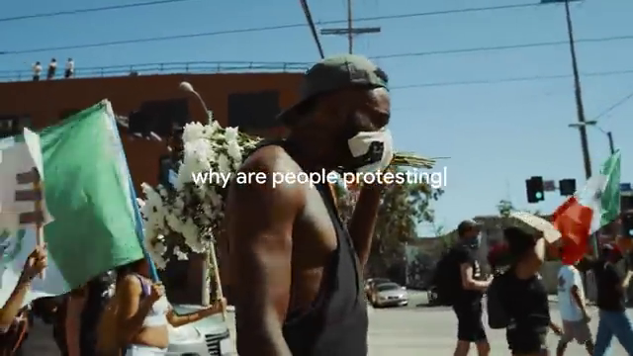
[00:01:30] officers that he could not breathe
[00:01:35] so why do we still have strength to
[00:01:37] [Music]
[00:01:38] continue
[00:01:42] [Applause]
[00:01:47] chance of black lives matter echoed from
[00:01:50] thousands of protesters
[00:01:51] in cities around the world why are we
[00:01:53] not defeated
[00:01:54] we have made too much progress and we
[00:01:57] are not
[00:01:58] going back we are going forward
--- Screenshot at 00:02:00 ---
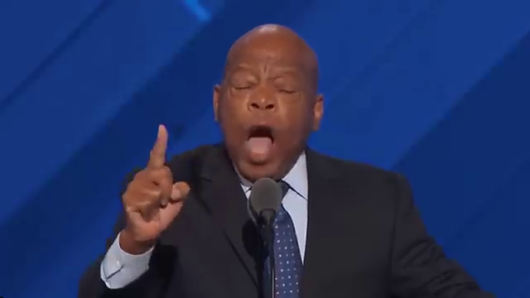
[00:02:02] planes are starting to arrive in beirut
[00:02:03] full of international aid
[00:02:05] firefighters from around the world
[00:02:07] arriving in california
[00:02:08] there are over 100 coronavirus vaccines
[00:02:10] in development worldwide this is one of
[00:02:12] those times when people look out for one
[00:02:14] another and have each other's backs
[00:02:15] we kept going for those who showed us
[00:02:17] the way think about
[00:02:19] how you would like the world to be for
[00:02:21] your daughters and granddaughters
[00:02:23] remember the struggles along the way are
[00:02:26] only meant
[00:02:27] to shape you for your purpose press on
--- Screenshot at 00:02:30 ---
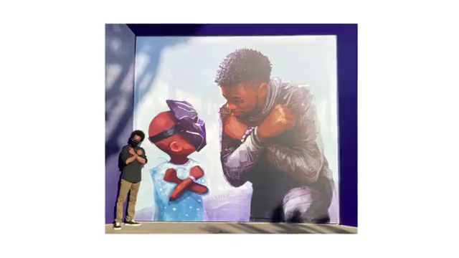
[00:02:31] with pride and press on with purpose
[00:02:34] why is it that this year showed its
[00:02:36] worst and we still found ways to try it
[00:02:39] an incredible feat for maya gabriella
[00:02:41] naomi osaka
[00:02:43] championship can't let corona stop you
[00:02:46] can't let quarlet
[00:02:47] stop you so until we get to every answer
[00:02:56] we're still searching

