# Google — Year in Search 2020

Source URL: https://www.youtube.com/watch?v=rokGy0huYEA

## Video Description

In times of uncertainty, people seek understanding and meaning. This year, the world searched “why” more than ever. This film features the questions we asked this year, with words and narration by Kofi Lost. Explore more trends from the year at https://google.com/yearinsearch  
  
#YearinSearch   
  
Mira este video en español: https://www.youtube.com/watch?v=d5ZzM-4mF8w  
Audio described version here: https://www.youtube.com/watch?v=2oVrUv-w3Oo   
  
  
C R E D I T S:  
  
Google Brand Studio  
Words/Narration: Kofi Lost  
Editor: Scott Butzer - Cabin Editing Company  
Sound Design: John Bolen - Formosa Group   
VFX/Color/Finish: Shape + Light  
  
Original Music: Peter CottonTale - “Together”   
Featured Artists: Chicago Children’s Choir, Cynthia Erivo, and The Matt Jones (Re-Collective Orchestra) - https://music.youtube.com/watch?v=95Id8XdUegE  
  
  
SELECT FOOTAGE COURTESY OF:  
@RMG News  
Getty Images / NBC News Archives  
Tom Fuller, Tom Wilkinson, and the University of Oxford  
Seán Doran  
Photo by Stephanie Maze  
Footage from the “World Surf Weekly” provided through the courtesy of the World Surf League  
Meged Gozani, Haaretz  
The Real Neal’s  
Breonna Taylor Mural by Future History Now  
Breonna Taylor Mural photo courtesy of Maurice Taylor  
Academy Awards® Clip  
Copyright © Academy of Motion Pictures Arts and Sciences  
WNBA/NBA footage courtesy of the National Basketball Association   
Jimmy Fallon footage courtesy of NBC Universal  
Estate of Breonna Taylor  
Trayvon Martin Foundation  
The estate of George Floyd  
Mamba & Mambacita Sports Foundation   
Photo copyright courtesy of NBC Archives  
Footage copyright courtesy of Alyza Enriquez  
Richner Communications, Inc /Long Island Herald  
Story to Spectacle  
Nandi Bushell  
Eddie VanHalen music video footage courtesy of Rhino Records, a Warner Music Group company  
Canal OFF  
XOS Digital  
Mural Credit -Dom Whitehurst  
Photo courtesy of Nate Palmer  
Photography by PABLO MARTINEZ MONSIVAIS/AP  
Commencement speech courtesy of Howard University  
Mural Artist Nikkolas Smith  
Footage courtesy US Tennis Association  
JaVale McGee, https://www.youtube.com/javalemcgee  
  
  
Subscribe to our Channel: https://www.youtube.com/google  
  
Tweet with us on Twitter: https://twitter.com/google  
  
Follow us on Instagram: https://www.instagram.com/google  
  
Join us on Facebook: https://www.facebook.com/Google

## Transcript & Screenshots

--- Screenshot at 00:00:00 ---



[00:00:00] [Music]

[00:00:02] the most human trait

[00:00:03] [Music]

[00:00:04] is to want to know why and in a year

[00:00:08] that tested

[00:00:09] everyone around the world why was

[00:00:11] searched more than ever

[00:00:17] the spread of the coronavirus has passed

[00:00:20] a significant milestone

[00:00:22] and while we didn't find all the answers

[00:00:24] we kept asking

[00:00:27] some questions inspired jordan

--- Screenshot at 00:00:30 ---

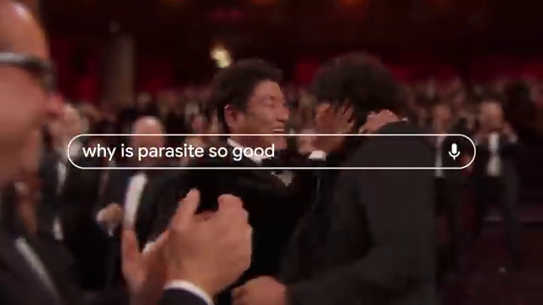

[00:00:30] others excitement

[00:00:32] [Music]

[00:00:36] yes yes

[00:00:40] yes i don't know what an improper

[00:00:42] fraction is

[00:00:43] keep all of those distractions out of

[00:00:45] the way

[00:00:48] oh my god put it on there and start it

[00:00:50] up for me what are y'all doing

[00:00:53] it's still march how many days

[00:00:56] in march some questions made us cry

--- Screenshot at 00:01:00 ---

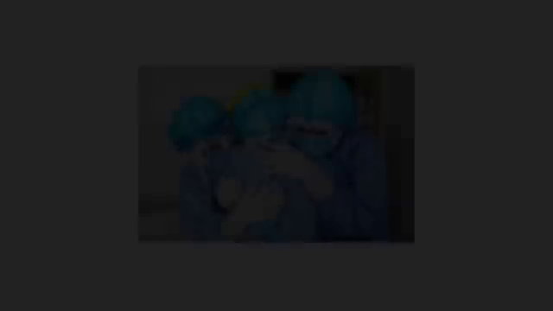

[00:01:00] you know we've been through our ups and

[00:01:01] been through our downs i think the most

[00:01:03] important part is that we all stay

[00:01:04] together throughout

[00:01:06] i love you guys

[00:01:08] [Applause]

[00:01:10] some made us worry about this spinning

[00:01:12] rock we call home fires were detected in

[00:01:14] the amazon rainforest

[00:01:18] why were so many lives lost almost 1.5

[00:01:21] million people have now died of covet 19

[00:01:24] worldwide

[00:01:26] why are we still asking the same

[00:01:27] questions

[00:01:29] george floyd repeatedly told the

--- Screenshot at 00:01:30 ---

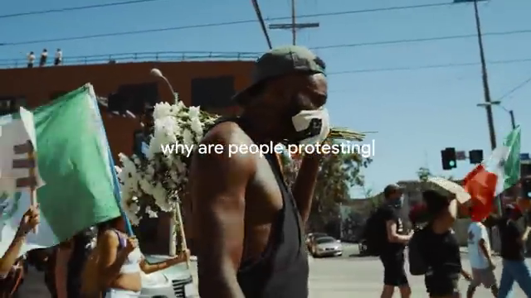

[00:01:30] officers that he could not breathe

[00:01:35] so why do we still have strength to

[00:01:37] [Music]

[00:01:38] continue

[00:01:42] [Applause]

[00:01:47] chance of black lives matter echoed from

[00:01:50] thousands of protesters

[00:01:51] in cities around the world why are we

[00:01:53] not defeated

[00:01:54] we have made too much progress and we

[00:01:57] are not

[00:01:58] going back we are going forward

--- Screenshot at 00:02:00 ---

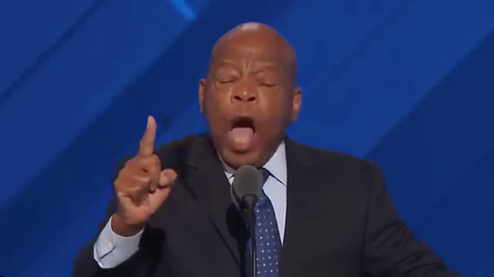

[00:02:02] planes are starting to arrive in beirut

[00:02:03] full of international aid

[00:02:05] firefighters from around the world

[00:02:07] arriving in california

[00:02:08] there are over 100 coronavirus vaccines

[00:02:10] in development worldwide this is one of

[00:02:12] those times when people look out for one

[00:02:14] another and have each other's backs

[00:02:15] we kept going for those who showed us

[00:02:17] the way think about

[00:02:19] how you would like the world to be for

[00:02:21] your daughters and granddaughters

[00:02:23] remember the struggles along the way are

[00:02:26] only meant

[00:02:27] to shape you for your purpose press on

--- Screenshot at 00:02:30 ---

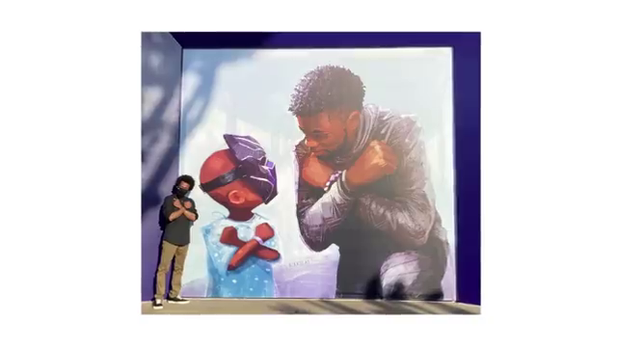

[00:02:31] with pride and press on with purpose

[00:02:34] why is it that this year showed its

[00:02:36] worst and we still found ways to try it

[00:02:39] an incredible feat for maya gabriella

[00:02:41] naomi osaka

[00:02:43] championship can't let corona stop you

[00:02:46] can't let quarlet

[00:02:47] stop you so until we get to every answer

[00:02:56] we're still searching