MemDump Tools User Guide

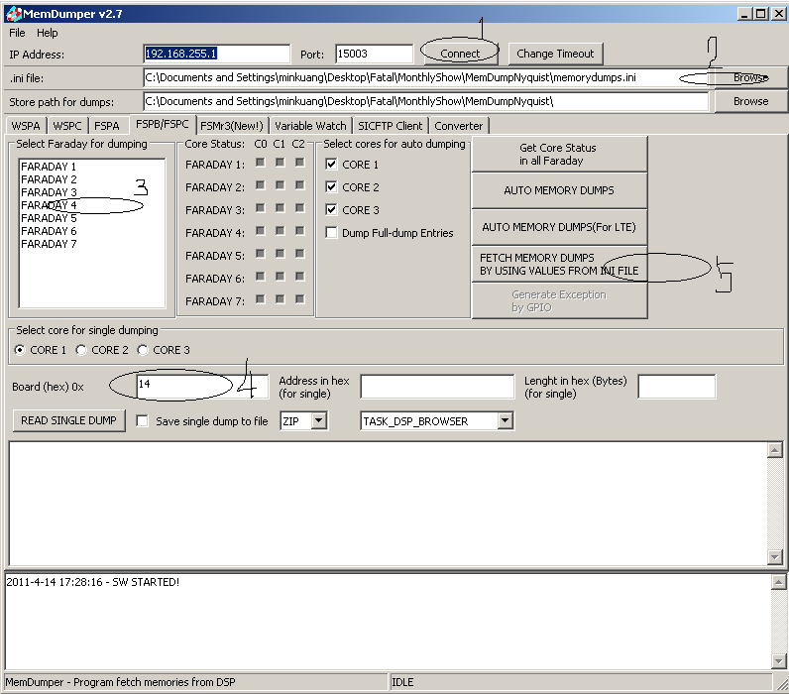

Step 1: click the button of Connect
Step 2: click the button of Browser, and choose the initial file memorydumps.ini
Step 3: Choose the Nyquist number same as Faraday number
Step 4: Choose the Board number
Step 5: click the following button
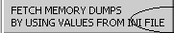
Final: this tool will dump the memory of 4 cores on your selected nyquist:
CORE0 02f10000:00050000 <<INT MEM
CORE0 10838000:00138000 <<INT MEM
CORE0 80000000:01000000 <<EXT MEM
CORE0 84000000:01000000 <<EXT MEM
CORE0 85000000:01000000 <<EXT MEM
CORE0 86000000:01000000 <<EXT MEM
CORE0 87000000:01000000 <<EXT MEM
CORE1 11828000:000B8000 <<INT MEM
CORE1 88000000:01000000 <<EXT MEM
CORE1 89000000:01000000 <<EXT MEM
CORE1 8a000000:01000000 <<EXT MEM
CORE1 8b000000:01000000 <<EXT MEM
CORE2 12800000:00080000 <<INT MEM
CORE2 8c000000:01000000 <<EXT MEM
CORE2 8d000000:01000000 <<EXT MEM
CORE2 8e000000:01000000 <<EXT MEM
CORE2 8f000000:01000000 <<EXT MEM
CORE3 13800000:00080000 <<INT MEM
CORE3 90000000:01000000 <<EXT MEM
CORE3 91000000:01000000 <<EXT MEM
CORE3 92000000:01000000 <<EXT MEM
CORE3 93000000:01000000 <<EXT MEM

