Integrated Architecture Builder

fabrica_papel

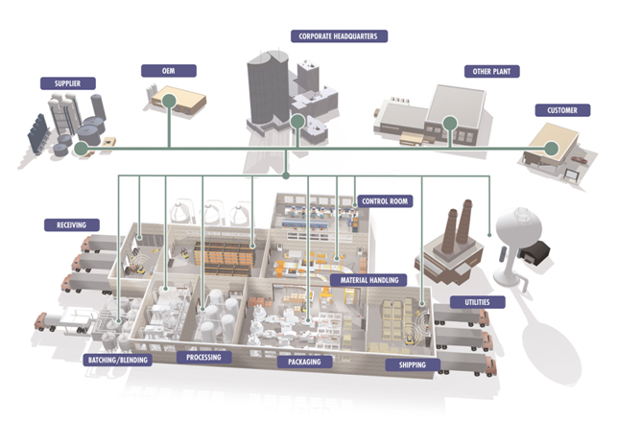

Project Documentation

Reference

Version

**Thursday, August 15, 2019 - 15:18**

/

Author

**Table of Contents:**

Integrated Architecture Builder 1

1 Overview of Project 'fabrica_papel' 5

1.1 IAB Software Information: 5

1.2 Integrated Architecture 6

1.3 ControlLogix 8

1.4 CompactLogix 10

1.5 Micro800 System 12

1.6 View 14

1.7 In-Cabinet Modular Distributed I/O 16

1.8 EtherNet/IP 18

1.9 Project's System List 20

1.10 Project Errors/Warnings 20

1.11 Project's Network list 21

1.12 Project's hardware platforms list 21

1.13 Architecture View 22

2 Bill of Materials 23

2.1 Consolidated BOM 23

2.2 Organized BOM 32

3 Network Details 38

3.1 Network 'Fabrica_Papel' 38

3.1.1 EtherNet/IP network status : To be checked! 38

3.1.2 Graphics: 38

3.1.3 Layout Information 40

4 Hardware Platforms 41

# Overview of Project 'fabrica_papel'

## ControlLogix

For manufacturers, OEMs and Systems Integrators in virtually every industry, the Logix Control Platform increases productivity while reducing total cost of ownership.

Unlike conventional architectures, the Logix Control Platform provides fully integrated, scalable solutions for the full range of automation disciplines including discrete, motion, process control, batch, drive systems and safety using a single control platform, a single development environment and using a single, open communication protocol. The platform enables you to re-use engineering designs and practices to reduce development time and cost, respond more quickly to customer or market demands, reduce maintenance costs and downtime and easily gain access to actionable plant and production information for improved management and decision-making.

**ControlLogix Programmable Automation Controller**

*The Most Powerful, Most Expandable Controller*

ControlLogix brings together the benefits of the Logix platform—common programming environment, common networks, common control engine—to provide you with the performance your application requires in an easy-to-use environment. As part of the Logix Control Platform, you receive tight integration between the programming software, controller and I/O to reduce development time and cost at commissioning and during normal operation.



* *Mix multiple controllers, networks and I/O without restrictions to address all disciplines*
* *Mix standard and safety control in same chassis*

The ControlLogix programmable automation controller (PAC) features a modular control platform with virtually infinite expansion of controllers, networks and I/O. With memory options up to 32MB, ControlLogix controllers support intensive process applications and provide fast processing of motion instructions in a single integrated solution.

ControlLogix provides modular network communications that let you purchase only what you need. Interface using ControlLogix communication modules via a ControlLogix gateway without the need for a processor in the gateway chassis, or interface directly to a ControlLogix processor.

## CompactLogix

For manufacturers, OEMs and Systems Integrators in virtually every industry, the Logix Control Platform increases productivity while reducing total cost of ownership.

Unlike conventional architectures, the Logix Control Platform provides fully integrated, scalable solutions for the full range of automation disciplines including discrete, motion, process control, batch, drive systems and safety using a single control platform, a single development environment and using a single, open communication protocol. The platform enables you to re-use engineering designs and practices to reduce development time and cost, respond more quickly to customer or market demands, reduce maintenance costs and downtime and easily gain access to actionable plant and production information for improved management and decision-making.

**CompactLogix Programmable Automation Controller**

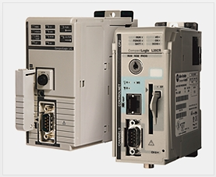CompactLogix is an economical, scalable control system for small, standalone machine-level applications to mid-sized, system-connected applications. CompactLogix controllers use a common control engine with a common development environment to provide mid-range application control in an easy-to-use environment. Tight integration between the programming software, controller and I/O modules reduces development time and cost at commissioning and during normal operation. This commonality provides cost-effective integration of a machine or safety application into a plant-wide control system because it integrates safety, motion, discrete and drive capabilities in a single controller. Its compact form factor and rackless design are compatible with a full range of [Compact I/O](http://wwwdev.ab.com/programmablecontrol/pac/compactlogix/io.html) products.

## Micro800 System

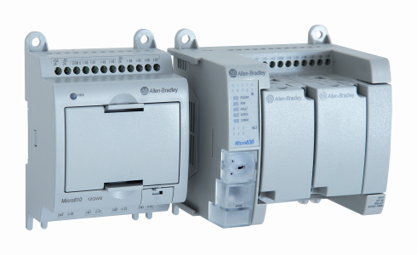

Micro800 Control Systems are easy to install and maintain. One software package applies to the entire family. These systems offer just enough control for your lower-cost, stand-alone machines. You can buy only the functionality you need, and use plug-in modules to personalize your system for specific application needs

## Project's System List

*This Project contains the following Systems:*

## Project Errors/Warnings

Your project has errors and/or warnings. This means that your system may or may not work as expected. You need to review and resolve these issues to your satisfaction by going to the Project Checker tab of the Project Completeness Wizard and the Errors/Warnings tab of the Communications Details dialog to see the errors and/or warnings.

The General Checker has found the following warnings:

|  |  |  |
| --- | --- | --- |
| Fabrica_Papel | Warning | You currently have 1 or more switches or groups of switches that are not fully connected to each other. Please connect all switches or groups together to ensure uninterrupted communication across this network. |
| CLogix_PLCMaquina1 | Warning | Warning: At least one component in the 1756 chassis is not of a like environmental type. Meaning you are mixing some combination of standard, XT, and conformal coated devices. When you mix environmental types, then the rating of the chassis goes to the least robust device. |
| CLogix_PLCMaquina1 | Warning | Your project contains possible CIP Security hardware. Use FactoryTalk Policy Manager to configure CIP Security. FactoryTalk Policy Manager comes with FactoryTalk Services Platform V6.11 or higher software package. |
| CLogix_PLCMaquina2 | Warning | Warning: At least one component in the 1756 chassis is not of a like environmental type. Meaning you are mixing some combination of standard, XT, and conformal coated devices. When you mix environmental types, then the rating of the chassis goes to the least robust device. |
| CLogix_PLCMaquina2 | Warning | Your project contains possible CIP Security hardware. Use FactoryTalk Policy Manager to configure CIP Security. FactoryTalk Policy Manager comes with FactoryTalk Services Platform V6.11 or higher software package. |
| Pantalla_Compresora | Warning | HMI device Pantalla_Compresora (Catalog number: 2711R-T4T) is not assigned to a controller. |

## Project's Network list

*This Project contains the following networks:*

|  |  |  |
| --- | --- | --- |
| ***Network Type*** | ***Network Name*** | ***Network Status*** |
| EtherNet/IP | Fabrica_Papel | To be checked! |

## Project's hardware platforms list

*This Project contains the following Hardware platforms:*

|  |  |
| --- | --- |
| ***HW Platform Type*** | ***HW Platform Name*** |
| Micro800 | Micro850_Compresora |
| View | Pantalla_Compresora |
| ControlLogix | CLogix_PLCMaquina1 |
| View | Pantalla_Maquina1 |
| View | Pantalla_Maquina2 |
| Micro800 | Micro850_Rebobinadora1 |
| Micro800 | Micro850_Rebobinadora2 |
| Point I/O | Extension_Maquina1 |
| ControlLogix | CLogix_PLCMaquina2 |
| Point I/O | Extension_Maquina2 |
| View | Pantalla_Higienico1 |
| View | Pantalla_Higienico2 |
| Compact | CompactLogix_Higienico1 |
| Compact | CompactLogix_Higienico2 |
| View | Pantalla_Diverter |
| Compact | CompactLogix_Diverter |

## Architecture View

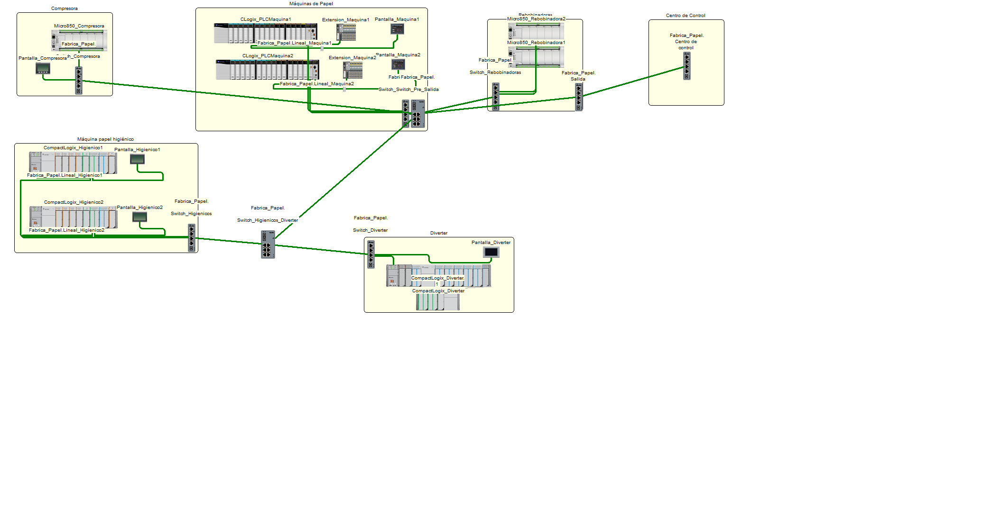

# Bill of Materials

The list prices shown in this tool are reference points used by your distributor or Rockwell Automation to calculate your extended net prices and do not include applicable discounts and taxes. To obtain your extended net pricing for products, contact Rockwell Automation or your authorized distributor.

## Consolidated BOM

|  |  |  |  |  |
| --- | --- | --- | --- | --- |
| **Qty** | **Catalog #** | **Description** | **($ - USD) Unit Price** | **($ - USD) Total Price** |
| 1 | 2080-LC50-48AWB | Controller, 28 120V AC Inputs, 20 Relay Output, 24 DC Input Power, Embedded USB Programming Port, Ethernet Port and Non-Isolated RS232/485 Serial Port, 5 Plug-In Ports, supports upto 4 Expansion Modules. | 691.00 | 691.00 |
| 1 | 2711R-T4T | PanelView 800 4.3-Inch HMI Terminal, Touch Screen TFT with 4 function keypads, with Serial and Ethernet ports | 451.50 | 451.50 |
| 2 | 1756-A17 | 1756 Chassis 17 slots | 1,053.15 | 2,106.30 |
| 2 | 1756-PA75 | 85-265V AC Power Supply (5V @ 13 Amp) | 1,340.85 | 2,681.70 |
| 14 | 1756-IB32 | 10-31 VDC Input 32 Pts (36 Pin) | 571.20 | 7,996.80 |
| 28 | 1756-TBCH | 36 Pin Screw Clamp Block With Standard Housing | 103.20 | 2,889.60 |
| 2 | 1756-OB32K | 10-31 VDC Output 32 Pts (36 Pin) - Conformally Coated | 885.15 | 1,770.30 |
| 2 | 1756-OB32 | 10-31 VDC Output 32 Pts (36 Pin) | 808.50 | 1,617.00 |
| 10 | 1756-IF16 | Analog Input - Current/Voltage 16 Pts (36 Pin) | 1,857.45 | 18,574.50 |
| 2 | 1756-OF8 | Analog Output - Current/Voltage 8 Pts (20 Pin) | 2,406.60 | 4,813.20 |
| 2 | 1756-TBNH | 20 Position NemA Screw Clamp Block | 83.37 | 166.74 |
| 2 | 1756-EN2T | EtherNet 10-100M Bridge Module | 3,250.80 | 6,501.60 |
| 2 | 1756-L81E | Logix5580E Controller With 3 Mbytes Memory | 6,181.00 | 12,362.00 |
| 2 | 2715P-T12WD-B | Graphic Terminal,12.1 in.,TFT Color,Wide Aspect Ratio,Touch Screen,Dual Port Ethernet,18-30 V DC,Without Allen-Bradley/PanelView Brand | 4,540.00 | 9,080.00 |
| 2 | 2080-LC50-48QBB | Controller, 28 24 VDC/VAC Inputs, 20 Source Output, 24 DC Input Power,Up to 6 HSC channels, Embedded USB Programming Port, Ethernet Port and Non-Isolated RS232/485 Serial Port, 5 Plug-In Ports, supports upto 4 Expansion Modules & upto 3 axis of PTO motion | 691.00 | 1,382.00 |
| 4 | 2085-IQ16 | Input Module, Digital, 16 Point, 12/24VDC, Sink/Source , IEC | 150.00 | 600.00 |
| 2 | 2085-OB16 | Output Module, Digital, 16 Point, 12/24VDC, Source | 188.00 | 376.00 |
| 2 | 2085-ECR | Expansion I/O End Caps / Terminator | 16.28 | 32.56 |
| 2 | 1794-PS13 | 85-264 VAC To 24 VDC 1.3A Power Supply | 247.80 | 495.60 |
| 2 | 1734-AENT | 1734 EtherNet/IP Adapter | 573.30 | 1,146.60 |
| 16 | 1734-OE2V | 2-Point Analog Voltage Output Module | 340.20 | 5,443.20 |
| 16 | 1734-TOP | One-Piece Terminal Base, 8-point, Screw Clamp Terminals | 19.47 | 311.52 |
| 2 | 2711R-T7T | PanelView 800 7-Inch HMI Terminal, Touch Screen TFT, with Serial and Ethernet ports | 866.25 | 1,732.50 |
| 2 | 1769-ECR | Right End Cap Terminator | 39.09 | 78.18 |
| 2 | 1769-L30ER | CompactLogix 5370 L3 Controller, 2 EtherNet/IP ports, 1MB memory w/ supercap backup, up to 8 1769 I/O expansion modules, 16 EtherNet/IP and 120 TCP connections | 2,247.00 | 4,494.00 |
| 3 | 1769-PA4 | 120/240V AC Power Supply (5V @ 4 Amp) | 521.00 | 1,563.00 |
| 8 | 1769-OF8C | 8 Channel Analog Current Output Module | 1,669.00 | 13,352.00 |
| 3 | 1769-OB8 | 8 Point High Power 24 VDC Output Module | 293.00 | 879.00 |
| 4 | 1769-OB32 | 32 Point 24 VDC Output Module | 592.00 | 2,368.00 |
| 8 | 1769-IQ32 | 32 Point 24 VDC Input Module | 488.00 | 3,904.00 |
| 2 | 1769-IF16C | 16 Channel Compact High-density Analog Current Input Module | 1,307.00 | 2,614.00 |
| 1 | 2711P-T9W22A9P | Graphic Terminal, Performance Model, Extended Features,9.0 in., TFT Color, Standard Aspect Ratio, Touch screen, Device Level Ring Ethernet,85-264 V AC | 3,945.00 | 3,945.00 |
| 1 | 1769-ECL | Left End Cap Terminator | 50.45 | 50.45 |
| 1 | 1769-L33ER | CompactLogix 5370 L3 Controller, 2Mb Memory, w/Supercap Backup, up to 16 1769 I/O expansion modules, 32 EtherNet/IP and 120 TCP connections | 3,194.00 | 3,194.00 |
| 2 | 1769-IA16 | 16 Point 120 VAC Input Module | 325.00 | 650.00 |
| 1 | 1769-IQ16 | 16 Point 24 VDC Sinking/Sourcing Input Module | 277.00 | 277.00 |
| 1 | 1769-CRR1 | Right bank-to-right bank expansion (305 mm) | 194.00 | 194.00 |
| 1 | 1769-PA2 | 120/240V AC Power Supply (5V @ 2 Amp) | 315.00 | 315.00 |
| 7 | 1783-US4T1F | Stratix 2000 Switch, Unmanaged, 4 Copper Ports, 1 Fiber w/LC-Connector | 263.55 | 1,844.85 |
| 15 | 1585J-M4TBJM-2 | Patchcord: RJ45 Male / RJ45 Male, 4-Conductor, Teal TPE, Flex Rated, 2 meters (6.56 feet) | 44.95 | 674.25 |
| 8 | FLCDMC5BLY | Panduit FIC: Multimode 50 micron (OM2), LC Connector | 7.25 | 57.98 |
| 2 | 1585J-M4TBJM-10 | Patchcord: RJ45 Male / RJ45 Male, 4-Conductor, Teal TPE, Flex Rated, 10 meters (32.8 feet) | 87.35 | 174.70 |
| 1 | 1585J-M4TBJM-25 | Patchcord: RJ45 Male / RJ45 Male, 4-Conductor, Teal TPE, Flex Rated, 25 meters (82 feet) | 166.85 | 166.85 |
| 1 | 1585J-E8TBJM-80 | Patchcord: RJ45 Male / RJ45 Male, 8-Conductor, Teal Robotic TPE, Flex Rated, Right Angle to Straight, 80.0 meters (262.47 feet) | 473.12 | 473.12 |
| 2 | 1783-ETAP | EtherNet/IP Tap w/ 3 copper ports | 389.55 | 779.10 |
| 2 | 1585J-M4TBJM-4 | Patchcord: RJ45 Male / RJ45 Male, 4-Conductor, Teal TPE, Flex Rated, 4 meters (13.12 feet) | 55.55 | 111.10 |
| 2 | 1783-US6T2F | Stratix 2000 Switch, Unmanaged, 6 Copper Ports, 2 Fiber w/LC-Connector | 526.05 | 1,052.10 |
| 1 | 1585J-M4TBJM-35 | Patchcord: RJ45 Male / RJ45 Male, 4-Conductor, Teal TPE, Flex Rated, 35 meters (114.8 feet) | 220.00 | 220.00 |
| 1 | FSIR502Y | Panduit Raw Cable: Duplex Zipcord Multimode 50 micron (OM2), 1.6mm diameter, 2-Conductor, Orange Riser, 774.0m total reqd. | 4.93 | 3815.82 |
| 1 | 9701-VWSB100AENE | FactoryTalk View SE Station 100 Display | 4,252.00 | 4,252.00 |
|  |  |  |  |  |
|  |  |  | **Total:** | **$ 134,721.72** |

## Organized BOM

|  |  |  |  |  |
| --- | --- | --- | --- | --- |
| **Qty** | **Catalog #** | **Description** | **($ - USD) Unit Price** | **($ - USD) Total Price** |
|  |  | **Networks** |  |  |
|  |  |  |  |  |
|  |  | **Fabrica_Papel : Switch_Compresora** |  |  |
| 1 | 1783-US4T1F | Stratix 2000 Switch, Unmanaged, 4 Copper Ports, 1 Fiber w/LC-Connector | 263.55 | 263.55 |
| 2 | 1585J-M4TBJM-2 | Patchcord: RJ45 Male / RJ45 Male, 4-Conductor, Teal TPE, Flex Rated, 2 meters (6.56 feet) | 44.95 | 89.90 |
| 1 | 2080-LC50-48AWB | (Micro850_Compresora) Controller, 28 120V AC Inputs, 20 Relay Output, 24 DC Input Power, Embedded USB Programming Port, Ethernet Port and Non-Isolated RS232/485 Serial Port, 5 Plug-In Ports, supports upto 4 Expansion Modules. | In Hardware** | 0.00 |
| 1 | 2711R-T4T | (Pantalla_Compresora) PanelView 800 4.3-Inch HMI Terminal, Touch Screen TFT with 4 function keypads, with Serial and Ethernet ports | In Hardware** | 0.00 |
| 2 | FLCDMC5BLY | Panduit FIC: Multimode 50 micron (OM2), LC Connector | 7.25 | 14.5 |
| 1 | FSIR502Y | Panduit Raw Cable: Duplex Zipcord Multimode 50 micron (OM2), 1.6mm diameter, 2-Conductor, Orange Riser (159.00m total reqd.) | In Bulk Cable* | 0.00 |
|  |  |  |  |  |
|  |  | **Fabrica_Papel : Switch_MaquinasPapel** |  |  |
| 1 | 1783-US4T1F | Stratix 2000 Switch, Unmanaged, 4 Copper Ports, 1 Fiber w/LC-Connector | 263.55 | 263.55 |
| 2 | 1585J-M4TBJM-10 | Patchcord: RJ45 Male / RJ45 Male, 4-Conductor, Teal TPE, Flex Rated, 10 meters (32.8 feet) | 87.35 | 174.70 |
| 2 | 1756-EN2T | (CLogix_PLCMaquina1) EtherNet 10-100M Bridge Module | In Hardware** | 0.00 |
| 1 | 1585J-M4TBJM-2 | Patchcord: RJ45 Male / RJ45 Male, 4-Conductor, Teal TPE, Flex Rated, 2 meters (6.56 feet) | 44.95 | 44.95 |
|  |  |  |  |  |
|  |  | **Fabrica_Papel : Switch_Rebobinadoras** |  |  |
| 1 | 1783-US4T1F | Stratix 2000 Switch, Unmanaged, 4 Copper Ports, 1 Fiber w/LC-Connector | 263.55 | 263.55 |
| 2 | 1585J-M4TBJM-2 | Patchcord: RJ45 Male / RJ45 Male, 4-Conductor, Teal TPE, Flex Rated, 2 meters (6.56 feet) | 44.95 | 89.90 |
| 2 | 2080-LC50-48QBB | (Micro850_Rebobinadora1) Controller, 28 24 VDC/VAC Inputs, 20 Source Output, 24 DC Input Power,Up to 6 HSC channels, Embedded USB Programming Port, Ethernet Port and Non-Isolated RS232/485 Serial Port, 5 Plug-In Ports, supports upto 4 Expansion Modules & upto 3 axis of PTO motion | In Hardware** | 0.00 |
| 1 | 1585J-M4TBJM-25 | Patchcord: RJ45 Male / RJ45 Male, 4-Conductor, Teal TPE, Flex Rated, 25 meters (82 feet) | 166.85 | 166.85 |
|  |  |  |  |  |
|  |  | **Fabrica_Papel : Switch_Diverter** |  |  |
| 1 | 1783-US4T1F | Stratix 2000 Switch, Unmanaged, 4 Copper Ports, 1 Fiber w/LC-Connector | 263.55 | 263.55 |
| 2 | 1585J-M4TBJM-2 | Patchcord: RJ45 Male / RJ45 Male, 4-Conductor, Teal TPE, Flex Rated, 2 meters (6.56 feet) | 44.95 | 89.90 |
| 1 | 1769-L33ER | (CompactLogix_Diverter) CompactLogix 5370 L3 Controller, 2Mb Memory, w/Supercap Backup, up to 16 1769 I/O expansion modules, 32 EtherNet/IP and 120 TCP connections | In Hardware** | 0.00 |
| 1 | 2711P-T9W22A9P | (Pantalla_Diverter) Graphic Terminal, Performance Model, Extended Features,9.0 in., TFT Color, Standard Aspect Ratio, Touch screen, Device Level Ring Ethernet,85-264 V AC | In Hardware** | 0.00 |
| 1 | 1585J-E8TBJM-80 | Patchcord: RJ45 Male / RJ45 Male, 8-Conductor, Teal Robotic TPE, Flex Rated, Right Angle to Straight, 80.0 meters (262.47 feet) | 473.12 | 473.12 |
|  |  |  |  |  |
|  |  | **Fabrica_Papel : Lineal_Maquina1** |  |  |
| 1 | 1756-L81E | (CLogix_PLCMaquina1) Logix5580E Controller With 3 Mbytes Memory | In Hardware** | 0.00 |
| 3 | 1585J-M4TBJM-2 | Patchcord: RJ45 Male / RJ45 Male, 4-Conductor, Teal TPE, Flex Rated, 2 meters (6.56 feet) | 44.95 | 134.85 |
| 1 | 1783-ETAP | EtherNet/IP Tap w/ 3 copper ports | 389.55 | 389.55 |
| 1 | 1734-AENT | (Extension_Maquina1) 1734 EtherNet/IP Adapter | In Hardware** | 0.00 |
| 1 | 2715P-T12WD-B | (Pantalla_Maquina1) Graphic Terminal,12.1 in.,TFT Color,Wide Aspect Ratio,Touch Screen,Dual Port Ethernet,18-30 V DC,Without Allen-Bradley/PanelView Brand | In Hardware** | 0.00 |
|  |  |  |  |  |
|  |  | **Fabrica_Papel : Lineal_Maquina2** |  |  |
| 1 | 1756-L81E | (CLogix_PLCMaquina2) Logix5580E Controller With 3 Mbytes Memory | In Hardware** | 0.00 |
| 3 | 1585J-M4TBJM-2 | Patchcord: RJ45 Male / RJ45 Male, 4-Conductor, Teal TPE, Flex Rated, 2 meters (6.56 feet) | 44.95 | 134.85 |
| 1 | 1783-ETAP | EtherNet/IP Tap w/ 3 copper ports | 389.55 | 389.55 |
| 1 | 1734-AENT | (Extension_Maquina2) 1734 EtherNet/IP Adapter | In Hardware** | 0.00 |
| 1 | 2715P-T12WD-B | (Pantalla_Maquina2) Graphic Terminal,12.1 in.,TFT Color,Wide Aspect Ratio,Touch Screen,Dual Port Ethernet,18-30 V DC,Without Allen-Bradley/PanelView Brand | In Hardware** | 0.00 |
|  |  |  |  |  |
|  |  | **Fabrica_Papel : Lineal_Higienico1** |  |  |
| 1 | 1585J-M4TBJM-4 | Patchcord: RJ45 Male / RJ45 Male, 4-Conductor, Teal TPE, Flex Rated, 4 meters (13.12 feet) | 55.55 | 55.55 |
| 1 | 1769-L30ER | (CompactLogix_Higienico1) CompactLogix 5370 L3 Controller, 2 EtherNet/IP ports, 1MB memory w/ supercap backup, up to 8 1769 I/O expansion modules, 16 EtherNet/IP and 120 TCP connections | In Hardware** | 0.00 |
| 1 | 1585J-M4TBJM-2 | Patchcord: RJ45 Male / RJ45 Male, 4-Conductor, Teal TPE, Flex Rated, 2 meters (6.56 feet) | 44.95 | 44.95 |
| 1 | 2711R-T7T | (Pantalla_Higienico1) PanelView 800 7-Inch HMI Terminal, Touch Screen TFT, with Serial and Ethernet ports | In Hardware** | 0.00 |
|  |  |  |  |  |
|  |  | **Fabrica_Papel : Switch_Higienicos** |  |  |
| 1 | 1783-US4T1F | Stratix 2000 Switch, Unmanaged, 4 Copper Ports, 1 Fiber w/LC-Connector | 263.55 | 263.55 |
| 2 | FLCDMC5BLY | Panduit FIC: Multimode 50 micron (OM2), LC Connector | 7.25 | 14.5 |
| 1 | FSIR502Y | Panduit Raw Cable: Duplex Zipcord Multimode 50 micron (OM2), 1.6mm diameter, 2-Conductor, Orange Riser (175.00m total reqd.) | In Bulk Cable* | 0.00 |
|  |  |  |  |  |
|  |  | **Fabrica_Papel : Lineal_Higienico2** |  |  |
| 1 | 1585J-M4TBJM-4 | Patchcord: RJ45 Male / RJ45 Male, 4-Conductor, Teal TPE, Flex Rated, 4 meters (13.12 feet) | 55.55 | 55.55 |
| 1 | 1769-L30ER | (CompactLogix_Higienico2) CompactLogix 5370 L3 Controller, 2 EtherNet/IP ports, 1MB memory w/ supercap backup, up to 8 1769 I/O expansion modules, 16 EtherNet/IP and 120 TCP connections | In Hardware** | 0.00 |
| 1 | 1585J-M4TBJM-2 | Patchcord: RJ45 Male / RJ45 Male, 4-Conductor, Teal TPE, Flex Rated, 2 meters (6.56 feet) | 44.95 | 44.95 |
| 1 | 2711R-T7T | (Pantalla_Higienico2) PanelView 800 7-Inch HMI Terminal, Touch Screen TFT, with Serial and Ethernet ports | In Hardware** | 0.00 |
|  |  |  |  |  |
|  |  | **Fabrica_Papel : Switch_Pre_Salida** |  |  |
| 1 | 1783-US6T2F | Stratix 2000 Switch, Unmanaged, 6 Copper Ports, 2 Fiber w/LC-Connector | 526.05 | 526.05 |
| 1 | 1585J-M4TBJM-35 | Patchcord: RJ45 Male / RJ45 Male, 4-Conductor, Teal TPE, Flex Rated, 35 meters (114.8 feet) | 220.00 | 220.00 |
|  |  |  |  |  |
|  |  | **Fabrica_Papel : Switch_Higienicos_Diverter** |  |  |
| 1 | 1783-US6T2F | Stratix 2000 Switch, Unmanaged, 6 Copper Ports, 2 Fiber w/LC-Connector | 526.05 | 526.05 |
| 2 | FLCDMC5BLY | Panduit FIC: Multimode 50 micron (OM2), LC Connector | 7.25 | 14.5 |
| 1 | FSIR502Y | Panduit Raw Cable: Duplex Zipcord Multimode 50 micron (OM2), 1.6mm diameter, 2-Conductor, Orange Riser (271.00m total reqd.) | In Bulk Cable* | 0.00 |
|  |  |  |  |  |
|  |  | **Fabrica_Papel : Salida** |  |  |
| 1 | 1783-US4T1F | Stratix 2000 Switch, Unmanaged, 4 Copper Ports, 1 Fiber w/LC-Connector | 263.55 | 263.55 |
| 2 | FLCDMC5BLY | Panduit FIC: Multimode 50 micron (OM2), LC Connector | 7.25 | 14.5 |
| 1 | FSIR502Y | Panduit Raw Cable: Duplex Zipcord Multimode 50 micron (OM2), 1.6mm diameter, 2-Conductor, Orange Riser (169.00m total reqd.) | In Bulk Cable* | 0.00 |
|  |  |  |  |  |
|  |  | **Fabrica_Papel : Centro de control** |  |  |
| 1 | 1783-US4T1F | Stratix 2000 Switch, Unmanaged, 4 Copper Ports, 1 Fiber w/LC-Connector | 263.55 | 263.55 |
|  |  |  | **Subtotal:** | **$ 5,554.05** |
|  |  |  |  |  |
|  |  | **Hardware** |  |  |
|  |  |  |  |  |
|  |  | **Micro850_Compresora** |  |  |
| 1 | 2080-LC50-48AWB | Controller, 28 120V AC Inputs, 20 Relay Output, 24 DC Input Power, Embedded USB Programming Port, Ethernet Port and Non-Isolated RS232/485 Serial Port, 5 Plug-In Ports, supports upto 4 Expansion Modules. | 691.00 | 691.00 |
|  |  |  | **Subtotal:** | **$ 691.00** |
|  |  |  |  |  |
|  |  | **Pantalla_Compresora** |  |  |
| 1 | 2711R-T4T | PanelView 800 4.3-Inch HMI Terminal, Touch Screen TFT with 4 function keypads, with Serial and Ethernet ports | 451.50 | 451.50 |
|  |  |  | **Subtotal:** | **$ 451.50** |
|  |  |  |  |  |
|  |  | **CLogix_PLCMaquina1** |  |  |
| 1 | 1756-A17 | 1756 Chassis 17 slots | 1,053.15 | 1,053.15 |
| 1 | 1756-PA75 | 85-265V AC Power Supply (5V @ 13 Amp) | 1,340.85 | 1,340.85 |
| 7 | 1756-IB32 | 10-31 VDC Input 32 Pts (36 Pin) | 571.20 | 3,998.40 |
| 14 | 1756-TBCH | 36 Pin Screw Clamp Block With Standard Housing | 103.20 | 1,444.80 |
| 1 | 1756-OB32K | 10-31 VDC Output 32 Pts (36 Pin) - Conformally Coated | 885.15 | 885.15 |
| 1 | 1756-OB32 | 10-31 VDC Output 32 Pts (36 Pin) | 808.50 | 808.50 |
| 5 | 1756-IF16 | Analog Input - Current/Voltage 16 Pts (36 Pin) | 1,857.45 | 9,287.25 |
| 1 | 1756-OF8 | Analog Output - Current/Voltage 8 Pts (20 Pin) | 2,406.60 | 2,406.60 |
| 1 | 1756-TBNH | 20 Position NemA Screw Clamp Block | 83.37 | 83.37 |
| 1 | 1756-EN2T | EtherNet 10-100M Bridge Module | 3,250.80 | 3,250.80 |
| 1 | 1756-L81E | Logix5580E Controller With 3 Mbytes Memory | 6,181.00 | 6,181.00 |
|  |  |  | **Subtotal:** | **$ 30,739.87** |
|  |  |  |  |  |
|  |  | **Pantalla_Maquina1** |  |  |
| 1 | 2715P-T12WD-B | Graphic Terminal,12.1 in.,TFT Color,Wide Aspect Ratio,Touch Screen,Dual Port Ethernet,18-30 V DC,Without Allen-Bradley/PanelView Brand | 4,540.00 | 4,540.00 |
|  |  |  | **Subtotal:** | **$ 4,540.00** |
|  |  |  |  |  |
|  |  | **Pantalla_Maquina2** |  |  |
| 1 | 2715P-T12WD-B | Graphic Terminal,12.1 in.,TFT Color,Wide Aspect Ratio,Touch Screen,Dual Port Ethernet,18-30 V DC,Without Allen-Bradley/PanelView Brand | 4,540.00 | 4,540.00 |
|  |  |  | **Subtotal:** | **$ 4,540.00** |
|  |  |  |  |  |
|  |  | **Micro850_Rebobinadora1** |  |  |
| 1 | 2080-LC50-48QBB | Controller, 28 24 VDC/VAC Inputs, 20 Source Output, 24 DC Input Power,Up to 6 HSC channels, Embedded USB Programming Port, Ethernet Port and Non-Isolated RS232/485 Serial Port, 5 Plug-In Ports, supports upto 4 Expansion Modules & upto 3 axis of PTO motion | 691.00 | 691.00 |
| 2 | 2085-IQ16 | Input Module, Digital, 16 Point, 12/24VDC, Sink/Source , IEC | 150.00 | 300.00 |
| 1 | 2085-OB16 | Output Module, Digital, 16 Point, 12/24VDC, Source | 188.00 | 188.00 |
| 1 | 2085-ECR | Expansion I/O End Caps / Terminator | 16.28 | 16.28 |
|  |  |  | **Subtotal:** | **$ 1,195.28** |
|  |  |  |  |  |
|  |  | **Micro850_Rebobinadora2** |  |  |
| 1 | 2080-LC50-48QBB | Controller, 28 24 VDC/VAC Inputs, 20 Source Output, 24 DC Input Power,Up to 6 HSC channels, Embedded USB Programming Port, Ethernet Port and Non-Isolated RS232/485 Serial Port, 5 Plug-In Ports, supports upto 4 Expansion Modules & upto 3 axis of PTO motion | 691.00 | 691.00 |
| 2 | 2085-IQ16 | Input Module, Digital, 16 Point, 12/24VDC, Sink/Source , IEC | 150.00 | 300.00 |
| 1 | 2085-OB16 | Output Module, Digital, 16 Point, 12/24VDC, Source | 188.00 | 188.00 |
| 1 | 2085-ECR | Expansion I/O End Caps / Terminator | 16.28 | 16.28 |
|  |  |  | **Subtotal:** | **$ 1,195.28** |
|  |  |  |  |  |
|  |  | **Extension_Maquina1** |  |  |
| 1 | 1794-PS13 | 85-264 VAC To 24 VDC 1.3A Power Supply | 247.80 | 247.80 |
| 1 | 1734-AENT | 1734 EtherNet/IP Adapter | 573.30 | 573.30 |
| 8 | 1734-OE2V | 2-Point Analog Voltage Output Module | 340.20 | 2,721.60 |
| 8 | 1734-TOP | One-Piece Terminal Base, 8-point, Screw Clamp Terminals | 19.47 | 155.76 |
|  |  |  | **Subtotal:** | **$ 3,698.46** |
|  |  |  |  |  |
|  |  | **CLogix_PLCMaquina2** |  |  |
| 1 | 1756-A17 | 1756 Chassis 17 slots | 1,053.15 | 1,053.15 |
| 1 | 1756-PA75 | 85-265V AC Power Supply (5V @ 13 Amp) | 1,340.85 | 1,340.85 |
| 7 | 1756-IB32 | 10-31 VDC Input 32 Pts (36 Pin) | 571.20 | 3,998.40 |
| 14 | 1756-TBCH | 36 Pin Screw Clamp Block With Standard Housing | 103.20 | 1,444.80 |
| 1 | 1756-OB32K | 10-31 VDC Output 32 Pts (36 Pin) - Conformally Coated | 885.15 | 885.15 |
| 1 | 1756-OB32 | 10-31 VDC Output 32 Pts (36 Pin) | 808.50 | 808.50 |
| 5 | 1756-IF16 | Analog Input - Current/Voltage 16 Pts (36 Pin) | 1,857.45 | 9,287.25 |
| 1 | 1756-OF8 | Analog Output - Current/Voltage 8 Pts (20 Pin) | 2,406.60 | 2,406.60 |
| 1 | 1756-TBNH | 20 Position NemA Screw Clamp Block | 83.37 | 83.37 |
| 1 | 1756-EN2T | EtherNet 10-100M Bridge Module | 3,250.80 | 3,250.80 |
| 1 | 1756-L81E | Logix5580E Controller With 3 Mbytes Memory | 6,181.00 | 6,181.00 |
|  |  |  | **Subtotal:** | **$ 30,739.87** |
|  |  |  |  |  |
|  |  | **Extension_Maquina2** |  |  |
| 1 | 1794-PS13 | 85-264 VAC To 24 VDC 1.3A Power Supply | 247.80 | 247.80 |
| 1 | 1734-AENT | 1734 EtherNet/IP Adapter | 573.30 | 573.30 |
| 8 | 1734-OE2V | 2-Point Analog Voltage Output Module | 340.20 | 2,721.60 |
| 8 | 1734-TOP | One-Piece Terminal Base, 8-point, Screw Clamp Terminals | 19.47 | 155.76 |
|  |  |  | **Subtotal:** | **$ 3,698.46** |
|  |  |  |  |  |
|  |  | **Pantalla_Higienico1** |  |  |
| 1 | 2711R-T7T | PanelView 800 7-Inch HMI Terminal, Touch Screen TFT, with Serial and Ethernet ports | 866.25 | 866.25 |
|  |  |  | **Subtotal:** | **$ 866.25** |
|  |  |  |  |  |
|  |  | **Pantalla_Higienico2** |  |  |
| 1 | 2711R-T7T | PanelView 800 7-Inch HMI Terminal, Touch Screen TFT, with Serial and Ethernet ports | 866.25 | 866.25 |
|  |  |  | **Subtotal:** | **$ 866.25** |
|  |  |  |  |  |
|  |  | **CompactLogix_Higienico1** |  |  |
| 1 | 1769-ECR | Right End Cap Terminator | 39.09 | 39.09 |
| 1 | 1769-L30ER | CompactLogix 5370 L3 Controller, 2 EtherNet/IP ports, 1MB memory w/ supercap backup, up to 8 1769 I/O expansion modules, 16 EtherNet/IP and 120 TCP connections | 2,247.00 | 2,247.00 |
| 1 | 1769-PA4 | 120/240V AC Power Supply (5V @ 4 Amp) | 521.00 | 521.00 |
| 4 | 1769-OF8C | 8 Channel Analog Current Output Module | 1,669.00 | 6,676.00 |
| 1 | 1769-OB8 | 8 Point High Power 24 VDC Output Module | 293.00 | 293.00 |
| 1 | 1769-OB32 | 32 Point 24 VDC Output Module | 592.00 | 592.00 |
| 1 | 1769-IQ32 | 32 Point 24 VDC Input Module | 488.00 | 488.00 |
| 1 | 1769-IF16C | 16 Channel Compact High-density Analog Current Input Module | 1,307.00 | 1,307.00 |
|  |  |  | **Subtotal:** | **$ 12,163.09** |
|  |  |  |  |  |
|  |  | **CompactLogix_Higienico2** |  |  |
| 1 | 1769-ECR | Right End Cap Terminator | 39.09 | 39.09 |
| 1 | 1769-L30ER | CompactLogix 5370 L3 Controller, 2 EtherNet/IP ports, 1MB memory w/ supercap backup, up to 8 1769 I/O expansion modules, 16 EtherNet/IP and 120 TCP connections | 2,247.00 | 2,247.00 |
| 1 | 1769-PA4 | 120/240V AC Power Supply (5V @ 4 Amp) | 521.00 | 521.00 |
| 4 | 1769-OF8C | 8 Channel Analog Current Output Module | 1,669.00 | 6,676.00 |
| 1 | 1769-OB8 | 8 Point High Power 24 VDC Output Module | 293.00 | 293.00 |
| 1 | 1769-OB32 | 32 Point 24 VDC Output Module | 592.00 | 592.00 |
| 1 | 1769-IQ32 | 32 Point 24 VDC Input Module | 488.00 | 488.00 |
| 1 | 1769-IF16C | 16 Channel Compact High-density Analog Current Input Module | 1,307.00 | 1,307.00 |
|  |  |  | **Subtotal:** | **$ 12,163.09** |
|  |  |  |  |  |
|  |  | **Pantalla_Diverter** |  |  |
| 1 | 2711P-T9W22A9P | Graphic Terminal, Performance Model, Extended Features,9.0 in., TFT Color, Standard Aspect Ratio, Touch screen, Device Level Ring Ethernet,85-264 V AC | 3,945.00 | 3,945.00 |
|  |  |  | **Subtotal:** | **$ 3,945.00** |
|  |  |  |  |  |
|  |  | **CompactLogix_Diverter** |  |  |
| 1 | 1769-ECL | Left End Cap Terminator | 50.45 | 50.45 |
| 1 | 1769-L33ER | CompactLogix 5370 L3 Controller, 2Mb Memory, w/Supercap Backup, up to 16 1769 I/O expansion modules, 32 EtherNet/IP and 120 TCP connections | 3,194.00 | 3,194.00 |
| 2 | 1769-IA16 | 16 Point 120 VAC Input Module | 325.00 | 650.00 |
| 6 | 1769-IQ32 | 32 Point 24 VDC Input Module | 488.00 | 2,928.00 |
| 1 | 1769-PA4 | 120/240V AC Power Supply (5V @ 4 Amp) | 521.00 | 521.00 |
| 1 | 1769-IQ16 | 16 Point 24 VDC Sinking/Sourcing Input Module | 277.00 | 277.00 |
| 1 | 1769-CRR1 | Right bank-to-right bank expansion (305 mm) | 194.00 | 194.00 |
| 2 | 1769-OB32 | 32 Point 24 VDC Output Module | 592.00 | 1,184.00 |
| 1 | 1769-OB8 | 8 Point High Power 24 VDC Output Module | 293.00 | 293.00 |
| 1 | 1769-PA2 | 120/240V AC Power Supply (5V @ 2 Amp) | 315.00 | 315.00 |
|  |  |  | **Subtotal:** | **$ 9,606.45** |
|  |  |  |  |  |
|  |  | **Consolidated Network Spool Cables** |  |  |
| 1 | FSIR502Y | Panduit Raw Cable: Duplex Zipcord Multimode 50 micron (OM2), 1.6mm diameter, 4-Conductor, Orange Riser, 774.0m total reqd. | 4.93 | 3815.82 |
|  |  |  | **Subtotal:** | **$3815.82** |
|  |  |  |  |  |
|  |  | **Rockwell Software** |  |  |
|  |  |  |  |  |
|  |  | **FactoryTalk View Site Edition Station** |  |  |
| 1 | 9701-VWSB100AENE | FactoryTalk View SE Station 100 Display | 4,252.00 | 4,252.00 |
|  |  |  | **Subtotal:** | **$ 4,252.00** |
|  |  |  |  |  |
|  |  |  | **Total:** | **$ 134,721.72** |

# Network Details

## Network 'Fabrica_Papel'

### EtherNet/IP network status : To be checked!

### Graphics:

Zone: Network

PONER ZONAS.

### Layout Information:

Network

Switch_Compresora, 1783-US4T1F

A#10.0.2.4, Micro850_Compresora, 2080-LC50-48AWB

A#10.0.2.5, Pantalla_Compresora, 2711R-T4T

Switch_MaquinasPapel, 1783-US4T1F

A#10.0.2.7, CLogix_PLCMaquina1, [15], 1756-EN2T

A#10.0.2.12, CLogix_PLCMaquina2, [15], 1756-EN2T

Switch_Rebobinadoras, 1783-US4T1F

A#10.0.2.16, Micro850_Rebobinadora1, 2080-LC50-48QBB

A#10.0.2.17, Micro850_Rebobinadora2, 2080-LC50-48QBB

Switch_Diverter, 1783-US4T1F

A#10.0.2.22, CompactLogix_Diverter, [0], 1769-L33ER

A#10.0.2.23, Pantalla_Diverter, 2711P-T9W22A9P

Lineal_Maquina1

A#10.0.2.6, CLogix_PLCMaquina1, [16], 1756-L81E

A#10.0.2.8, Extension_Maquina1, [0], 1734-AENT

A#10.0.2.9, Pantalla_Maquina1, 2715P-T12WD-B

Lineal_Maquina2

A#10.0.2.11, CLogix_PLCMaquina2, [16], 1756-L81E

A#10.0.2.13, Extension_Maquina2, [0], 1734-AENT

A#10.0.2.14, Pantalla_Maquina2, 2715P-T12WD-B

Lineal_Higienico1

A#10.0.2.18, CompactLogix_Higienico1, [0], 1769-L30ER

A#10.0.2.19, Pantalla_Higienico1, 2711R-T7T

Switch_Higienicos, 1783-US4T1F

Lineal_Higienico2

A#10.0.2.20, CompactLogix_Higienico2, [0], 1769-L30ER

A#10.0.2.21, Pantalla_Higienico2, 2711R-T7T

Switch_Pre_Salida, 1783-US6T2F

Switch_Higienicos_Diverter, 1783-US6T2F

Salida, 1783-US4T1F

Centro de control, 1783-US4T1

# Hardware Platforms

## Platform 'Micro850_Compresora'

### Graphics:

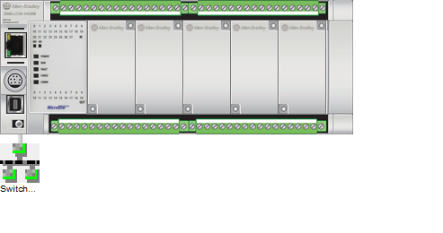

**Network Connectivity**

|  |  |
| --- | --- |
| 2080-LC50-48AWB | Connected to Fabrica_Papel/Switch_Compresora |

## Platform 'Pantalla_Compresora'

### Graphics:

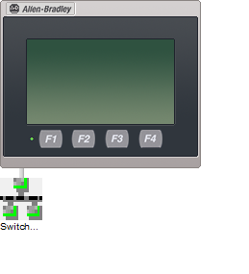

**Network Connectivity**

|  |  |
| --- | --- |
| 2711R-T4T | Connected to Fabrica_Papel/Switch_Compresora |

## Platform 'CLogix_PLCMaquina1'

### Graphics:

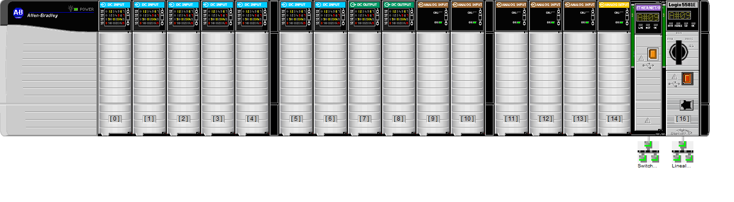

**Network Connectivity**

|  |  |
| --- | --- |
| 1756-EN2T (slot 15) | Connected to Fabrica_Papel/Switch_MaquinasPapel |
| 1756-L81E (slot 16) | Connected to Fabrica_Papel/Lineal_Maquina1 |

## Platform 'Pantalla_Maquina1'

### Graphics:

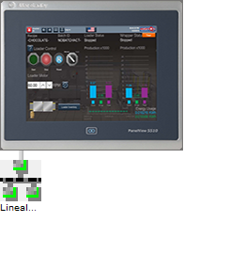

**Network Connectivity**

|  |  |
| --- | --- |
| 2715P-T12WD-B | Connected to Fabrica_Papel/Lineal_Maquina1 |

## Platform 'Pantalla_Maquina2'

### Graphics:



**Network Connectivity**

|  |  |
| --- | --- |
| 2715P-T12WD-B | Connected to Fabrica_Papel/Lineal_Maquina2 |

## Platform 'Micro850_Rebobinadora1'

### Graphics:

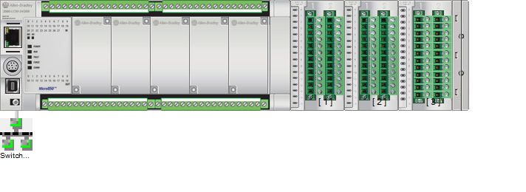

**Network Connectivity**

|  |  |
| --- | --- |
| 2080-LC50-48QBB | Connected to Fabrica_Papel/Switch_Rebobinadoras |

## Platform 'Micro850_Rebobinadora2'

### Graphics:



**Network Connectivity**

|  |  |
| --- | --- |
| 2080-LC50-48QBB | Connected to Fabrica_Papel/Switch_Rebobinadoras |

## Platform 'Extension_Maquina1'

### Graphics:

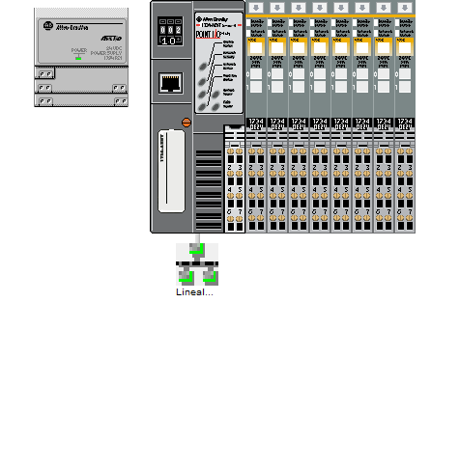

**Network Connectivity**

|  |  |
| --- | --- |
| 1734-AENT (slot 0) | Connected to Fabrica_Papel/Lineal_Maquina1 |

## Platform 'CLogix_PLCMaquina2'

### Graphics:

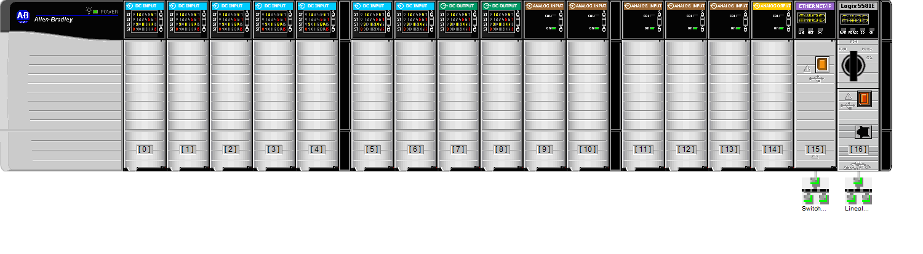

**Network Connectivity**

|  |  |
| --- | --- |
| 1756-EN2T (slot 15) | Connected to Fabrica_Papel/Switch_MaquinasPapel |
| 1756-L81E (slot 16) | Connected to Fabrica_Papel/Lineal_Maquina2 |

## Platform 'Extension_Maquina2'

### Graphics:



**Network Connectivity**

|  |  |
| --- | --- |
| 1734-AENT (slot 0) | Connected to Fabrica_Papel/Lineal_Maquina2 |

## Platform 'Pantalla_Higienico1'

### Graphics:

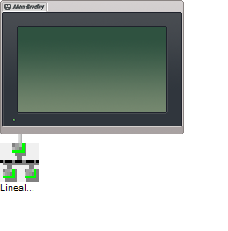

**Network Connectivity**

|  |  |
| --- | --- |
| 2711R-T7T | Connected to Fabrica_Papel/Lineal_Higienico1 |

## Platform 'Pantalla_Higienico2'

### Graphics:



**Network Connectivity**

|  |  |
| --- | --- |
| 2711R-T7T | Connected to Fabrica_Papel/Lineal_Higienico2 |

## Platform 'CompactLogix_Higienico1'

### Graphics:

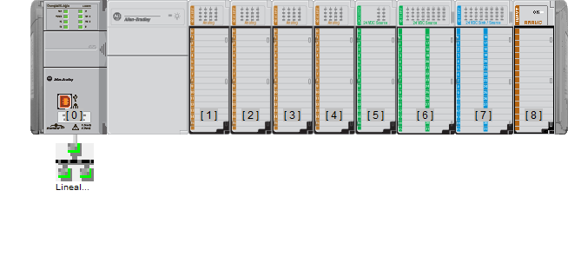

**Network Connectivity**

|  |  |
| --- | --- |
| 1769-L30ER (slot 0) | Connected to Fabrica_Papel/Lineal_Higienico1 |

## Platform 'CompactLogix_Higienico2'

### Graphics:



**Network Connectivity**

|  |  |
| --- | --- |
| 1769-L30ER (slot 0) | Connected to Fabrica_Papel/Lineal_Higienico2 |

## Platform 'Pantalla_Diverter'

### Graphics:

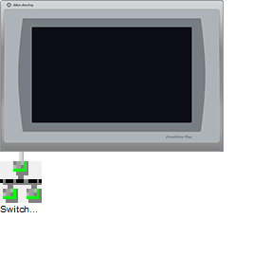

**Network Connectivity**

|  |  |
| --- | --- |
| 2711P-T9W22A9P | Connected to Fabrica_Papel/Switch_Diverter |

## Platform 'CompactLogix_Diverter'

### Graphics:

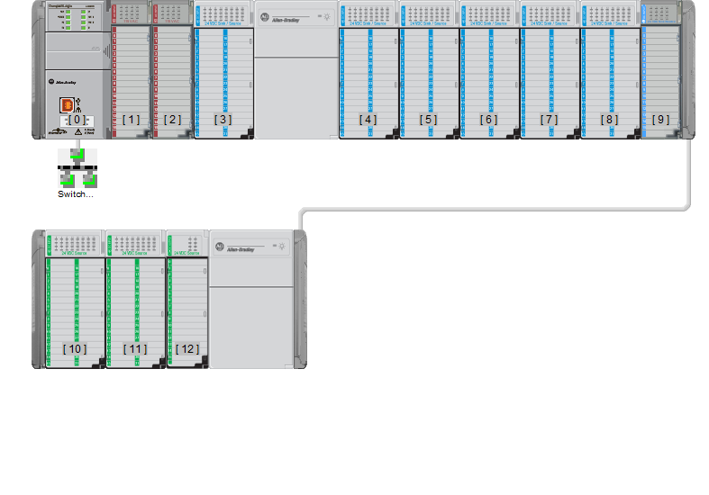

**Network Connectivity**

|  |  |
| --- | --- |
| 1769-L33ER (slot 0) | Connected to Fabrica_Papel/Switch_Diverter |