TABLE OF CONTENTS
Cover Page.................................................................................i
Candidate Certificate....................................................................ii
Candidate Declaration...................................................................iii
Abstract........................................................................................iv
Chapter 1: Introduction....................................................................1
Chapter 2: Literature Review............................................................6
Chapter 3: System Analysis.................................................................11
Chapter 4: Technology Stack..............................................................17
Chapter 5: System Design..................................................................23
Chapter 6: Testing.............................................................................33
Chapter 7: Results..............................................................................39
Chapter 8: Challenges Faced...............................................................43
Chapter 9: Conclusion and Future Scope.............................................47
References....................................................................................30
Appendices....................................................................................31

ABSTRACT
Password reuse, weak password selection, and insecure storage practices remain key causes of account compromise in modern web systems. This project presents a Zero-Knowledge Password Vault with Client-Side Risk Intelligence that addresses these issues through privacy-preserving cryptography and actionable security analytics. The implemented system follows a strict separation of responsibilities: the browser performs all sensitive cryptographic operations, while the server acts only as an authenticated ciphertext storage and session management service. A master password is never transmitted to the server. Instead, the client derives a non-extractable AES-GCM key using PBKDF2 with SHA-256 and 310,000 iterations, encrypts the vault locally, and sends only encrypted payloads to the backend. The backend stores user account metadata, bcrypt-hashed login password, and encrypted vault blobs in MongoDB, with additional controls such as rate limiting, CSRF protection, input validation, secure cookies, and audit logging. The system further integrates client-side risk intelligence including entropy-based strength scoring, duplicate password detection, stale password identification, and breach exposure checks using the Have I Been Pwned k-anonymity protocol. The developed prototype demonstrates that strong usability and strong privacy are not mutually exclusive. Experimental usage confirms practical response times, successful end-to-end encrypted vault synchronization, and meaningful security insights without disclosure of plaintext credentials to the server.

CHAPTER 1: INTRODUCTION
1.1 BACKGROUND
The rapid growth of digital services has significantly increased the number of credentials that a typical user must manage. In practice, many users adopt insecure habits such as storing passwords in plain notes, using predictable patterns, or reusing the same password across multiple platforms. These habits create a high-impact risk because a single breach can cascade into compromise of multiple accounts. Password managers were introduced to solve this challenge; however, trust in the service provider remains a concern when server-side infrastructure has access to decryptable data.
1.2 PROBLEM DEFINITION
The core problem addressed in this project is the lack of trustworthy, privacy-preserving password storage with proactive risk awareness. Traditional architectures may encrypt data at rest but still allow privileged server components to access plaintext under certain conditions. This creates a trust bottleneck and a single point of failure. The project therefore targets a model where the server can authenticate users and store data but can never decrypt user vault content.
1.3 OBJECTIVES
- To implement a web-based password vault that follows strict zero-knowledge principles.
- To perform encryption and decryption exclusively in the browser using Web Crypto API.
- To use robust cryptographic primitives: PBKDF2-SHA256 for key derivation and AES-GCM-256 for authenticated encryption.
- To provide secure account authentication with optional TOTP-based multi-factor authentication.
- To implement client-side password risk intelligence including strength, breach, duplicate, and age analysis.
- To maintain secure operational controls including CSRF defense, rate limiting, validation, and audit logging.
1.4 SCOPE
The current scope includes account registration and login, encrypted vault CRUD operations, risk scoring dashboard, session/device visibility, and vault version rollback. The system is designed as a production-oriented academic prototype and is suitable for extension into enterprise or mobile use cases. Browser extension autofill, hardware key integration, and distributed encrypted storage are intentionally left for future work.
1.5 MOTIVATION
The project was motivated by two practical observations: first, users require simple workflows for secure password management; second, a privacy-first architecture should not depend on blind trust in backend operators. By combining zero-knowledge storage with actionable risk intelligence, the system not only protects secret data but also improves day-to-day password hygiene.

CHAPTER 2: LITERATURE REVIEW
2.1 OVERVIEW OF EXISTING PASSWORD MANAGERS
Modern password managers generally provide secure storage, generator utilities, and cross-device synchronization. Open-source solutions such as Bitwarden emphasize encrypted vault storage and transparency, while proprietary cloud-based solutions focus on convenience and ecosystem integration. Browser-native managers offer ease of use but may not provide comprehensive risk intelligence or architecture-level guarantees on key handling.
2.2 RESEARCH ON ZERO-KNOWLEDGE SECURITY
Zero-knowledge password management designs separate user authentication from vault decryption capability. Prior architectural references highlight that secrecy depends not only on cipher strength but also on key custody. If key material can be reconstructed server-side, confidentiality assumptions weaken. Accordingly, client-only key derivation and non-extractable key usage represent a stronger practical model for end-user privacy.
2.3 PASSWORD SECURITY AND BREACH INTELLIGENCE
NIST SP 800-63B and OWASP recommendations emphasize strong password policies, avoidance of predictable patterns, and screening against breached credential datasets. The Have I Been Pwned k-anonymity method demonstrates how breach checking can be performed with reduced disclosure by querying only hash prefixes. This approach aligns with privacy-by-design principles and is appropriate for client-side validation flows.
2.4 COMPARATIVE ANALYSIS
Compared with many baseline managers, the proposed system contributes a project-specific combination: strict client-side cryptography, privacy-preserving breach checks, vault-level intelligence scoring, and backend hardening controls mapped to common web attack vectors. This integrated design supports both confidentiality and practical maintainability in an educational full-stack environment.
CHAPTER 3: SYSTEM ANALYSIS
3.1 FUNCTIONAL REQUIREMENTS
- User registration, login, logout, and profile session continuity.
- Encrypted vault retrieval and update through authenticated API routes.
- Client-side decryption after successful login and master password entry.
- CRUD operations for vault entries with search and category filtering.
- MFA setup, verification, and disable flows using TOTP.
- Vault version history and rollback support.
- Password generation and real-time risk analysis dashboard.
- Session listing and selective session revocation.
3.2 NON-FUNCTIONAL REQUIREMENTS
- Security: resistance to brute force, CSRF, injection, and session hijacking.
- Confidentiality: server must not access plaintext vault or master password.
- Availability: responsive APIs and graceful behavior under failed external checks.
- Performance: acceptable key-derivation delay with strong security parameters.
- Maintainability: modular frontend JS and route-wise backend separation.
- Scalability: session and audit model extensible for distributed deployment.
3.3 EXISTING VS PROPOSED SYSTEM
In conventional systems, vault encryption may occur server-side or through models where backend services can access decryptable states. In the proposed architecture, encryption takes place before transmission and the backend stores only opaque ciphertext with metadata (salt and IV). This materially reduces breach impact because exposure of database records does not provide plaintext credential access.

3.4 FEASIBILITY
3.4.1 Technical Feasibility
The stack relies on mature, well-documented technologies: Node.js, Express, MongoDB, and Web Crypto API. The selected primitives are supported in modern browsers and integrate directly into a modular JavaScript frontend.
3.4.2 Economic Feasibility
The system uses open-source tools and local development infrastructure, making implementation economically feasible in an academic setting.
3.4.3 Operational Feasibility
The user interface supports straightforward workflows for account operations and vault management. Security checks are embedded into normal user interactions rather than requiring specialist knowledge.

CHAPTER 4: TECHNOLOGY STACK
4.1 FRONTEND TECHNOLOGIES
The frontend is implemented in HTML, CSS, and modular Vanilla JavaScript to minimize dependency risk and preserve full control over sensitive memory handling. Cryptographic operations are performed through Web Crypto API primitives: PBKDF2 key derivation with SHA-256, AES-GCM encryption/decryption, and SHA-1 digesting for breach lookup prefixing. The UI includes dedicated modules for authentication, vault orchestration, cryptography, risk intelligence, and password generation.
4.2 BACKEND TECHNOLOGIES
The backend uses Node.js with Express for routing and middleware composition. MongoDB with Mongoose handles persistence for user accounts, sessions, audit logs, and vault versions. Authentication uses JWT in secure cookie transport. Auxiliary security libraries include Helmet, express-rate-limit, express-validator, express-mongo-sanitize, cookie-parser, and CORS controls. TOTP MFA support is provided by speakeasy and QR code generation by qrcode.
4.3 DATABASE LAYER
MongoDB collections are structured for operational clarity: User stores account identity and encrypted vault blob; Session stores per-device session state; AuditLog stores security-relevant events with metadata; VaultVersion stores encrypted snapshots for rollback. This design supports traceability and controlled recovery without violating zero-knowledge constraints.
4.4 WHY THESE TECHNOLOGIES WERE CHOSEN
- Web Crypto API provides standards-based browser-native cryptography and non-extractable key options.
- Express enables modular middleware security composition and maintainable API routing.
- MongoDB supports flexible document schemas and rapid iteration for project-scale prototypes.
- JWT with secure cookies supports stateless verification with controlled session tracking in database.
- Jest and Supertest provide effective backend test automation for route behavior and security checks.

CHAPTER 5: SYSTEM DESIGN
5.1 USE CASE DESCRIPTION
- Actor: End User. Use cases: register account, login, unlock vault, manage passwords, analyze risk, configure MFA, revoke sessions, rollback vault.
- Actor: System. Use cases: validate requests, issue and verify session tokens, persist encrypted vault payloads, generate audit events.
5.2 HIGH-LEVEL ARCHITECTURE
The design follows a browser-centric trust boundary. The frontend performs all sensitive cryptographic transformations and sends only ciphertext to backend endpoints. The backend verifies identity and authorizes requests but never receives the master secret. Communication is via HTTPS with cookie-based session flow and CSRF token checks.
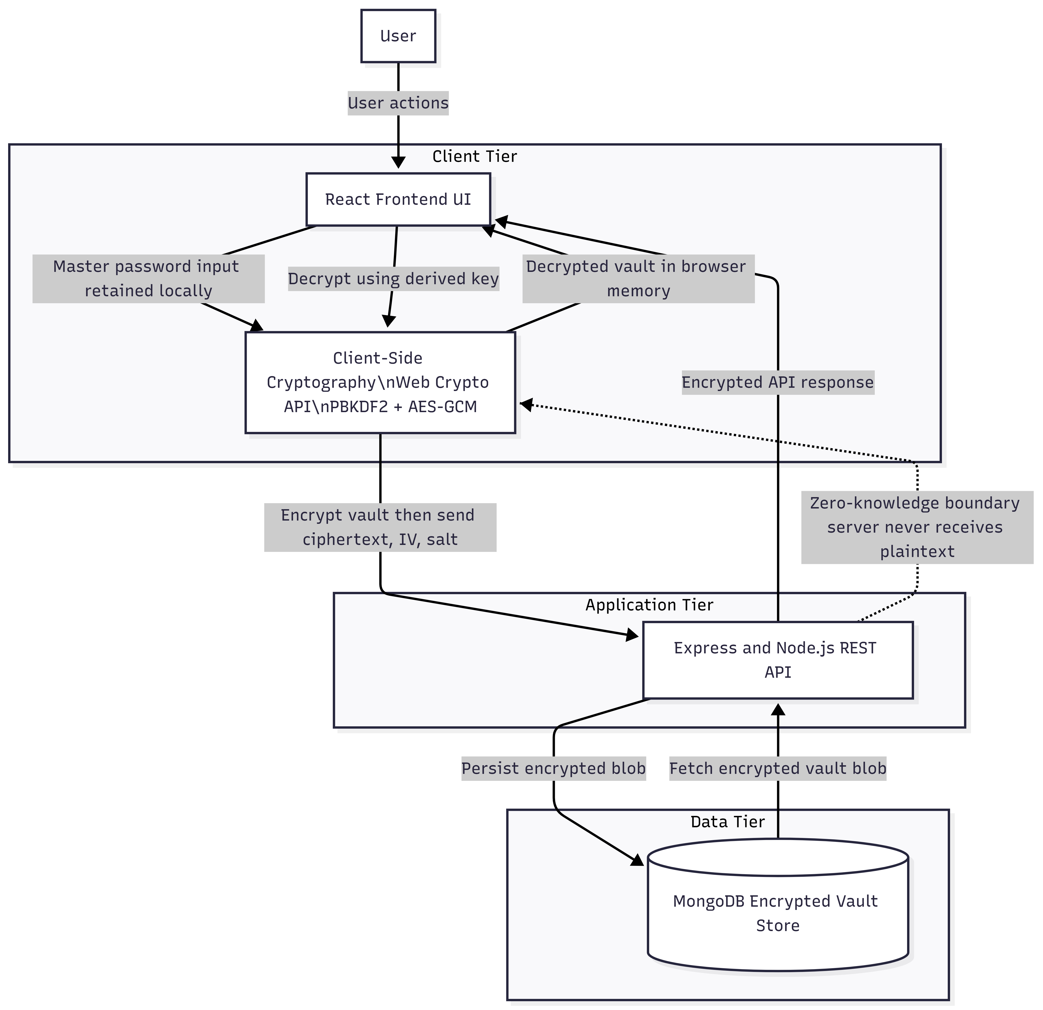
Fig 5.1 System Architecture Diagram
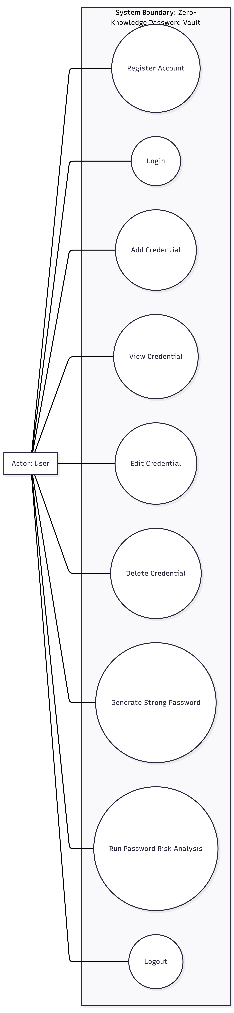
Fig 5.2 Use Case Diagram
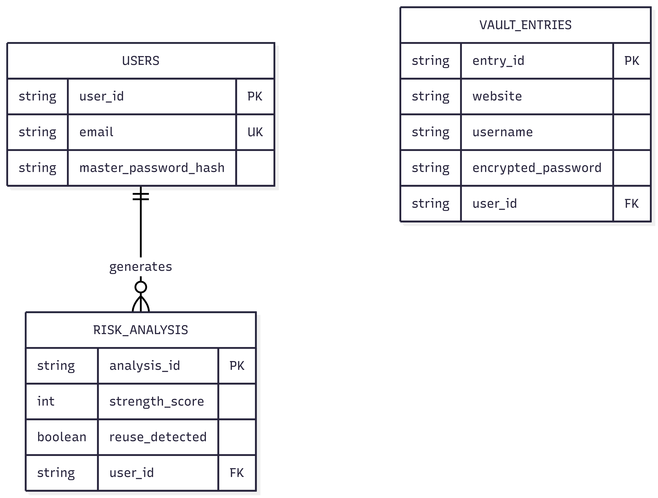
Fig 5.3 ER Diagram

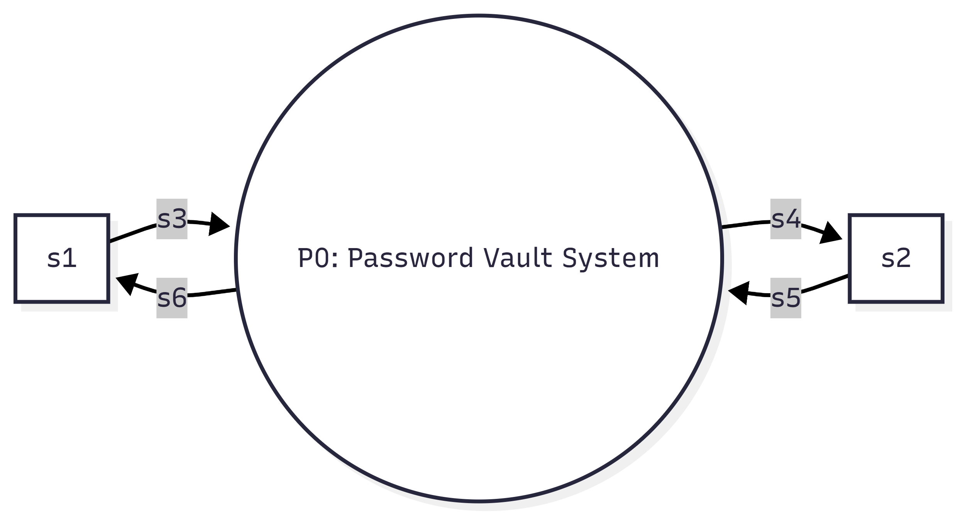
Fig 5.4 Data Flow Diagram Level 0
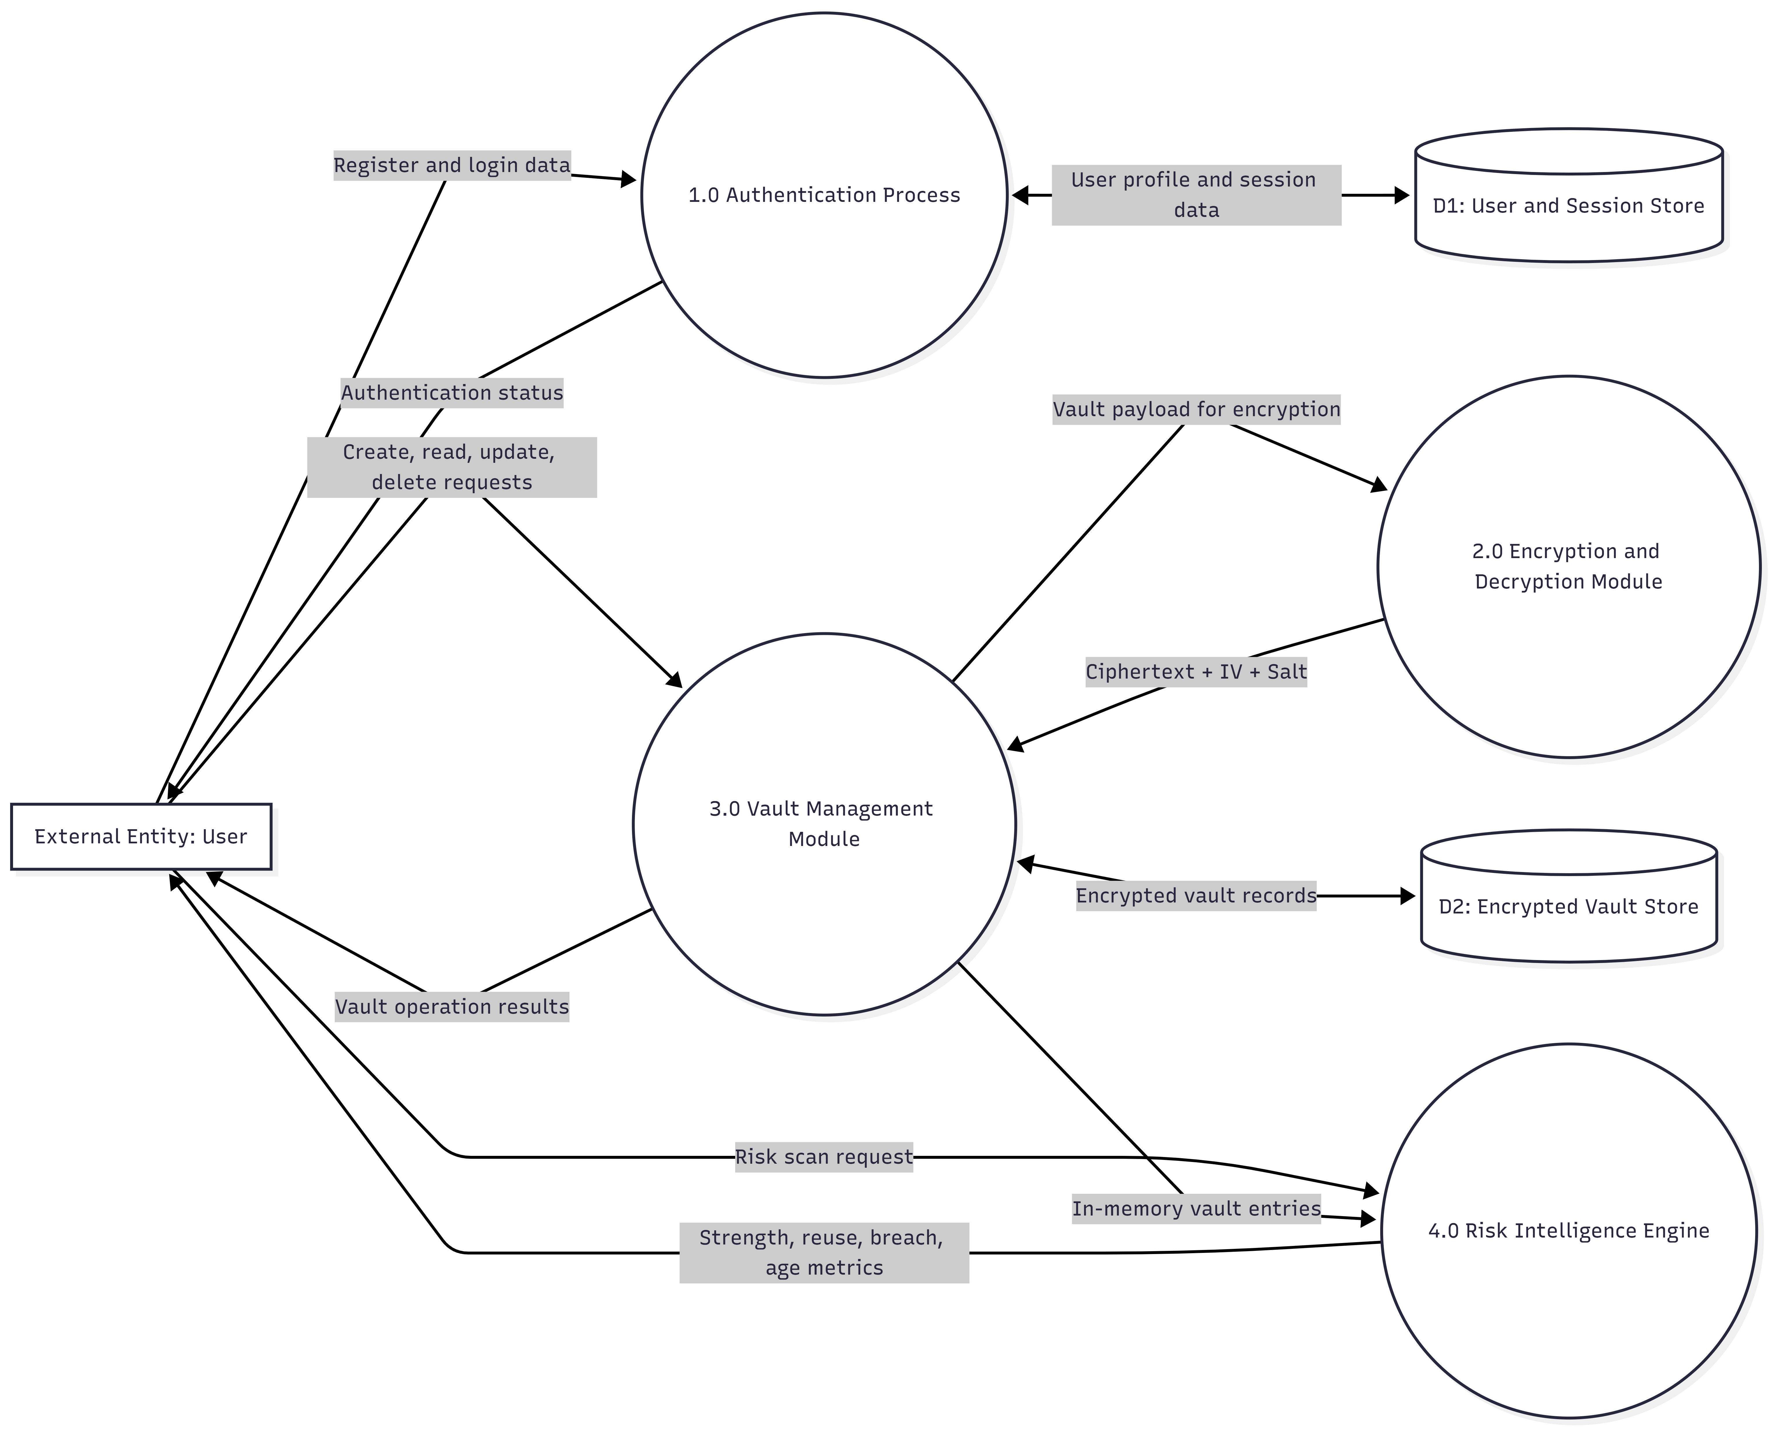
Fig 5.5 Data Flow Diagram Level 1
5.3 AUTHENTICATION FLOW
During registration, user account password is validated and hashed with bcrypt before storage. During login, credentials are verified and JWT is issued with a generated session identifier. If MFA is enabled, TOTP validation is required before token issuance. A valid authenticated state then permits retrieval of encrypted vault data. Master password handling remains exclusively client-side.

Fig 5.6 Sequence Diagram for User Login
5.4 ENCRYPTION AND DECRYPTION WORKFLOW
When unlocking vault, the browser derives an AES key from master password and stored salt using PBKDF2 (310000 iterations). On save, vault JSON is encrypted with AES-GCM and a fresh IV, then uploaded as base64 ciphertext. On load, ciphertext is downloaded and decrypted locally using derived key and IV. Authentication tags in AES-GCM ensure tamper detection during decryption.

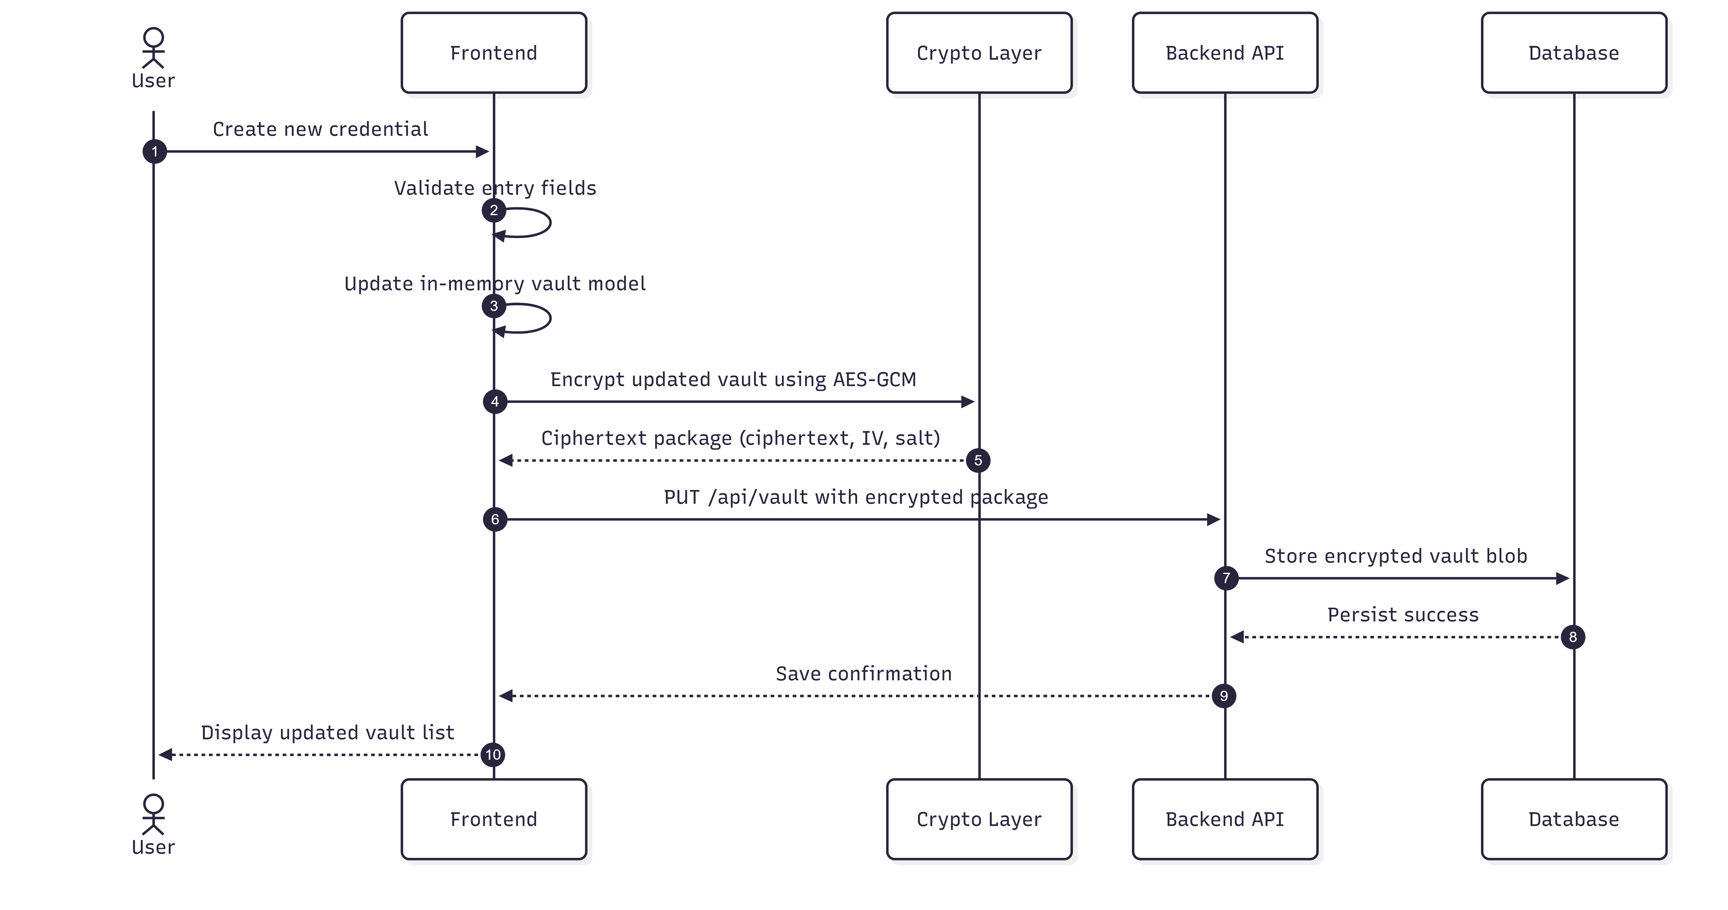
Fig 5.7 Sequence Diagram for Adding New Credential
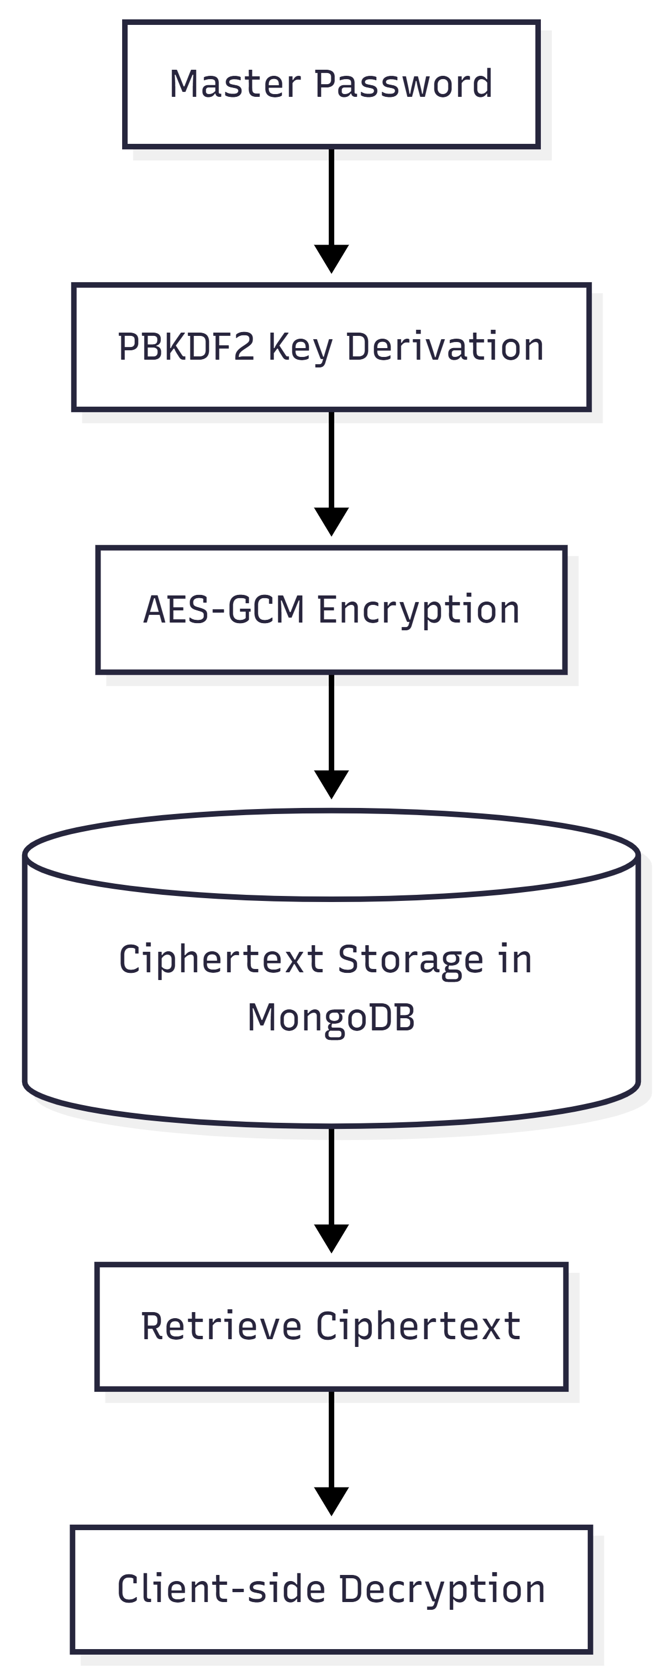
Fig 5.8 Zero-Knowledge Encryption Workflow Diagram
5.5 ER DIAGRAM EXPLANATION
Core entities are User, Session, AuditLog, and VaultVersion. A User has many Sessions, many AuditLog records, and many VaultVersion records. Vault entry objects are nested within encrypted payload and therefore are not relationally visible server-side. This intentionally preserves confidentiality at storage level.

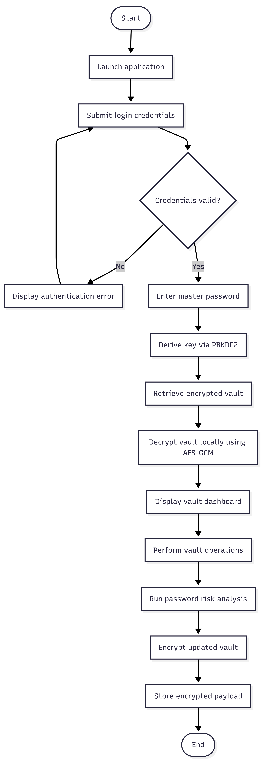
Fig 5.9 Activity Diagram

5.6 MODULE DESCRIPTION
- Auth Module: registration, login, MFA setup/verify/disable, logout, session listing and revocation.
- Vault Module: encrypted blob retrieval, encrypted blob update, version listing, rollback.
- Crypto Module: key derivation, encryption/decryption, binary/base64 conversion utilities.
- Risk Intelligence Module: strength score, breach check via k-anonymity, duplicate and stale detection.
- Generator Module: cryptographically secure password generation with entropy estimation.

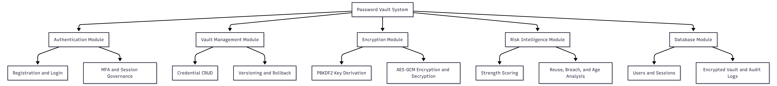
Fig 5.10 Module Hierarchy Diagram
5.7 DATA FLOW EXPLANATION
Sensitive data enters at the browser UI, is transformed into encrypted payloads, then transmitted to backend APIs and persisted in MongoDB. Reverse flow retrieves encrypted data to the browser where local decryption restores runtime vault state. At no stage is plaintext vault content transported or stored outside the user runtime context.

CHAPTER 6: TESTING
6.1 TESTING STRATEGY
Testing was conducted at unit, integration, and system levels. Backend API behavior was validated through Jest and Supertest. Cryptographic flow checks ensured that only encrypted payloads are persisted. Security controls such as rate limiting and CSRF validation were tested under expected and adverse request patterns.
6.2 UNIT TESTING
- Auth route behavior: register success/failure, login invalid credentials, MFA-required response.
- Vault route behavior: encrypted payload validation, unauthorized access rejection.
- Session validation middleware: token/session mismatch and expiry handling.
6.3 INTEGRATION TESTING
- End-to-end auth to vault flow with cookie session propagation.
- Encrypt-save-fetch-decrypt cycle with expected plaintext equivalence.
- Tamper handling by modifying ciphertext/IV and verifying decryption failure.
6.4 SYSTEM TESTING
- Browser workflow: register, login, unlock, add/edit/delete entries, logout.
- Risk dashboard behavior with weak, reused, breached, and old passwords.
- Session controls and audit log visibility after authentication events.
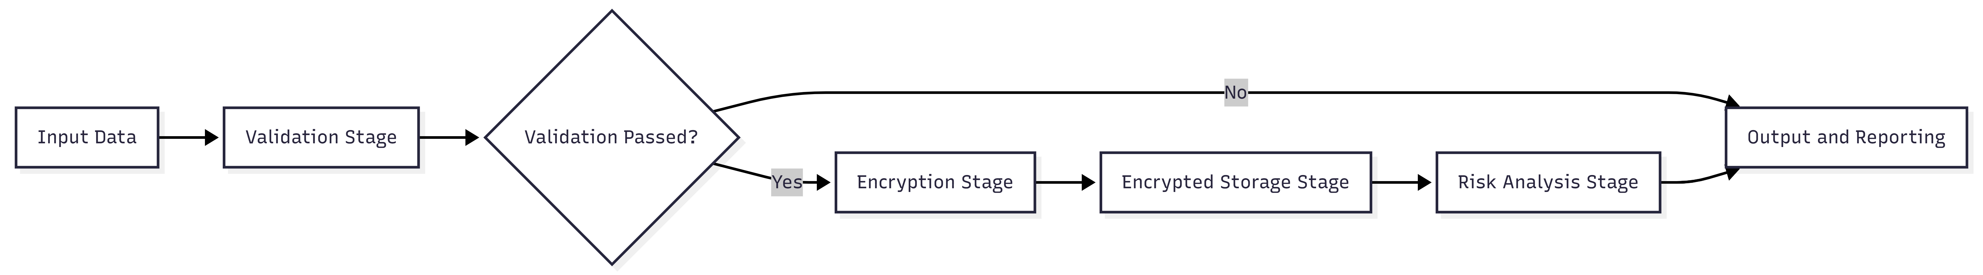
Fig 6.1 Testing Flow Diagram
6.5 TEST CASE TABLE
TC ID | Test Scenario | Input/Precondition | Expected Output | Actual Output | Status
TC-01 | User Registration | Valid email and strong password | Account created; JWT cookie set | As expected | Pass
TC-02 | Login Failure | Invalid password | 401 Unauthorized | As expected | Pass
TC-03 | MFA Required | MFA-enabled account without token | mfaRequired true response | As expected | Pass
TC-04 | Vault Save | Encrypted blob, IV, salt provided | Vault stored successfully | As expected | Pass
TC-05 | Vault Read | Authenticated user | Encrypted vault payload returned | As expected | Pass
TC-06 | Rate Limit | Repeated login attempts > threshold | 429 Too Many Requests | As expected | Pass
TC-07 | Breach Check | Common leaked password | Breached warning shown | As expected | Pass
TC-08 | Duplicate Detection | Two entries same password | Duplicate risk flagged | As expected | Pass

CHAPTER 7: RESULTS
7.1 FUNCTIONAL OUTCOMES
The implemented system supports the complete planned workflow: secure registration and login, optional MFA, encrypted vault management, session controls, risk intelligence analytics, and rollback-capable vault versioning. All core endpoints and client modules interacted consistently in integration testing.
7.2 SECURITY OUTCOMES
Observed network payloads during vault synchronization contained only encrypted base64 blobs with IV and salt metadata. MongoDB persisted ciphertext-only vault content. Brute-force mitigation and CSRF controls behaved as expected. Session invalidation and expiry checks enforced re-authentication where appropriate.
7.3 PERFORMANCE OBSERVATIONS
PBKDF2 derivation introduced a deliberate client-side delay that strengthens offline attack resistance. AES-GCM encryption/decryption for normal vault sizes remained practically instantaneous. API response times were suitable for interactive usage in local deployment conditions.

7.4 INTERFACE SNAPSHOTS (ASCII WIREFRAMES)
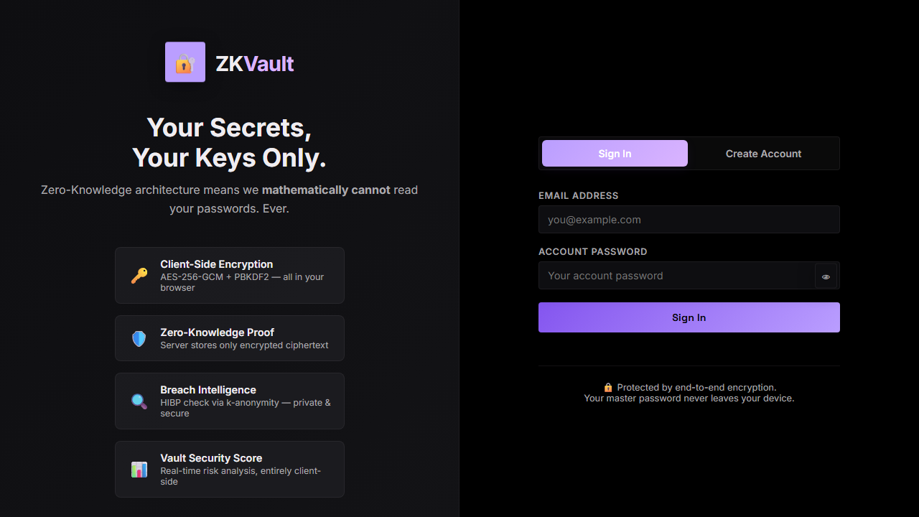
Fig 7.1 Login Page Wireframe
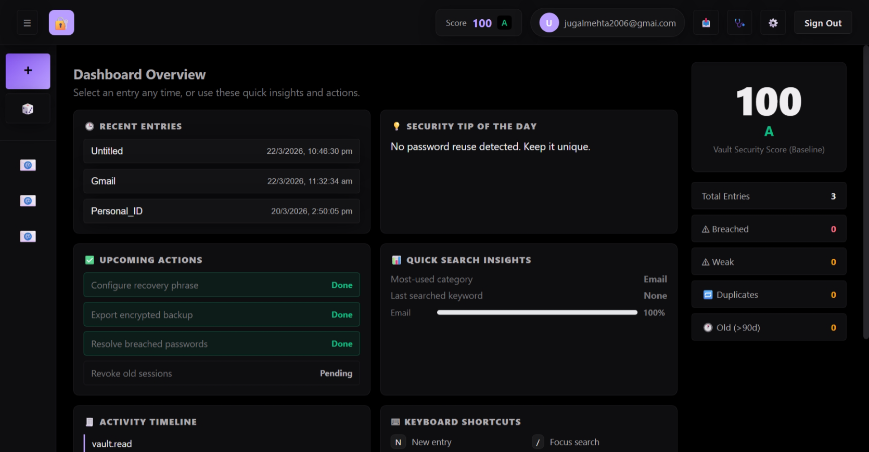
Fig 7.2 Vault Dashboard Wireframe

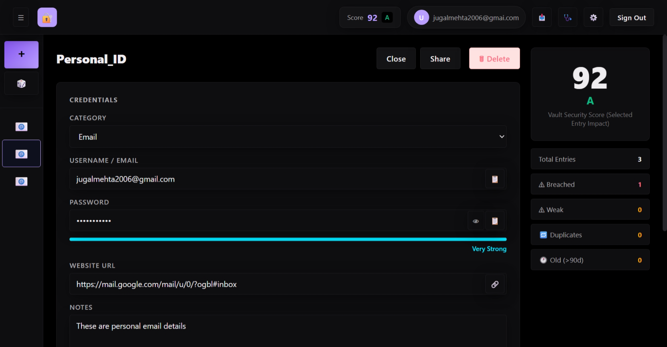
Fig 7.3 Risk Analysis Wireframe
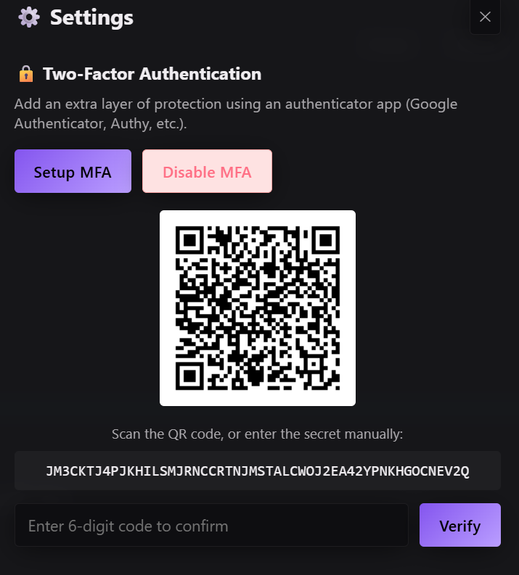
Fig 7.4 MFA Setup Wireframe
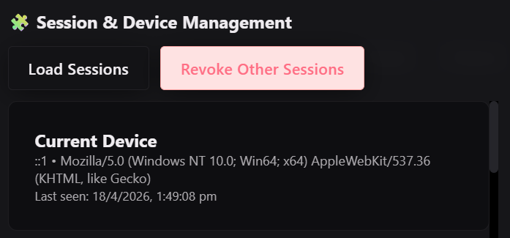
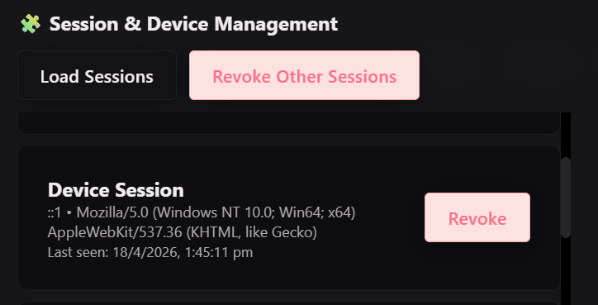
Fig 7.5 Session Management Wireframe

CHAPTER 8: CHALLENGES FACED
8.1 CRYPTOGRAPHIC DESIGN CHALLENGES
Balancing usability and cryptographic hardness required careful parameter selection. High PBKDF2 iteration counts improve security but impact unlock latency on low-power devices. The project handled this through moderate UX buffering while retaining strong derivation parameters.
8.2 SESSION AND SECURITY MIDDLEWARE INTEGRATION
Combining JWT cookie auth, CSRF checks, rate limiting, and per-session database tracking required strict middleware ordering and consistent error handling. Integration testing was essential to avoid false negatives in authenticated routes.
8.3 RISK INTELLIGENCE RELIABILITY
Breach-check logic required robust fallback behavior for external API failures and careful privacy controls during hash prefix queries. The solution preserved user privacy by keeping full hash and plaintext comparison strictly client-side.
8.4 DATA RECOVERY AND ROLLBACK
Because plaintext data is never retained server-side, rollback had to be implemented with encrypted version snapshots only. This required version indexing and explicit rollback endpoints while preserving zero-knowledge constraints.
8.5 TESTING AND VALIDATION CONSTRAINTS
Security-sensitive systems need both functionality checks and negative-path checks such as tamper validation, invalid token behavior, and rate-limit triggering. Designing these tests without weakening architecture assumptions was a significant engineering task.

CHAPTER 9: CONCLUSION AND FUTURE SCOPE
9.1 CONCLUSION
This project demonstrates a practical, full-stack, zero-knowledge password manager with integrated client-side risk intelligence. The implemented architecture ensures that cryptographic trust resides with the user, not the server. With modular design, hardened API controls, and user-centric security feedback, the system provides a strong academic and technical foundation for privacy-preserving credential management.
9.2 FUTURE SCOPE
- WebAuthn-based biometric and hardware-key assisted authentication.
- Secure encrypted sharing workflows using public-key cryptography between users.
- Browser extension for autofill with strict local decryption boundaries.
- Mobile-first client applications with synchronized encrypted vault access.
- Risk analytics enhancements with adaptive recommendations and anomaly detection.
- Production deployment hardening with managed certificate rotation and SIEM integration.

REFERENCES
[1] Bitwarden, "Bitwarden Help Center," 2026. [Online]. Available: https://bitwarden.com/help/. [Accessed: Apr. 18, 2026].
[2] M. Burnett and D. Kleiman, Perfect Passwords. Syngress, 2006.
[3] M. Conti, N. Dragoni, and V. Lesyk, "A Survey of Man in the Middle Attacks," IEEE Commun. Surveys Tuts., vol. 18, no. 3, pp. 2027-2051, 2016.
[4] MongoDB, "MongoDB Manual," 2026. [Online]. Available: https://www.mongodb.com/docs/manual/. [Accessed: Apr. 18, 2026].
[5] NIST, "Digital Identity Guidelines: Authentication and Lifecycle Management (SP 800-63B)," 2023.
[6] Node.js, "Node.js Documentation," 2026. [Online]. Available: https://nodejs.org/docs/latest/api/. [Accessed: Apr. 18, 2026].
[7] OWASP Foundation, "Password Storage Cheat Sheet," 2026. [Online]. Available: https://cheatsheetseries.owasp.org/. [Accessed: Apr. 18, 2026].
[8] React, "React Documentation," 2026. [Online]. Available: https://react.dev/. [Accessed: Apr. 18, 2026].
[9] T. Hunt, "Have I Been Pwned Pwned Passwords API v3," 2026. [Online]. Available: https://haveibeenpwned.com/API/v3. [Accessed: Apr. 18, 2026].
[10] W3C, "Web Cryptography API," 2017. [Online]. Available: https://www.w3.org/TR/WebCryptoAPI/. [Accessed: Apr. 18, 2026].

APPENDICES
APPENDIX A: API ENDPOINT SUMMARY
Auth: POST /api/auth/register, POST /api/auth/login, POST /api/auth/logout, GET /api/auth/me, POST /api/auth/mfa/setup, POST /api/auth/mfa/verify, POST /api/auth/mfa/disable, GET /api/auth/sessions, DELETE /api/auth/sessions/:id, GET /api/auth/audit-logs.
Vault: GET /api/vault, PUT /api/vault, GET /api/vault/versions, POST /api/vault/rollback.
APPENDIX B: SECURITY CONFIGURATION SNAPSHOT
Security controls include Helmet headers, CSRF token validation, rate limiting for auth endpoints, JWT httpOnly cookies, input validation and sanitization, encrypted vault-only persistence, and audit event logging.
APPENDIX C: MODULE-WISE FILE MAP
Frontend modules: auth.js, crypto.js, vault.js, risk.js, generator.js, app.js. Backend modules: server.js, app.js, routes/auth.js, routes/vault.js, middleware/auth.js, middleware/sanitize.js, models/User.js, models/Session.js, models/AuditLog.js, models/VaultVersion.js.

