INTERVENTIONAL IMAGING PIPELINE
AI Decision Support for the Cardiac Catheterisation Laboratory
Prepared for Clinical Review
A plain-language handover for a clinical partner

Date: 18 July 2026
Prepared by: 01.jugalmodi@gmail.com
Status: Research software — not a medical device, not for clinical care
Contact: tech@manufex.io

Contents
If the list below shows a placeholder, right-click it and choose “Update Field” (or it will refresh automatically when the document is opened in Word).
…

1. Executive Summary
This project is an artificial-intelligence assistant for the cardiac catheterisation laboratory — the room where a live X-ray (angiography / fluoroscopy) guides a catheter through a patient’s blood vessels. You give it an X-ray image or a short cine clip, and it does three things a cardiologist cares about: it draws the map of the coronary arteries, it flags a possible narrowing or blockage (stenosis), and it follows the catheter and guidewire through a video. It returns not just an answer but a confidence level, and it is deliberately built to say “I am not sure — please review” rather than guess.
Everything is designed to run on a laptop or a small computer on the procedure cart, with no internet connection required at the bedside. That single constraint — privacy, reliability, and the reality of air-gapped hospital networks — shapes every technical choice in the system.
Where the project stands today, in one line each:
- Coronary vessel mapping — working well: passes its clinical accuracy bar (vessel-outline agreement of 0.915 against a target of 0.75) and survives compression onto the device without breaking thin vessels.
- Catheter & guidewire tracking — working: trained end-to-end and produces stable tracks through a clip; formal on-device speed and accuracy numbers are not yet recorded.
- Stenosis (blockage) detection — not ready yet: the model works but is not yet accurate enough for clinical use (it currently misses roughly three of every four narrowings). We have proven the cause is a shortage of diverse patient data, not a flaw in the method.
The single ask: access to a de-identified, patient-diverse set of coronary angiography images or clips, plus occasional clinical review of the cases the system flags. This is precisely the input that would move blockage detection across the clinical bar. Nothing in this request involves clinical use, liability, or patient care — those follow only after a formal validation phase.

2. Why This Exists
During an angiography procedure the cardiologist is making rapid decisions from a live, noisy, grey-scale X-ray: which vessel is which, is that faint narrowing a real stenosis, where exactly is the wire tip. A second pair of “eyes” that highlights the vessel tree, marks candidate lesions, and tracks the devices — while staying out of the way — can reduce missed findings and support faster, more consistent reads. The goal here is assistance, not replacement.

2.1 Why it must run on the device, not in the cloud
- Air-gapped by design: A cath lab often sits on an isolated hospital network with no outbound internet. A tool that phones a cloud server simply will not run there.
- Patient privacy: Sending live patient imaging to an external service creates privacy and governance exposure that most hospitals will not accept. Keeping everything on a local device avoids it entirely.
- Reliability & speed: During a procedure you cannot wait on a network round-trip per video frame. On-device inference gives predictable, real-time behaviour.
The consequence of this choice — fitting expert-grade AI onto a modest local device — is the core engineering idea of the whole project, explained next.

3. What It Actually Does Today
Three capabilities are built. The table summarises status; each subsection gives the detail and the honest pass/fail against the bar that was set for it.
Capability | What it outputs | Current accuracy | Usable bar | Status
Coronary vessel mapping | Outline (mask) of the artery tree | Dice 0.915 (0.914 on device) | Dice ≥ 0.75 | PASS
Stenosis / blockage detection | Boxes on candidate lesions + confidence | F1 0.291, recall 0.271 | F1 ≥ 0.57* | BELOW BAR
Catheter & guidewire tracking | Device boxes tracked across a clip | Trained; on-device metrics pending | IoU ≥ 0.50 + stable IDs | FUNCTIONAL

*The blockage-detection bar appears as F1 ≥ 0.55 in the written playbook but is set to 0.57 in the code and experiment records. Both are provisional research placeholders and are above the best published results (~0.5) for this task — the exact bar should be set with clinical stakeholders. “F1”, “Dice” and “recall” are defined in the Glossary.

3.1 Coronary vessel mapping
Output: a pixel outline of the coronary artery tree laid over the angiogram — the “map” a clinician would trace by hand. This is the most mature capability.
- Result (source: coronary run RESULTS.md): Vessel-outline agreement (Dice) 0.915, well above the 0.75 bar; best mid-training 0.927.
- Connectivity: Vessel-connectivity score (clDice) 0.956 — the measure of whether thin vessels stay connected rather than breaking into dots.
- Survives the device: After compressing the model to run on an Apple-silicon device, agreement held at 0.914 and connectivity at 0.976 — a connectivity drop of only 0.0023, far inside the 0.03 tolerance. Compression did not break the thin vessels, which is the failure everyone worries about.
Bottom line: coronary mapping clears its accuracy bar and its on-device safety gate. Two formal checks remain open — comparing connectivity against the large “teacher” model, and a final on-device speed benchmark.
(A picture of a coronary vessel-map overlay is not shown here: the segmentation validation images live on the cloud build side and are not stored locally, so none is available to embed without over-claiming. The numbers above are the measured result.)

3.2 Catheter & guidewire tracking
Output: the catheter and guidewire are detected in every frame and given a stable identity so they can be followed smoothly through a cine clip (rather than flickering on and off).
- Status: The detector was trained end-to-end and the tracking layer runs on clips; a demo tracking video and the trained model files exist in the repository.
- Honest caveat (source: PROJECT_TRACKER.md): The formal gate numbers for this stage — overlap accuracy (IoU ≥ 0.50), frames per second, and identity-switch count — have not yet been measured and recorded on the target device. So this is functionally complete but not yet formally signed off.
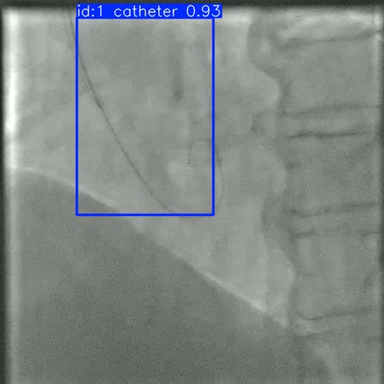
A real frame from the catheter-tracking demo (outputs/track.mp4): the catheter is detected and given a stable identity — “id:1 catheter 0.93”.

3.3 Stenosis / blockage detection
Output: boxes drawn around candidate narrowings, each with a confidence score. This is the clinically hardest task and the one that is not ready. Current numbers on an honest, patient-separated test set:
Measure | Value | Meaning in plain terms
F1 | 0.291 | Overall balance of catching lesions vs. false alarms (0–1)
Recall | 0.271 | Share of true lesions actually caught — misses ~73%
Precision | 0.314 | Share of its flags that are real
mAP50 | 0.209 | Detection-quality score used in the field

Why this is not yet usable: a missed blockage is the dangerous error, and a recall of 0.27 means too many are missed. Section 5 explains the real cause (a data shortage, not a broken model) and what is being done about it. Because it is below the bar, this model is never allowed to assert a confident “blockage found” — it runs only as a screening flag that defers to the clinician.

4. How It Works, Without the Jargon
The central idea is borrowed from medical training itself: an expert trains a resident, and the resident then works solo — faster, at the bedside — while the expert stays back at the desk.
- The “teacher”: A large, highly accurate model is trained on powerful rented cloud computers. It is the most accurate option, but far too big and slow to run during a procedure. It never touches a patient — it only teaches.
- The “student”: A small model is trained to imitate the teacher (a technique called distillation). It recovers most of the teacher’s skill at a fraction of the size, so it can run on a laptop or cart.
- Shrink to fit: The student is then compressed further (quantization) to be faster and lighter still, and re-checked to make sure the compression did not break anything important.
Why not simply run the big expert model live? Because it will not fit on the device and cannot keep up with a live procedure. The teacher–student approach is what lets the system deliver near-expert quality at bedside speed and size.
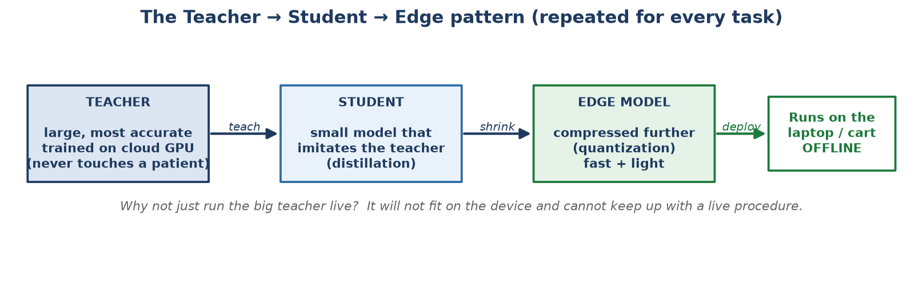
Figure 1. The same teacher → student → edge pattern is used for every task in the system.

4.1 The specific model families used (one line each)
- nnU-Net — the field’s gold-standard for medical image outlining; used as the teacher for vessel mapping (cloud only).
- TinyU-Net — a compact outline model (~2–3 million parameters) that runs on the device; the student for vessel mapping.
- YOLO11 — a fast, widely-used “draw a box around the thing” detector; used for both blockage detection and catheter detection because speed and never-miss recall matter most.
- ByteTrack — a tracker that keeps each device’s identity consistent from frame to frame, so the catheter does not “jump” in the video.
- Grounding DINO + SAM — large helper models used only behind the scenes on the build side to label new data faster; they are never shipped to the device.
Deeper definitions of every term are in the Glossary (Section 11).

5. Why the Harder Capability (Blockage Detection) Isn’t Ready Yet
This is the most important section for deciding whether to help, because the bottleneck is exactly the thing a clinical partner can unblock.

5.1 The real cause: too few unique patients, not a broken model
Public blockage datasets have very few distinct patients. The largest one available (Danilov) has 8,325 images — but those come from only about 64 patients, so most images are near-copies of one another. A model can memorise 64 patients without learning to generalise to a 65th.
A cautionary result we caught and corrected: An earlier run scored an impressive F1 of 0.885. On inspection, neighbouring frames of the same patient had leaked into both the practice and the test sets — the model was effectively being tested on patients it had already seen. When we enforced an honest patient-separated split, the score fell to 0.214. We report the honest 0.214, not the flattering 0.885. This kind of self-scrutiny is how the whole project is run.

5.2 What we tried, and what more diverse data produced
Adding a newer, more patient-diverse dataset (CADICA — 42 patients with marked lesions) is the single biggest honest improvement to date:
Data used | Patient split | F1 | Recall | mAP50
ARCADE only | — | 0.246 | — | 0.147
+ Danilov | honest (separated) | 0.214 | 0.166 | 0.108
+ CADICA (more patients) | honest (separated) | 0.291 | 0.271 | 0.209

Adding ~42 diverse lesion patients lifted recall by about 63% relative (0.166 → 0.271) and F1 from 0.214 to 0.291. It closed roughly a third of the gap to the bar — from one dataset. This is direct evidence that patient diversity, not a bigger or cleverer model, is the lever. Our own research review reached the same conclusion (source: STAGE_ACCURACY_RESEARCH.md).

5.3 What the model’s output actually looks like
Below, left: lesions marked by a human on validation frames. Right: the model’s own predictions on the same frames. It fires on real vessels and finds several true lesions, but misses many — which is the recall gap in Section 3.3, and exactly what more patient data is expected to close.
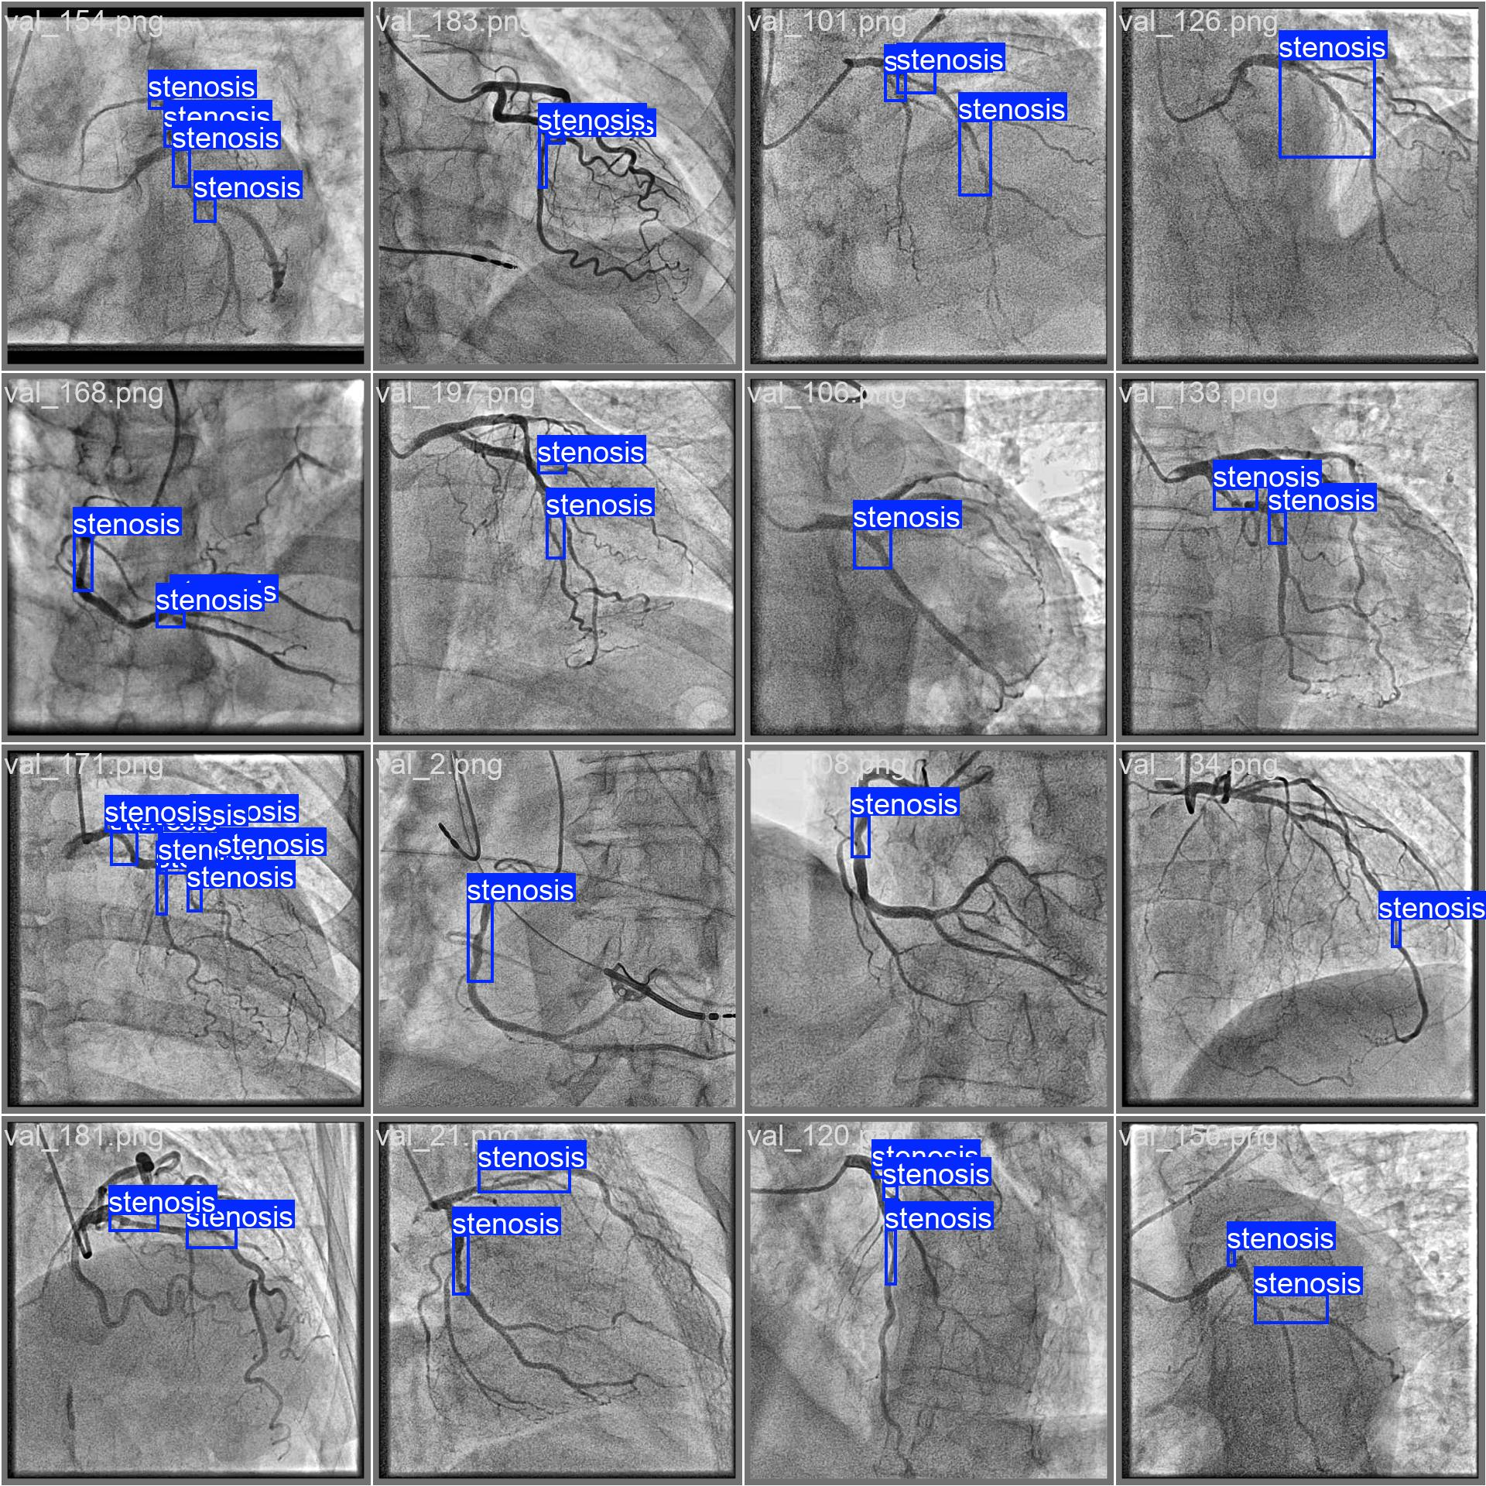 | 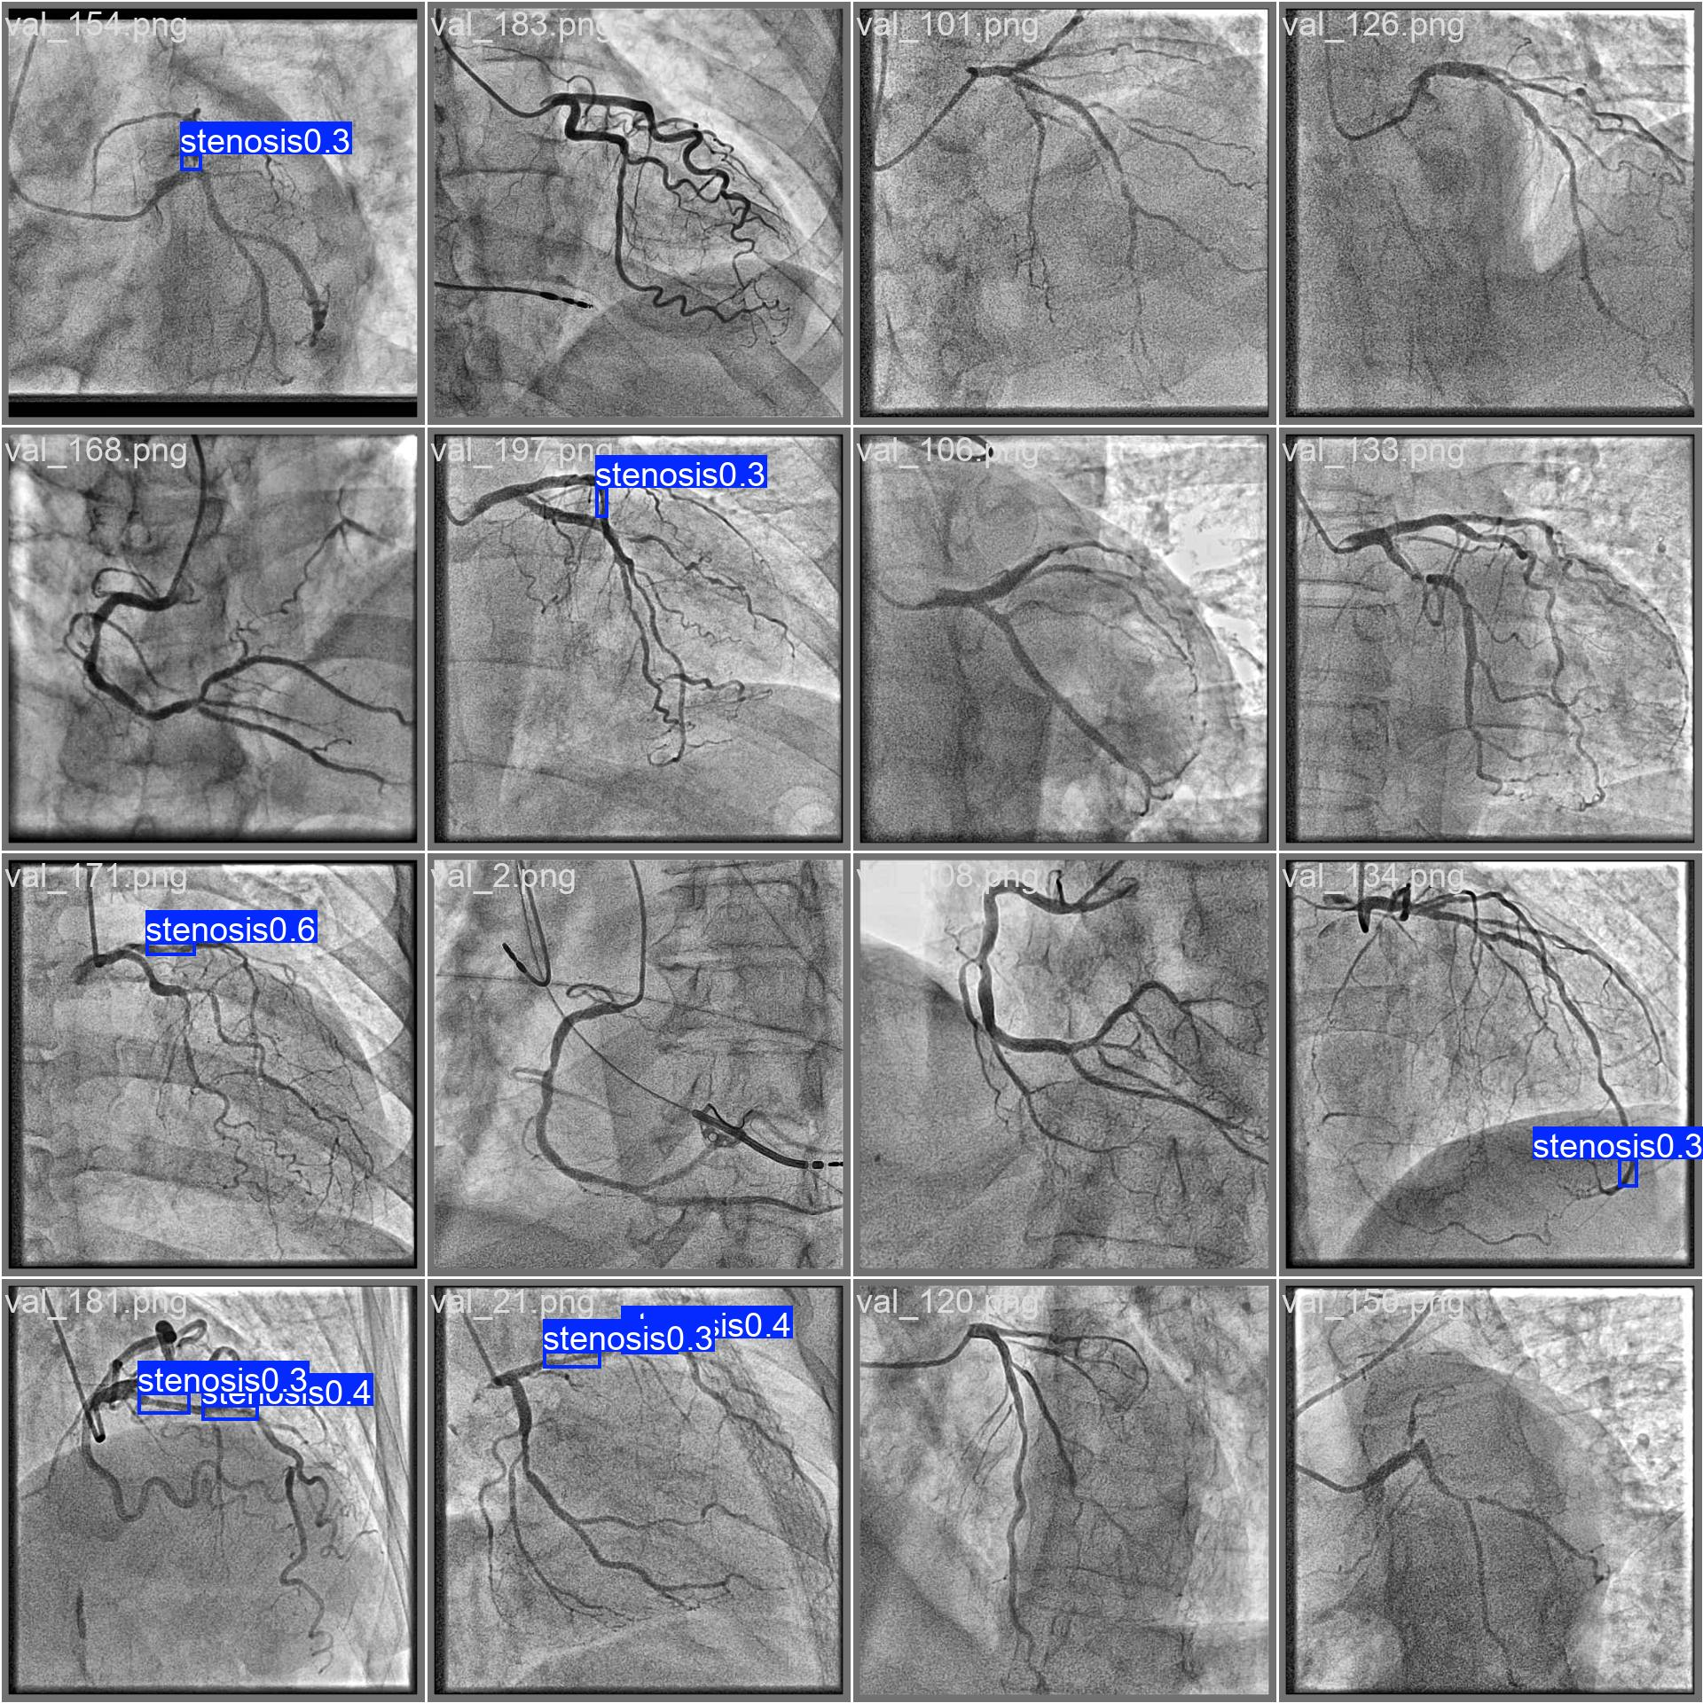
Human-marked lesions (ground truth) | Model predictions
Source images: experiments/stenosis_arcade+cadica+danilov_yolo11s_768_e150/run/.

5.4 Why your patient population is the fix
The next levers, in order of expected return, are: (1) more diverse labelled patients, (2) semi-supervised learning that lets the model learn from unlabelled clips, and (3) only then a larger model. Levers (2) and (3) give little until (1) is addressed. A clinical partner with access to a diverse, de-identified patient set is therefore the highest-value contribution possible to this capability.

5.5 The full evidence trail — all three runs, side by side
So the progression is visible (not just the final result), the full metrics and the model’s own output for each of the three honest runs are shown below. All numbers are the final validation figures from each run’s results.csv (via its RESULTS.md).
Run | Precision | Recall | F1 | mAP50 | mAP50-95
ARCADE only (11n/640) | 0.242 | 0.251 | 0.246 | 0.147 | 0.054
+ Danilov, honest split (11s/768) | 0.299 | 0.166 | 0.214 | 0.108 | 0.034
+ CADICA, honest split (11s/768) | 0.314 | 0.271 | 0.291 | 0.209 | 0.080

Recall (the safety-critical axis) roughly doubles once diverse patients are added — 0.251 → 0.166 → 0.271 — while the honest F1 climbs 0.214 → 0.291. The dip at “+Danilov” is the point from Section 5.2: Danilov adds frames but few new patients.
Below, for each run: the model’s predictions on validation frames, its precision–recall curve, and its confusion matrix. Read left-to-right, top-to-bottom, the detections get denser and the curve pushes outward as patient diversity grows.
Run | Model predictions | Precision–recall curve | Confusion matrix
ARCADE only  F1 0.246 | 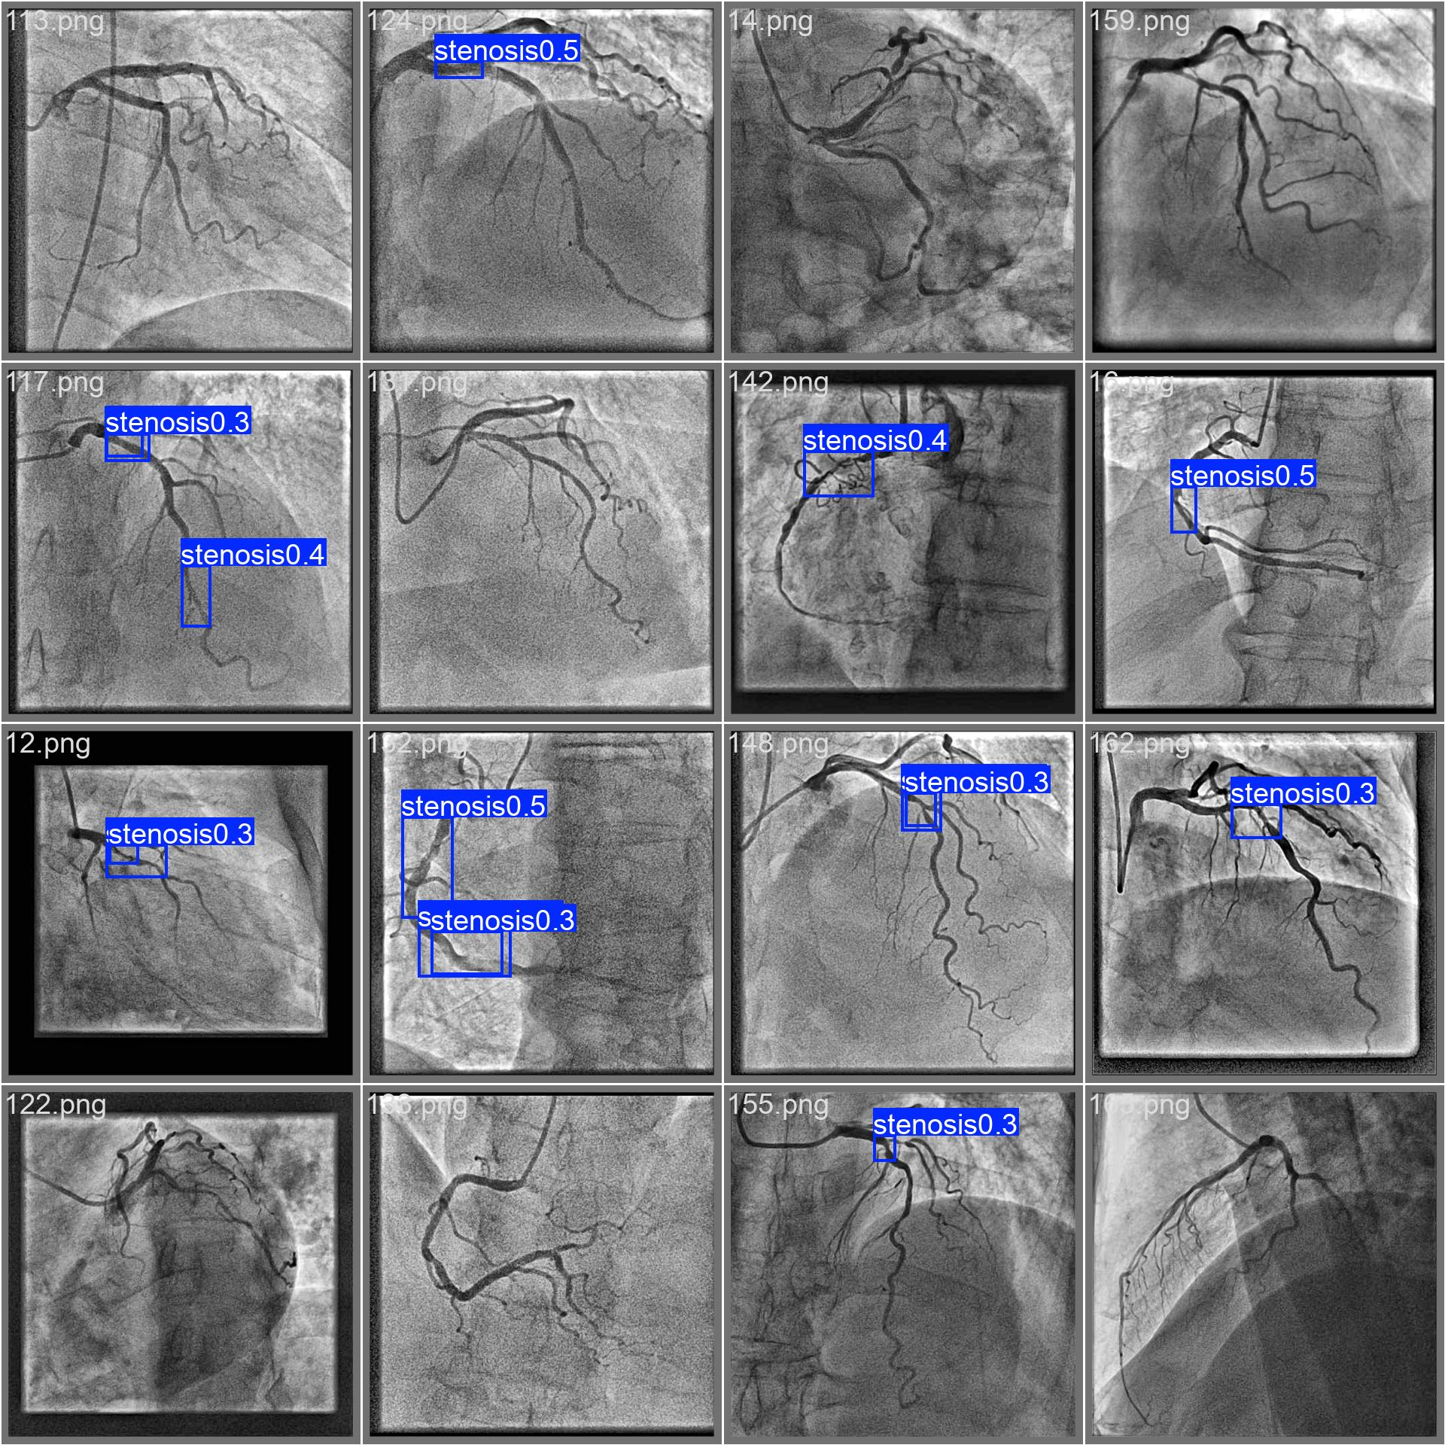 | 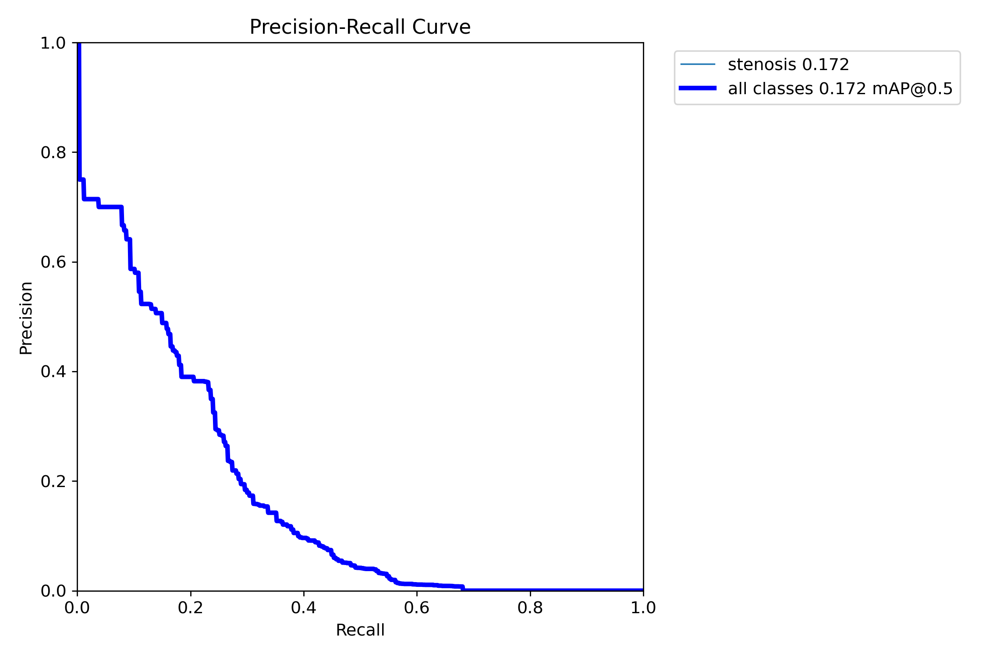 | 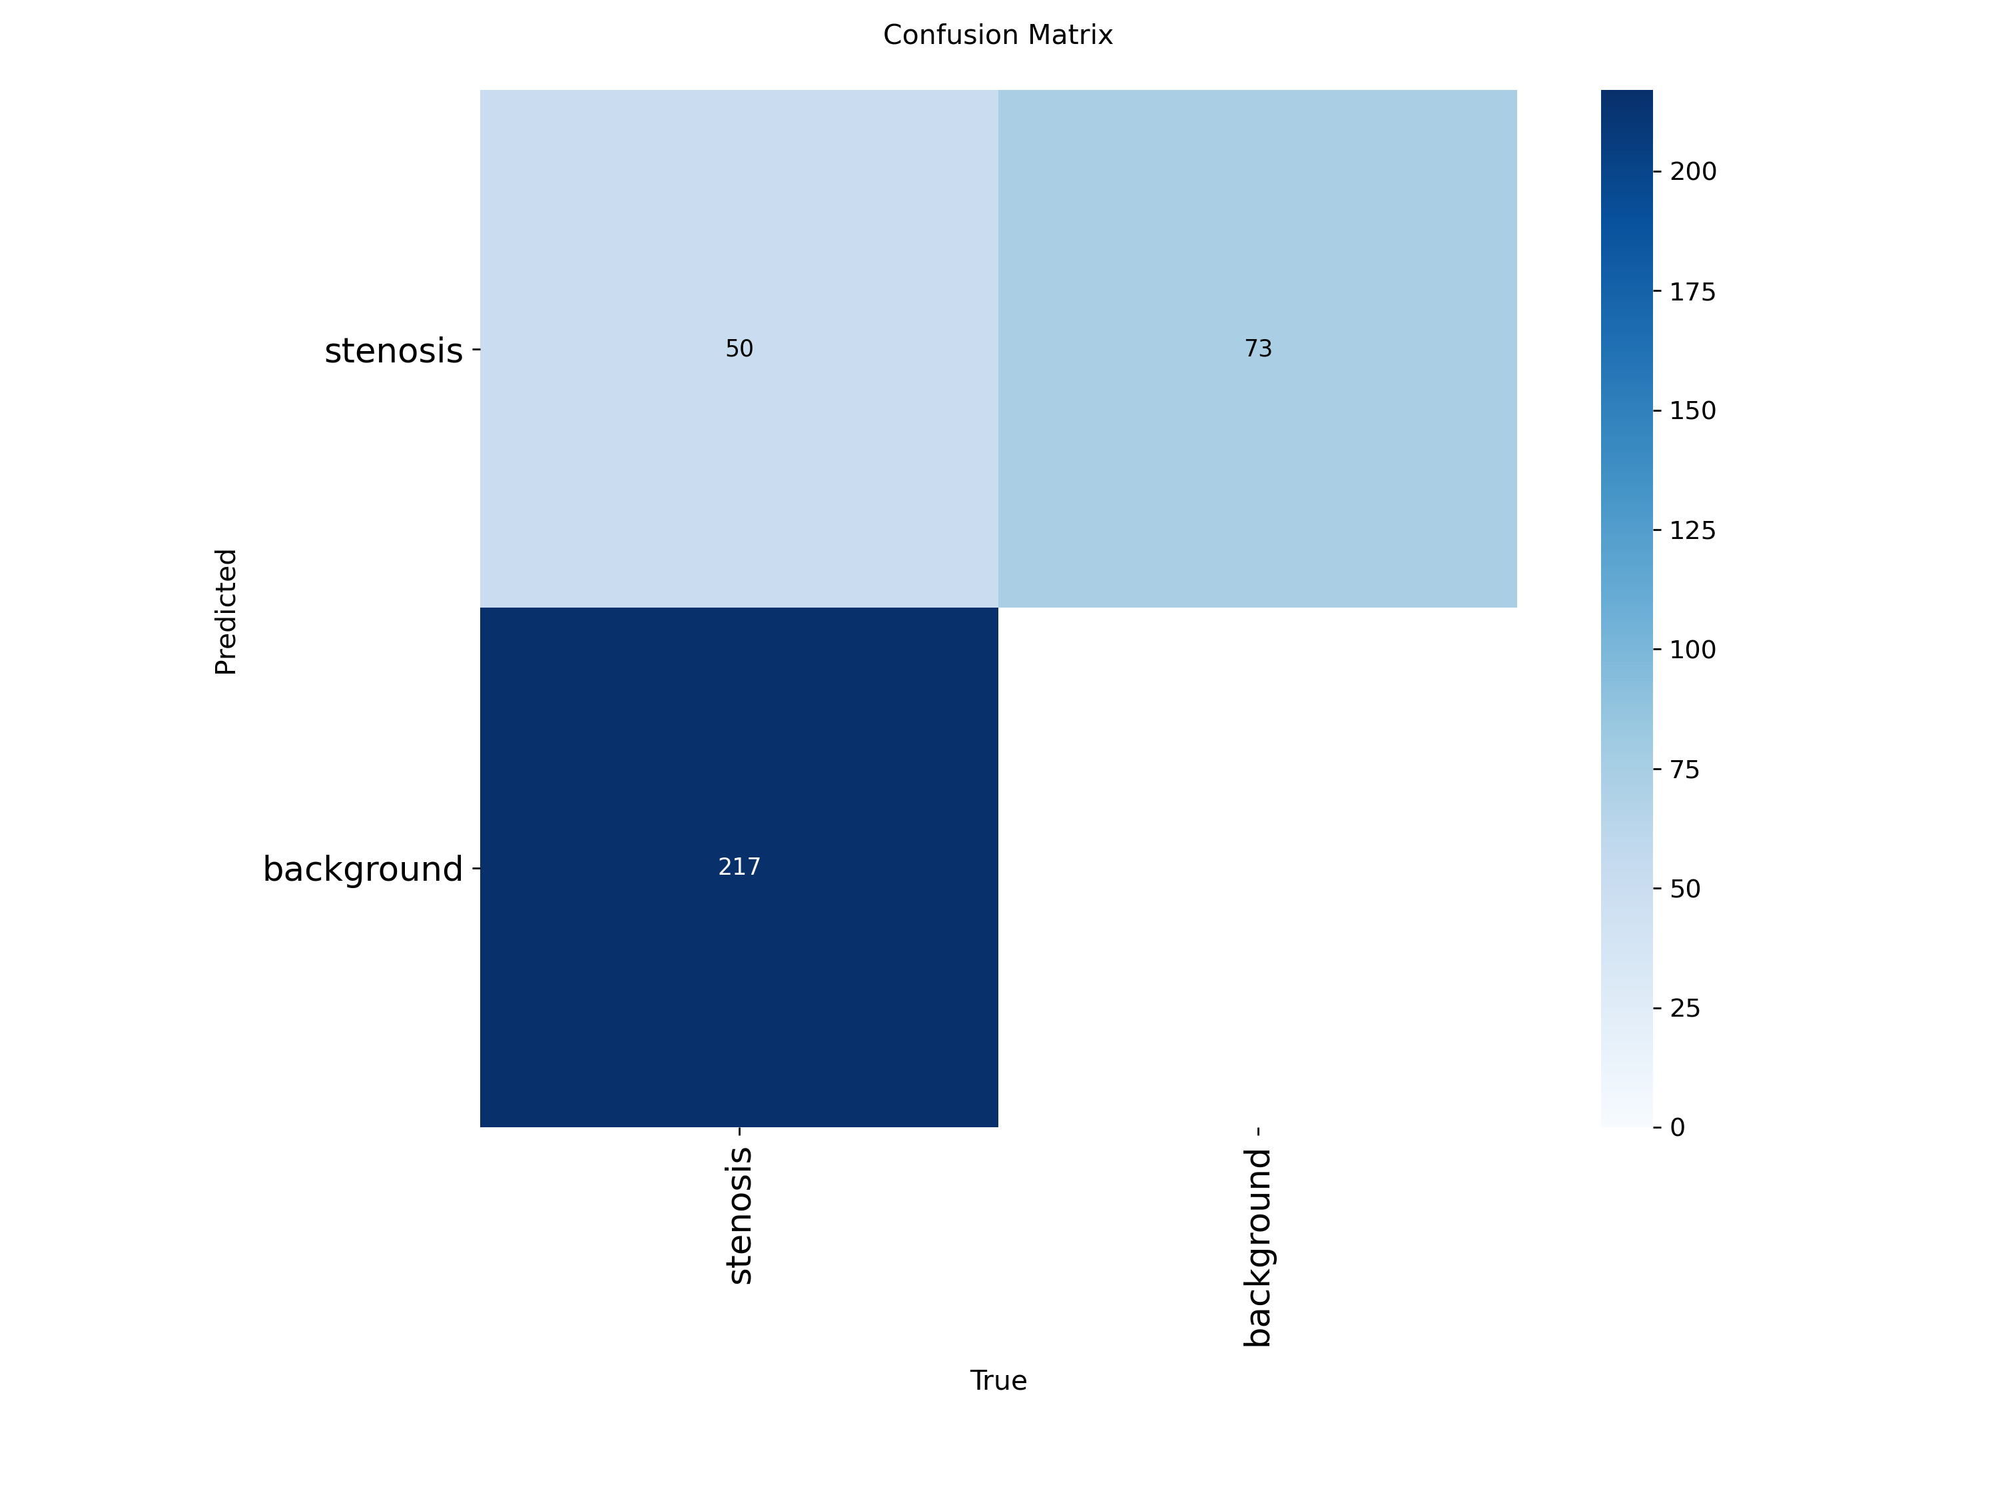
+ Danilov (honest)  F1 0.214 | 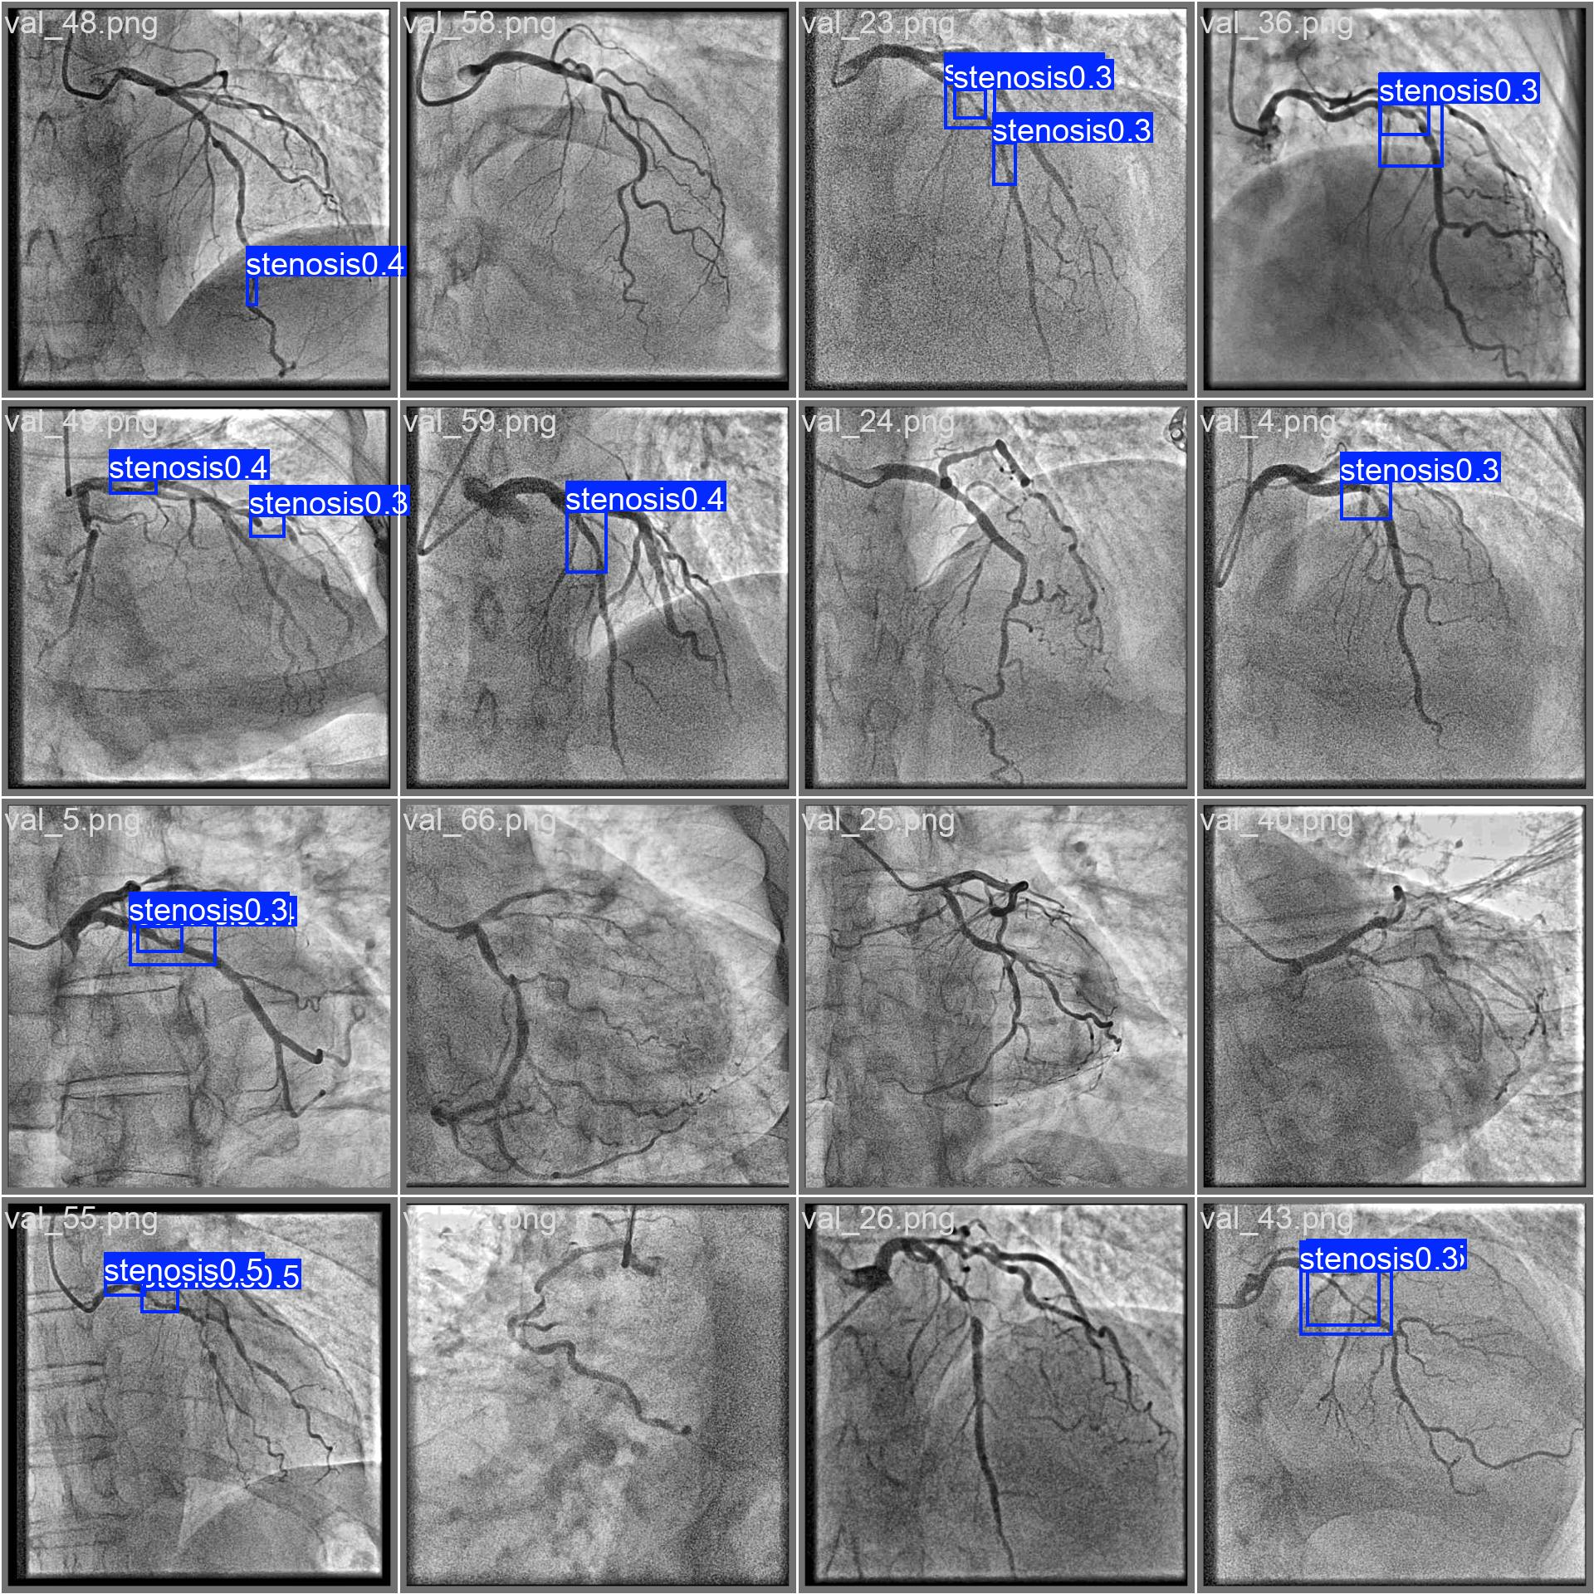 | 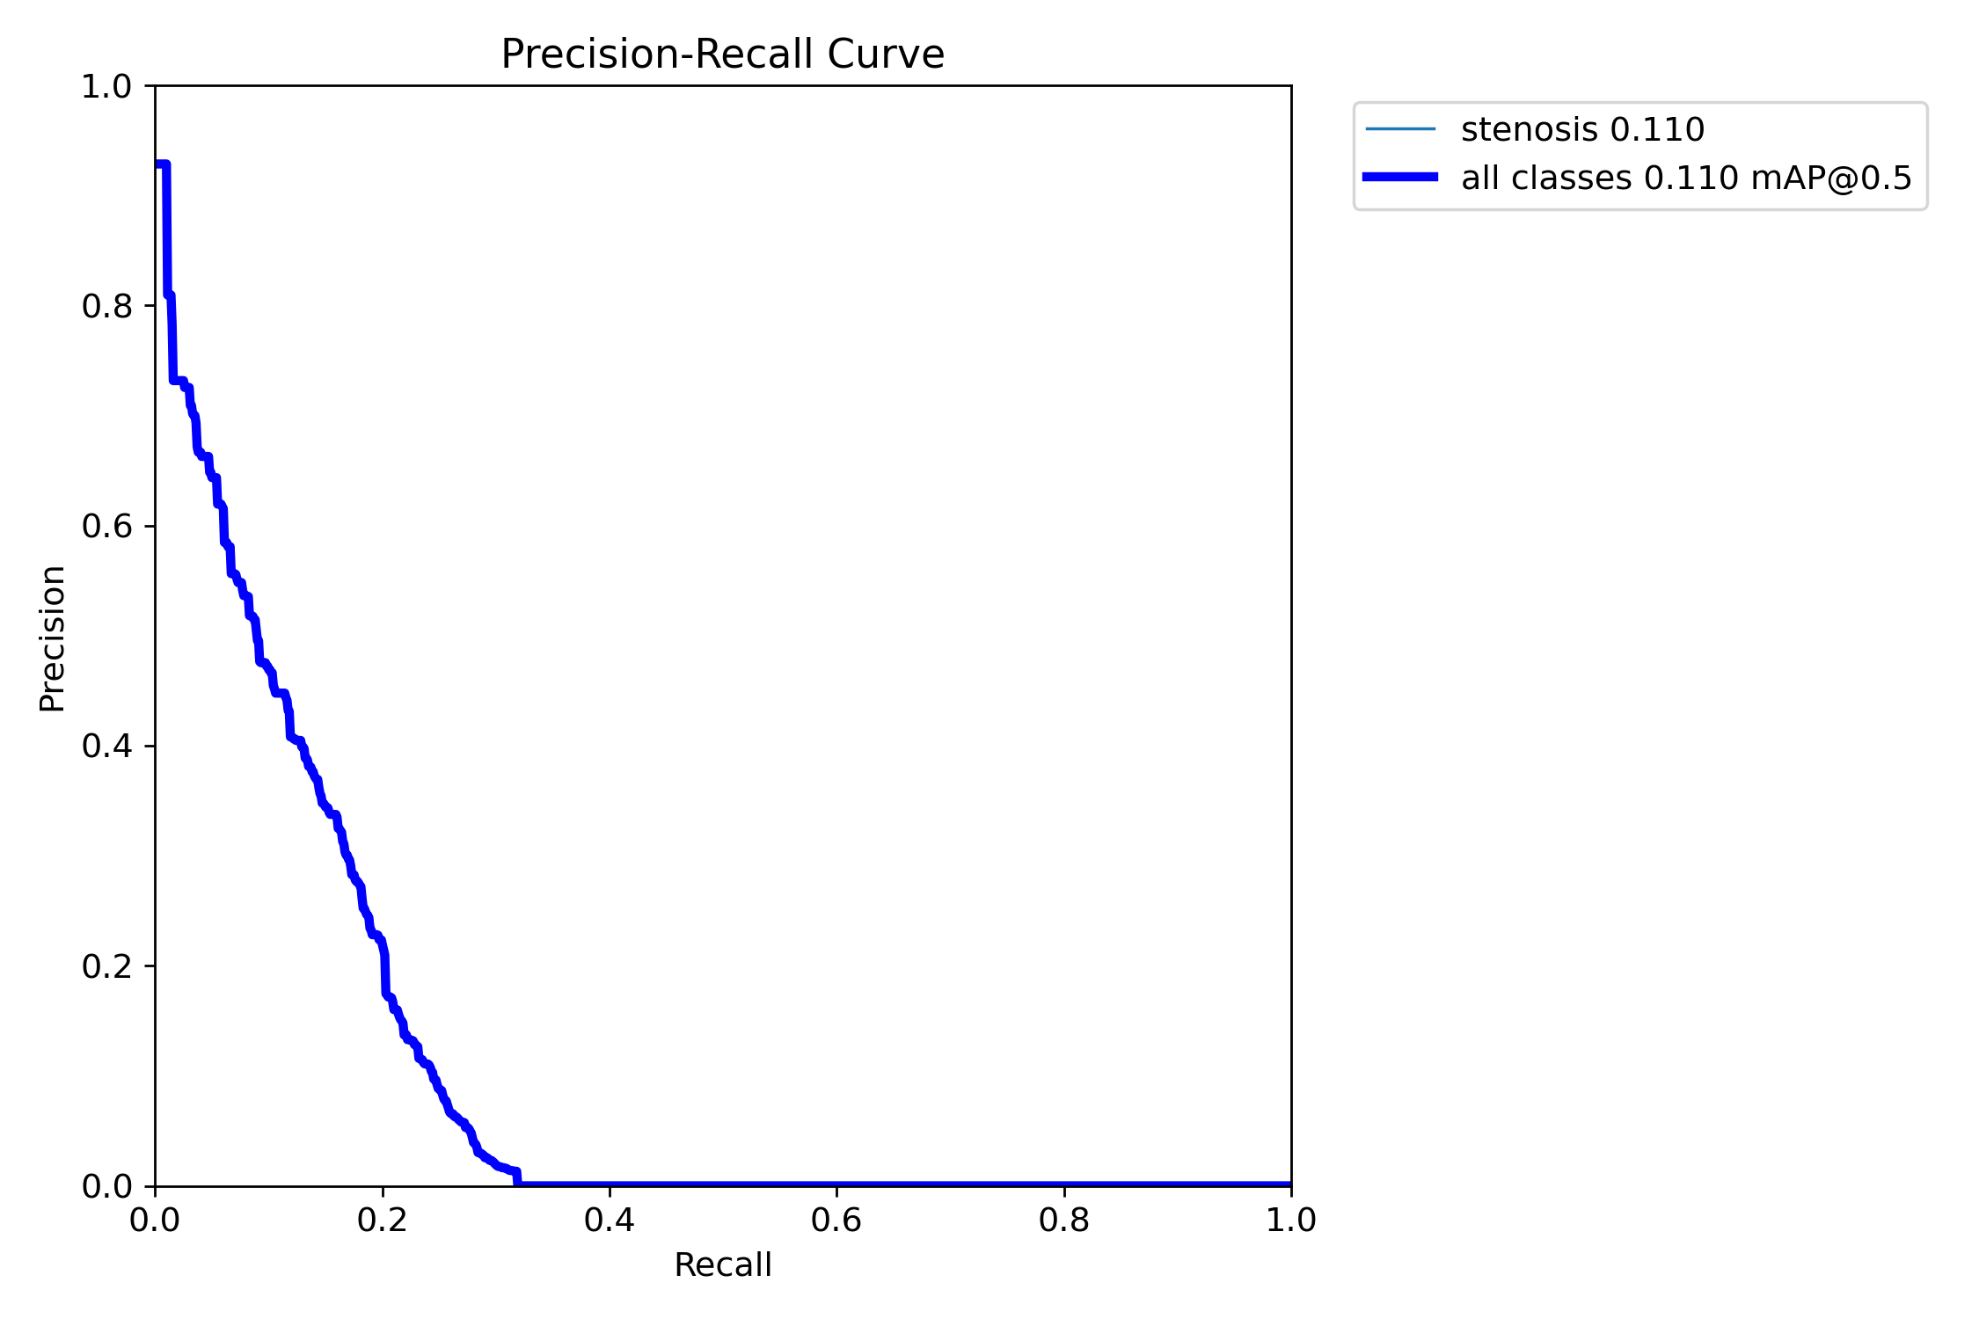 | 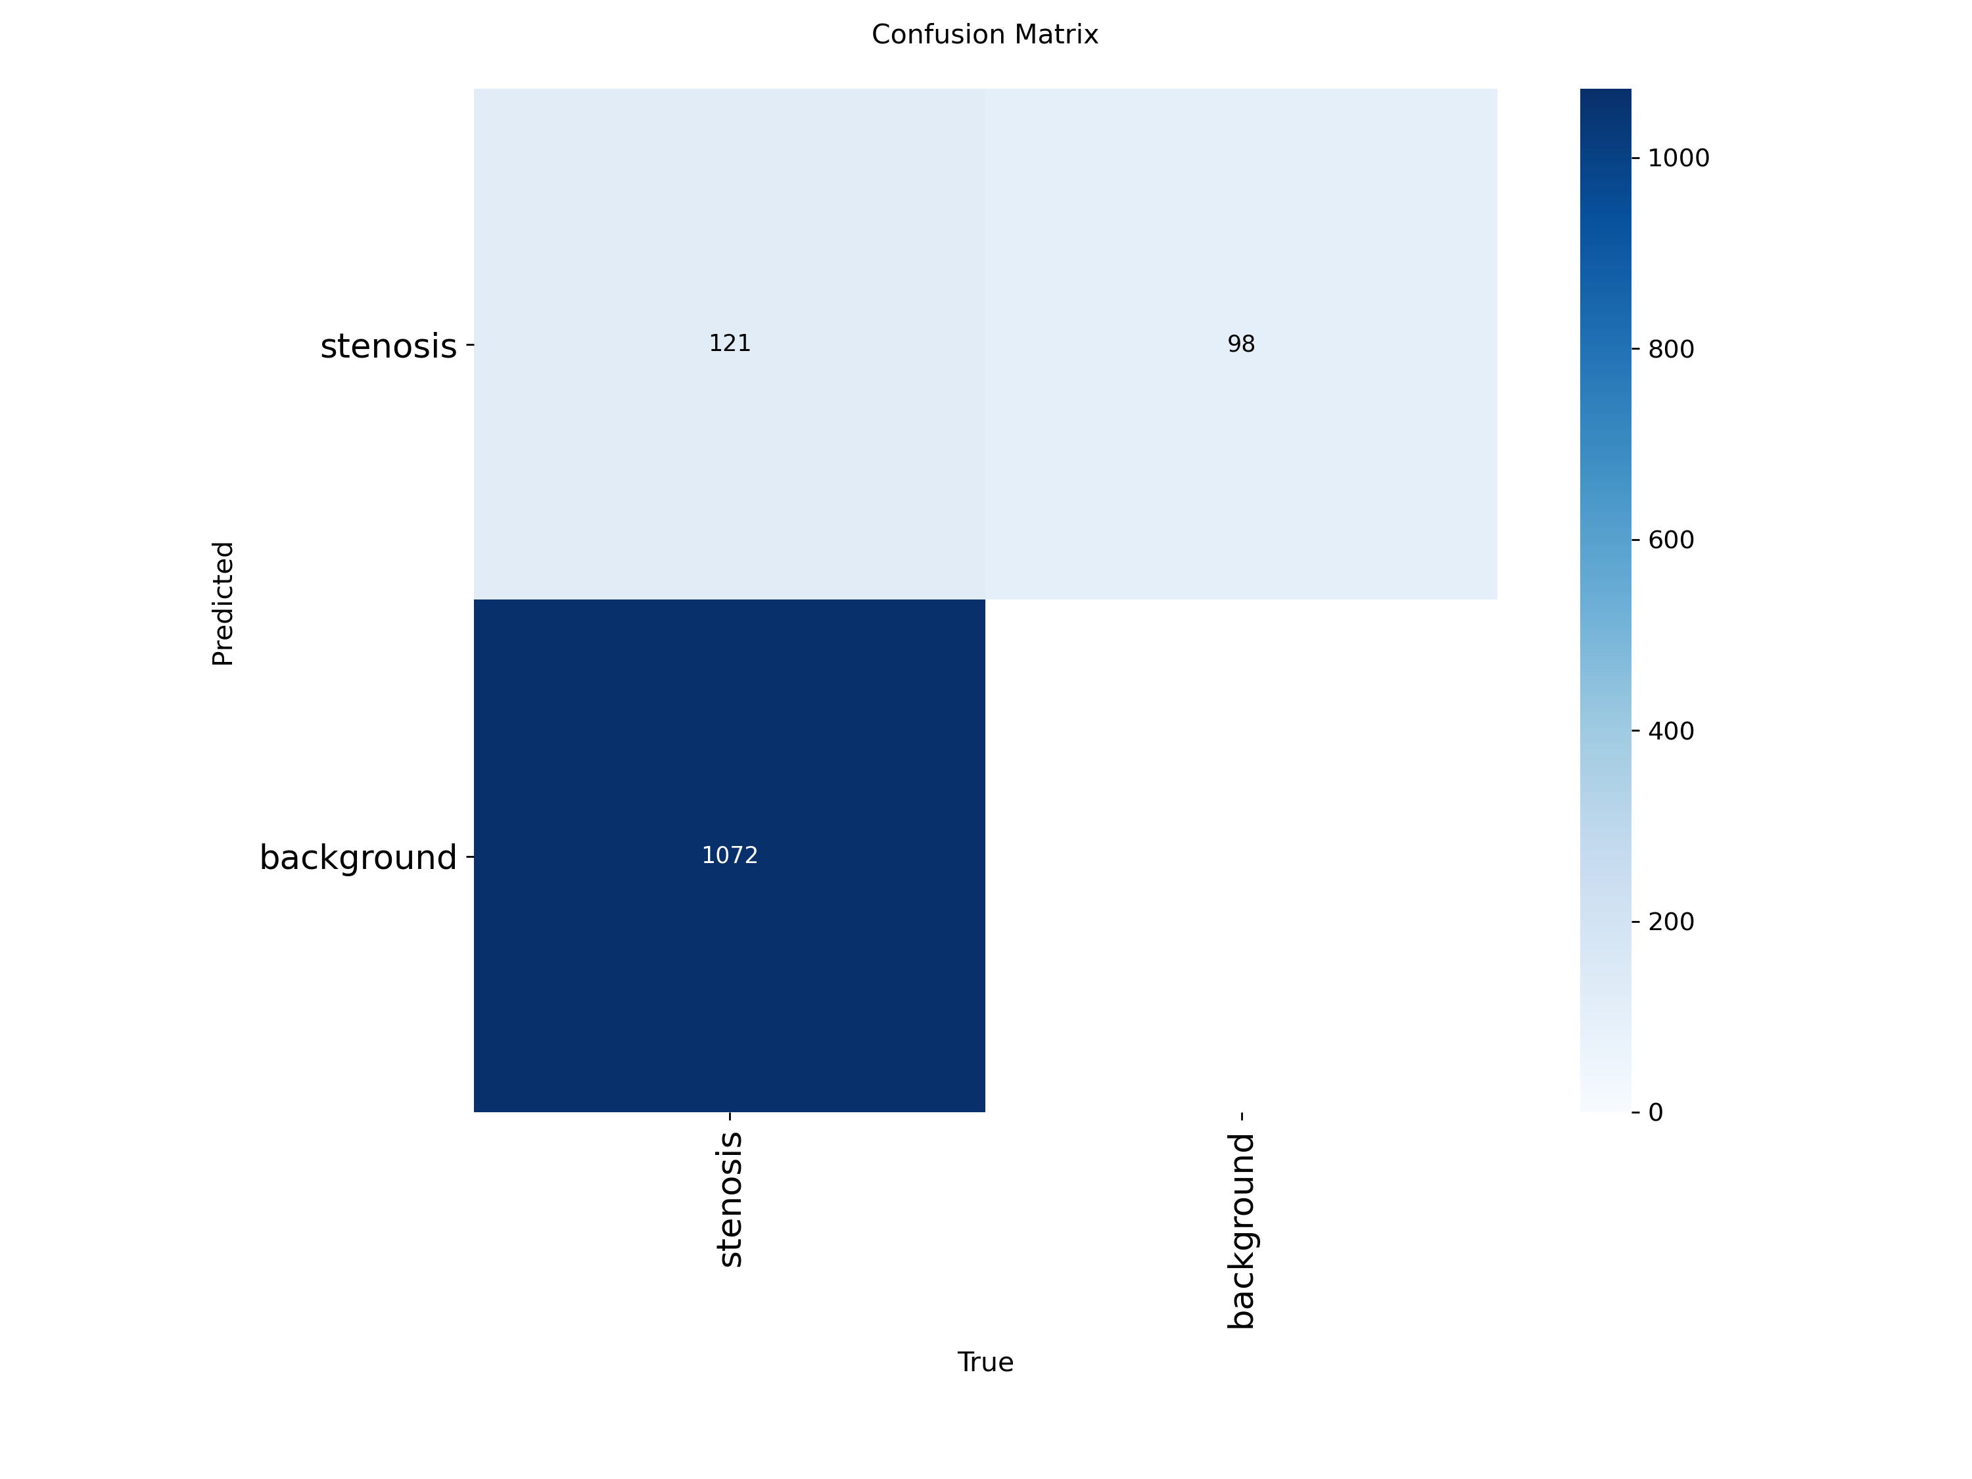
+ CADICA (honest)  F1 0.291 |  | 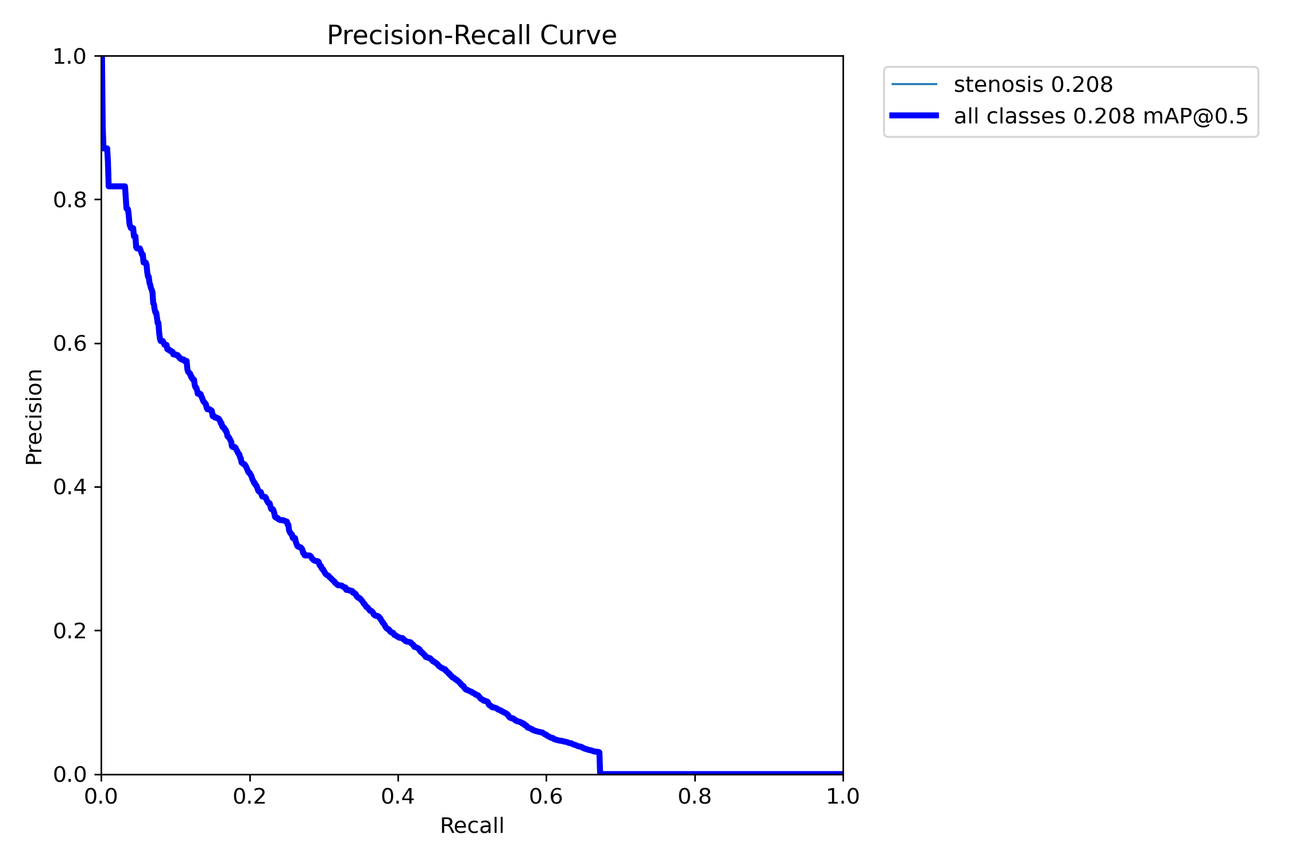 | 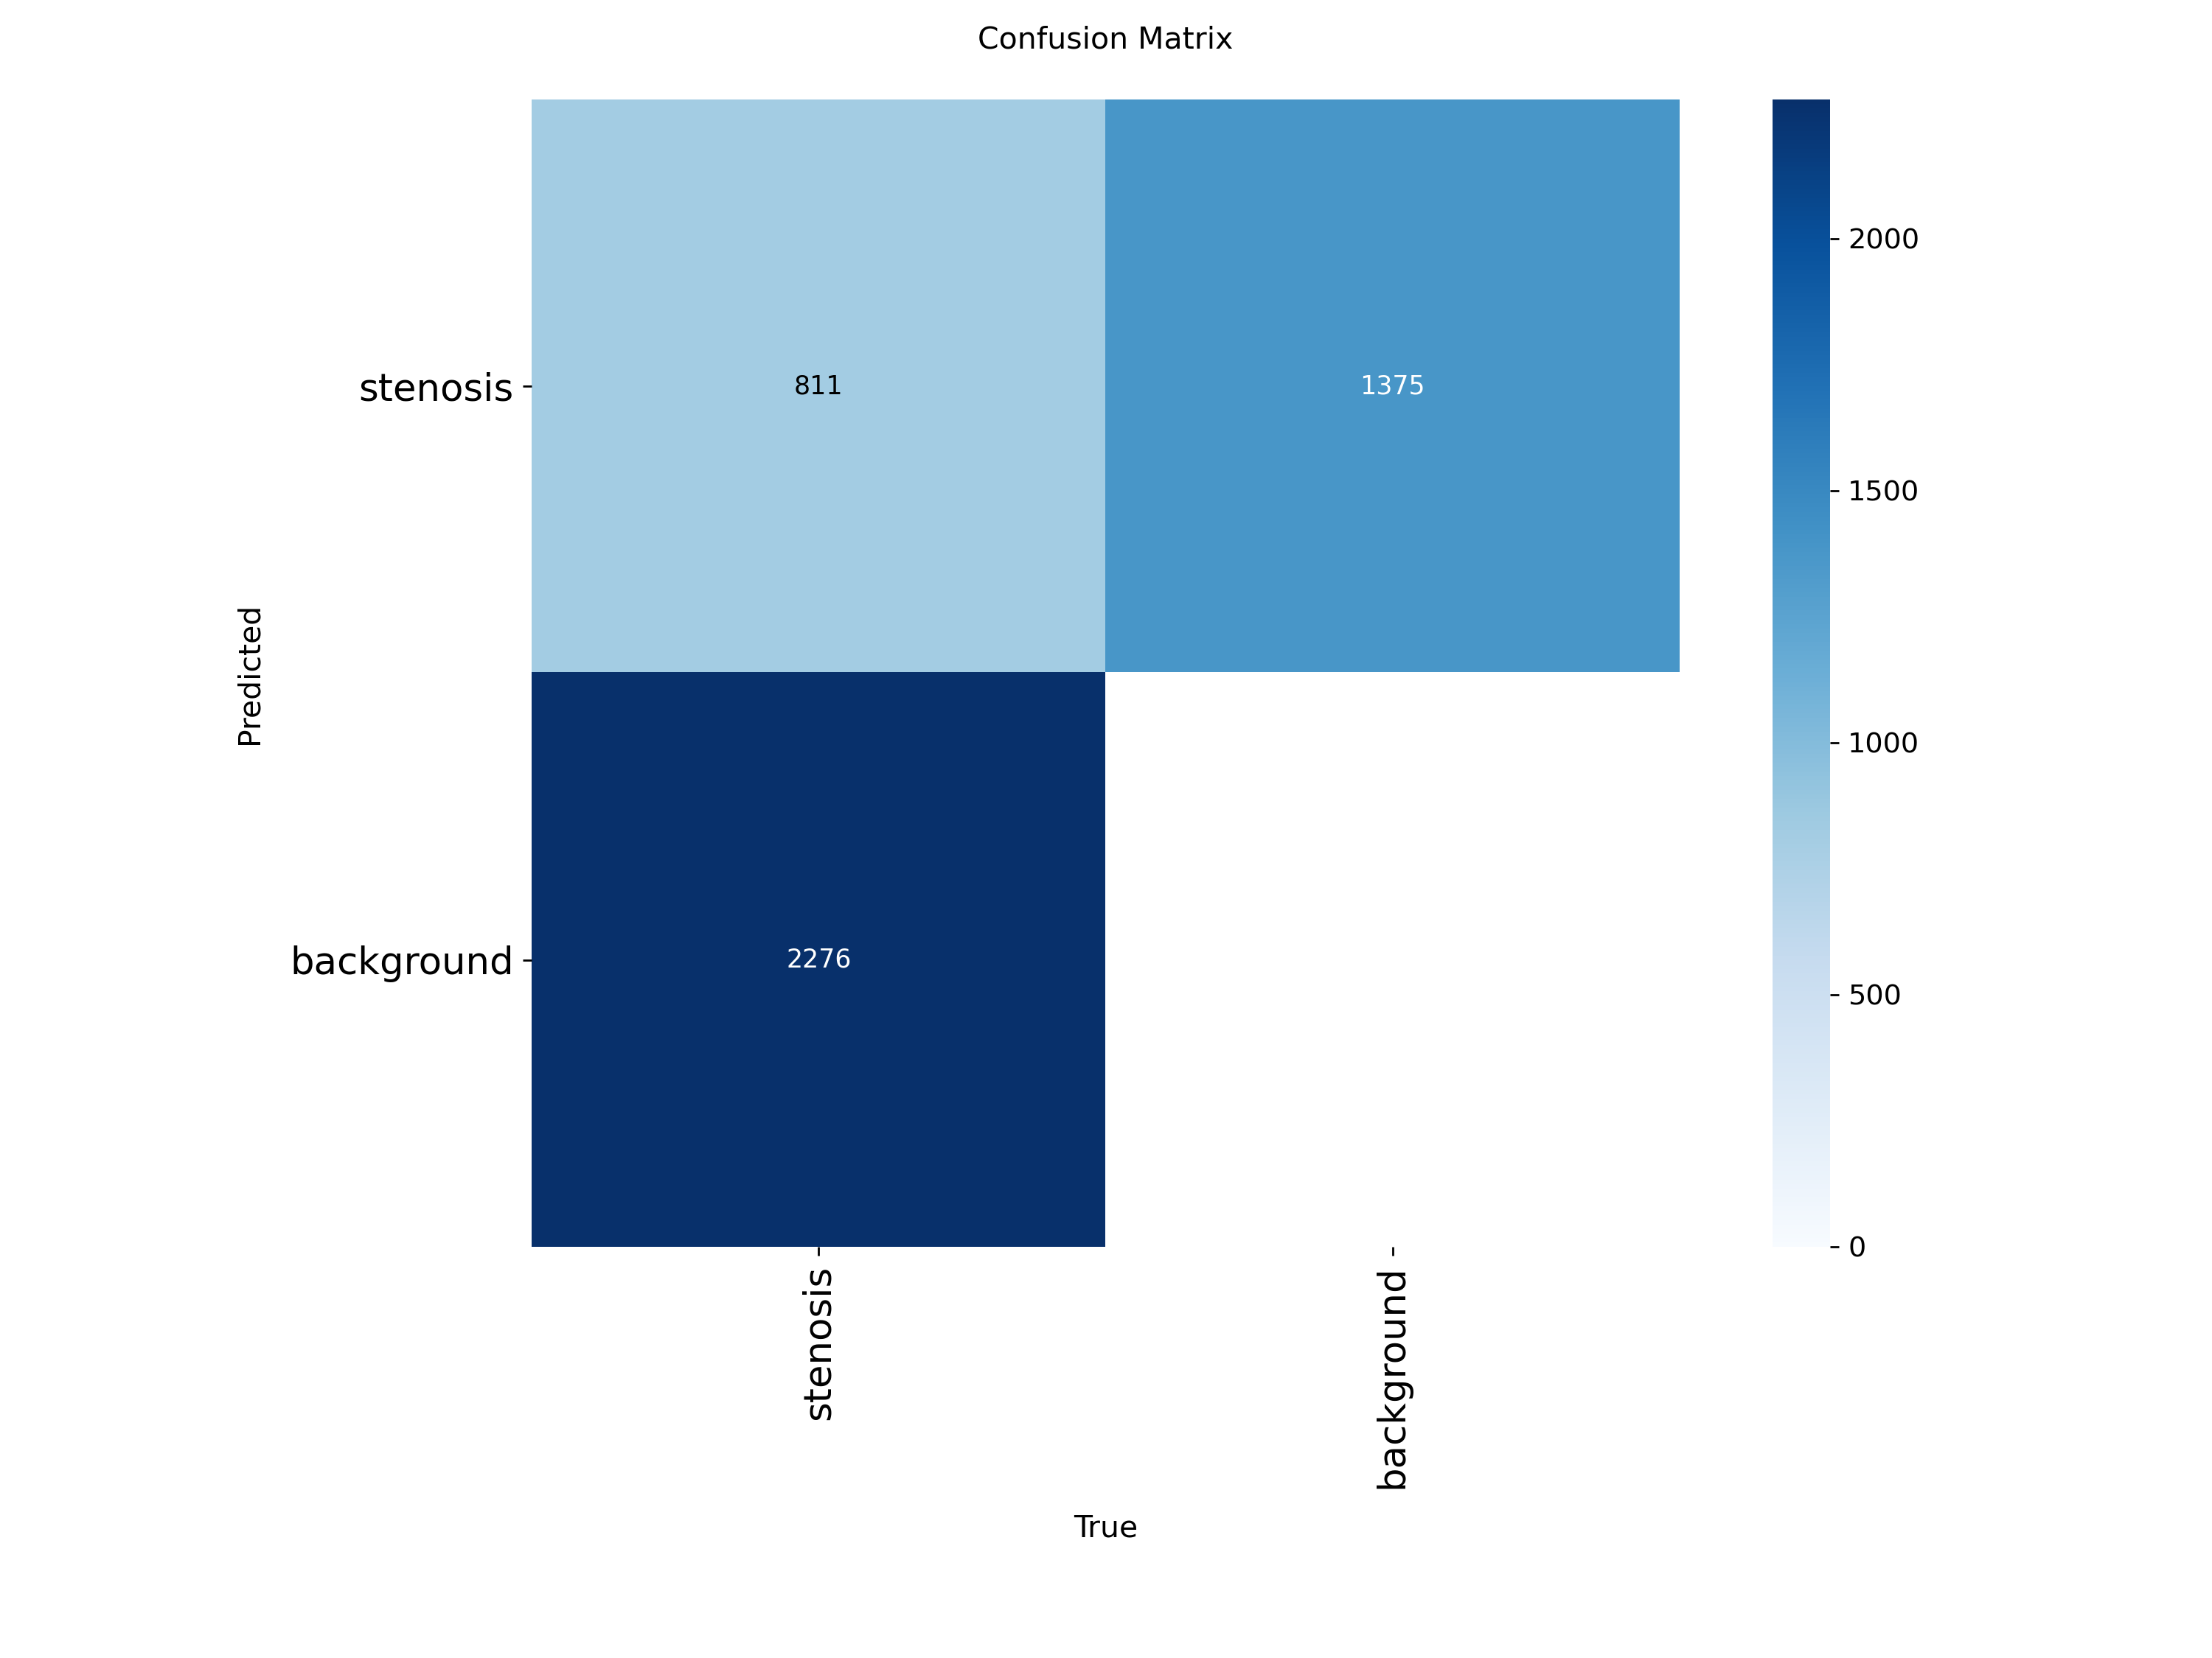

Source: experiments/stenosis_*/run/ (val_batch0_pred.jpg, BoxPR_curve.png, confusion_matrix.png).

6. Safety and Governance Design
The system is built around one principle: the dangerous failure is being “wrong but confident.” Several safeguards follow directly from that.
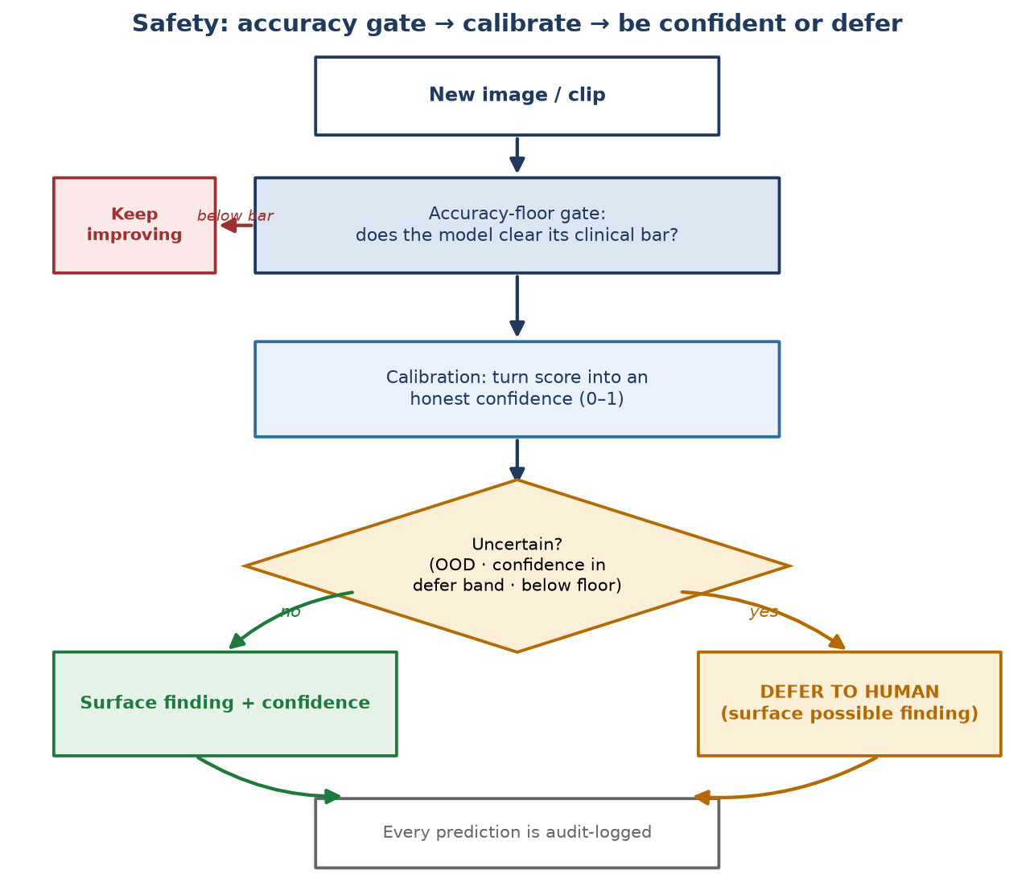
Figure 3. Every input passes an accuracy gate, is calibrated, then is either surfaced with confidence or deferred to a human — and always audit-logged.
- Accuracy gates first: a model may not ship on speed alone — it must first clear a minimum accuracy bar set for its task. A fast model that is not accurate enough is disqualified, not accepted.
- Post-compression connectivity check: after the on-device compression, the system re-checks that thin vessels did not fragment (this passed for coronary mapping, with a connectivity drop of only 0.0023).
- Calibrated confidence + defer-to-human: the model estimates its own confidence and, by default, defers uncertain cases to a human. The blockage-screening layer defers whenever a case is unfamiliar (out-of-distribution), when confidence sits in an ambiguous band, or when a faint possible lesion is near the threshold — it will surface a possible finding rather than silently pass it.
- Cross-vendor testing (planned): the design includes leave-one-vendor-out testing across Siemens, GE and Philips machines so performance is not tied to one scanner. Note: this test harness is scaffolded but has not yet been run — it is an explicit open item.
- Audit logging: every prediction records the image fingerprint, the model version, and the result, so any output is fully traceable after the fact.
Intended use — stated plainly: This is research software intended as a screening / second-read aid that defers to the clinician. It is NOT an autonomous diagnostic device, it does NOT make the clinical decision, and it has NOT been cleared by any regulator. It is not for clinical care in its current form.

7. Infrastructure in Plain Terms
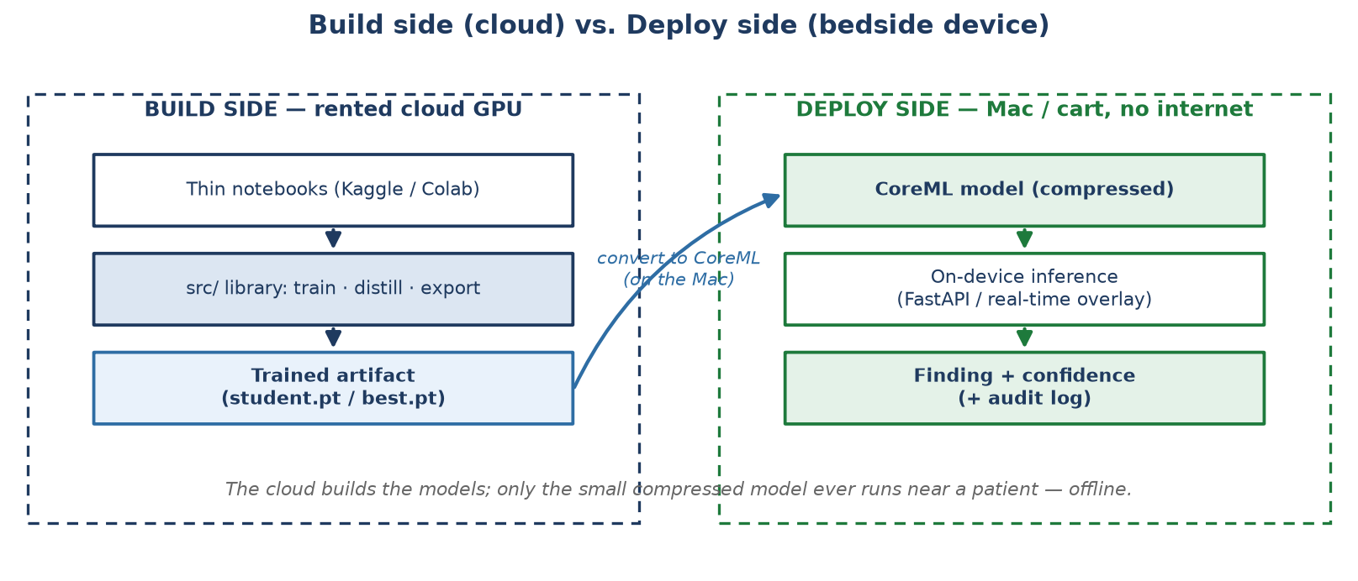
Figure 2. The cloud builds the models; only the small compressed model runs at the bedside, offline.
Heavy training happens on rented cloud GPUs (Kaggle / Google Colab), where the large “teacher” models are trained. Only the small, compressed “student” models are ever used near a patient, and those run locally on an Apple-silicon laptop or a procedure-cart mini-PC with no internet dependency at the point of care. In short: the cloud is used to build the models; the bedside device only runs the finished, shrunk version — offline. The codebase is kept honest by roughly 284 automated tests that run on every change.

8. What’s Next / Roadmap

8.1 Near term — close the blockage-detection data gap
Gather more diverse labelled patients and add semi-supervised learning from unlabelled clips to raise recall. This is the gating item for making blockage detection clinically useful, and the one a clinical partner most directly enables.

8.2 Mid term — a single “upload anything” diagnostic assistant
Today an operator must pick the task manually. The planned Diagnostic Orchestrator lets a clinician upload any image or clip; the system recognises what it is looking at, routes it to the right model(s), and returns a structured, plain-language report — for example “Possible coronary artery stenosis — clinician review required” — with a confidence level and the same defer-when-unsure safeguard built in. This is designed and documented; it is not yet built.

8.3 A realistic word on timeline
The internal plan sizes the stages in effort (weeks of work per stage), not calendar delivery dates, and several later stages depend on data access and formal validation that are not yet scheduled. We would rather state that honestly than invent dates. The nearest, most concrete milestone is the one gated on data: crossing the blockage-detection bar once a diverse patient set is available.

9. Overall Project Scope & What’s Still To Be Built
Everything in Sections 3–5 concerns coronary angiography (vessel mapping, blockage detection, catheter tracking). Honestly stated, that is one workstream inside a larger planned suite. The project is designed to cover four interventional-imaging domains that share the same pipeline machinery. Three of the four are configured and designed but at an earlier stage than coronary — the diagram shows the honest current position of each.
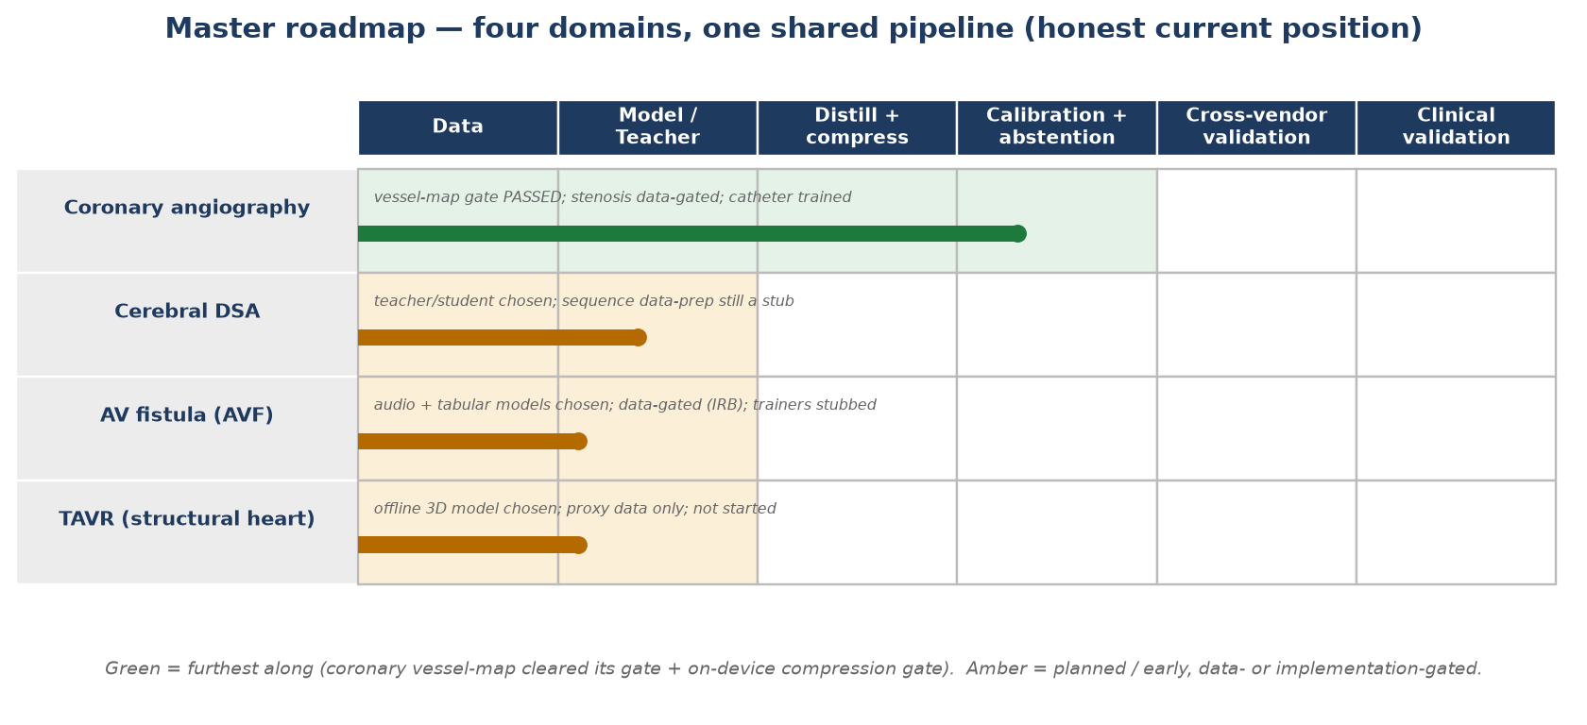
Figure 4. Four domains, one shared pipeline. Coronary (green) has run the machinery end-to-end; the other three (amber) are configured but data- or build-gated.
What each remaining domain is for, taken directly from its configuration file — with no clinical rationale invented beyond what the files specify:

9.1 Cerebral DSA (stroke / neurovascular imaging)
Planned use: outline the brain’s arteries from a timed contrast X-ray sequence (digital subtraction angiography), where the vessels fill over several frames rather than in one image. Config task: cerebral_dsa_segmentation, on the DIAS (weak scribble labels) and DSCA (224 sequences / 1,792 images) datasets. A large teacher (DSANet, Dice ceiling ~0.90) trains a small edge student that fuses a few frames over time (keyframe 2D + ConvLSTM, 4 frames, plus a minimum-intensity projection). Scored on Dice and clDice.
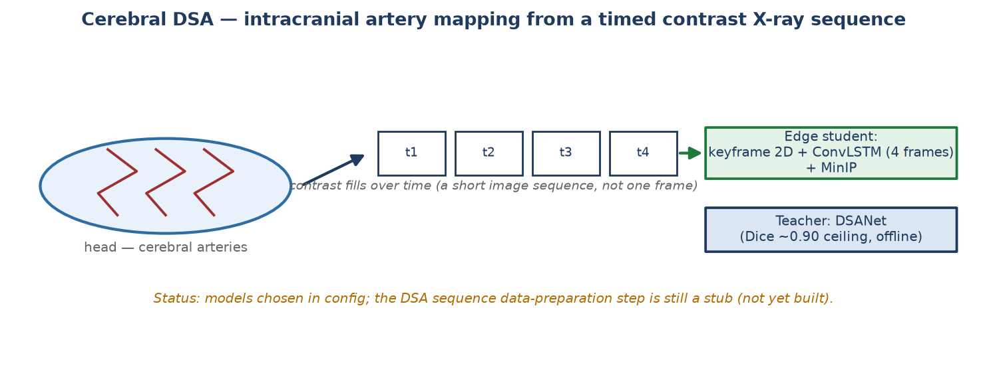
Status: the models are specified in the config, but the DSA sequence data-preparation step is still a placeholder in the code (not yet implemented) — so this is planned and designed, not yet runnable. (Source: configs/cerebral_dsa_temporal.yaml, PROJECT_TRACKER.md.)

9.2 AV fistula — dialysis access monitoring (two lightweight tracks)
Planned use: monitor the surgically-created artery–vein connection (fistula) that haemodialysis patients rely on, via two small models rather than imaging:
- Patency surveillance (tabular): predict access occlusion from routine numbers — dynamic venous and arterial pressure, flow rate, vessel diameter, CRP, ferritin — using a LightGBM model with SHAP explanations. Target AUROC ≥ 0.80. (configs/avf_tabular.yaml)
- Bruit screening (audio): screen the fistula’s sound (bruit) — a 15-second audio clip turned into a mel-spectrogram, read by a tiny model (small ViT, or a CNN-BiLSTM) small enough for a phone or wearable; labels come from duplex ultrasound. Framed explicitly as screening, not confirmation. (configs/avf_audio.yaml)
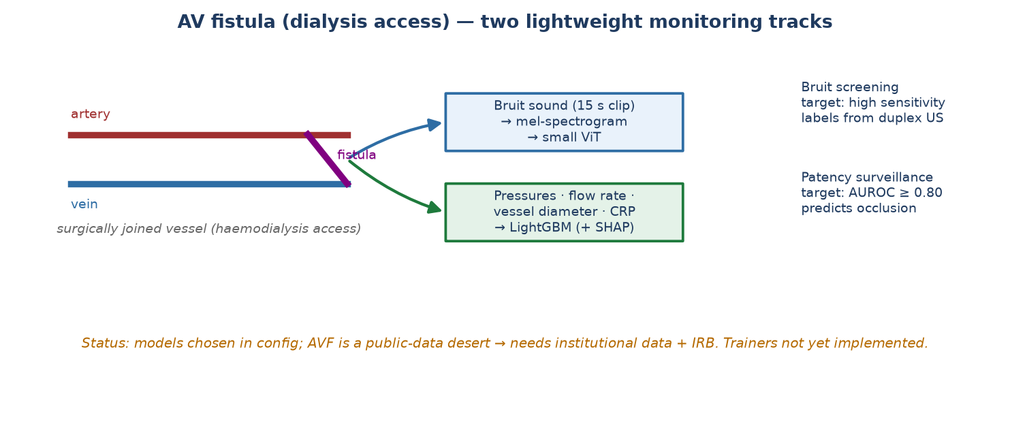
Status: models are chosen in the configs, but there is no public AV-fistula dataset (a “data desert”), so this needs institutional data and ethics approval (IRB); the audio trainer is a placeholder. Planned, data-gated. (Source: configs/avf_*.yaml, DATASET_VALIDATION.md, PROJECT_TRACKER.md.)

9.3 TAVR — structural-heart valve replacement
Planned use: support transcatheter aortic valve replacement in two phases. Before the procedure, size the aortic complex from a 3D CT scan — outlining the aortic root, annulus, sinus of Valsalva, sinotubular junction and coronary ostia, and extracting 22 measurements — using a 3D nnU-Net (or SwinUNETR). This part is explicitly an offline workstation job, not an on-device model, because 3D CT is too heavy for the cart. During the procedure, a lightweight detector tracks the valve and catheter on live fluoroscopy. Scored against expert measurements (agreement / ICC ≥ 0.95).
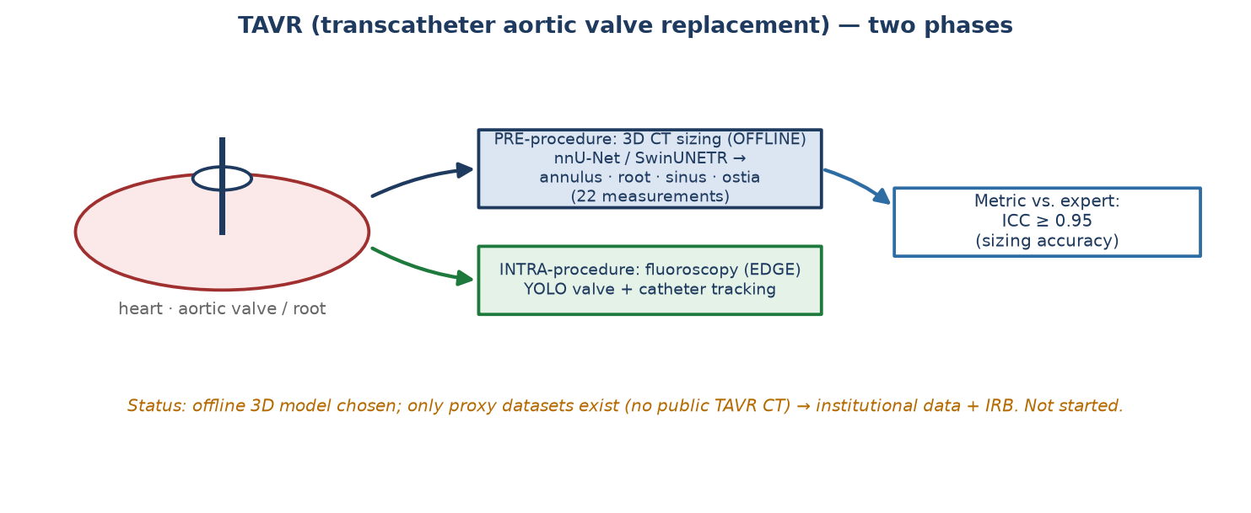
Status: the model is chosen, but no public TAVR CT dataset exists — only proxy datasets (MM-WHS, Seg.A) plus institutional CT under IRB. Not started. (Source: configs/tavr_ct_seg.yaml, pipelines/stage4_domain.md, DATASET_VALIDATION.md.)

9.4 Why one shared pipeline instead of four separate tools
The four domains differ only in their data, their teacher/student model choices, and what counts as a “finding.” Everything around that is shared code, already written and reused: the distillation loop that shrinks a teacher into an edge student, the export path that compresses and converts a model for the device, the calibration and defer-to-human safety layer, the per-prediction audit log, and the accuracy metrics. Because that machinery is common, adding a new domain means swapping in a dataset and a model — not rebuilding the plumbing, the safety checks, or the deployment path. One safety, calibration and audit standard then applies everywhere. The honest caveat: only coronary has actually been run through this machinery end-to-end so far; the other three have the configuration but not yet the data, preparation, or training.

10. What We’re Asking of You
- 1. Data access (highest value): a de-identified, patient-diverse set of coronary angiography images or short cine clips. Diversity of patients matters far more than sheer number of images.
- 2. Clinical review of flagged cases: occasional review of the cases the system flags, to tell us where it is right, where it misses, and where it false-alarms.
- 3. Feedback on report usefulness: a clinician’s view on whether the plain-language report is actually useful and safe in wording.
- 4. Guidance on the accuracy bars: help setting the clinically appropriate accuracy bars, which are provisional research placeholders today.
What we are NOT asking: nothing regarding clinical use, patient care, or liability. The system is not deployed on patients and will not be until a formal validation phase with appropriate oversight. Your involvement at this stage is advisory and data-related only.

11. Frequently Asked Questions
Q. Is this replacing my clinical judgment?
A. No. It is a second set of eyes that highlights and flags. It is explicitly designed to defer to you when uncertain, and it makes no autonomous diagnosis.
Q. What happens if it is wrong?
A. The design assumes it will sometimes be wrong. That is why it reports confidence, defers uncertain and unfamiliar cases to a human, and — for blockage detection specifically — runs only as a screening flag, never a confident “yes.” The clinician remains the decision-maker.
Q. Is patient data safe?
A. The patient-facing model runs entirely on a local device with no internet dependency, so images need not leave the hospital. Every prediction is also logged for traceability. Training data used for building the models is public and/or de-identified.
Q. Has this been used on real patients?
A. No. It is research software and has not been used in clinical care. Results in this document come from public research datasets, evaluated on honest patient-separated test sets.
Q. Who is accountable for a missed finding?
A. In its current form the software is not a medical device and is not to be relied upon clinically; the clinician remains responsible for all care decisions. Any future clinical use would require a formal validation phase and a defined regulatory and accountability framework agreed in advance.
Q. Why isn’t blockage detection just fixed with a bigger model?
A. Because the evidence shows the limit is the number of distinct patients in the data, not model size. Adding diverse patients produced the biggest gain to date; a bigger model on the same narrow data would add little. This is why patient-diverse data is the ask.

12. Glossary
Angiography / fluoroscopy — Live X-ray imaging used to see blood vessels and devices during a procedure.
Segmentation — Outlining a structure pixel-by-pixel — here, drawing the coronary artery tree.
Detection — Drawing a box around an object of interest — here, a blockage or a catheter.
Stenosis — A narrowing or blockage of an artery — the disease the detector looks for.
Dice score — How well two outlines overlap, from 0 (none) to 1 (perfect). 0.75+ is the bar for vessel mapping.
clDice — A connectivity-focused score: does the thin vessel stay one connected line rather than breaking into dots.
F1 — A single 0–1 balance of catching real cases (recall) against false alarms (precision).
Recall — The share of true findings that are actually caught. High recall matters most for blockages.
Precision — The share of the model’s flags that are genuinely correct.
mAP / mAP50 — Mean Average Precision — a standard 0–1 detection-quality score used to compare object detectors.
Distillation — Training a small model to imitate a large, accurate one so it can run on a small device.
Quantization / palettization — Compressing a model (using fewer bits per number) to make it smaller and faster; re-checked so it doesn’t lose accuracy.
Calibration — Making a model’s stated confidence match how often it is actually right, so an 80% claim means 80%.
Abstention / defer — The model choosing to hand an uncertain case to a human instead of guessing.
Out-of-distribution (OOD) — An input unlike anything the model was trained on (unfamiliar scanner, view, or artefact) — a trigger to defer.
Data leakage — When the same patient appears in both training and testing, inflating scores; avoided here by patient-separated splits.
nnU-Net — A leading medical-image segmentation framework; used as the vessel-mapping teacher.
TinyU-Net — A small segmentation model that runs on the device; the vessel-mapping student.
YOLO11 — A fast real-time object detector; used for blockage and catheter detection.
ByteTrack — A tracking method that keeps each detected object’s identity stable across video frames.
Grounding DINO / SAM — Large helper models used only on the build side to label data; never shipped to the device.
CoreML — Apple’s framework for running AI models efficiently on Apple-silicon devices — the deployment target.
GPU — A high-powered processor used to train the heavy models in the cloud.
Teacher / student — The large accurate model that trains (teacher) and the small deployable model that learns from it (student).

13. Roadmap & Change Log
This is a living document. Each substantive change to the project or to this handover is logged below (most recent first), so a returning reader can see what moved.
Date | Domain | Stage | What changed | New metric
2026-07-18 | Document | Handover v2 | Added rendered diagrams (teacher→student, build vs deploy, safety flow, roadmap swimlane, and cerebral-DSA / AVF / TAVR schematics); added the “Overall Project Scope” section; added the three-run stenosis evidence grid + progression table; cover-page contact added. | —
2026-07-16 | Coronary | 1 — vessel mapping | CLGeoDice distillation run; accuracy-floor gate verified for the first time. | Dice 0.915 / clDice 0.956 (≥ 0.75: PASS)
2026-07-16 | Coronary | 1 — edge export | CoreML 6-bit palettization + post-compression connectivity re-check. | clDice drop 0.0023 (≤ 0.03: PASS)
2026-07-16 | Coronary | 2 — blockage detection | Added CADICA (patient-diverse) on the honest patient-separated split — biggest honest lift. | F1 0.291 / recall 0.271 (< 0.57: below floor)
2026-07-13 | Coronary | 3 — catheter tracking | YOLO11n detector + ByteTrack trained end-to-end; demo clip produced. | trained; on-device gate numbers pending

Sources for the metrics above: outputs/coronary_student_clgeodice/RESULTS.md, experiments/stenosis_arcade+cadica+danilov_yolo11s_768_e150/RESULTS.md, PROJECT_TRACKER.md.

