**Analysis Of MIG Welding**

By

Ashutosh Kumar(2013044)

Ayushi Jain(2013050)

Rohit Bhardwaj(2013172)

Supervisor

Dr. H ChellaDurai

Mr. Tapas Bajpei



**Mechanical Engineering Department**

**INDIAN INSTITUTE OF INFORMATION TECHNOLOGY, DESIGN AND MANUFACTURING JABALPUR**

(Period of work: 30th May,2016 - 14th June,2016)

**Introduction**

Welding is a permanent joining process used to join different materials like metals, alloys or plastics, together at their contacting surfaces by application of heat and or pressure. During welding, the work-pieces to be joined are melted at the interface and after solidification a permanent joint can be achieved. Sometimes a filler material is added to form a weld pool of molten material which after solidification gives a strong bond between the materials. Weld ability of a material depends on different factors like the metallurgical changes that occur during welding, changes in hardness in weld zone due to rapid solidification, extent of oxidation due to reaction of materials with atmospheric oxygen and tendency of crack formation in the joint position.

**Present Investigation**

**Different type of welding processes**

Based on the heat source used welding processes can be categorized as follows:

**1.Arc Welding**: In arc welding process an electric power supply is used to produce an arc between electrode and the work-piece material to joint, so that work-piece metals melt at the interface and welding could be done. Power supply for arc welding process could be AC or DC type. The electrode used for arc welding could be consumable or non-consumable. For non-consumable electrode an external filler material could be used.

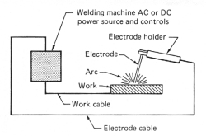

**2.Gas Welding**: In gas welding process a focused high temperature flame produced by combustion of gas or gas mixture is used to melt the work pieces to be joined. An external filler material is used for proper welding. Most common type gas welding process is Oxyacetylene gas welding where acetylene and oxygen react and producing some heat.

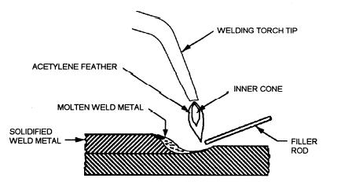

**3. Resistance Welding**: In resistance welding heat is generated due to passing of high amount current (1000–100,000 A) through the resistance caused by the contact between two metal surfaces. Most common types resistance welding is Spot-welding, where a pointed electrode is used. Continuous type spot resistance welding can be used for seam-welding where a wheel-shaped electrode is used.

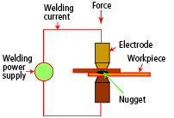

**4. High Energy Beam Welding:** In this type of welding a focused energy beam with high intensity such as Laser beam or electron beam is used to melt the work pieces and join them 2 together. These types of welding mainly used for precision welding or welding of advanced material or sometimes welding of dissimilar materials, which is not possible by conventional welding process.

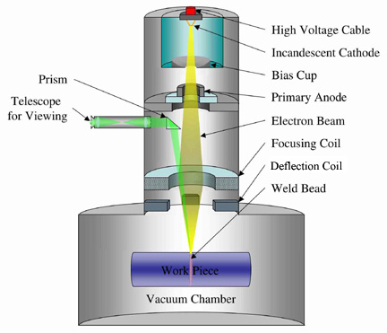

**5. Solid-State Welding:** Solid-state welding processes do not involve melting of the work piece materials to be joined. Common types of solid-state welding are ultrasonic welding, explosion welding, electromagnetic pulse welding, friction welding, friction-stir-welding etc.

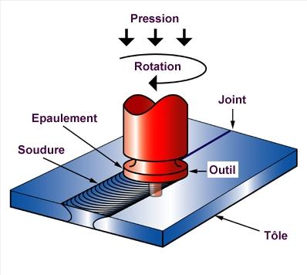

**Arc Welding:**

Among all these types of welding processes arc welding is widely used for different types of materials. Common types of arc welding process are:

**a) Shielded Metal Arc Welding (SMAW) or Manual Metal Arc Welding**: This is most common type arc welding process, where a flux coated consumable electrode is used. As the electrode melts, the flux disintegrates and produces shielding gas that protect the weld area from atmospheric oxygen and other gases and produces slag which covers the molten filler metal as it transfer from the electrode to the weld pool. The slag floats to the surface of weld pool and protects the weld from atmosphere as it solidifies.

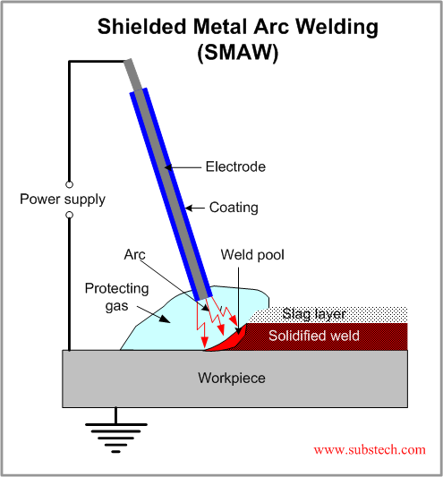

**b) Gas Metal Arc Welding (GMAW) or Metal inert or active gas welding (MIG/MAG):** In this type of welding process a continuous and consumable wire electrode is used. A shielding gas generally argon or sometimes mixture of argon and carbon dioxide are blown through a welding gun to the weld zone.

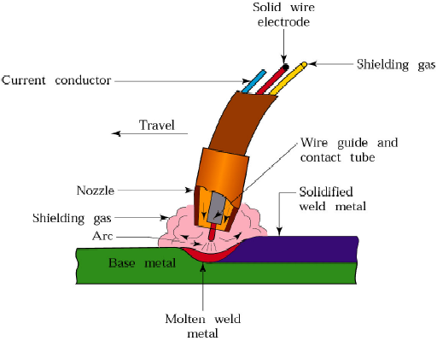

**c) Gas Tungsten Arc Welding (GTAW) or Tungsten Inert Gas (TIG):** GTAW or TIG welding process is an arc welding process uses a non consumable tungsten electrode to produce the weld. The weld area is protected from atmosphere with a shielding gas generally Argon or Helium or sometimes mixture of Argon and Helium. A filler metal may also feed manually for proper welding.

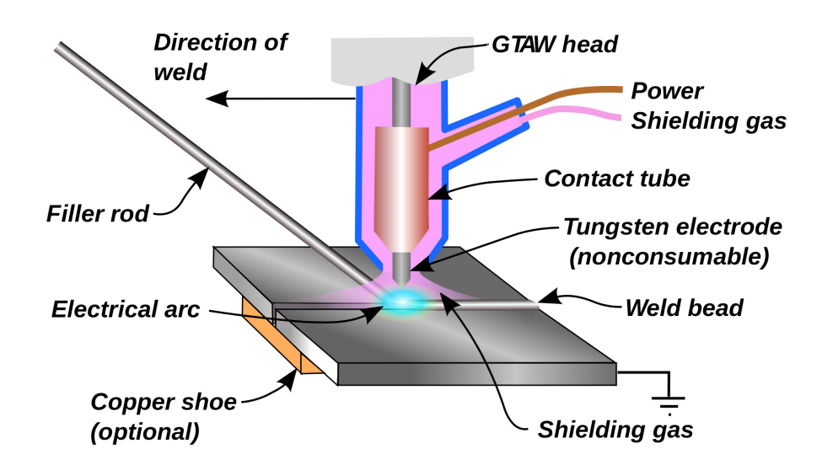

**Weld Joints:**

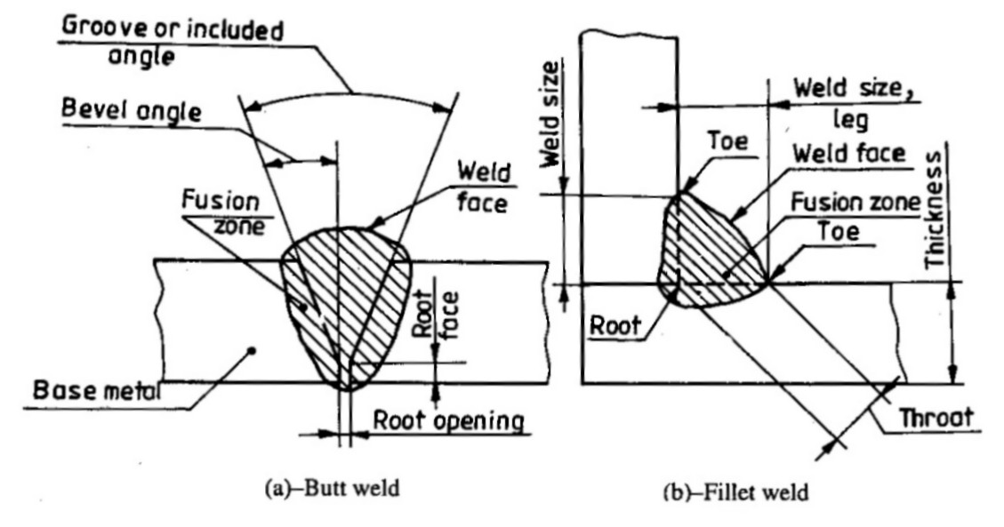

Basic Type of Weld Joints And Terms

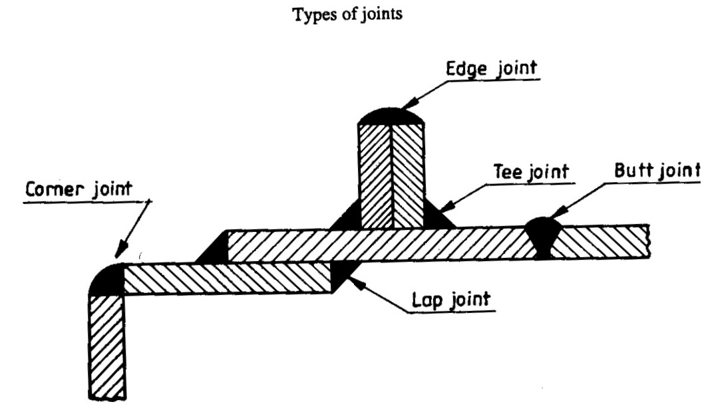

**Types of Joints**

**Results and Discussion**

* Basic concept and definition of welding has been studied.
* Types of welding on the basis of different parameters like type of heat source, filler material, mechanism involved etc. has been discussed.
* Focused on Arc welding and different type of arc welding was studied in detail.
* Weld joints and the parameters defining it were discussed.

**Conclusion:**

Types of welding has been studied based on their heat sources. Types of Arc welding was studied in detail especially. We took the glimpse of weld joints and its terminology.

**Timeline:**

Our next short term goal for next 15 days will be to study Weld symbols for joints, weld defects, the some terms like hydrogen embrittlement. And then we will further proceed to detailed study of MIG welding and its machine.

After this our target will be to take a literature review of automation of welding and a after effects of welding and their analysis.