1- Sign up to it

I selected the bitbucket repository option. Since it was interesting to me because it is from the same trello creators that we will use in another subject.

2- Check some differences between bitbucket and GitHub

The repositories to the lab 5:

The differences between github and bitbucket that I have found have been the following:

- First difference I saw is in the create of the repository. In bitbucket you can select the program language, like java, html, javascript...

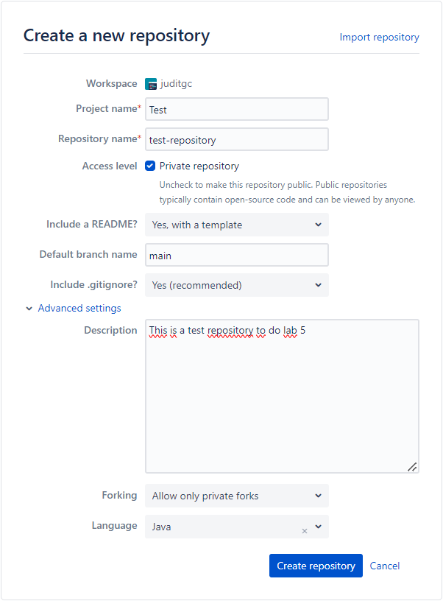
1.1 Create repository in bitbucket

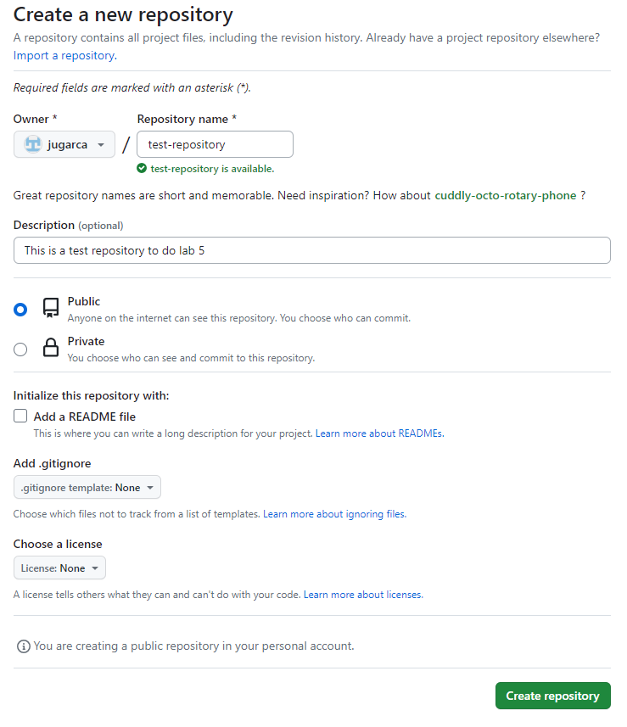
1.2 Create repository in github

- Next difference is in the create branch. In bitbucket you can selected the type of branch custom, feature, bugfix, hotfix

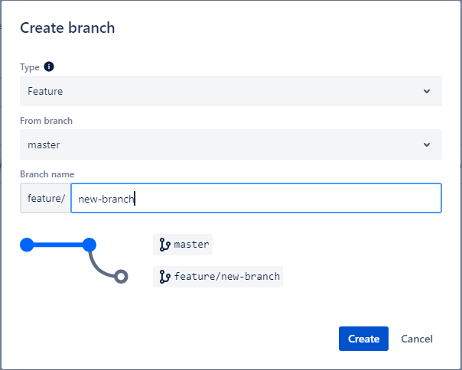
  - Create branch in bitbucket

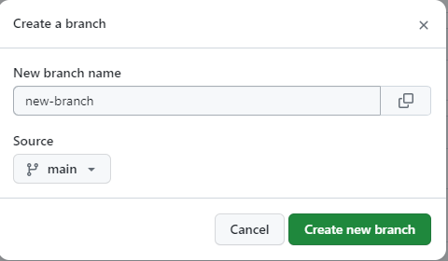
  - Create branch in github

- Another difference between bitbucket and git is the issue tracker. Bitbucket has integration with Jira (Atlassian Product) and git has its own issue tracker.

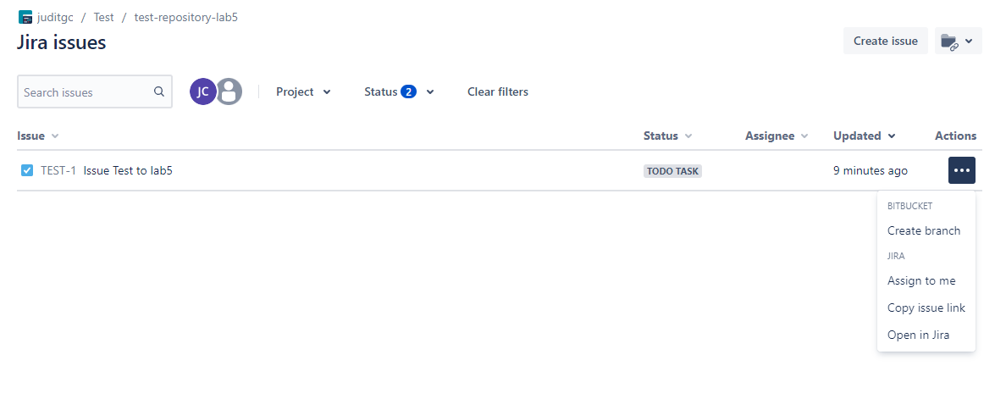
3.1- Issues in bitbucket

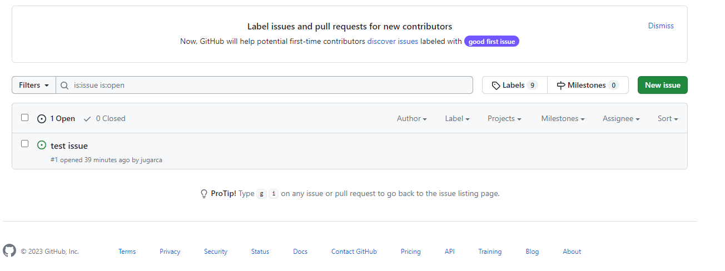
3.2- Issues in bitbucket

- In my opinion, the interface to see the diff in the pull request is more intuitive in bitbucket.
In github the difference of code is in other tab.

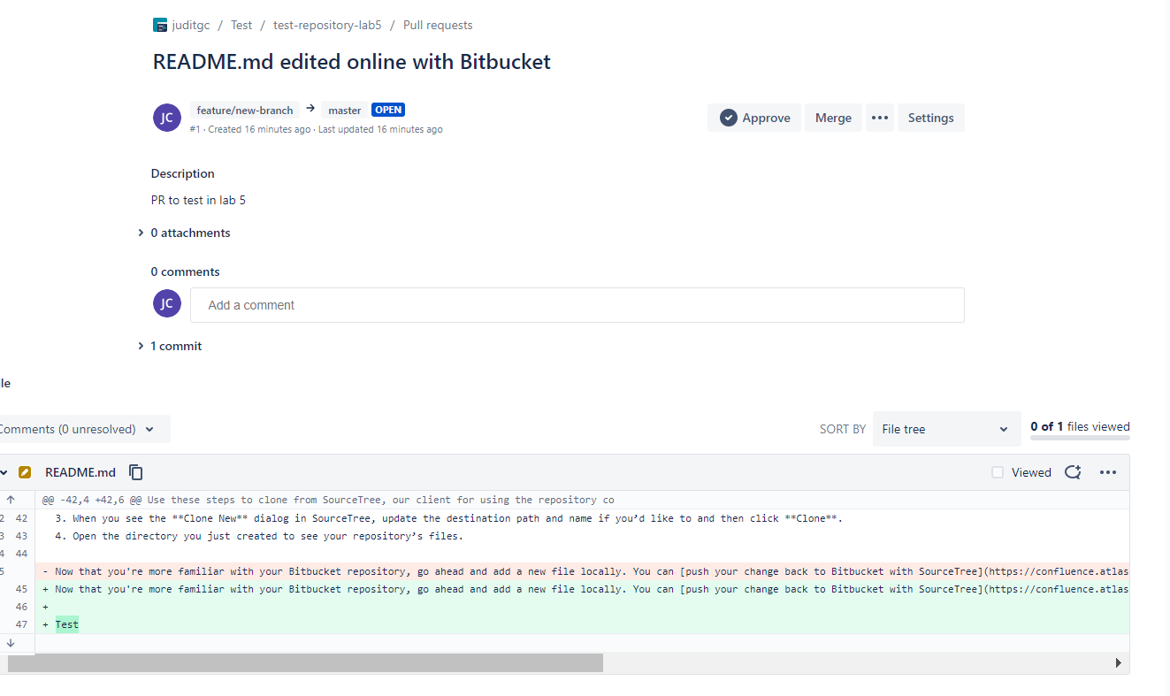
4.1- Pull Request in bitbucket

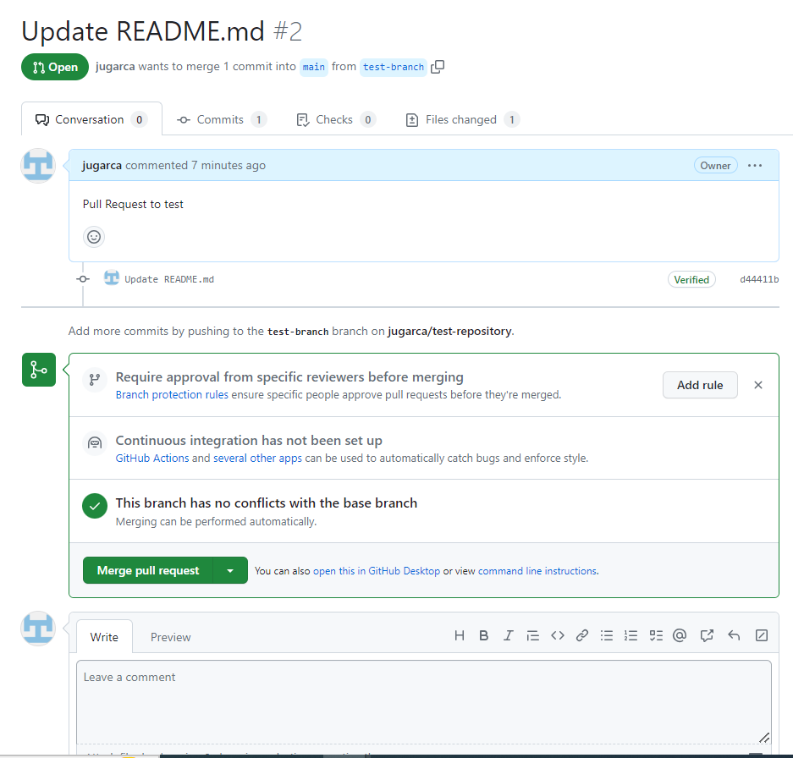
4.2- Pull Request tab 1 in github

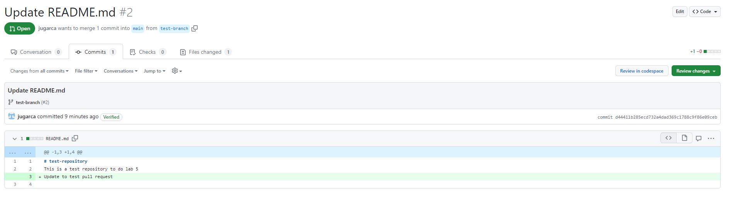
4.3- Pull Request tab 2 in github

