Examination

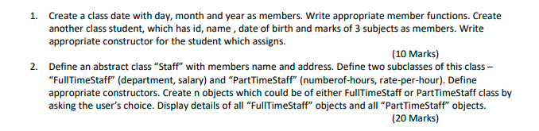

Write Appropriate Test Programs for Above Task with exception handling where
appropriate especially while handling Date Class.
10 Marks for Vivas

