Web development
- use :focus always if :hover is used.
- image has property “object-fit: cover”, use to fit image in a container
- use figure with img and figcaption.
- Static Website vs Dynamic website
- for form inputs, always provide name attribute as it is used to see the value in javascript, name attribute is also use to group radio buttons with value attribute.
- Adding Favicon : <link rel=”shortcut icon” type=”image/x-icon” href=”image/favicon.ico”>
- vertical-margin collapses, whereas horizontal-margin and padding don’t
- inline elements don’t get affected by width,height and vertical-margin properties(=> can’t set these properties on inline elements), but block does. Use inline-block if want inline elements to get affected by width or height.

JS
- (7) Number, boolean, String, Null, Undefined, Symbol, Object
- NaN, Infinity
- typeof, use === to compare.
- while, do while, for, forEach(), map(), filter()
- function Hoisting, scope: global, function
- function within function

Exectution Context

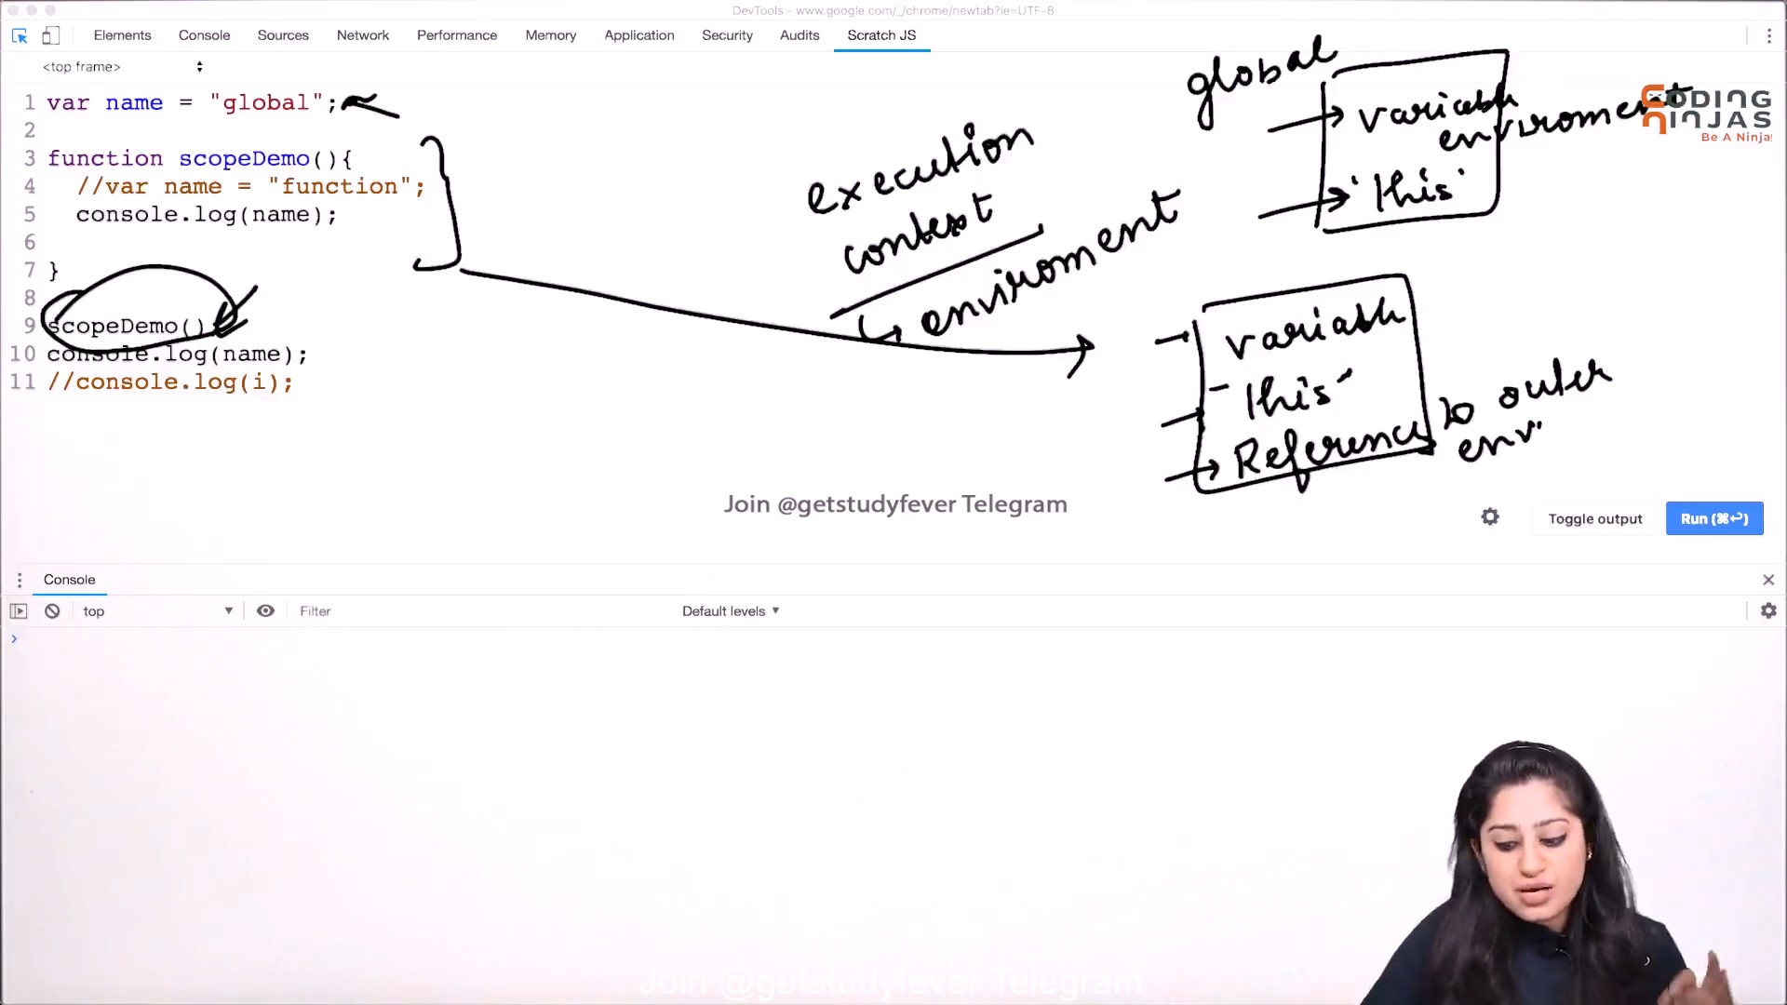
- Execution of a function is created when function is called.
- Multiple Execution to the same function will create different Exectuion context.

More...
- Closure
- Pure Function: dont change arguments, safe functions, always returns something.
- prototype
- prototype Inhertiance
- arrow function, ‘this’ is it
- callback, Promise, Asyn-await

Git and Github
- Git is version control system that helps in tracking history and allowing working together.

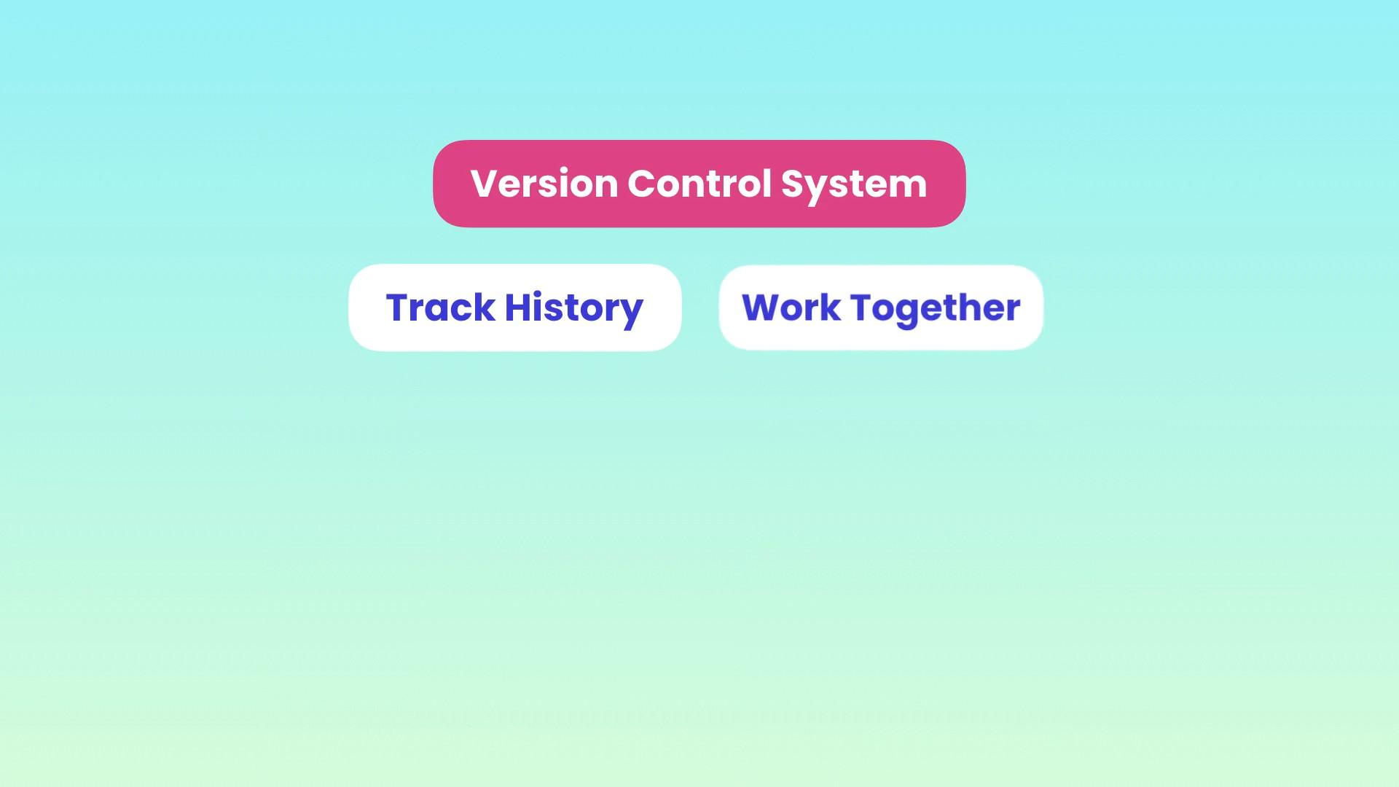
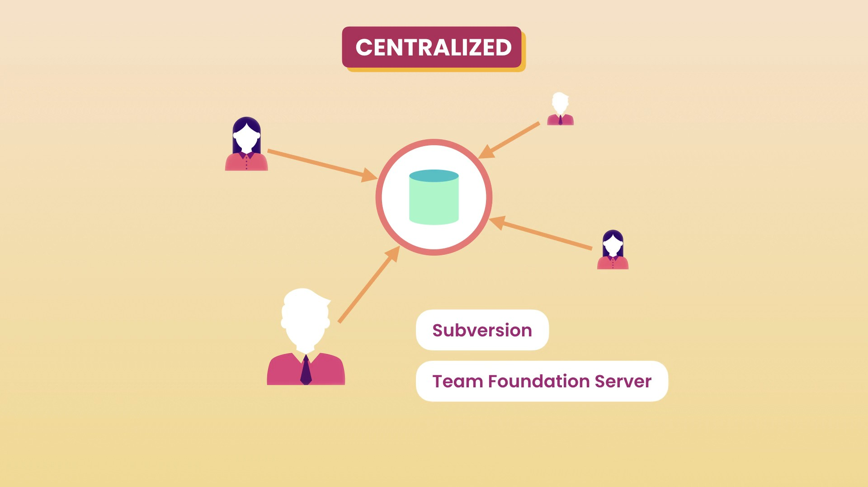
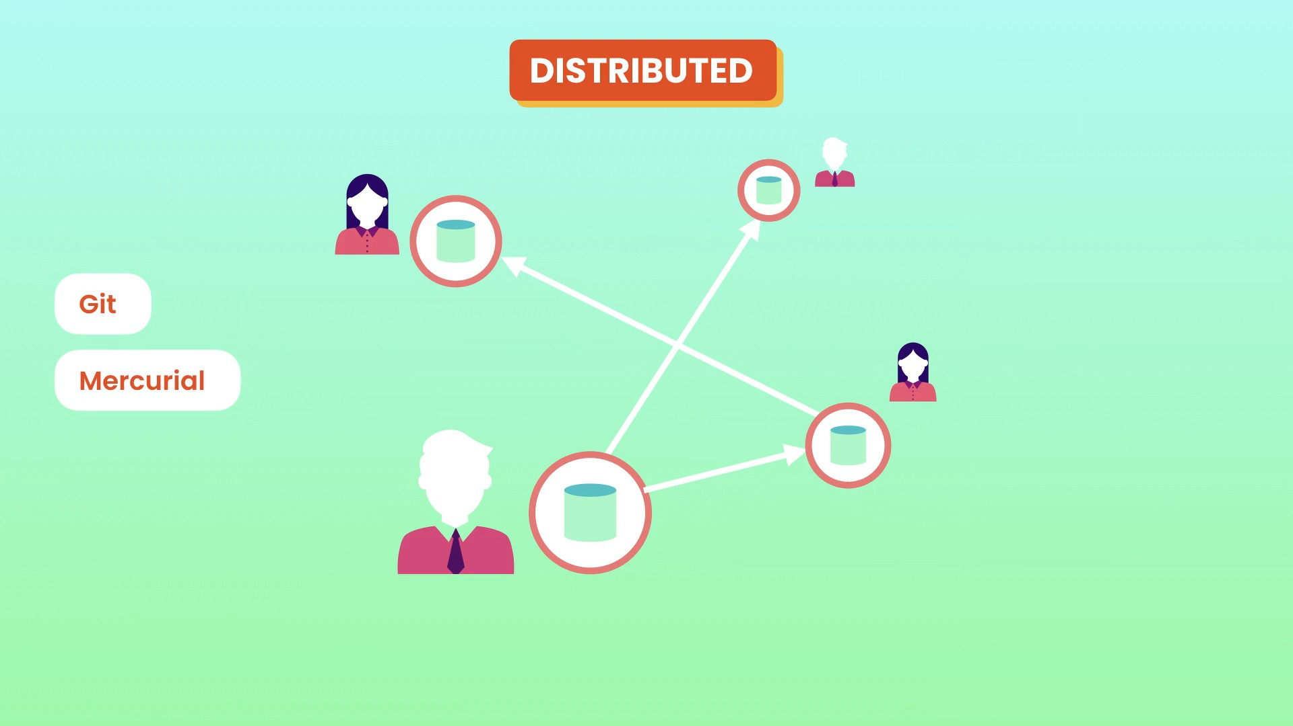
- I say Git is kind of hybrid model means central + distributed.
- `git --version`
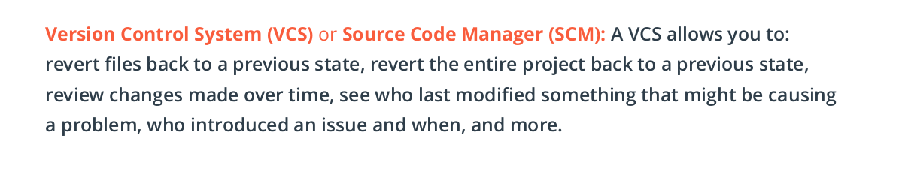
SETUP and SETTINGS
- `git config --global user.name jugshaurya`
- `git config --global user.email shauryasinghal84@gmail.com`
- `git config --global user.editor “code –wait”`
- see all the setting changes `git config --global -e`
- **Handling end of lines is important.Beacuse some user used windows machine and have both cr and lf characters @ the end of line in the code, whereas linux and macOs just have lf.
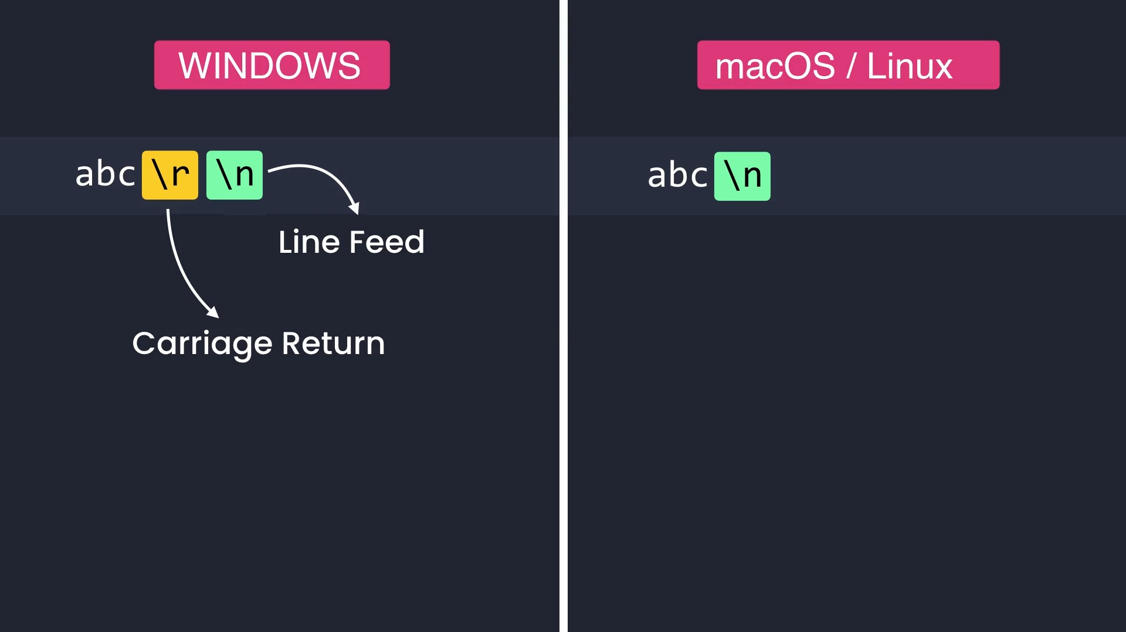
- Using autocrlf we can resolve these .
- Window users must set it to true.
- Linux/Macos user should set it to input.
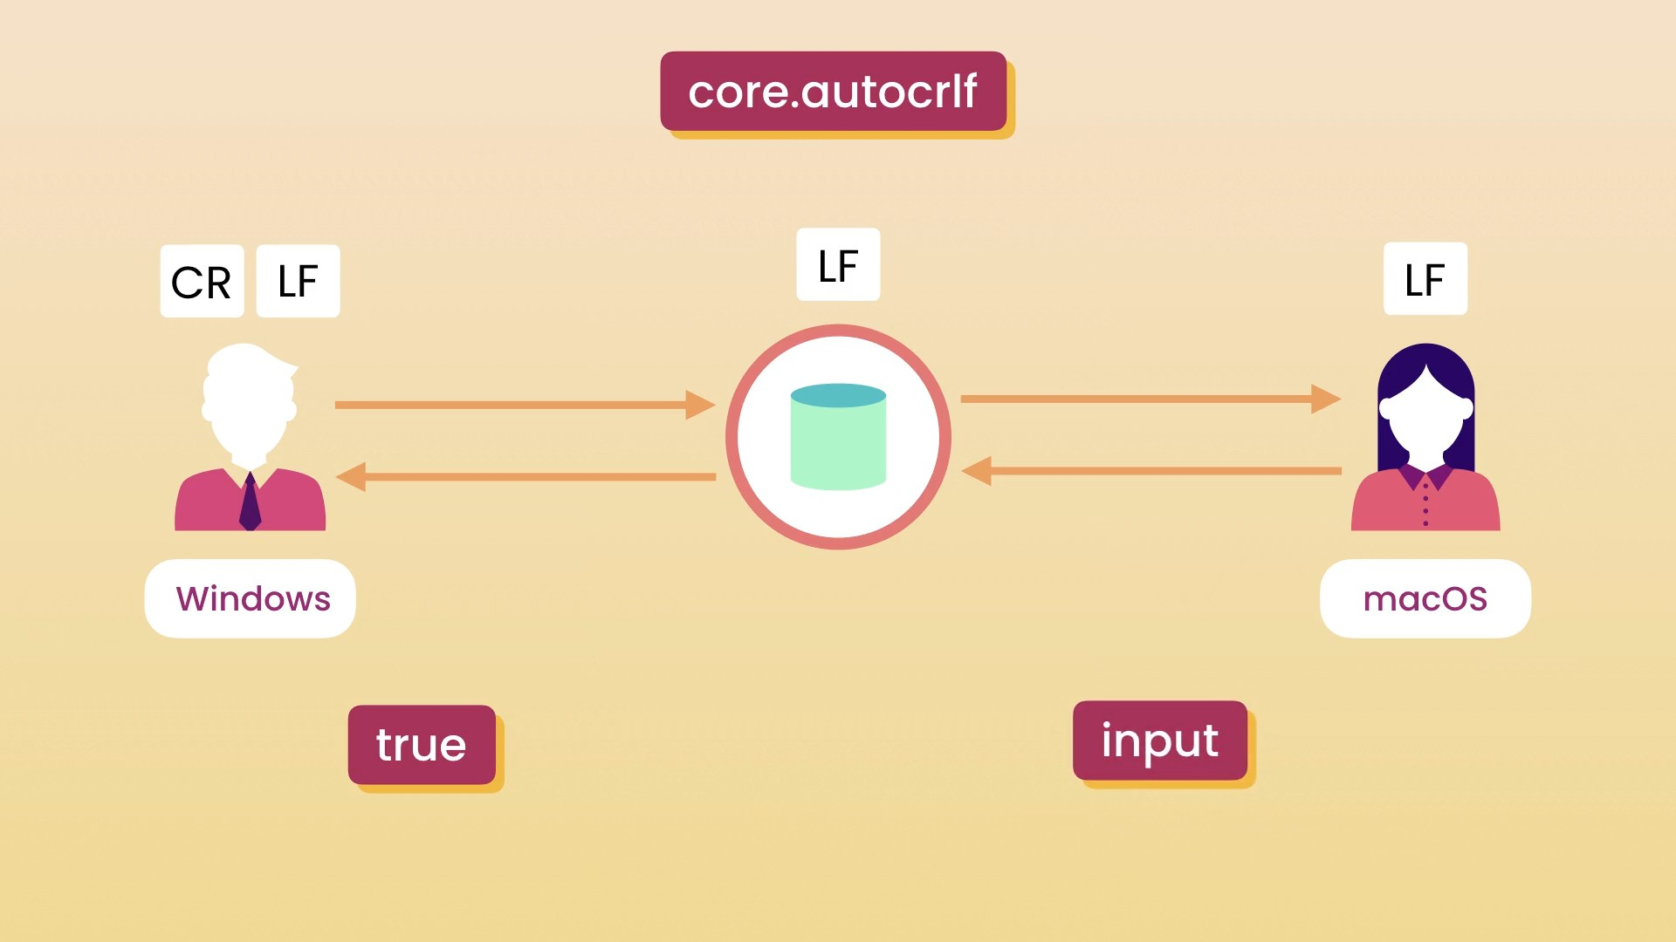
- `git config --global core.autocrlf input`. I am using linux.
- Note: when you commit changes to local repo, Staging area doesn’t get cleared.
- Note: git doesn’t store the diffs(deltas) but for every commit it stores the full snapshot of all the files. That is why you can see the set of files at a particular commit using Github via Browser files(on the given commit) button.

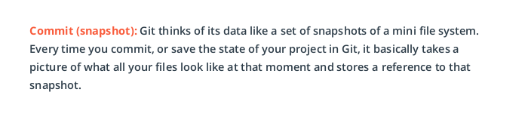
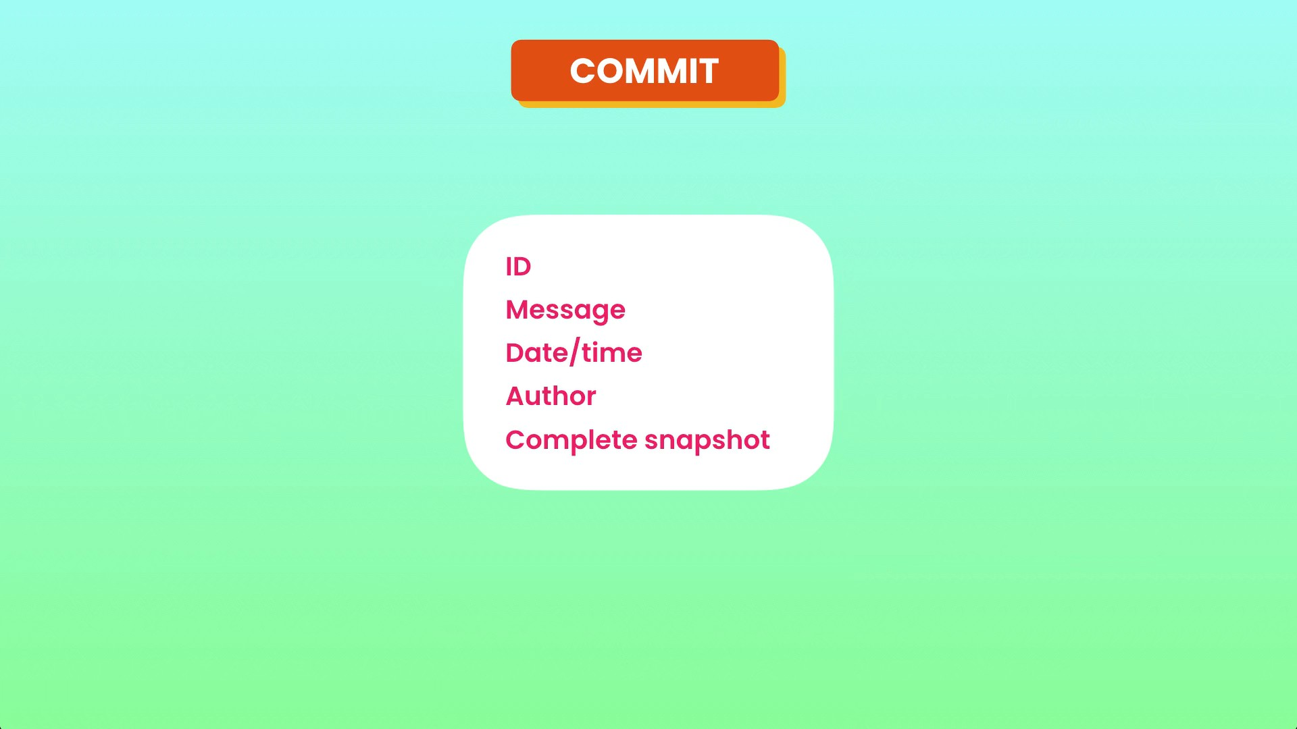

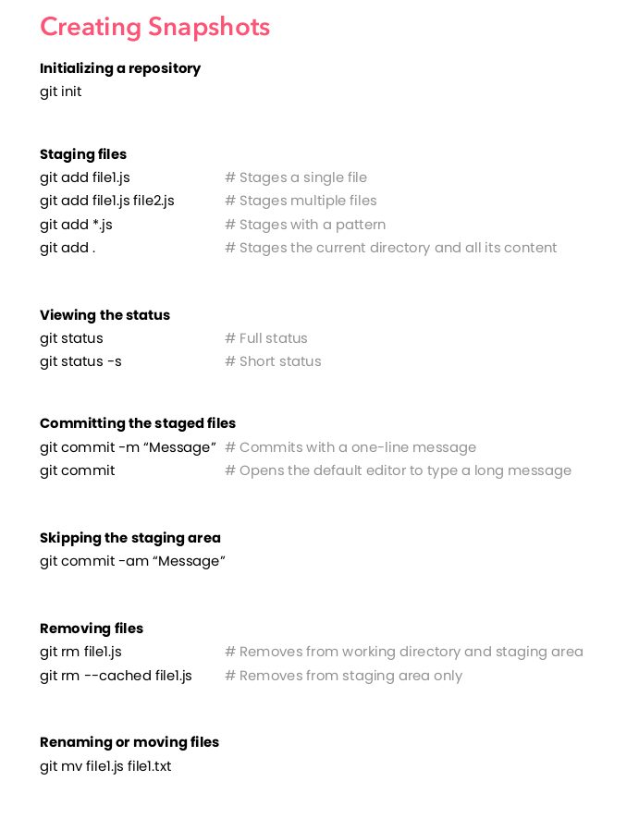
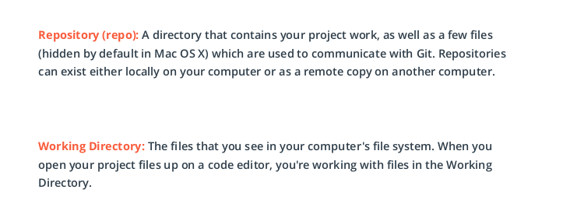

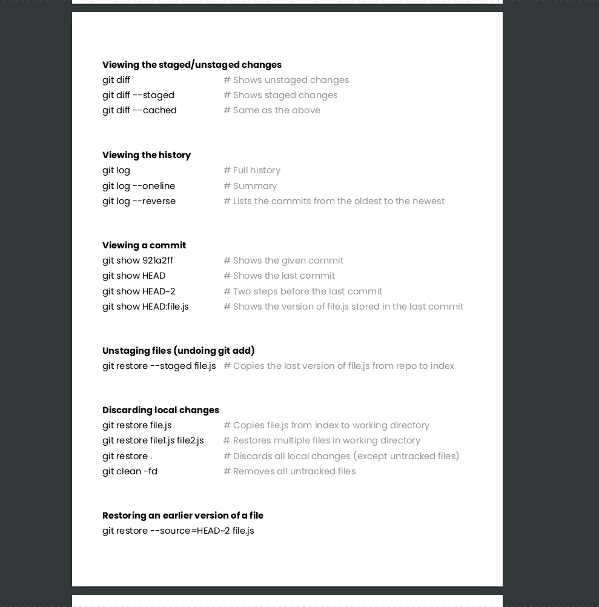
to working tree

Restoring a particulat file in a particular commit let say HEAD~2.
`$ git restore --source=HEAD~2 file_name.ext`
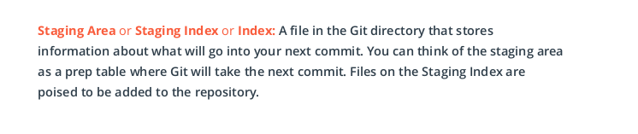
Explaining `git status -s`

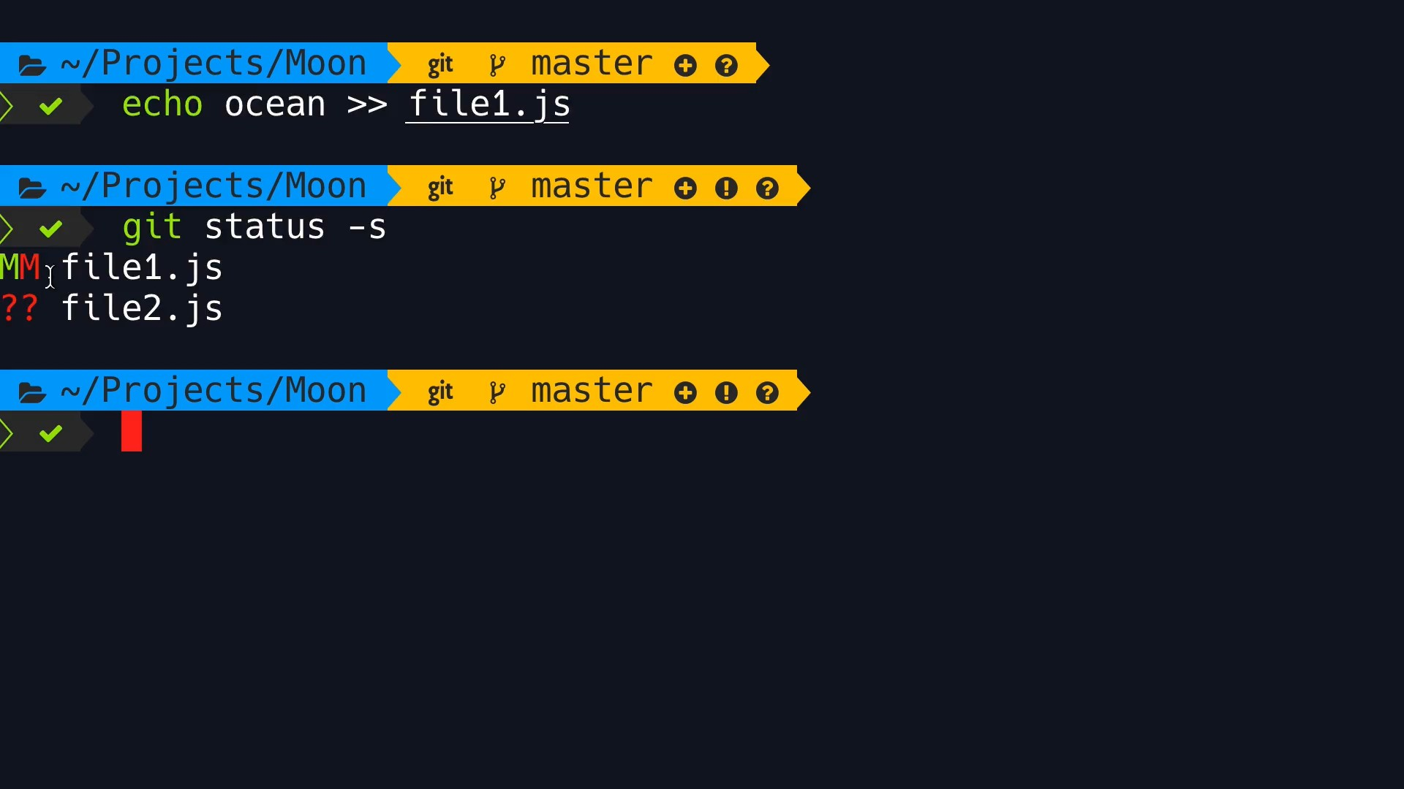
Staging area status
Working directory status

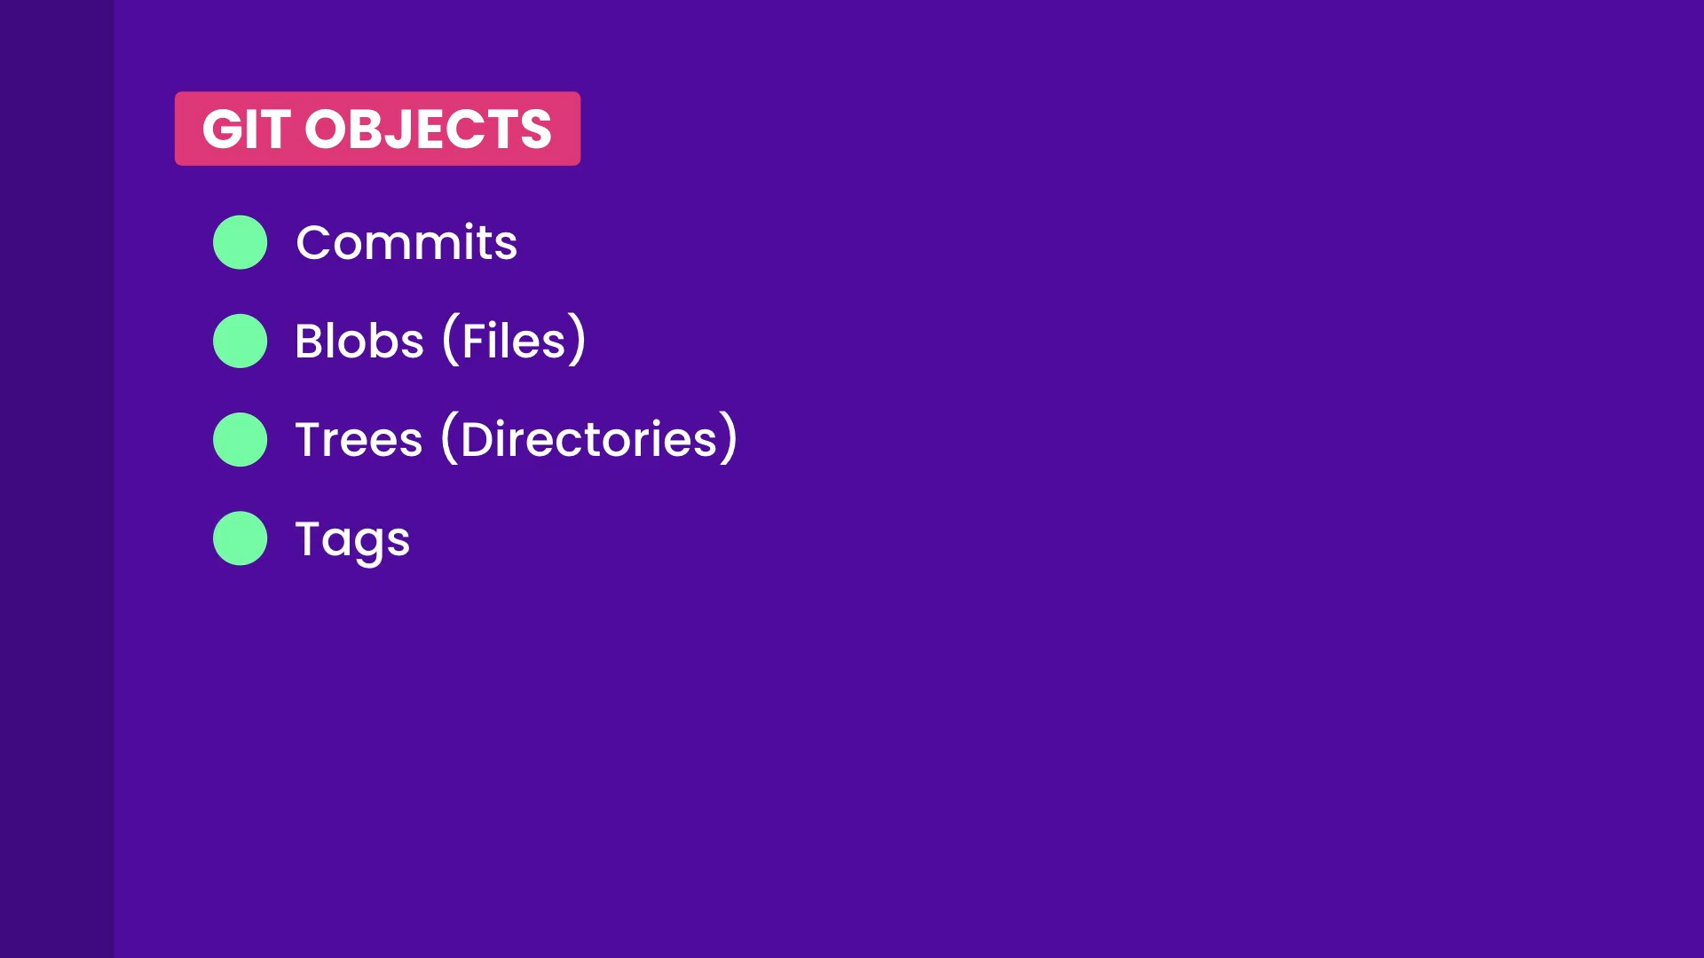
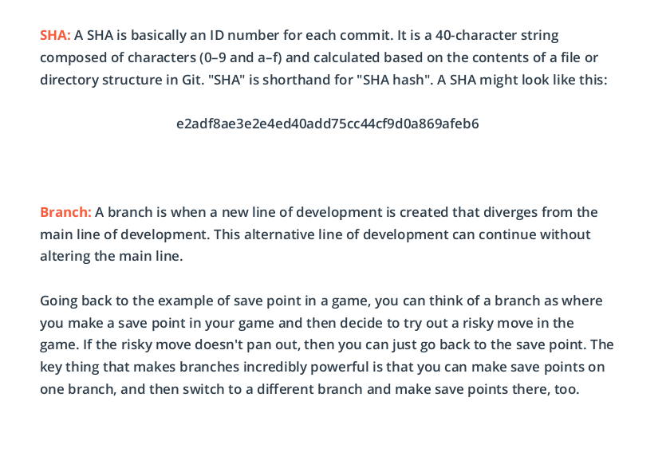
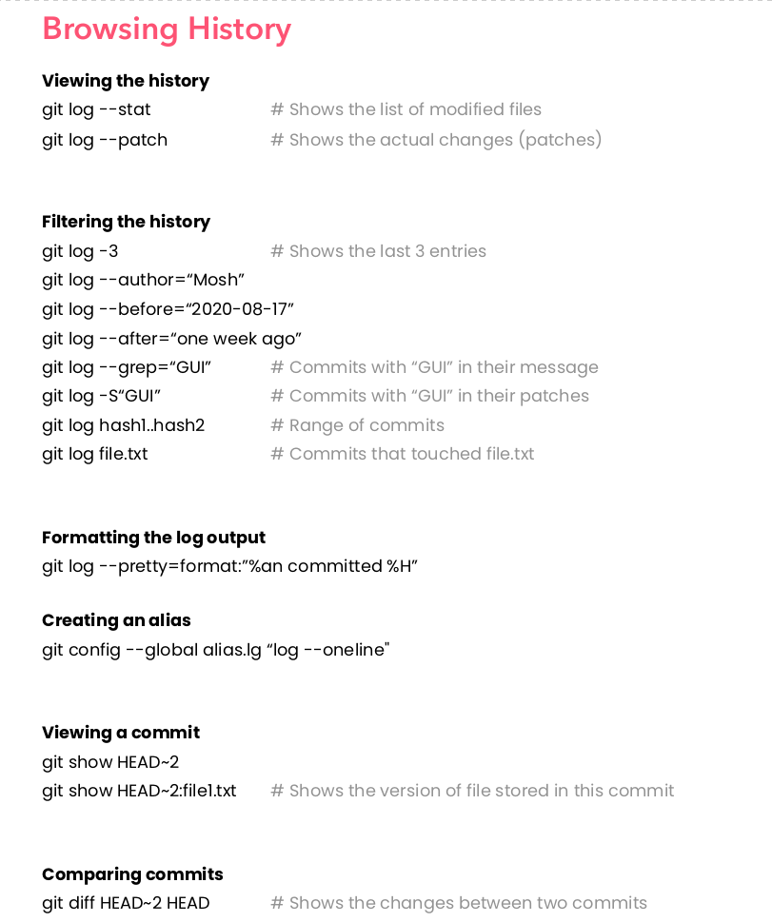

Tagging

The command we'll be using to interact with the repository's tags is the git tag command:
`git tag -a v1.0`
- This flag tells Git to create an annotated flag. If you don't provide the flag (i.e. git tag v1.0) then it'll create what's called a lightweight tag.
Annotated tags are recommended because they include a lot of extra information such as:
- - the person who made the tag
- - the date the tag was made
- - a message for the tag
- - Because of this, you should always use annotated tags.

Deleting A Tag
What if you accidentally misspelled something in the tag's message, or mistyped the actual tag name (v0.1 instead of v1.0). How could you fix this? The easiest way is just to delete the tag and make a new one.
A Git tag can be deleted with the -d flag (for delete!) and the name of the tag:
`$ git tag -d v1.0`

git checkout
It is used to move/detach head pointer to whereever we want(to prev commit, new branch, some other branch ...)
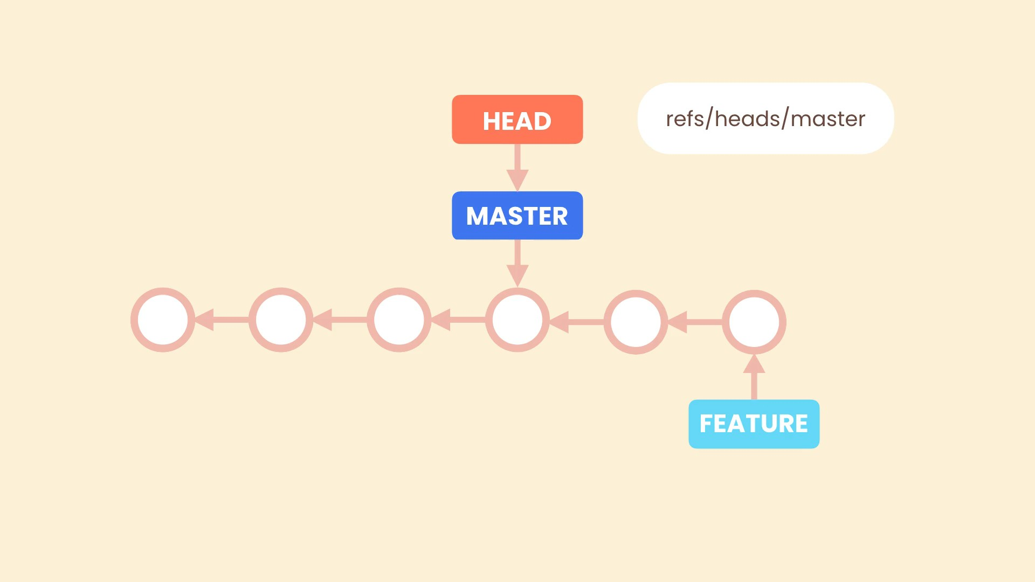

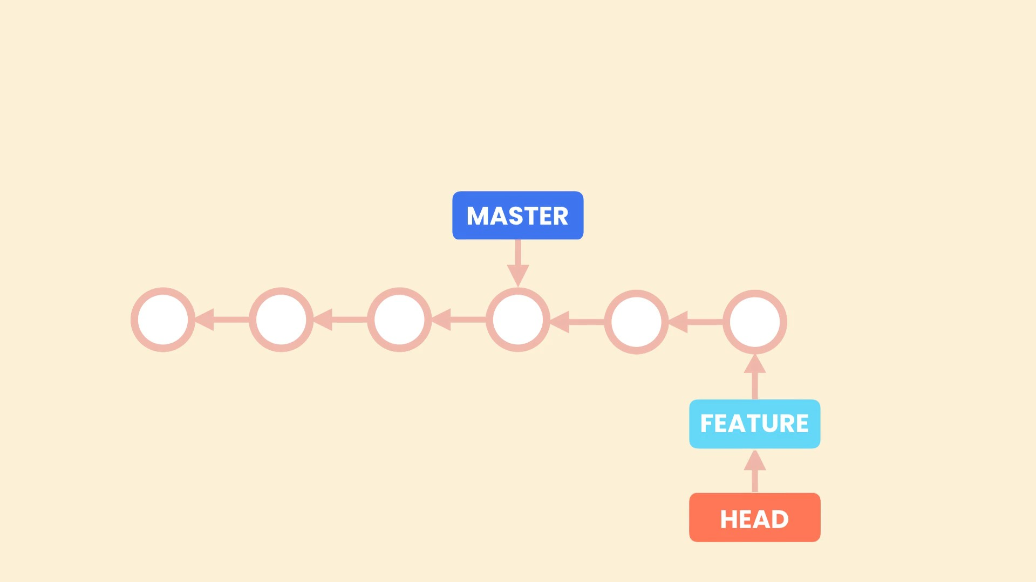
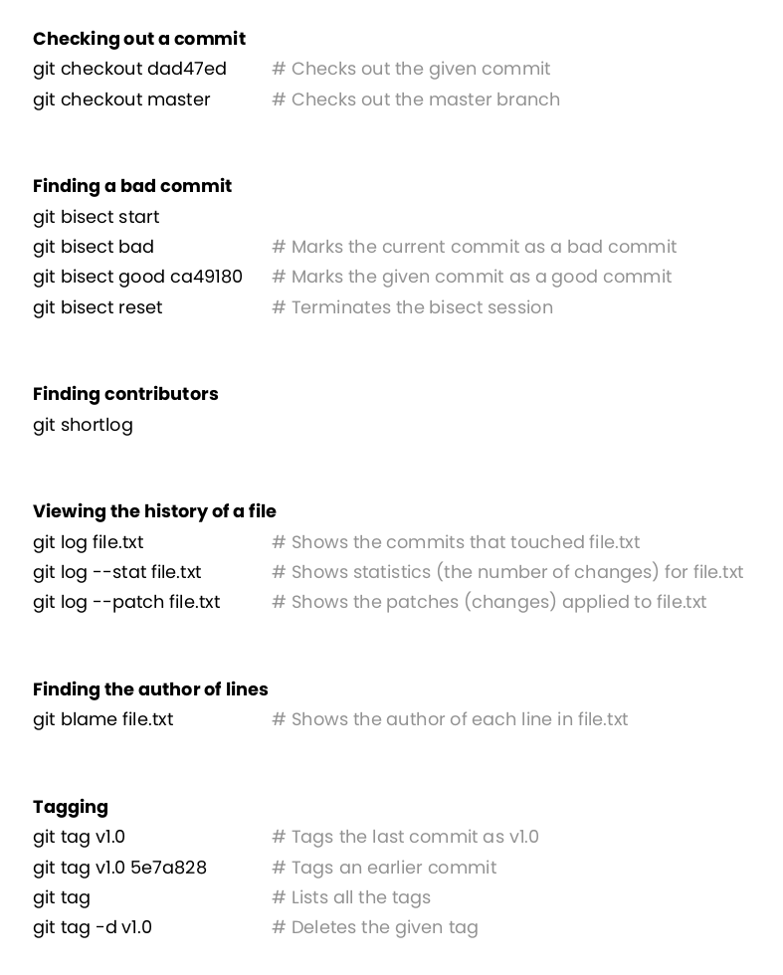

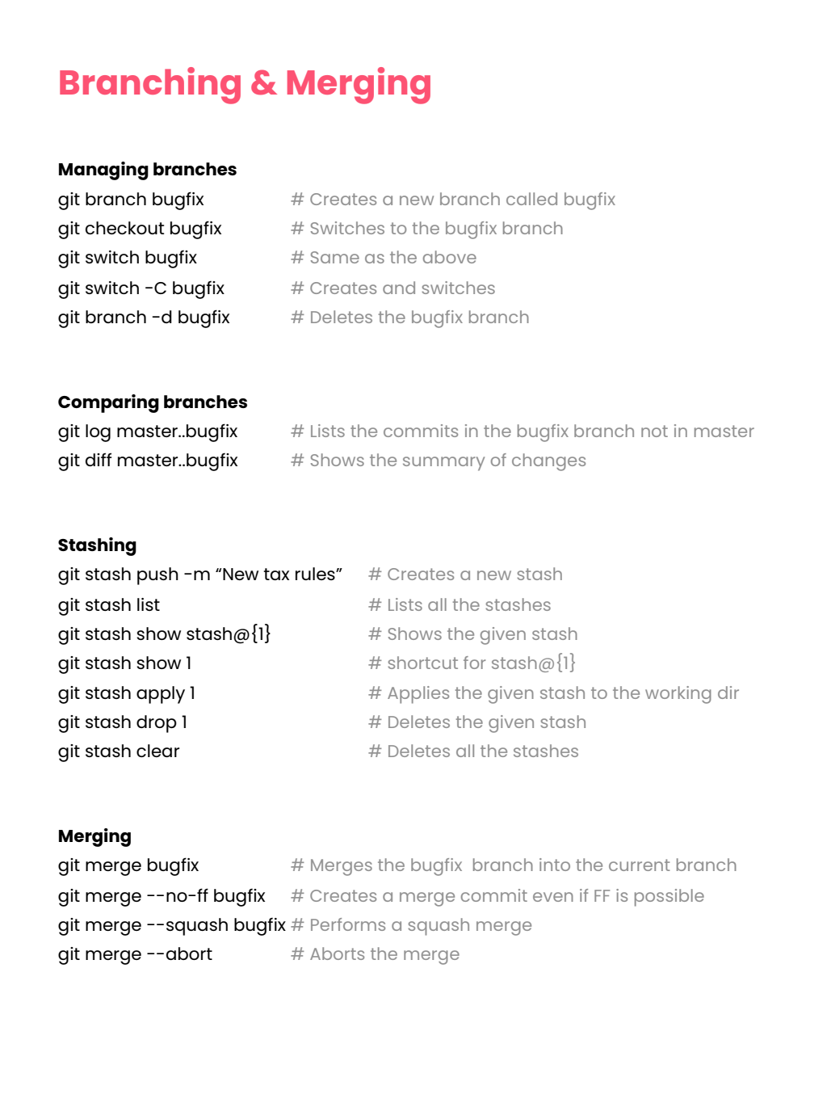
Branching + Stashing + Merging + Cherrypicking
git checkout -b bugfix # create and switches.
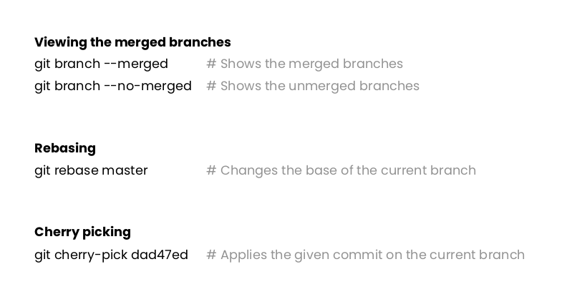
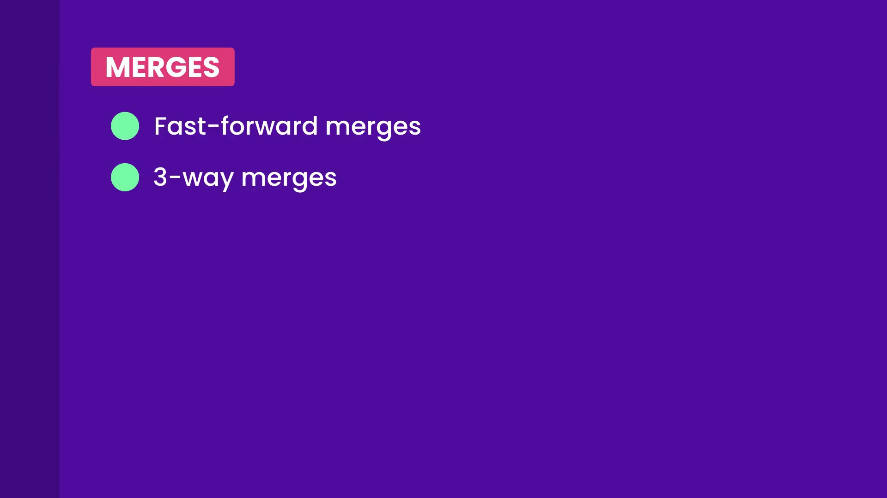
Fast Forward Merge:
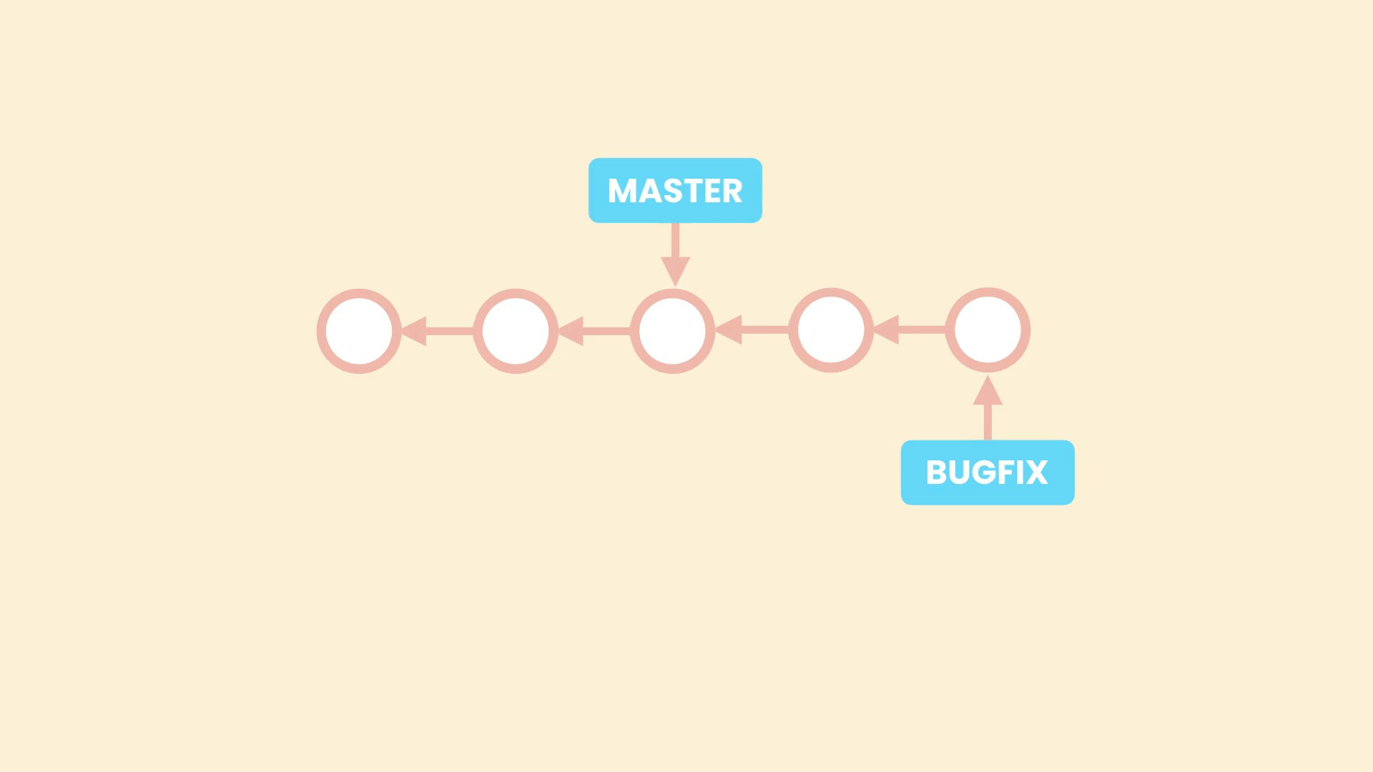
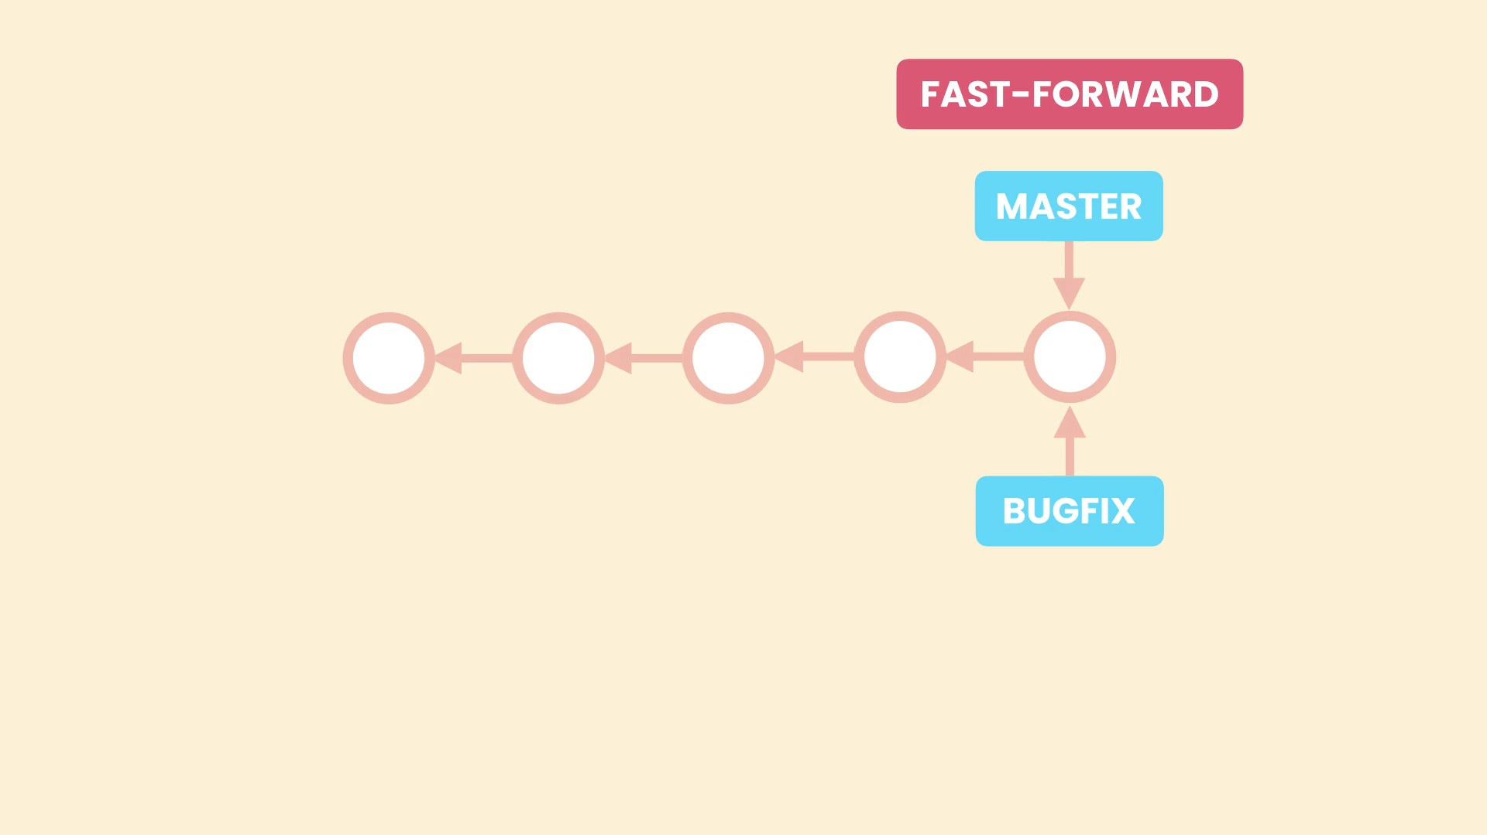
FF-merge: If the two branches hasve not diverged and there is a linear path from target branch to source branch

3-way merge

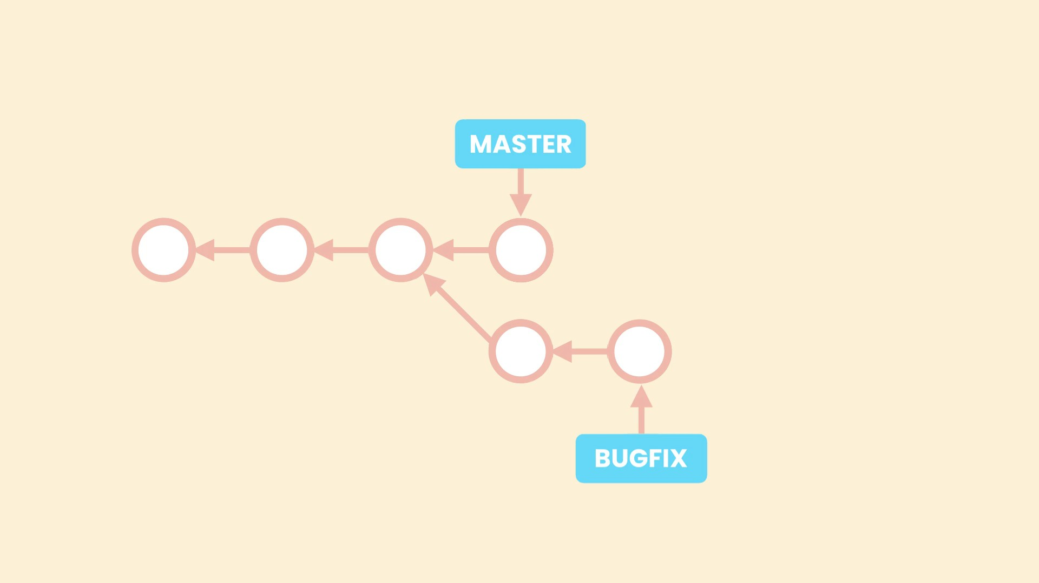
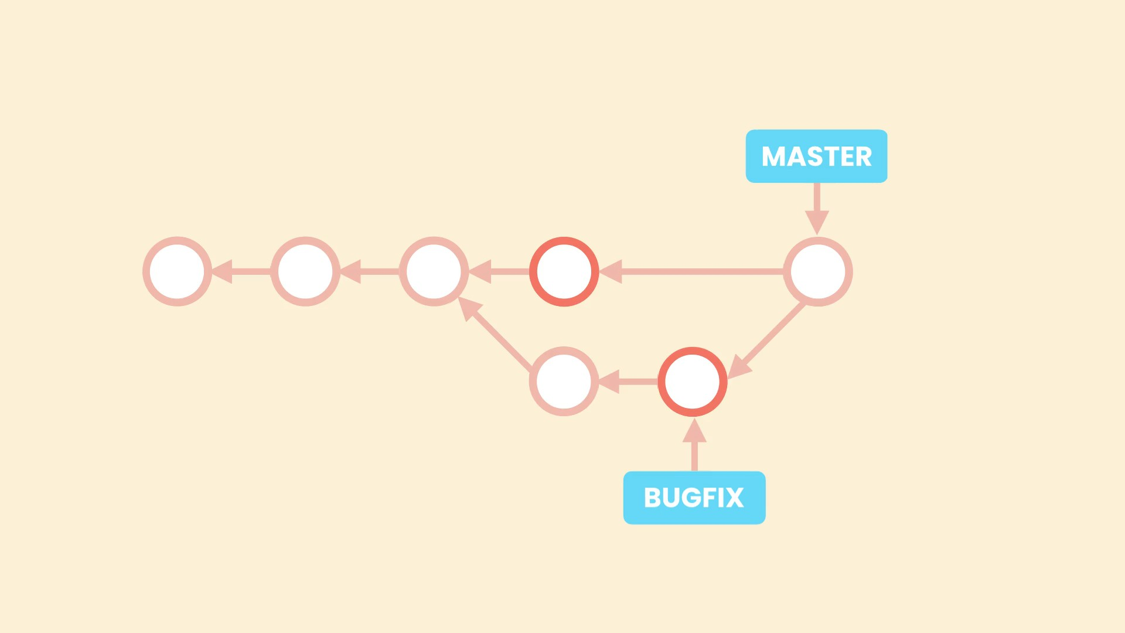
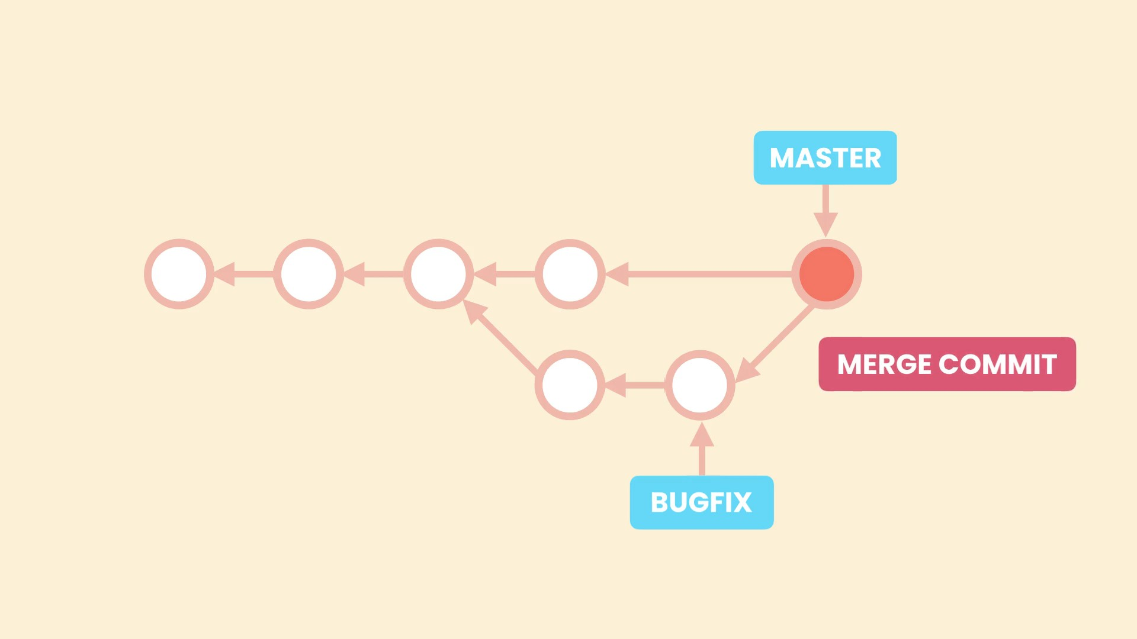
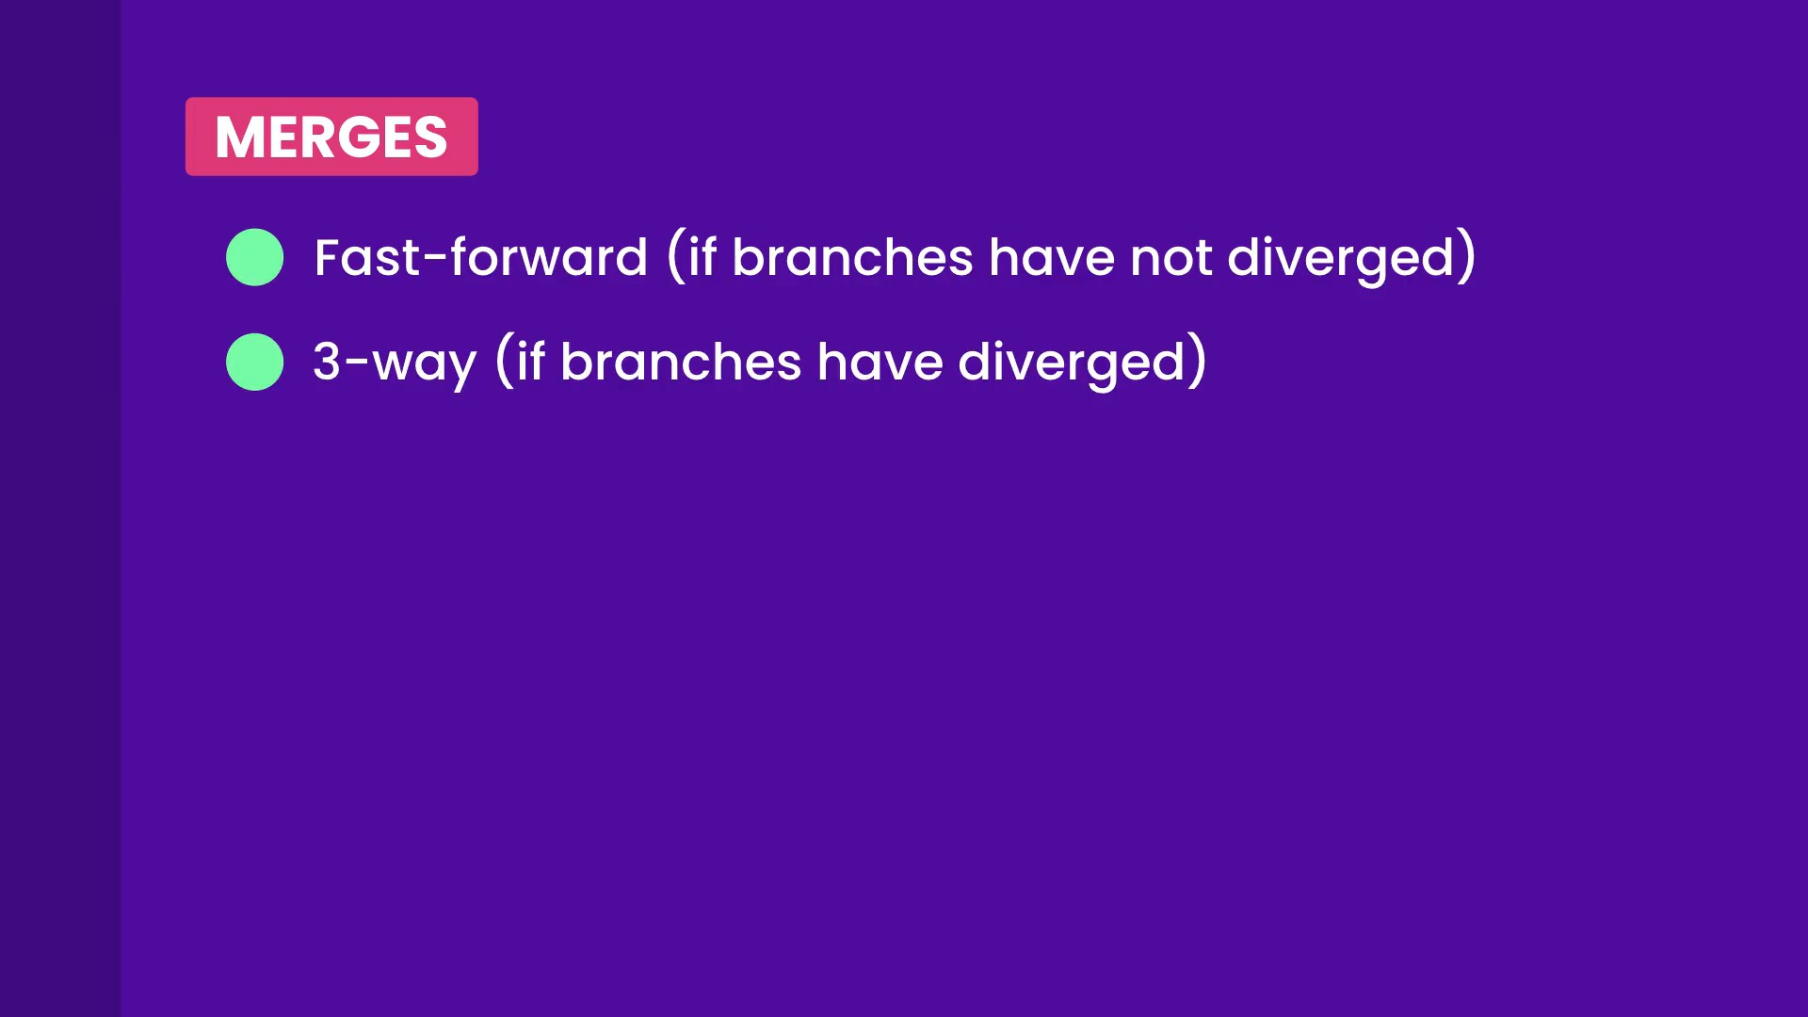
IMP: Fast forward merge don’t get an extra merge commit, but 3 way merge does.

Pros and cons of `3-way merge` over `ff-merge`:

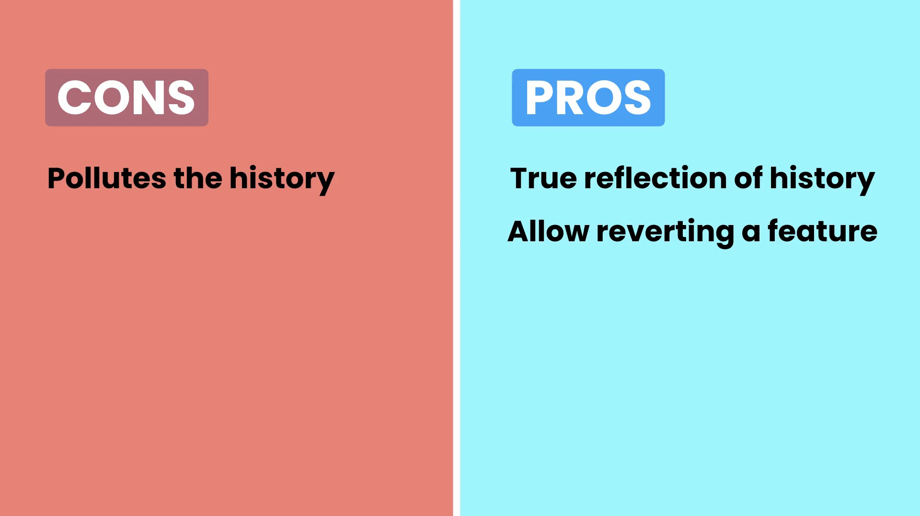
we can use –no-ff flag to disable ffmerges. And can set it in configuration as well.

