STELLA POLARIS NETWORK
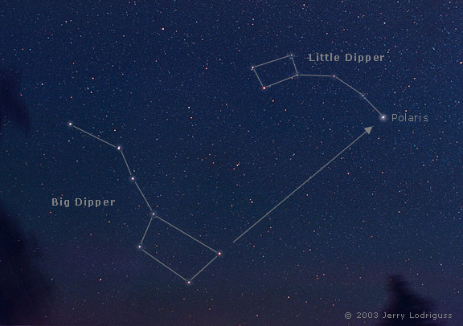
STELLA POLARIS IS A STAR
North Star is the prominent star that lies closest in the sky to the north celestial pole, and which appears (approximately) directly overhead to an observer at the Earth's North Pole. It is consequently known as Polaris (from Latin stella polaris "pole star").
ALSO, STELLA POLARIS WAS A COVER OPERATION
Operation Stella Polaris was the cover name for activity in which Finnish signals intelligence records, equipment and personnel were transported into Sweden after the ending of the Continuation War in 1944 so that the signals intelligence activities could continue in Sweden and the equipment would not end up in the hands of the Soviet Union. The threat of Soviet occupation was considered too likely and an operation was formed to support guerrilla warfare in Finland after occupation.
Background: Tor network currently
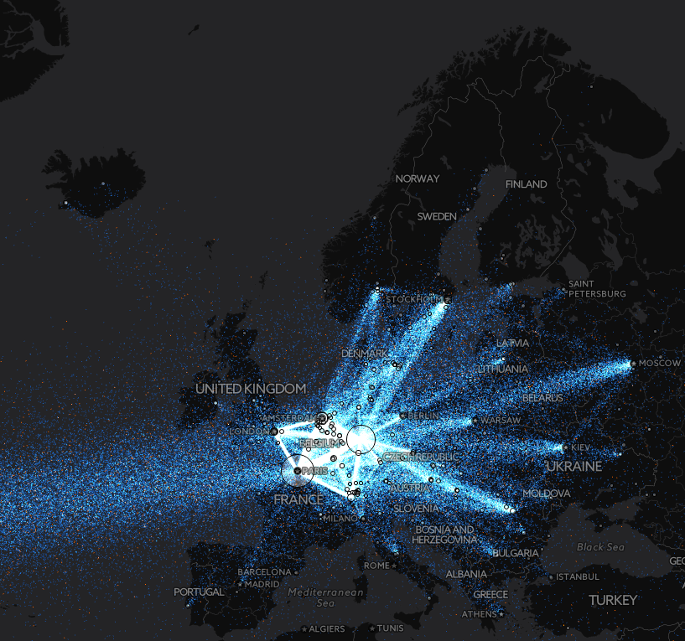
- Global resilient p2p network
- Not many relays in Finland
- No current test cases or plans to survive netsplit situations
- Tor has default hard-coded directory authorities
- These dirauth servers are the weakest centralized links of the network
Private sub Tor network – Fall-back network for disasters
- A part of the Tor network that can operate independently
- For instance, state wide private Tor
- Any Tor relay can be used as a fallbackdir
- Test case: 10-20 relays in Finland that are part of the 'main' Tor network; falling back to using them in the country during disaster
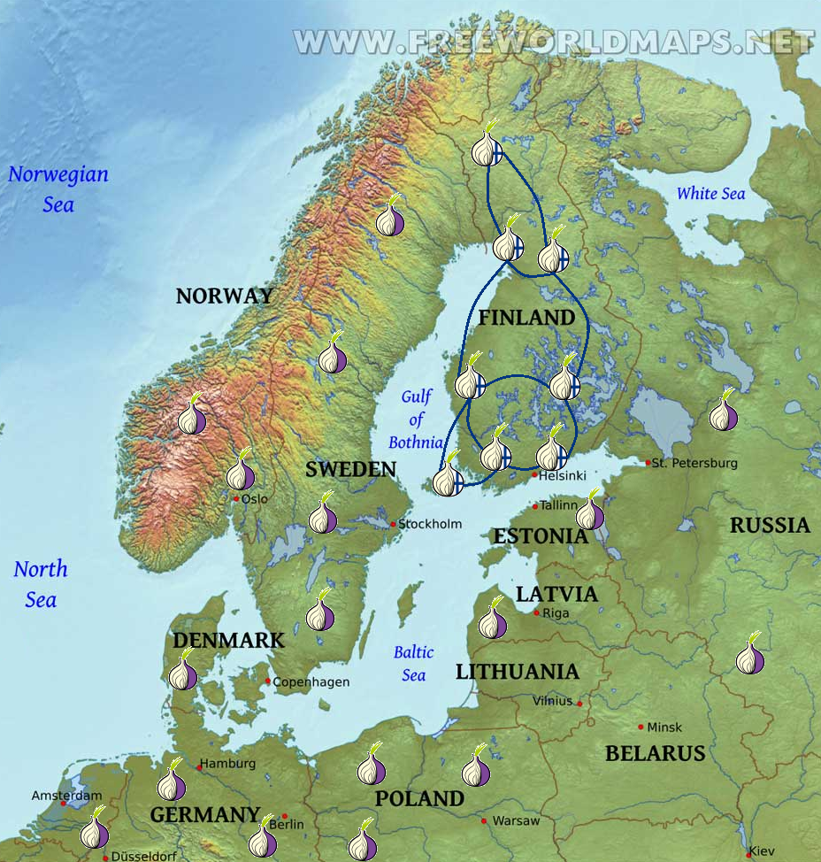
Tor settings
FallbackDir address:port orport=port id=fingerprint [weight=num] [ipv6=address:orport]
When we’re unable to connect to any directory cache for directory info (usually because we don’t know about any yet) we try a directory authority. Clients also simultaneously try a FallbackDir, to avoid hangs on client startup if a directory authority is down. Clients retry FallbackDirs more often than directory authorities, to reduce the load on the directory authorities. By default, the directory authorities are also FallbackDirs. Specifying a FallbackDir replaces Tor’s default hard-coded FallbackDirs (if any). (See the DirAuthority entry for an explanation of each flag.)

UseDefaultFallbackDirs 0|1
Use Tor’s default hard-coded FallbackDirs (if any). (When a FallbackDir line is present, it replaces the hard-coded FallbackDirs, regardless of the value of UseDefaultFallbackDirs.) (Default: 1)

Magnetic Storm Experiment: Northern Lights

- Disaster simulation experiment: Netsplit cuts Finland out the net
- As a result, Tor network should work independently
- Finnish Tor clients can use Finnish fall-back directory authorities
- Safe&Easy test: a set of Tor clients can only access Finnish IP addresses and have a new hard-coded list of Finnish dirAuthories
- Hard test: both clients and relays stop all communication outside Finland and use Finnish fall-back directory authorities

Consider
- This test network is actual a part of the real Tor network
- Keep Tor Project up-to-date about tests, ethics and privacy
- We cannot just randomly test everything
- Roger: it would not be nice to "practice" a nuclear war
- Ask dgoulet for his docs on setting up a Tor network
- Ask stuff from Sebastian, he has his own private Tor network
- New feature: exit policies could specify a country (FI)
- Even directory authorities could operate as onion services

