### **In this final lab, you are required to add your code in the given files: index.html, style.css, and javascript.js. Follow the requirements listed in each section: HTML, CSS, and JavaScript in order to add your code in their corresponding files.**

/20

### **As a result, you are going to create one page of ‘PUZZLE GAME'. It is a game that gives the player a number of chances to sort all puzzle pieces to win the game, otherwise will lose. Each player has a total of ten “SWITCH” actions to win.**

### **Before Start:**

* Download all the existing files HTML, CSS, and JavaScript.
* **Open all these files and read the code in general carefully before start reading the questions.**
* Write your name and ID in the beginning of each file, and then start modifying each file as described below in each section.

# Part 1: HTML

/5

Modify HTML file by filling each “HTMLQ#” part:

1. HTMLQ1

Add h1 element to write “FINAL LAB EXAM 2021/2022”.

Modify Table:

1. HTMLQ2

“PUZZLE” is the title of the table.

1. HTMLQ3

Modify the table structure to be as shown below.

|  |  |  |
| --- | --- | --- |
|  |  |  |
|  |  |  |
|  |  |  |

Modify Form:

1. HTMLQ4

“NEXT SWITCH” is the title of the form.

1. HTMLQ5

Add two buttons, “SWITCH” and “CLEAR”:

“SWITCH” is a submit button, and “CLEAR” is a reset button.

1. HTMLQ6

Add two text inputs. The first text input has id “F”. The second text input has id “S”.

# Part 2: CSS

/5

Modify the CSS part by filling each “CSSQ#” part: The below **wireframe** clarifies the *positioning* of the final result.

Modify HTML to link CSS file:

1. CSSQ1

link style.css file.

Modify CSS file:

1. CSSQ2  
   **<aside>**

* Add *properties* and *values* to change the positioning of the aside, as shown in the below wireframe.

1. CSSQ3  
    **<h2>**

* The color of the font is pink.
* The font is italic.

1. CSSQ4

**#result**

* The size of the font is 16pt
* The text in the center
* double border with 5px

1. CSSQ5

* Modify the **selector td** to make the action done when the mouse goes over the td.
* Set the opacity to be 0.4

1. CSSQ6

**td:active**

* Set value to the opacity to make it not transparent.

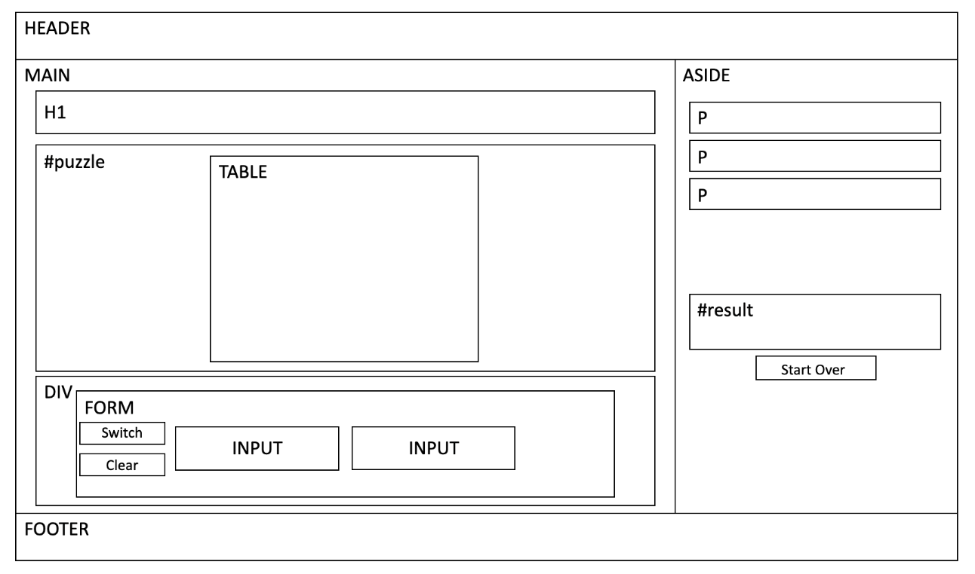

# Part 3: JavaScript

/10

Modify JavaScript part by filling each “JSQ#” part:

Modify HTML to link JS file:

1. JSQ1

link javascript.js file.

1. JSQ2

Call the function **ChooseIMG(this)** when the mouse goes down in each picture

1. JSQ3

Call function **SwitchPictures()** when clicking the button “SWITCH”.

Modify JS file:

**Function name():**

1. JSQ4

* Pop a window to ask the user to enter his/her name.
* After that, add the name in the paragraph with the id "p1".

**Function ChooseIMG(this):**

This function is called when the mouse goes down to choose an IMG. The function is adding the id information of the first choosing IMG in the first text input. Moreover, adding the id of the second choosing IMG in the second text input.

To switch the Chosen IMGs in SwitchPictures() function: The first choosing IMG saved in the global variable cell1 and The second choosing IMG saved in the global variable cell2.

1. JSQ5: save the id value of the image in the X variable.
2. JSQ6: save the X value in the first text input.
3. JSQ7: save the X value in the second text input.

**Function SwitchPictures():**

This function is called when the user clicks on the Switch button. The function is switching the two selected images mentioned already in the text inputs. It uses the global variables *cell1* and *cell2* to change the values of src and id of these images.

1. JSQ8: Switch the images information (src and id) by what is saved in the first and second text inputs.  
    Hint: Use the global variable cell1 and cell2.

**Function EvaluteResult(Chances):**

This function is called from SwitchPictures() function to check if the user wins or fails or is still in progress. It received the ‘Chances’ variable that contains the number of the remaining chances. The function counts how many images are in the correct places through a loop to decide the situation. We have two situations:

* If the variable ‘count’ equals 9, then the user wins.
* If the number of chances is zero and the ‘count’ is less than 9, then the user fails

1. JSQ9: When the user wins, do the following to the DIV with the id "result"

* Write the word "WIN" in the div.
* Change the div color to blue.
* Make div visible.

1. JSQ10: When user fails, do the following in the DIV with the id "result"

* write the word "Fail" in the div.
* Change the div color to Red.
* Make div visible

Part 4: Handing your Final Lab Solution

When you finish, make sure to:

1. Create a folder on your **Desktop** called “**S#_Name_IT312_Final_Lab**”
2. Put all modified files HTML, CSS, and JS files into this folder.
3. Compress the folder.
4. Open your **LMS** account, then **upload** the folder.

Output print screens:

When the page is Opened:

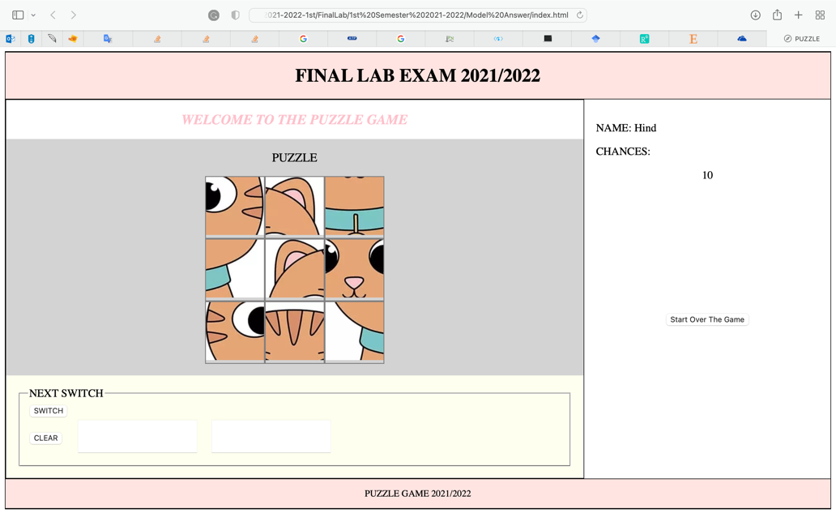

During Switching the images:

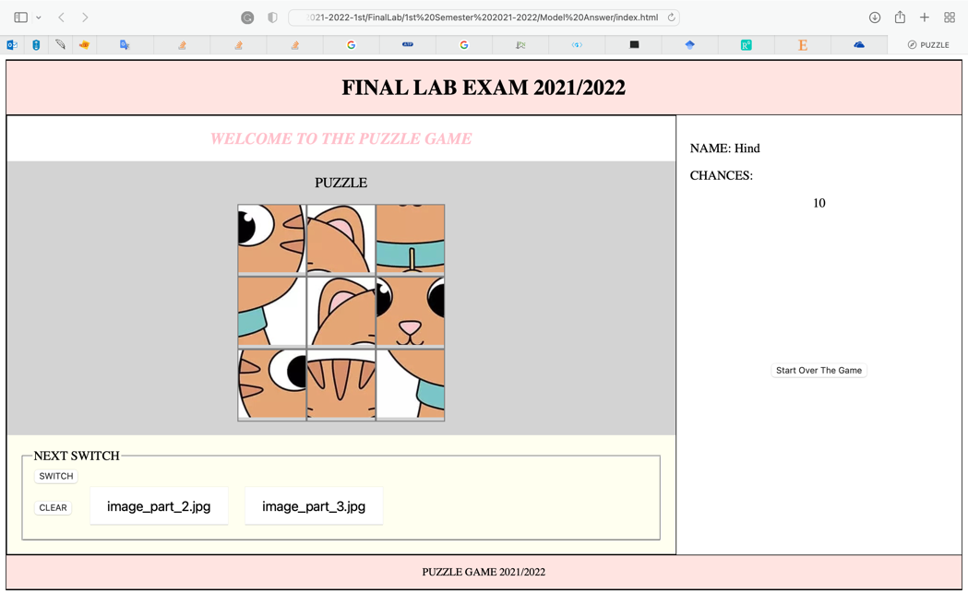

When the user WINS:

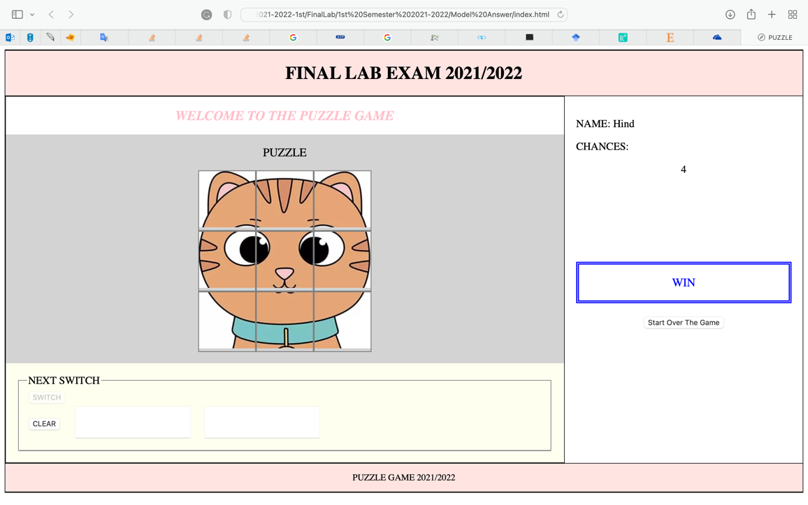

When the user FAILS:

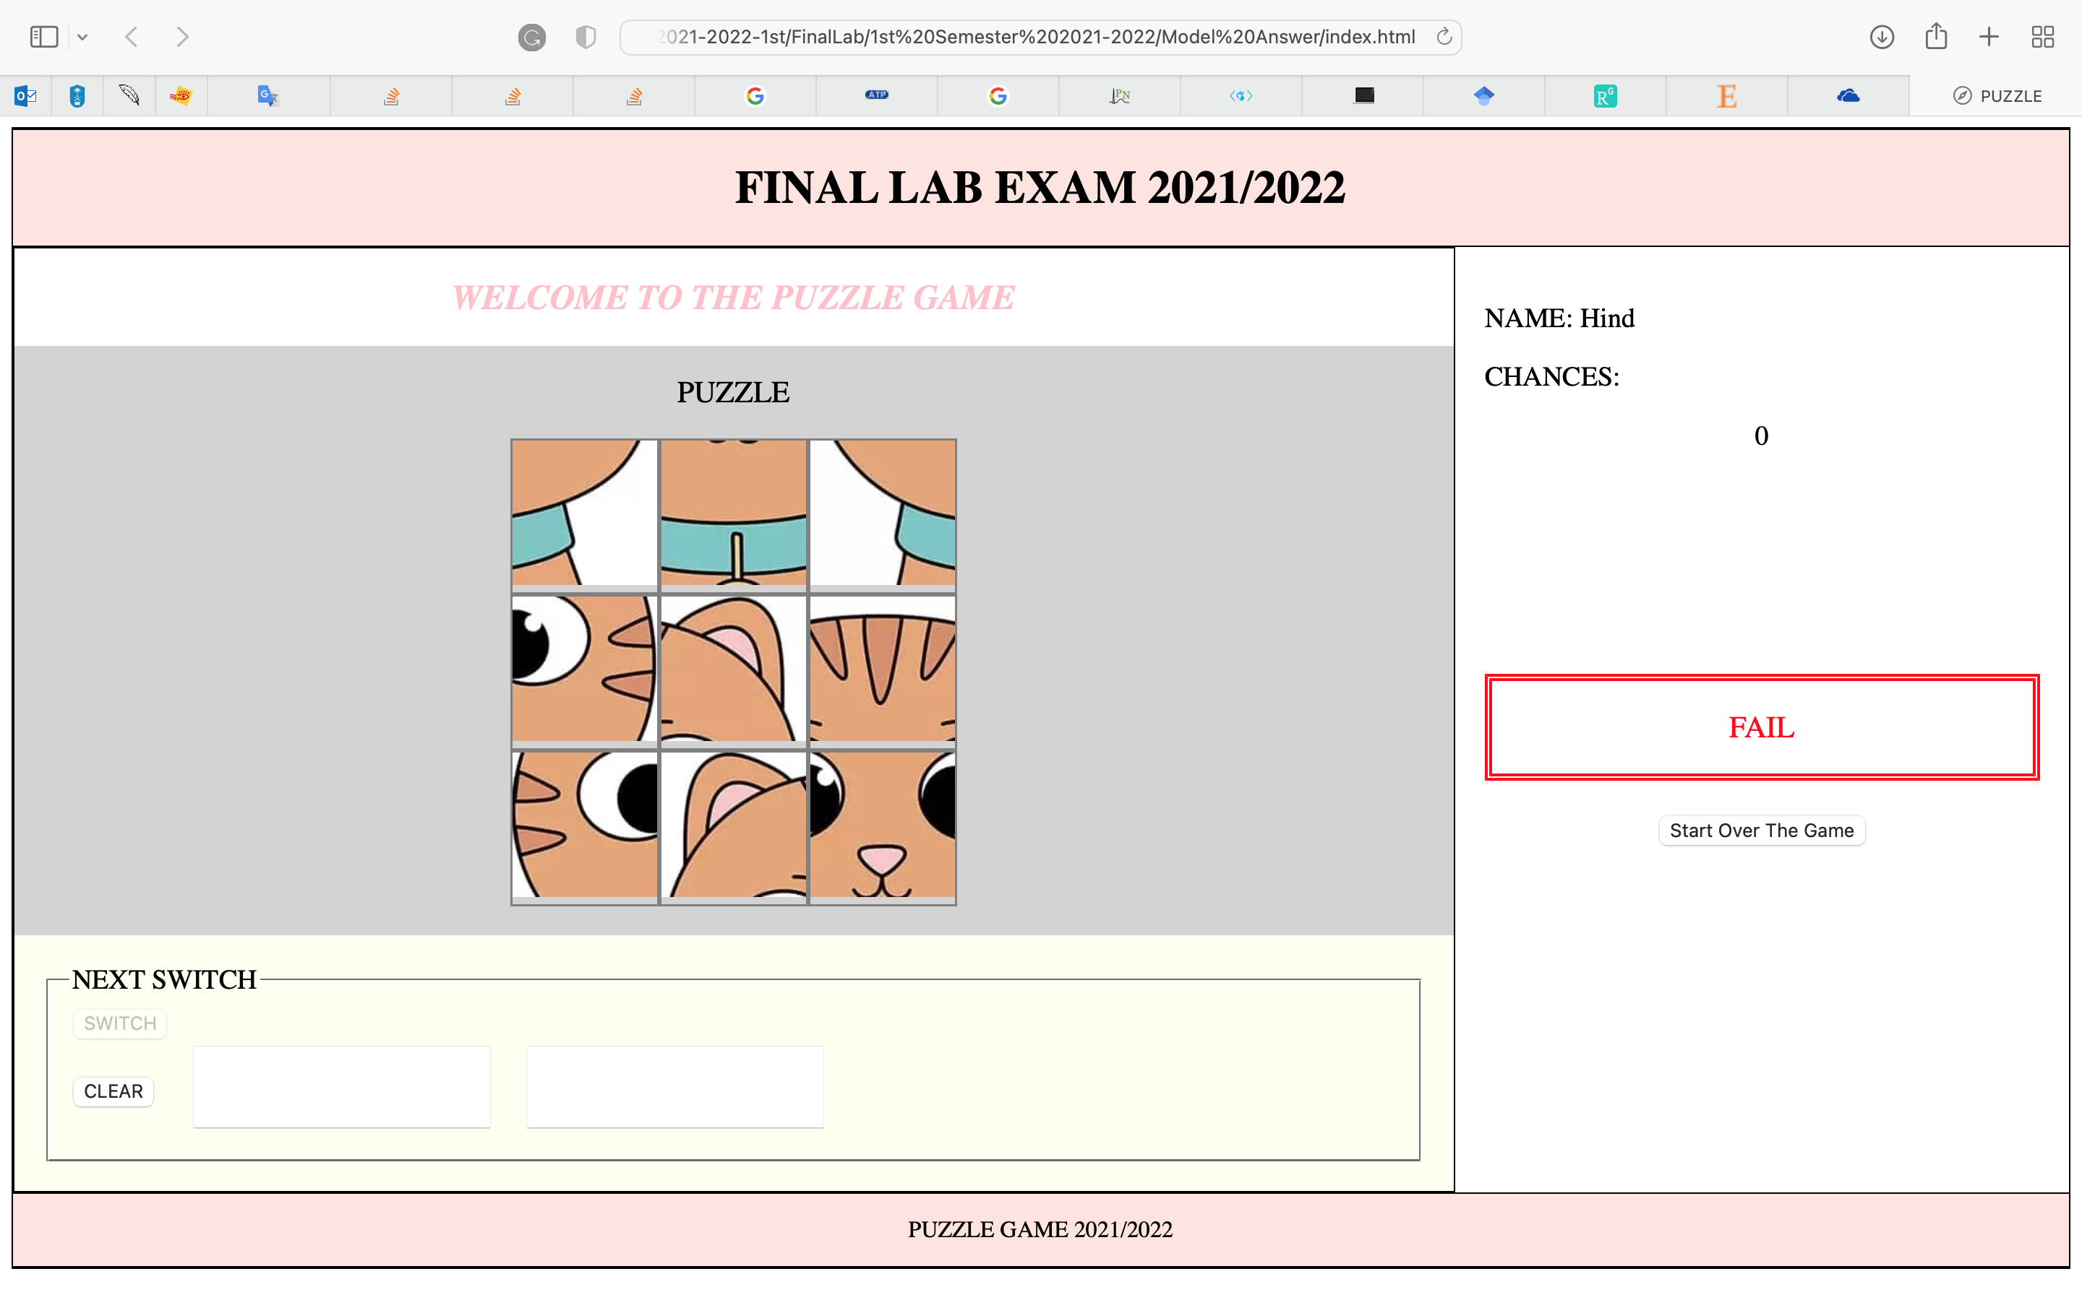

**Good Luck..**