Figure 3.1 WELCOME SCREEN

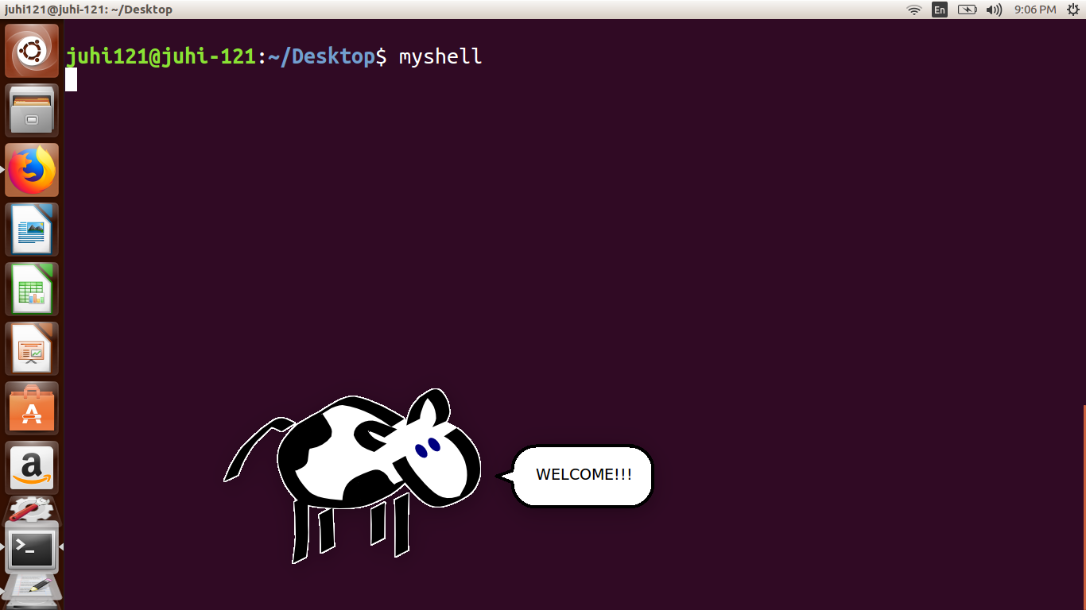

Figure 3.2 HELP COMMAND LISTING ALL THE SUPPORTED COMMANDS

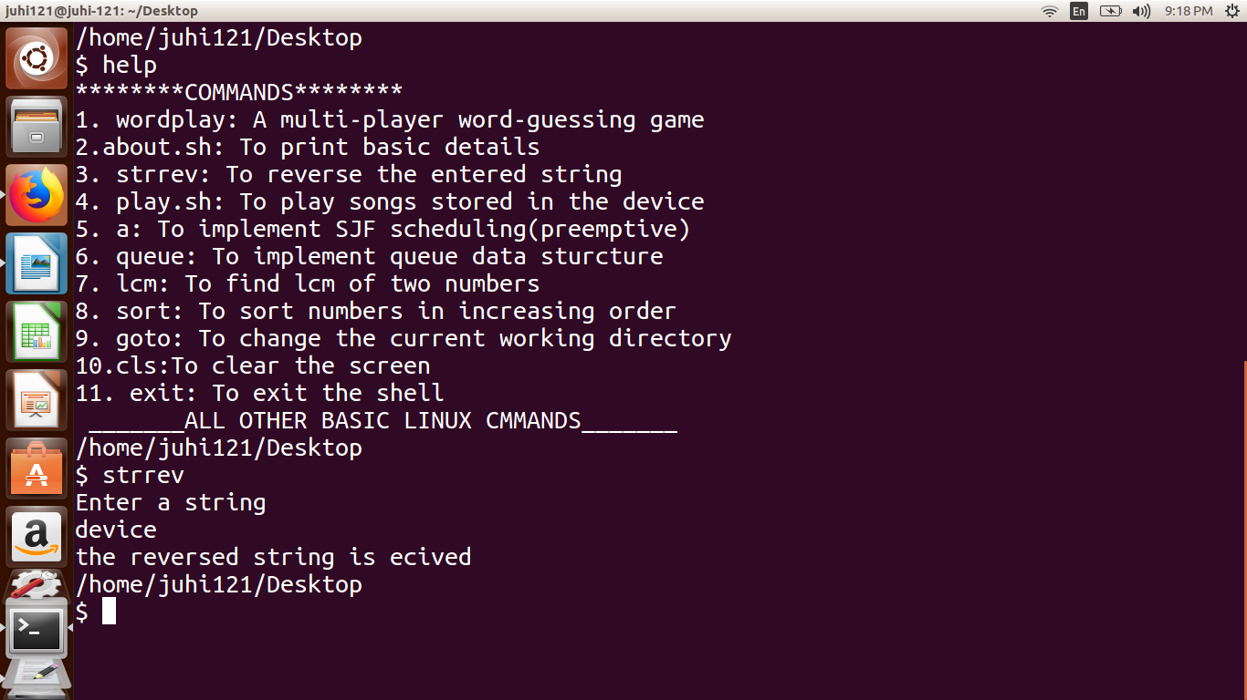

Figure 3.3 ELABORATED LIST OF FILE AND DIRECTORIES DEPICTING THE CONCEPT OF PARSING

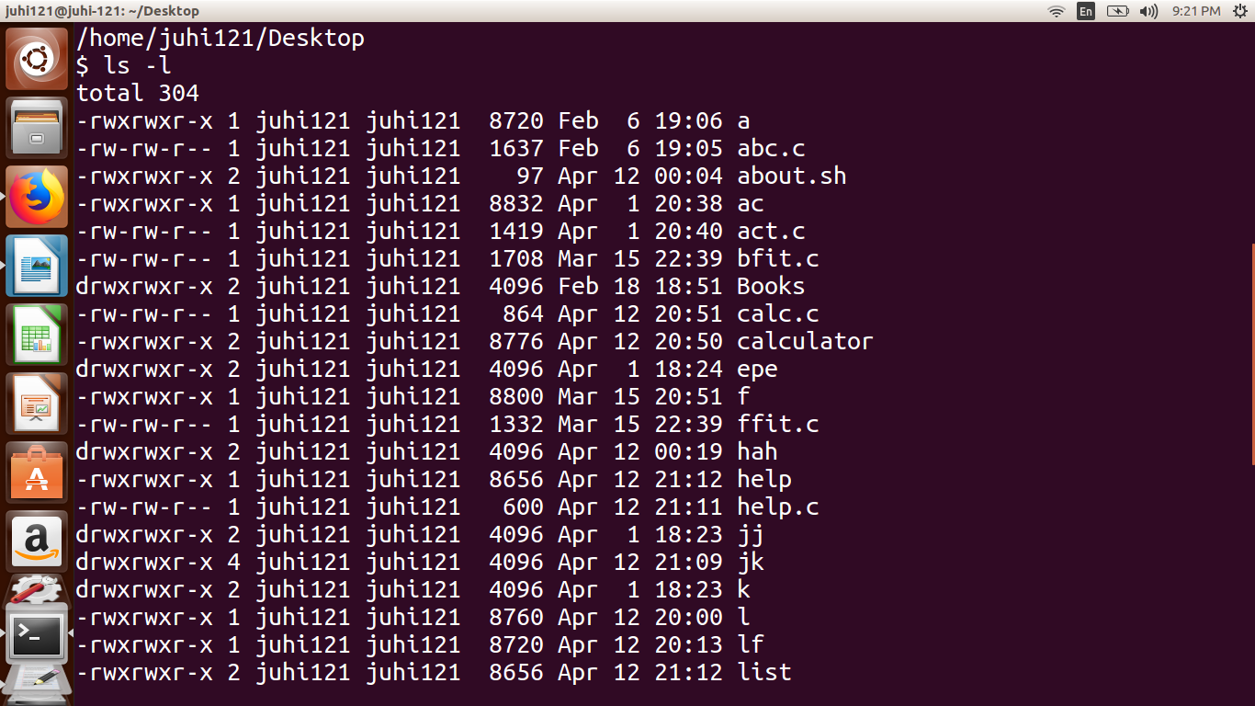

Figure 3.4 A BASIC MULTI-PLAYER WORD GAME

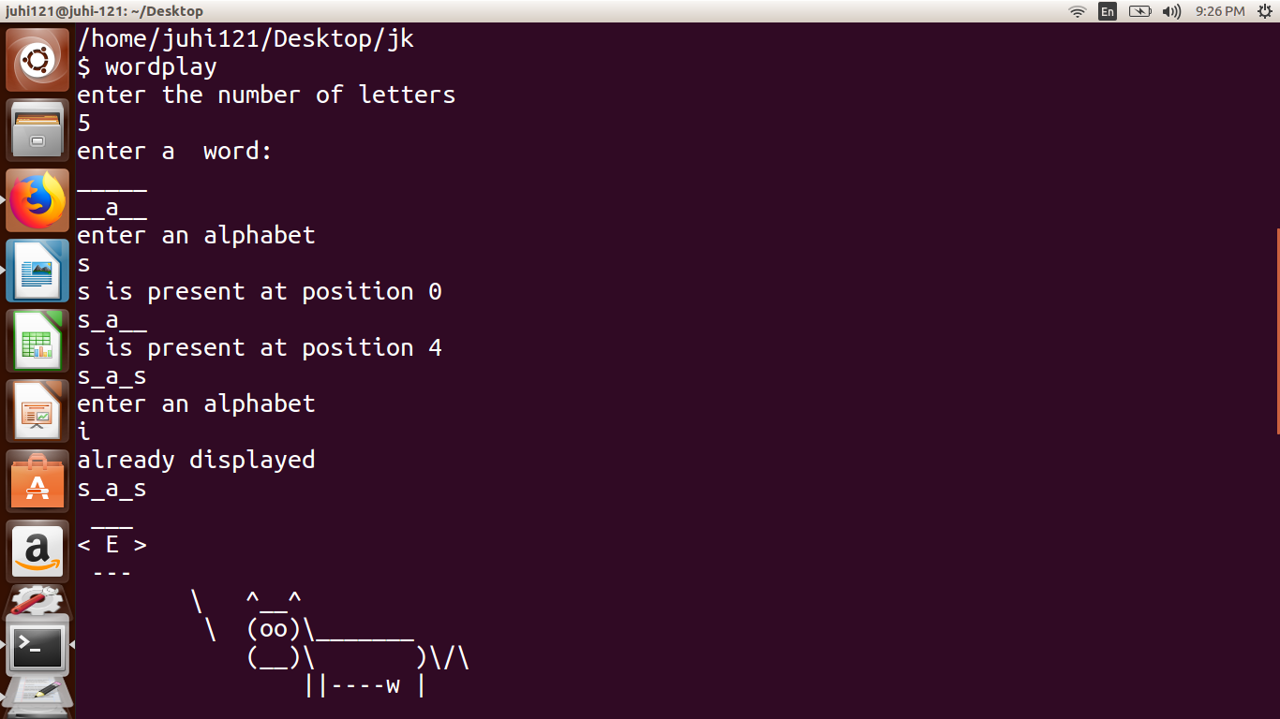

Figure 3.5 COMMAND SHOWING BASIC INFORMATION ABOUT THE SYSTEM AND

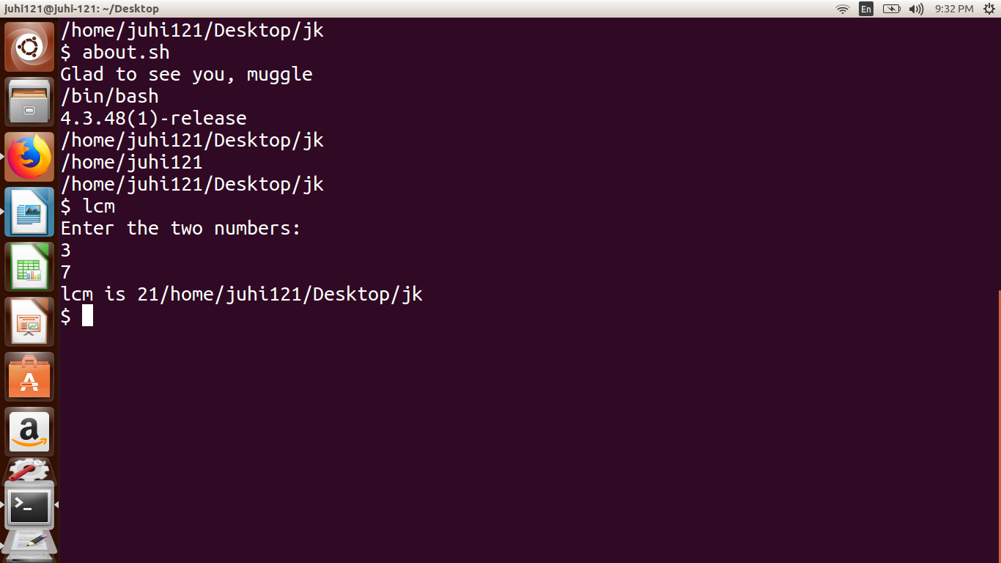

Figure 3.6 COMMAND FOR SEARCHING AND PLAYING m3u FILES USING THE DEFAULT MPLAYER

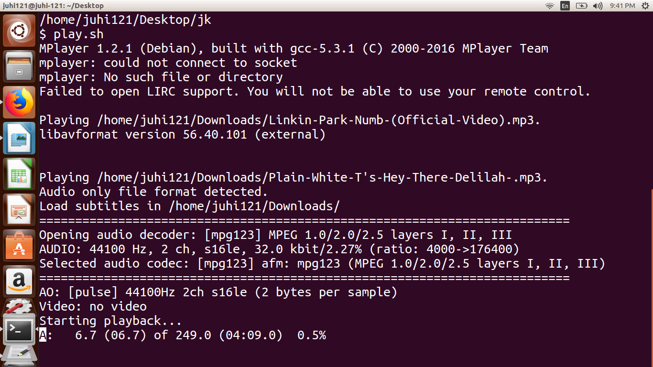

Figure 3.7 COMMAND TO IMPLEMENT QUEUE DATA STRUCTURE

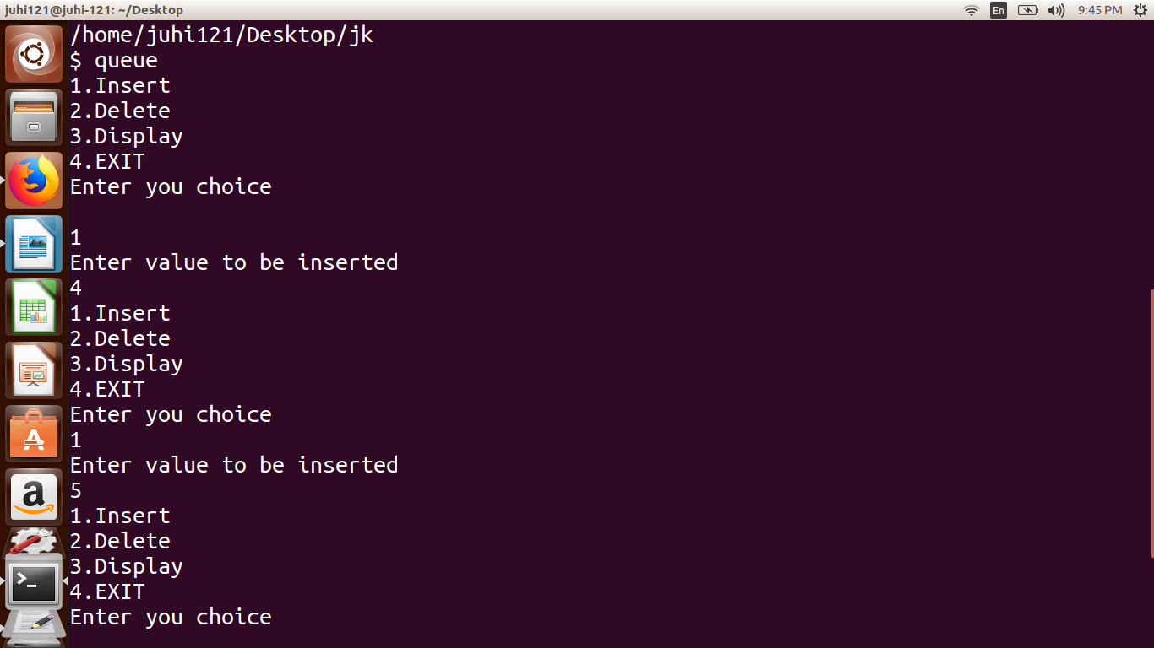

Figure 3.8 EXIT

