Project report

The model has all required physics, but I unfortunately ran out of time to make all plots requested.
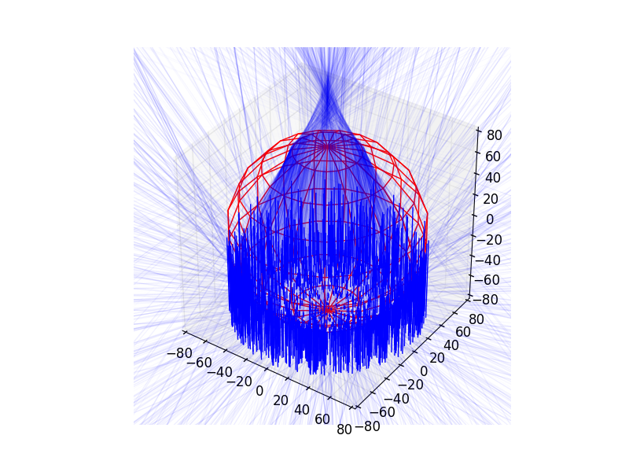Illustration 1: 2000 rays hitting a water droplet (x=1000). Logarithic ray intensity is visualised with line opacity.
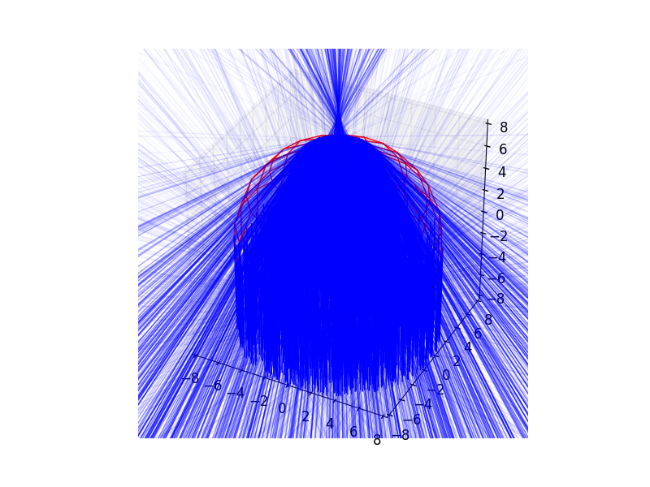Illustration 2: Same as illustration 1, but with x = 100

Attachment 1: classes.py
Model source code

