Google Drive Link: <https://drive.google.com/file/d/12P7XqEh6jTNUKxL89JHHHDxrlv5L2wKf/view?usp=sharing>

Screenshot:

Screenshot 1-

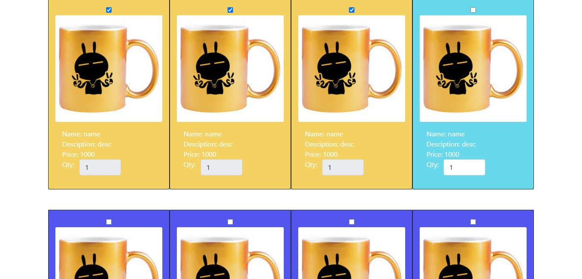

Screenshot 2-

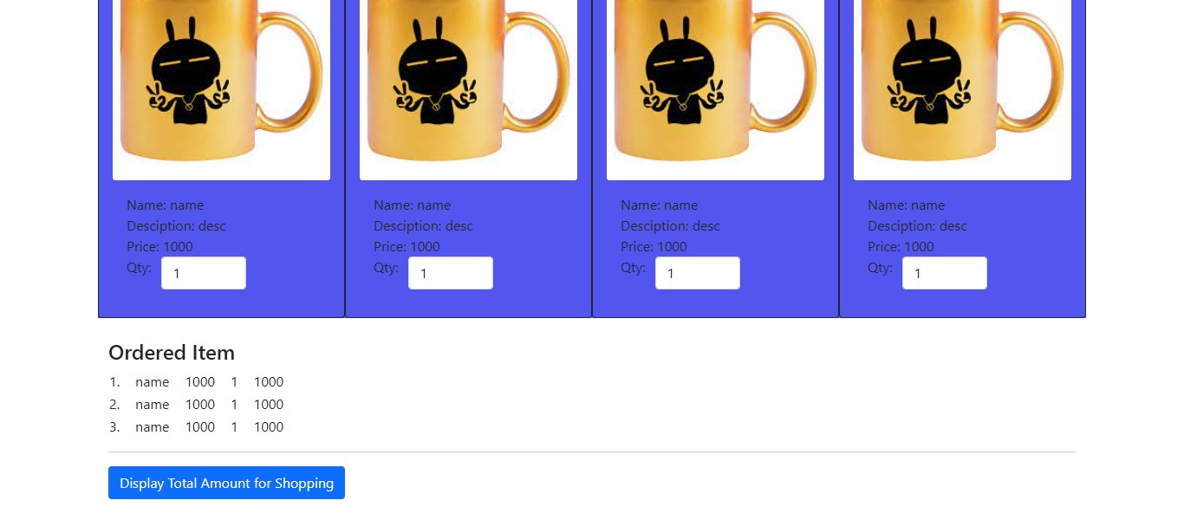

Screenshot 3-

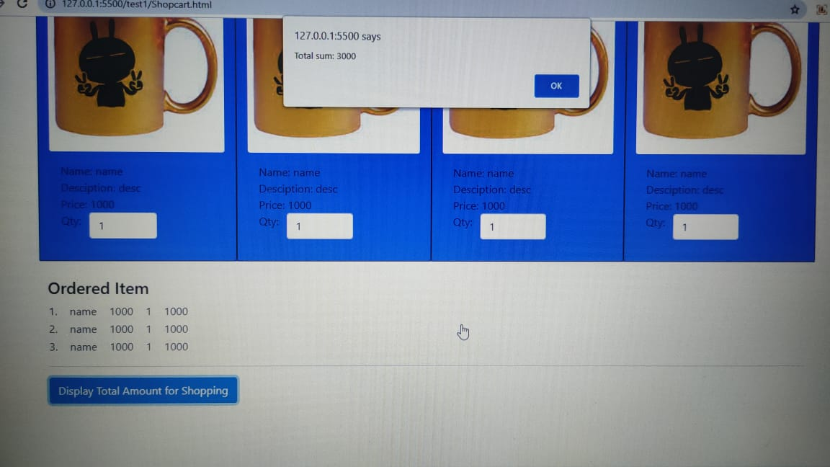

Screenshot 4-

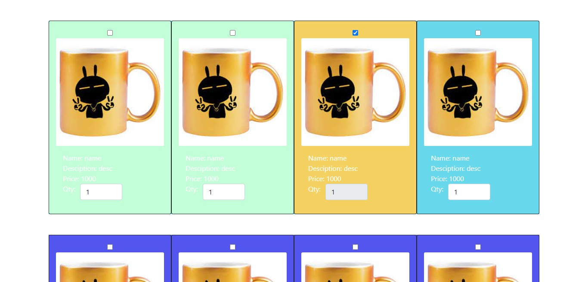

Screenshot 5-

