# CSP554—Big Data Technologies

## Assignment #10

**Exercise 1) 5 points extra credit**

**Follow the document “Spark Streaming Demo Instructions” included with this assignment and execute the demo code. Provide enough screen shots to indicate you have completed the document through section 4. Then remember to terminate your VM**.

Changing:-

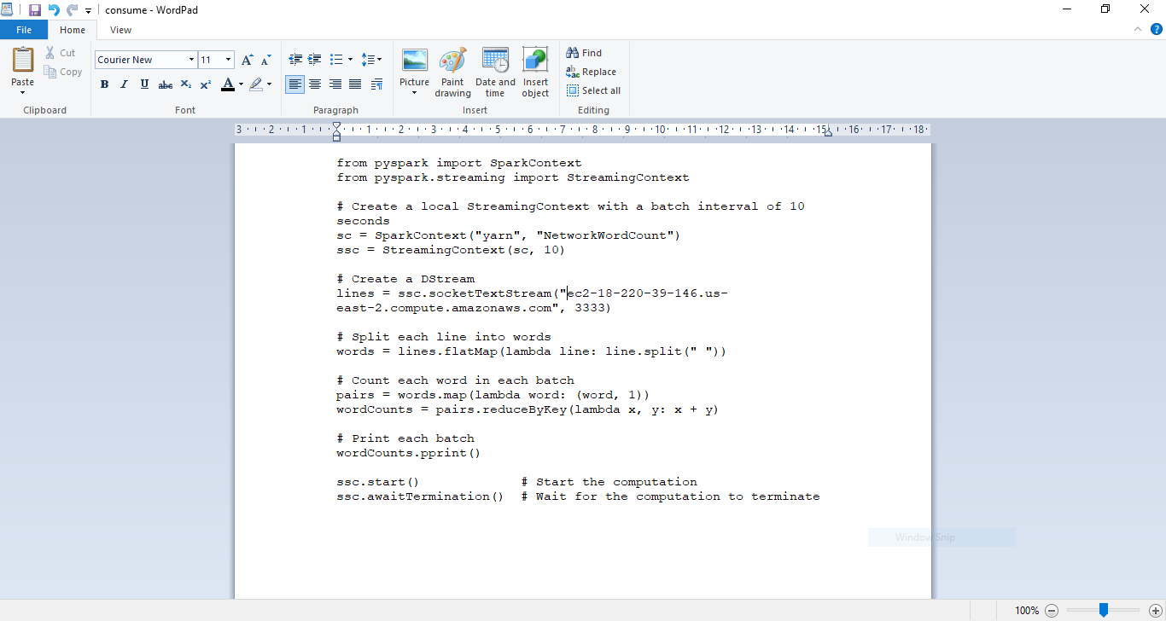

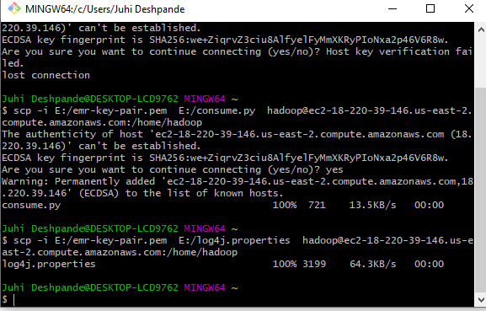

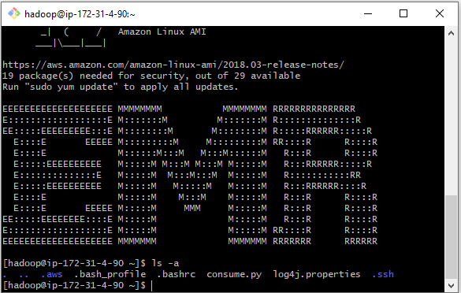

After sudo:

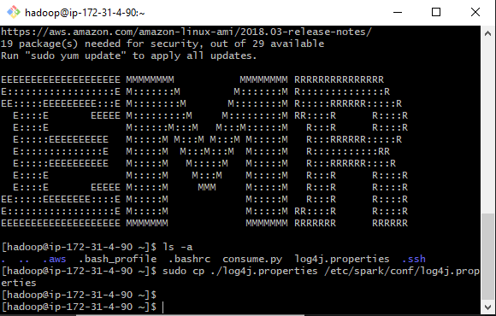

Nc-lk

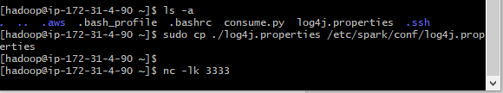

Ec1 window:

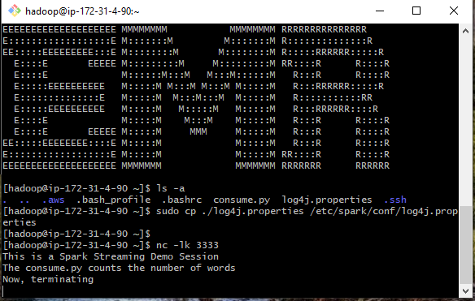

Ec2 window

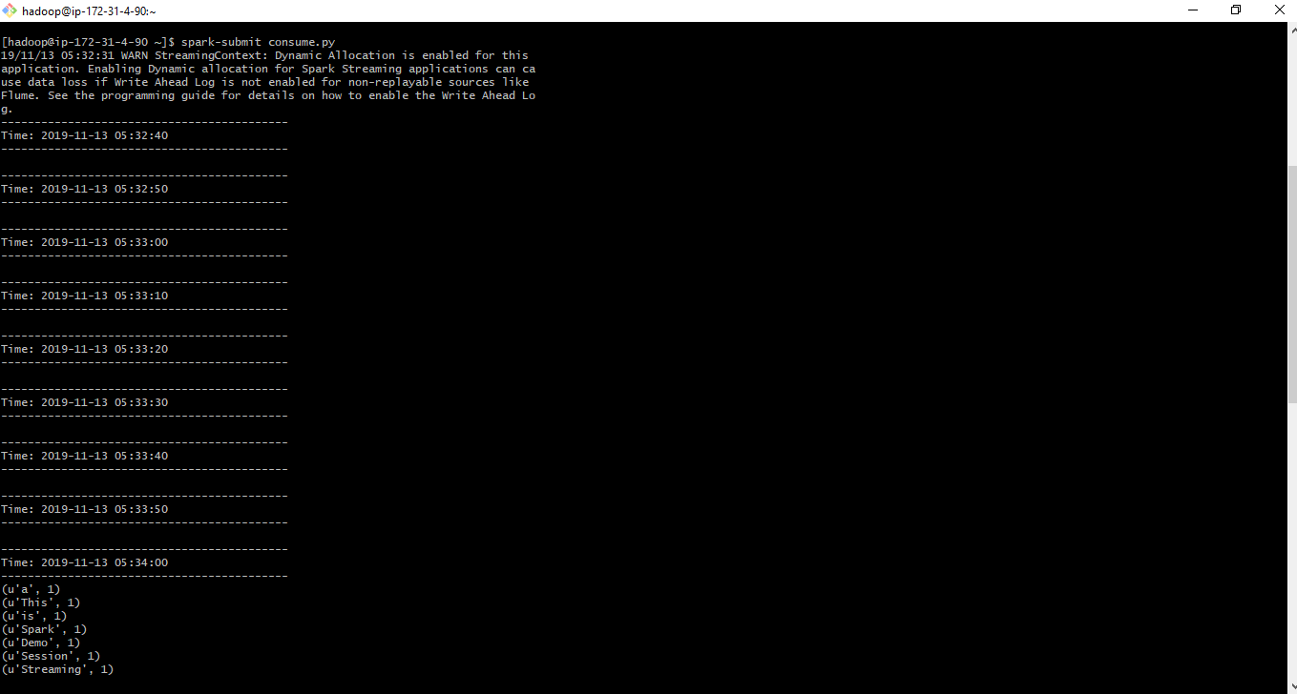

Ec2 window remaining

