# CSP554—Big Data Technologies

## Assignment #12

**Confirm this has all worked by executing the following command in the MongoDB shell:**

**db.unicorns.find();**

## 

**Exercise 1) (2 points)**

**Write a command that finds all unicorns having weight less than 500 pounds. Include the code you executed and some sample output as the result of this exercise. Recall you can place the command, if you choose, into a file, say ‘ex1.js’ and execute it with the load command as above and similarly for the following exercises.**

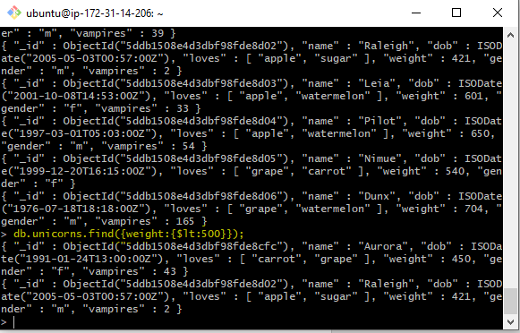

**Exercise 2) (2 points)**

**Write a command that finds all unicorns who love apples. Hint, search for “apple”. Include the code you executed and some sample output as the result of this exercise.**

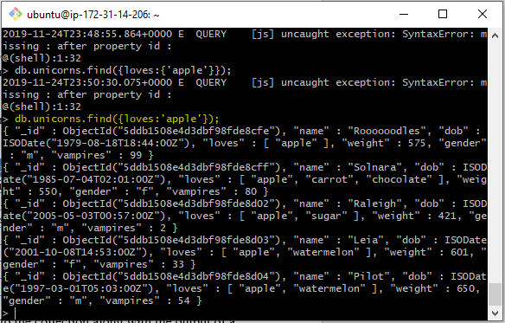

**Exercise 3) (2 points)**

**Write a command that adds a unicorn with the following attributes to the collection. Note dob means “Date of Birth.”**

|  |  |
| --- | --- |
| Attribute | Value(s) |
| name | Malini |
| dob | 11/03/2008 |
| loves | pears, grapes |
| weight | 450 |
| gender | F |
| vampires | 23 |
| horns | 1 |

**Include the code you executed to insert this unicorn into the collection along with the output of a find command showing it is in the collection.**

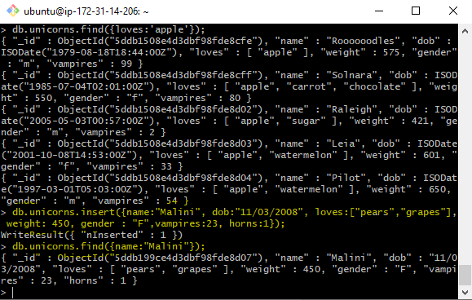

**Exercise 4) (4 points)**

**Write a command that updates the above record to add apricots to the list of things Malini loves. Include the code you executed and some sample output showing the addition.**

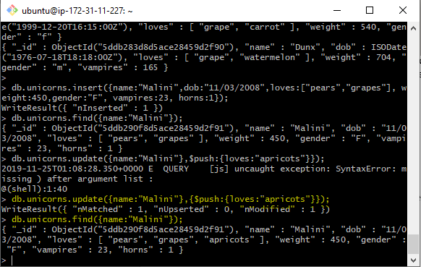

**Exercise 5) (2 points)**

**Write a command that deletes all unicorns with weight more than 600 pounds. Include the code you executed and some sample output as the result of this exercise.**

