# CSP554—Big Data Technologies

## Assignment #3 (Modules 03a & 03b, 15 points)

6) (5 points) Submit a copy of this modified program and a screen shot of the results of the program’s execution as the output of your assignment.

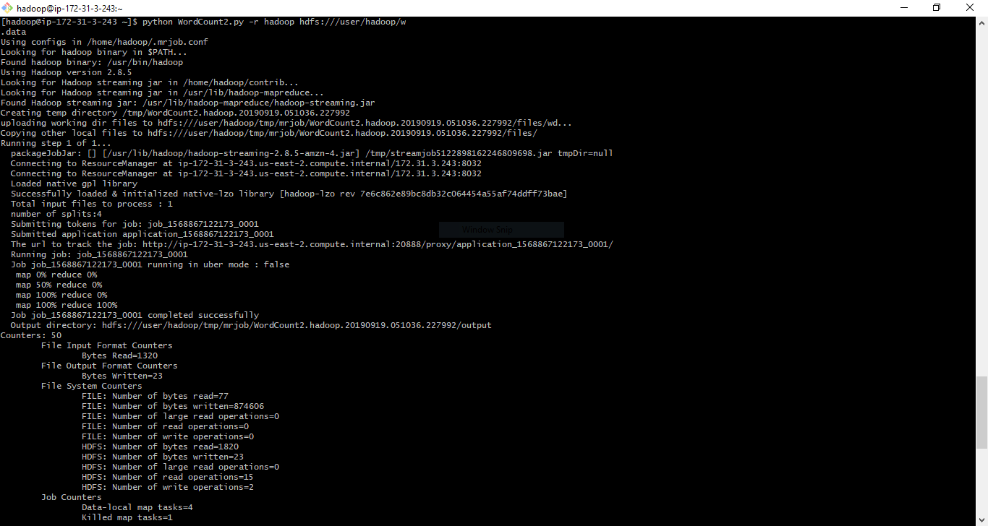

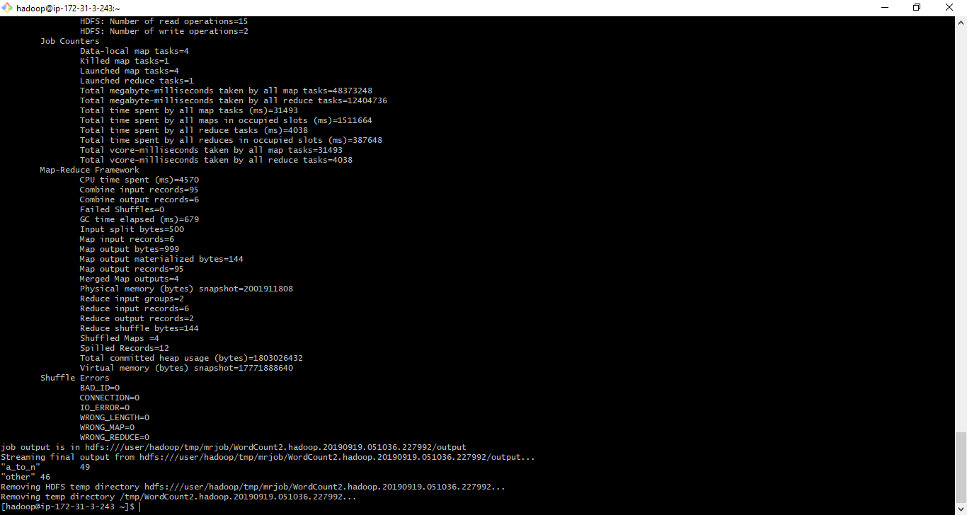

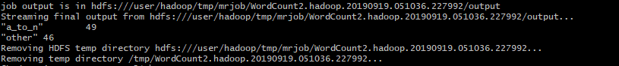

10) (5 points) Submit a copy of this modified program and a screen shot of the results of the program’s execution as the output of your assignment.

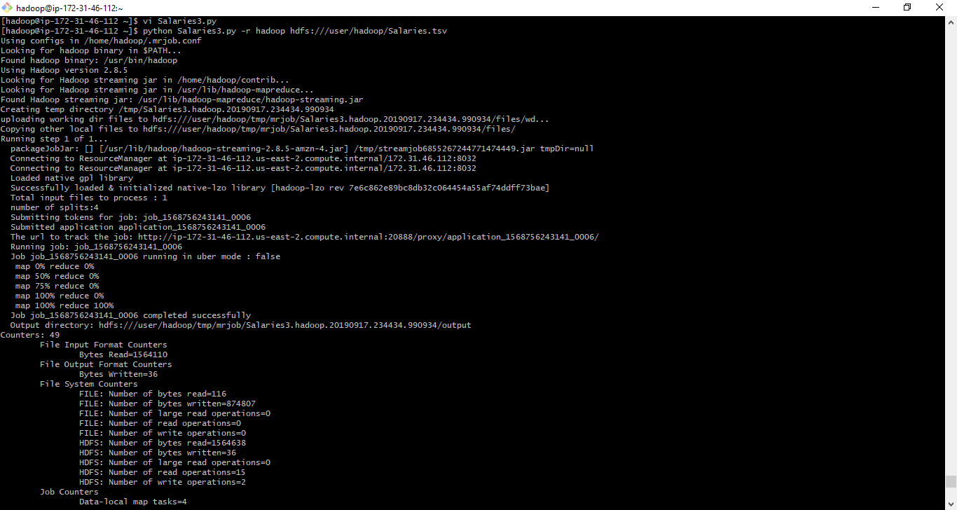

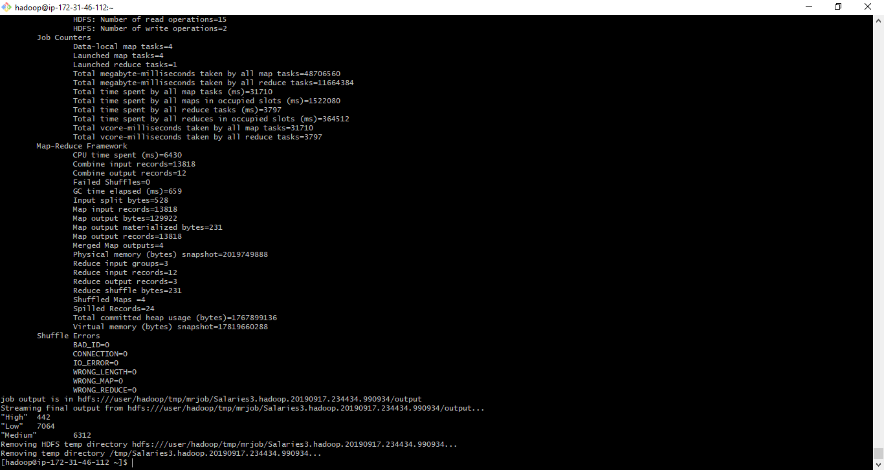

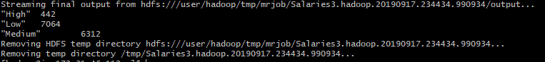

12) (5 points) Review the slides 15-22 in lecture notes Module 3b. Now write a program to perform the task of outputting a count of the number of movies each user (identified via their user id) reviewed

