# CSP554—Big Data Technologies

## Assignment #6

**Exercise 1:**

Step B:

**Magic Number: 147193**

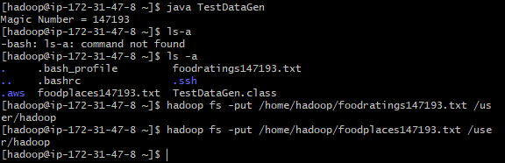

Step C:

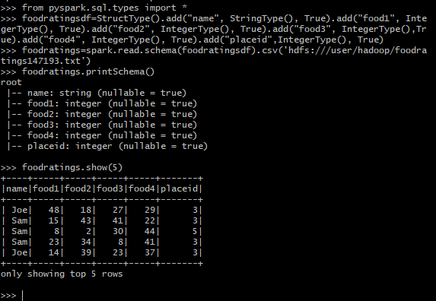

**Exercise 2:**

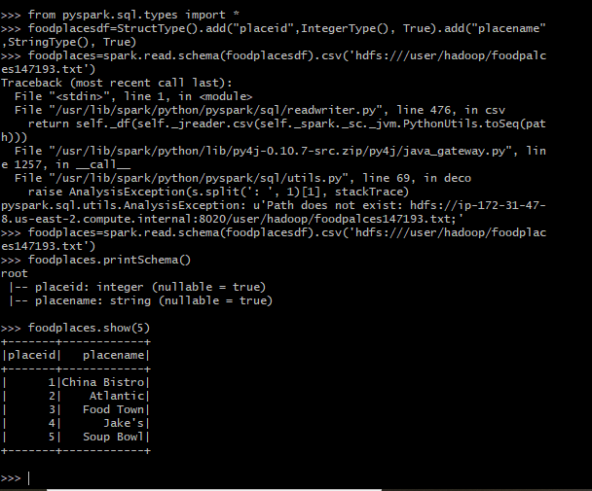

**Exercise 3:**

Step A:



Step B:

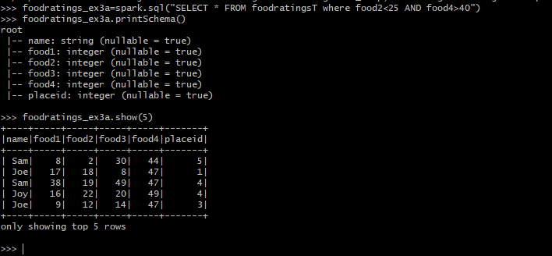

Step C:

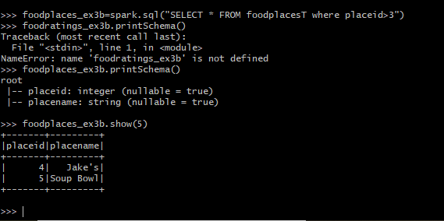

**Exercise 4:**

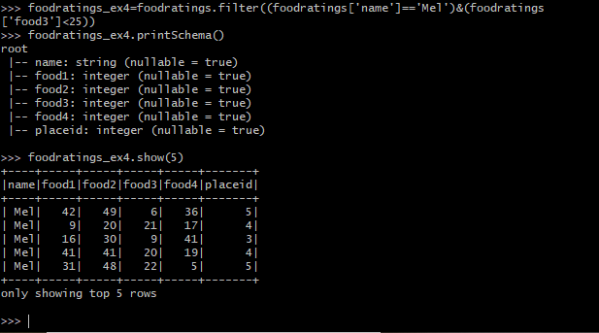

**Exercise 5:**

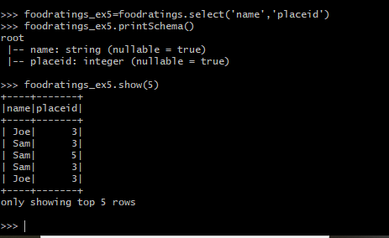

**Exercise 6:**

