**73. Set Matrix Zeroes**

Medium

12K

634

Companies

Given an m x n integer matrix matrix, if an element is 0, set its entire row and column to 0's.

You must do it [in place](https://en.wikipedia.org/wiki/In-place_algorithm).

**Example 1:**

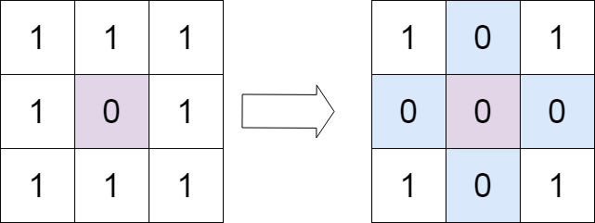

**Input:** matrix = [[1,1,1],[1,0,1],[1,1,1]]

**Output:** [[1,0,1],[0,0,0],[1,0,1]]

Solution:

class Solution {

public void setZeroes(int[][] matrix) {

int n=matrix.length;

int h=matrix[0].length;

int[][] m=new int[n][h];

for(int i=0;i<n;i++)

{

for(int j=0;j<h;j++)

{

m[i][j]=matrix[i][j];

}

}

for(int i=0;i<n;i++)

{

for(int j=0;j<h;j++)

{

if(matrix[i][j]==0)

{

for(int k=0;k<n;k++)

{

m[k][j]=0;

}

for(int k=0;k<h;k++)

{

m[i][k]=0;

}

}

}

}

for(int i=0;i<n;i++)

{

for(int j=0;j<h;j++)

{

matrix[i][j]=m[i][j];

}

}

}

}