1) sorting - Merge sort , Radix sort , Quick sort (also selection & insertion sort)

2) BFS , DFS , Topological sort

3**) Binary search Algorithm**

4) String matching algos ( Rabin karp , KMP algo)

5) 2 pointer

6) Internal working of Hashmaps

Merge Sort:

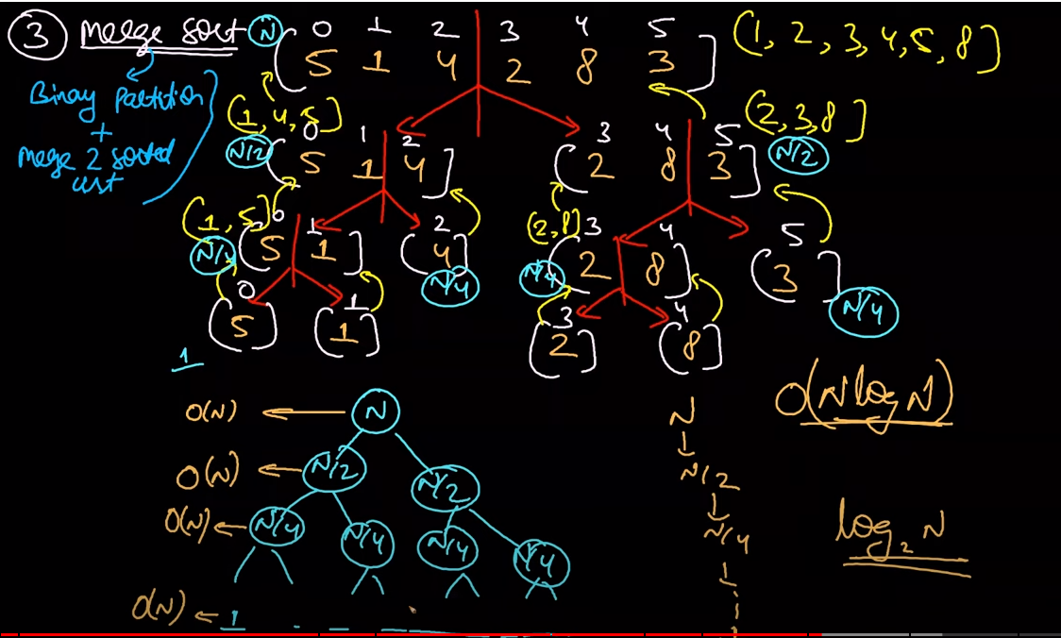

Hihgt of tree tc= logn

And merging=n

Tc=nlog(n)

If we are increasing by two or decreasing by 2 then tc will be in logbase2’

And

Quick sort is used for array most of time and merge sort for lined list because:

Quick sort require rando access merge sort doesn’t require random access.

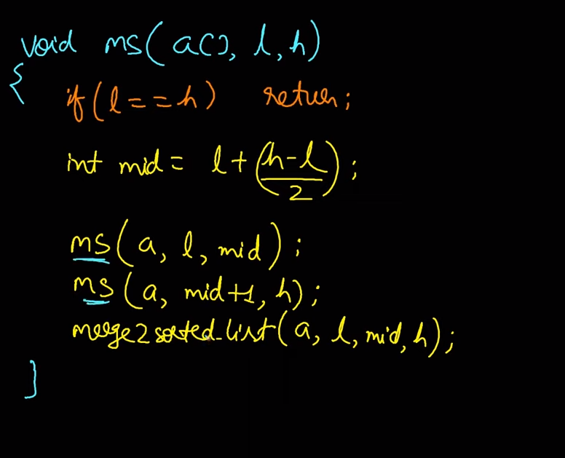ms is recursive call

And

Merge2sortlist is utiltity call not recursive call