Aim:To study networking devices, transmission media (cables), network topologies, and basic network troubleshooting commands.

Networking Devices:
- Hub: Basic device, broadcasts data to all ports.
- Switch: Smarter device, forwards data to specific destination using MAC address.
- Router: Connects different networks (LAN to WAN), forwards packets using IP addresses.
- Modem: Converts digital signals to analog (and vice versa) for Internet.
- Access Point: Provides wireless connectivity.
- Gateway: Connects networks with different protocols.
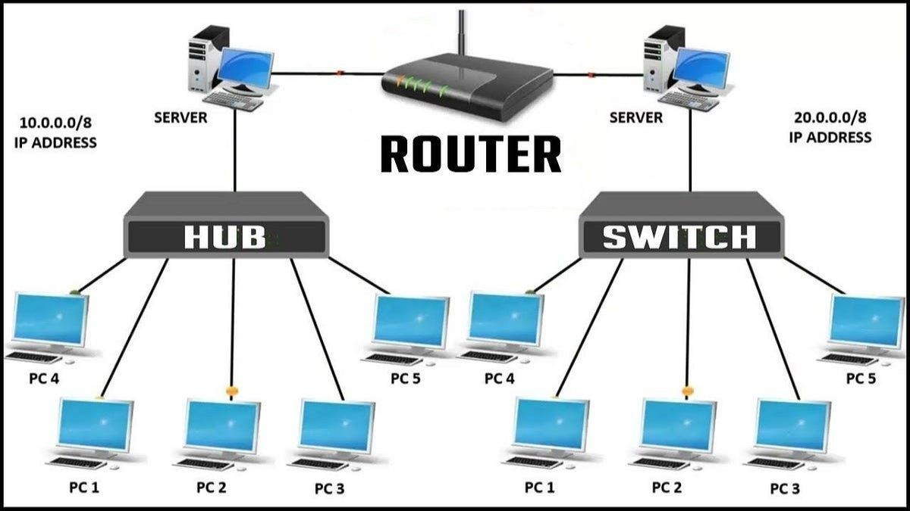

³Transmission Media (Cables)

Coaxial Cable
  - Single copper conductor with shielding.
  - Example: TV cable, older Ethernet.

Twisted Pair Cables
Cat5: Up to 100 Mbps, older LANs.
Cat5e: Enhanced, up to 1 Gbps.
Cat6: Supports 10 Gbps over short distances, better shielding.
Cat7: Supports 10–40 Gbps, shielded twisted pairs, high performance.
Used in Ethernet LANs.

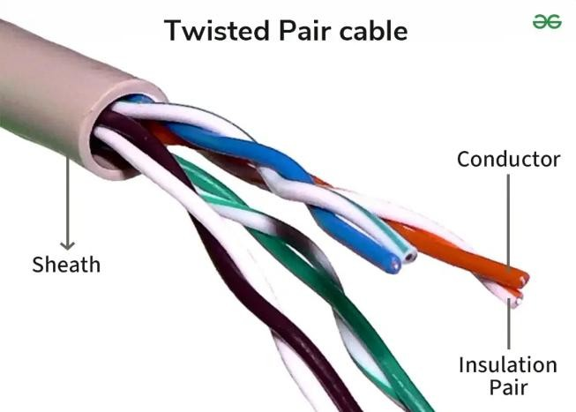
Fiber Optic Cable
  - Uses light signals for data transmission.
  - Very high bandwidth, long distance, immune to EMI.
  - Types: Single Mode (long distance), Multi Mode (short distance).

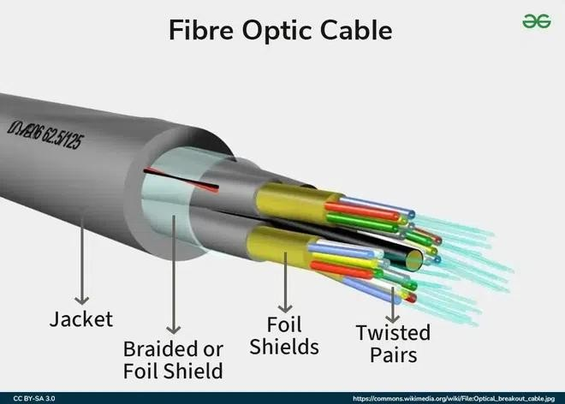

Network Topologies

- Bus Topology
  - Single backbone cable, all devices connected.
  - Simple, but failure in main cable disrupts network.

- Star Topology
  - All devices connect to a central switch/hub.
  - Easy to manage, failure of one device doesn’t affect others.

- Ring Topology
  - Devices connected in a circular path.
  - Data travels in one direction, failure in one device may affect all.

- Mesh Topology
  - Every device connected to every other device.
  - Very reliable but costly.

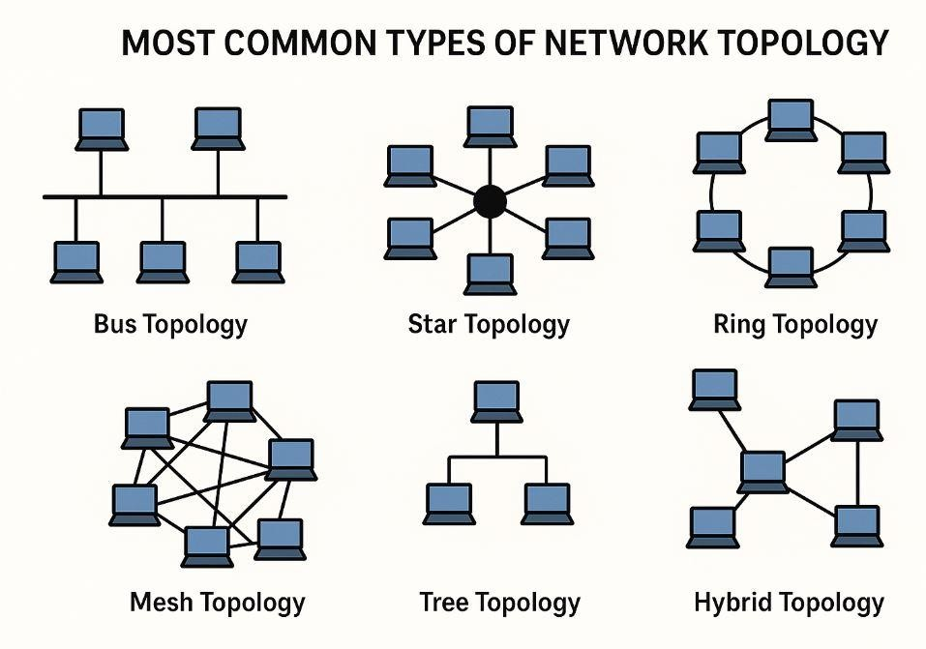

Network Troubleshooting Commands

ipconfig
  - Displays IP configuration.
  - Example: `ipconfig /all`

ping
  - Tests connectivity with a host.
  - Example: `ping google.com`

tracert
  - Shows path taken by packets to destination.
  - Example: `tracert google.com`

nslookup
  - Queries DNS to resolve domain names.
  - Example: `nslookup google.com`

getmac
  - Displays MAC address of system.
  - Example: `getmac`

route print
  - Shows routing table.
  - Example: `route print`

Conclusion
In this practical, we studied basic networking devices, types of cables, common network topologies, and used troubleshooting commands like `ping`, `ipconfig`, `tracert`, `nslookup`, `getmac`, and `route print` to analyze and solve network-related issues.

