**Assignment: 1 / Module 1**

**SE – Overview of IT Industry**

1. What is software? What is software engineering?

* Software is a set of instructions or programs that enable computers to perform specific tasks, powering applications and systems.
* Software engineering uses engineering principles to design, develop, test, and maintain software so that it is reliable, efficient, and user satisfied.

1. Explain types of software

* There are two types of Software:

1. System Software: System software manages computer hardware and provides essential services, including operating systems like Windows, Linux, and macOS, ensuring functionality. **E.g.:** Notepad, Calculator

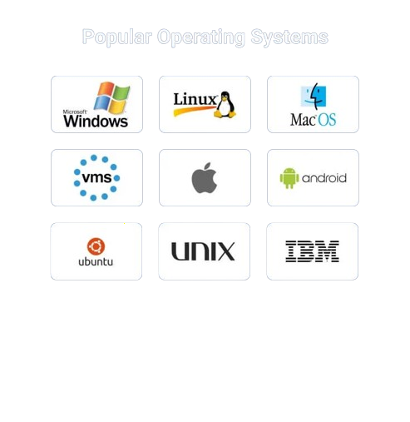

1. Application Software: Application software performs specific tasks for users, such as word processors, graphic design tools, web browsers, and email clients, enhancing productivity and creativity.

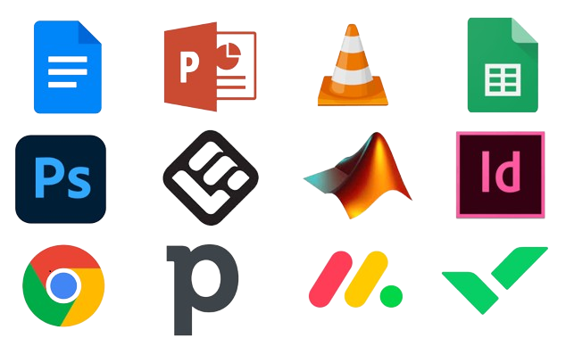

1. What is SDLC? Explain each phase of SDLC

* SDLC (Software Development Life Cycle) is step by step methodology to develop any software with high quality, effective cost and with shortest possible time.

**Phase of SDLC:**

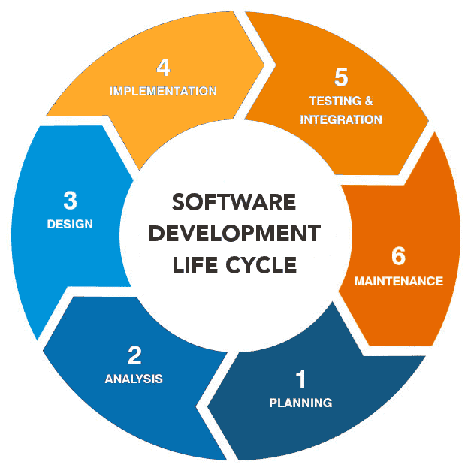

1. **Requirement gathering / Planning:** In this initial phase, project goals, requirements, and constraints are outlined. Key stakeholders collaborate to create a comprehensive project plan, defining scope, timelines, and resource allocation. This stage lays the foundation for subsequent phases, ensuring a clear understanding of project objectives.
2. **Analysis:** The Analysis phase is a crucial starting point in the Software Development Life Cycle (SDLC). It focuses on understanding and defining the needs of the end-users and stakeholders. The primary goal is to gather detailed requirements for the software system, ensuring that the development team has a clear understanding of what needs to be built.
3. **Designing:** Following planning, the System Design phase involves creating a blueprint for the software system. Architects and designers collaborate to define the system's architecture, specifying hardware, software, databases, and communication protocols. This phase translates the project specifications into a detailed technical plan, providing a roadmap for the development team.
4. **Implementation / Code:** This is the phase where the actual coding takes place. Developers write the source code based on the design specifications. The implementation phase transforms the conceptualized system into a tangible product, focusing on efficiency, maintainability, and adherence to coding standards.
5. **Testing:** Rigorous testing is critical to ensure the software meets the specified requirements and functions as intended. Testing occurs at multiple levels, including unit testing, integration testing, and system testing. Bugs and issues are identified and addressed to enhance the software's quality and reliability.
6. **Deployment / Maintenance:** The Deployment phase involves releasing the software to users or a production environment. This step requires careful planning to minimize downtime and potential disruptions. Deployment activities include installation, configuration, data migration, and training for end-users.
7. What is DFD? Create a DFD diagram on Flipkart.

* A Data Flow Diagram (DFD) is a visual representation of a system's processes, data storage, and the flow of data between them. It uses symbols to depict processes, data sources, data destinations, and data storage, providing a clear overview of how information moves within a system. DFDs are employed in system analysis and design to understand, document, and improve processes, facilitating communication between stakeholders.
* **DFD diagram of Flipkart :**

Reply

Order Item

View Product

Reply

**Customers**

Response

User Data

Category

Product List

Order Details

Order Tracker

Reply

Add Data

Reply

Add Data

Reply

Display

View Report

Response

Manage Order

Response

Response

Request For Login

Add / Edit

Listing

Check Details

**Log In**

1. What is Flow chart? Create a flowchart to make addition of two numbers

* A flowchart is a visual representation of a process, algorithm, or system, using different shapes and arrows to depict the flow of activities. It aids in understanding, analyzing, and documenting complex processes, making it a valuable tool for problem-solving and decision-making.
* **Flowchart to make addition of two numbers :**

**Start**

Input A

Input B

Calculate C=A+B

Display C

**Stop**

1. What is Use case Diagram? Create a use-case on bill payment on paytm.

* A use case diagram is a simple visual tool in software design. It shows who uses a system (actors) and what they can do with it (use cases). It helps people understand and discuss how a system should work.
* A use case is a written description of how users will perform tasks on your website. It outlines, from a user's point of view, a system's behavior as it responds to a request. Each use case is represented as a sequence of simple steps, beginning with a user's goal and ending when that goal is fulfilled.

Registered User

Service

Provider