**MODULE: 5 (Database)**

1. What do you understand By Database

* A database is an organized collection of structured information or data, typically stored electronically in a computer system. It's designed to efficiently manage, retrieve, and manipulate data according to predefined criteria and requirements. Databases are used in various applications and industries to store and manage large volumes of data in a structured and accessible manner. They are crucial for storing, retrieving, updating, and managing data efficiently, making them a fundamental component of many software systems and applications.

1. What is Normalization?

* Normalization is the process of organizing the data in the database.
* Normalization is used to minimize the redundancy from a relation or set of relations.
* It is also used to eliminate undesirable characteristics like Insertion, Update, and Deletion Anomalies.
* Normalization divides the larger table into smaller and links them using relationships.
* The normal form is used to reduce redundancy from the database table.

1. What is Difference between DBMS and RDBMS?

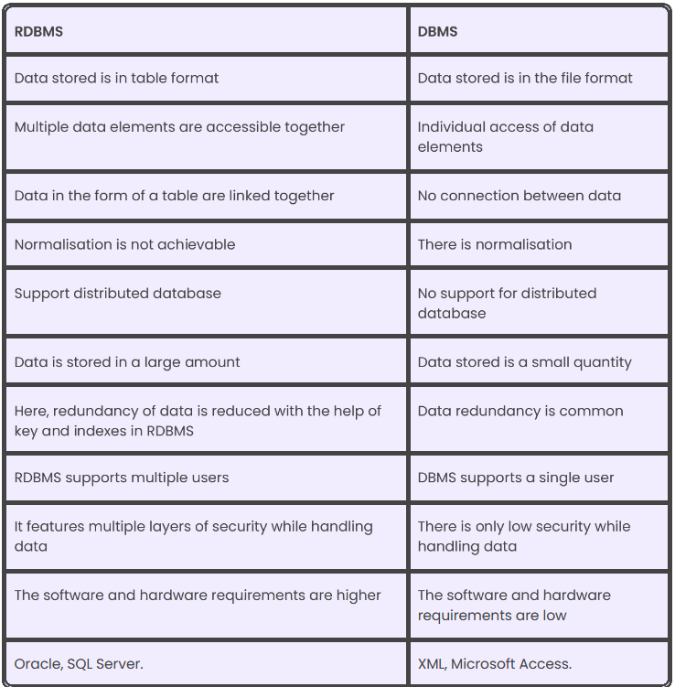

1. What is MF Cod Rule of RDBMS Systems?

* Null values must be uniformly treated as “missing information,” not as empty strings, blanks, or zeros.
* Null values can also be interpreted as ‘inapplicable data’ or we can say ‘unknown information’.
* It should be handled consistently
* Expression on NULL must give null, primary key must not be null, ever.

5. What do you understand By Data Redundancy?

* It occurs when identical copies of the same data are stored in multiple locations, leading to a range of problems
* it can occur either intentionally or accidentally (Due to complex processes or inefficient coding).
* It is concern because it can lead to inconsistencies, update anomalies, database performance etc.

6. What is DDL Interpreter?

* Data definition language – Describe the portion of SQL that creates, alters, and deletes database objects.
* It includes schemas, table, catalogs, variables and many more.
* We can create table (using link also).

7. What is DML Compiler in SQL?

* DML- Data manipulation language.
* It is the component of the SQL statements.
* List of DML commands - Insert (For inserting data into table), Update (For updating existing data within data), Delete (For delete records), Lock (Table control concurrency)

8. What is SQL Key Constraints writing an Example of SQL Key Constraints

* Primary key (Uniquely identifies)
* Foreign key (Referencing key)
* A primary key is a combination of fields that uniquely identify a record in a table, so that an individual record can be located without confusion.
* A foreign key sometimes called a referencing key used to link two tables together.
* Example: create table student (

Roll no int,

Name varchar,

Number int,

Primary key (Roll no),

Foreign key (Number) REFERENCES students (Roll no);

9. What is save Point? How to create a save Point write a Query?

* Rolling back any transaction.
* Also known as nested transactions.
* A special mark inside a transaction that allows all commands that are executed after it was established to be rolled back.
* Syntax for save point command:

SAVEPOINT_NAME;(Creation of save point among all the transaction) ROLLBACK to the SAVEPOINT are ROLLBACK to SAVEPOINT_NAME.

10. What is trigger and how to create a Trigger in SQL?

* Trigger allows you to specify SQL actions that should be executed automatically when a specific event occurs in the database.
* SQL triggers are generally associated with a particular table, this means that when the table is deleted, all its associated triggers are deleted accordingly.
* Trigger creation in SQL:

CREATE TRIGGER

‘games’. AFTER

INSERT

ON

‘games’. ‘USERS’ FOR EACH row BEGIN

INSERT INTO

another Table ()