CI/CD with GitHub Actions – Deploying a Node.js App to AWS EC2 using Docker & SSH
By: Juhi Sinha

1. Overview
In this setup, I automated the deployment of a Node.js application to an AWS EC2 instance using GitHub Actions.
The pipeline does:
- On every push to main:
  - Build the Node.js project and create a Docker image
  - Push the image to Docker Hub
  - SSH into the EC2 instance
  - Pull the latest image and run the container

2. Architecture
Components:
- GitHub – Hosts application source code and GitHub Actions workflow
- Docker Hub – Stores built Docker images
- AWS EC2 instance – Target server where the container runs
- GitHub Actions – CI/CD engine that builds, pushes, and deploys
Flow:
Developer push → GitHub Actions → Build & Push Docker image → SSH to EC2 → Docker pull & run
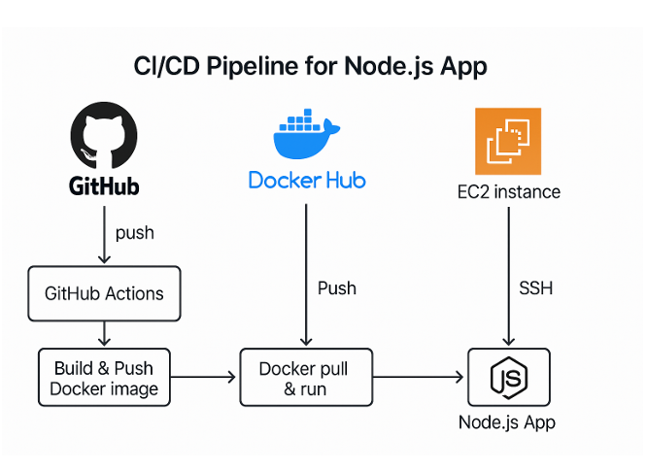

3. Prerequisites
✅ Node.js application with a package.json
✅ GitHub repository with the Node.js app pushed
✅ Docker Hub account and a repository created (e.g., username/node-app)
✅ AWS EC2 instance (Ubuntu or Amazon Linux) with:
- Security group allowing SSH (port 22) and app port (e.g., 3000 or 80)
- SSH key pair (.pem) downloaded
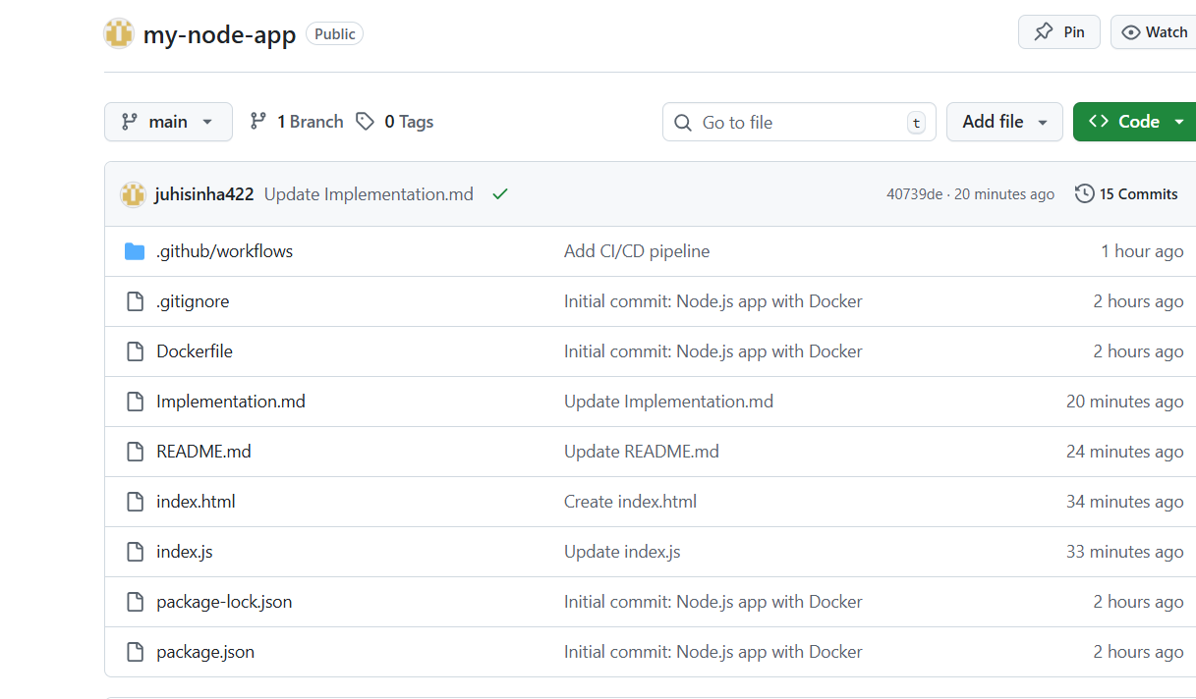

4. Prepare the EC2 Instance
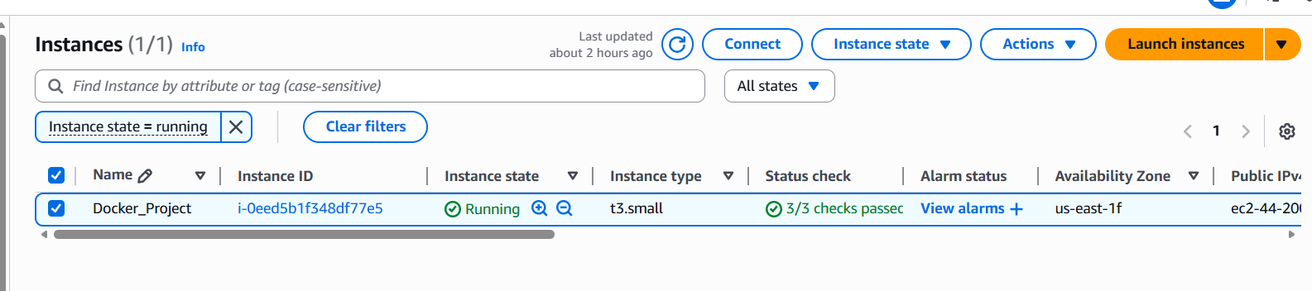

4.1 SSH into the Instance
ssh -i your-key.pem ubuntu@<EC2_PUBLIC_IP>
4.2 Install Docker
sudo apt update
sudo apt install -y docker.io
sudo usermod -aG docker ubuntu # or ec2-user for Amazon Linux
Log out & log back in so Docker group changes take effect.
4.3 Enable Docker at Startup (Optional)
sudo systemctl enable docker
sudo systemctl start docker
Now EC2 is ready to run containers.

5. Containerize the Node.js Application
In your project root, create a Dockerfile:
FROM node:18-alpine

WORKDIR /app

COPY package*.json ./

RUN npm install

COPY . .

EXPOSE 3000

CMD ["npm", "start"]
Adjust the port and start command according to your app.
Commit and push this to GitHub.

6. Configure GitHub Secrets
Go to: GitHub Repo → Settings → Secrets and variables → Actions → New repository secret
Create the following secrets:
Secret Name | Description
DOCKERHUB_USERNAME | Your Docker Hub username
DOCKERHUB_TOKEN | Docker Hub access token/password
EC2_HOST | Public IP or DNS of EC2
EC2_USER | ubuntu or ec2-user
EC2_SSH_KEY | Content of your private key file (.pem)<br>Copy the full text including BEGIN OPENSSH PRIVATE KEY
You can also add:
- DOCKER_IMAGE – e.g., username/node-app
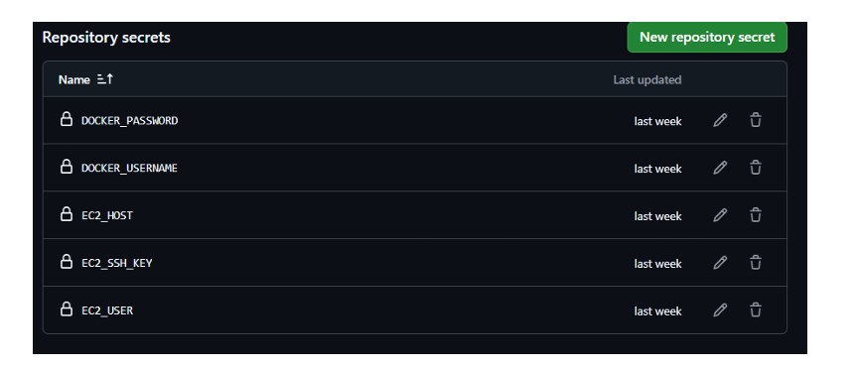

7. Create GitHub Actions Workflow
Create folder and file: .github/workflows/cicd.yml
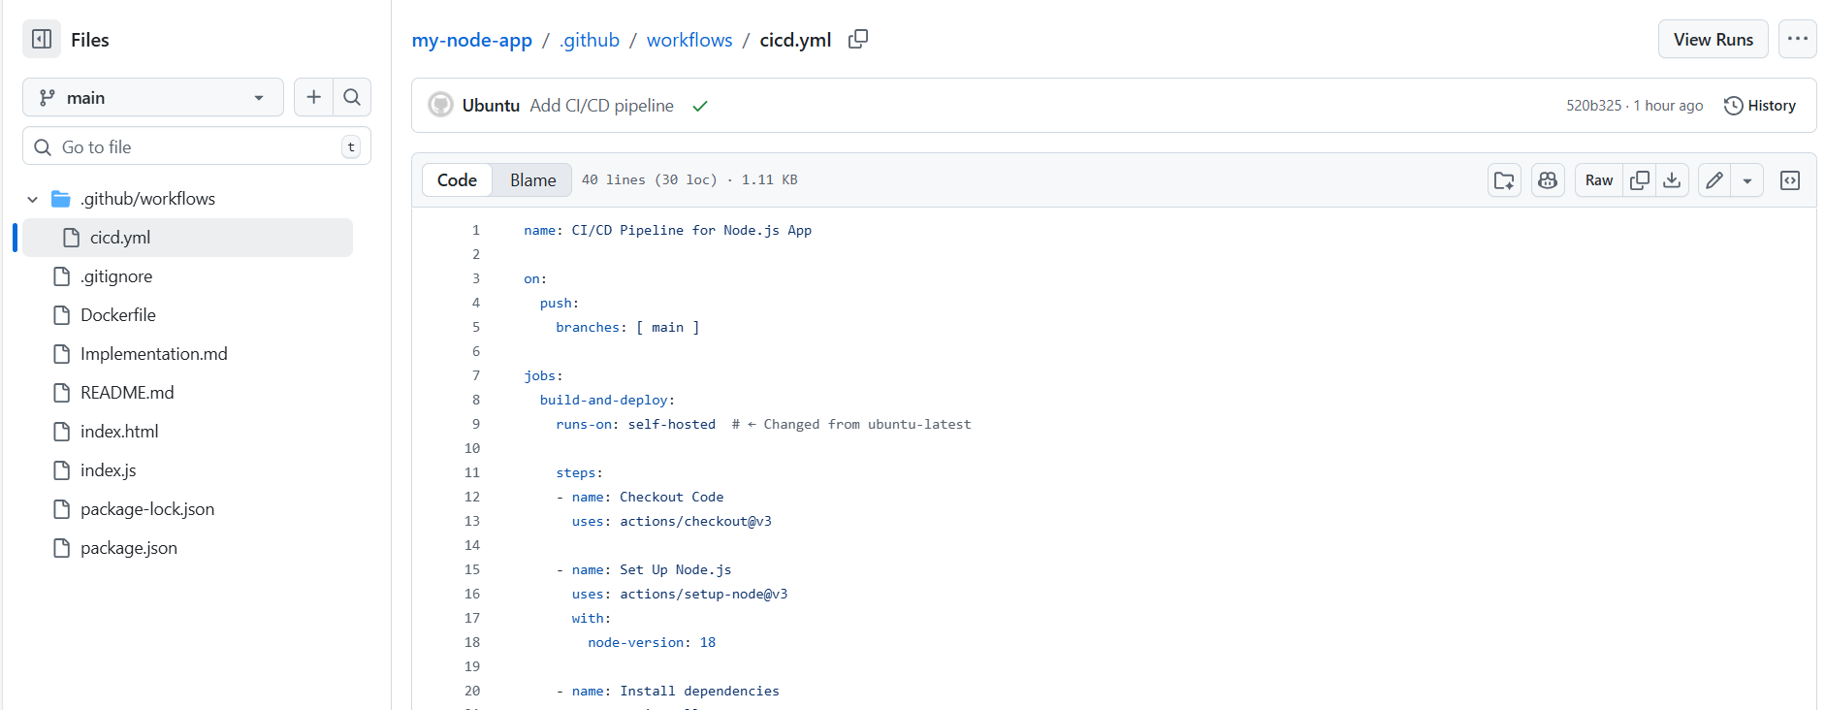
name: CI/CD Pipeline for Node.js App

on:
push:
branches: [ main ]

jobs:
build-and-deploy:
runs-on: ubuntu-latest

steps:
- name: Checkout Code
uses: actions/checkout@v3

- name: Set Up Node.js
uses: actions/setup-node@v3
with:
node-version: 18

- name: Install all dependencies
run: npm install

- name: Build Docker image
run: docker build -t ${{ secrets.DOCKER_USERNAME }}/my-node-app:latest .

- name: Login to Docker Hub
run: echo "${{ secrets.DOCKER_PASSWORD }}" | docker login -u "${{ secrets.DOCKER_USERNAME }}" --password-stdin

- name: Push Docker image to Docker Hub
run: docker push ${{ secrets.DOCKER_USERNAME }}/my-node-app:latest

- name: Done
run: echo "Docker Image pushed to Docker Hub!"

- name: Deploy to EC2 via SSH
uses: appleboy/ssh-action@v1.0.0
with:
host: ${{ secrets.EC2_HOST }}
username: ${{ secrets.EC2_USER }}
key: ${{ secrets.EC2_SSH_KEY }}
script: |
docker pull ${{ secrets.DOCKER_USERNAME }}/my-node-app:latest
docker stop myapp || true
docker rm myapp || true
docker run -d --name myapp -p 3000:3000 ${{ secrets.DOCKER_USERNAME }}/my-node-app:latest
This workflow will automatically run on every push to the main branch.
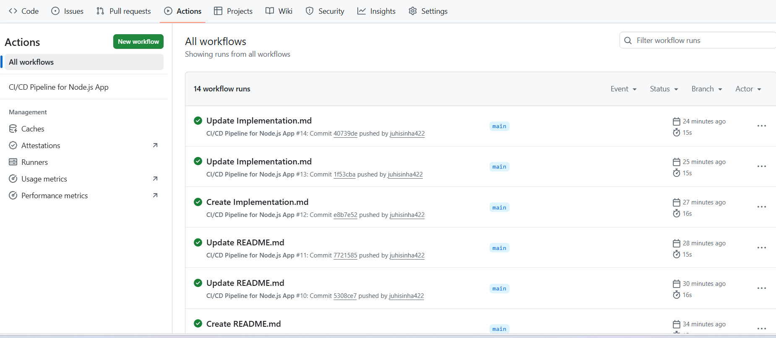
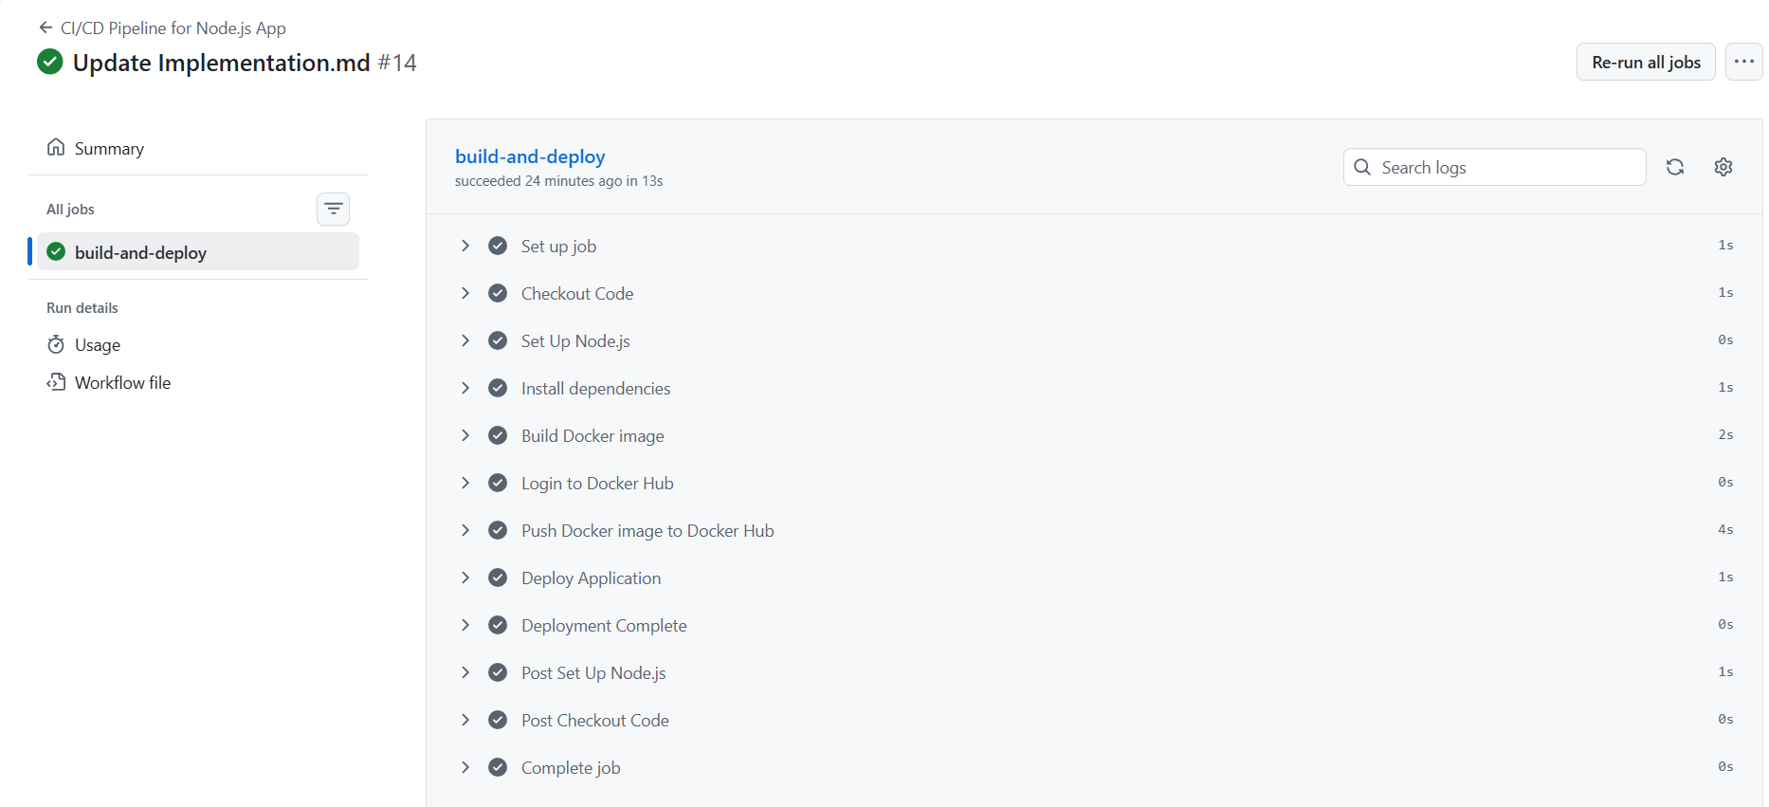

8. How the Deployment Step Works (SSH to EC2)
In the Deploy to EC2 via SSH step, appleboy/ssh-action:
- Uses the EC2 host, username, and private key from GitHub Secrets
- Opens an SSH session to the EC2 instance from the GitHub Actions runner
- Runs the script block on the EC2 server:
  - docker pull – gets the latest image that was just pushed
  - Stops/removes any existing container named myapp
  - Runs a new container with the new image and maps container port 3000 to host port 3000
Result: The application on EC2 is updated automatically whenever you push to main.

9. Testing the Pipeline
Steps:
- Commit and push a change to the main branch
- Go to GitHub → Actions → CI/CD Pipeline for Node.js App
- Open the latest run. You should see a job similar to:
  - ✅ Set up job
  - ✅ Checkout Code
  - ✅ Set Up Node.js
  - ✅ Install all dependencies
  - ✅ Build Docker image
  - ✅ Login to Docker Hub
  - ✅ Push Docker image to Docker Hub
  - ✅ Deploy to EC2 via SSH
  - ✅ Complete job
- After it succeeds, visit http://<EC2_PUBLIC_IP>:3000 in your browser and verify the app
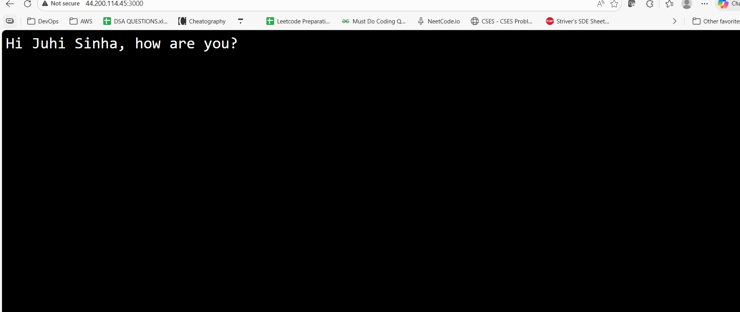

10. Final Result
Application Successfully Deployed! 🎉
The Node.js application is now running on AWS EC2 and accessible via:
URL: http:ec2-ip:3000
Response:
Hi Juhi Sinha, how are you?

Key Takeaways
✅ Automated CI/CD Pipeline – Every code push triggers automatic deployment
✅ Containerized Application – Docker ensures consistency across environments
✅ Secure Deployment – SSH keys and secrets stored securely in GitHub
✅ Scalable Architecture – Easy to replicate for multiple environments
✅ Real-time Updates – Changes are deployed within minutes of pushing code

Future Enhancements
- Add automated testing before deployment
- Implement blue-green deployment strategy
- Add monitoring and logging with CloudWatch
- Set up custom domain with HTTPS
- Implement rollback mechanism for failed deployments

Project Completed By: Juhi Sinha
Date: January 2026
GitHub Repository: https://github.com/juhisinha422/my-node-app
Live Application: http:ec2-ip:3000

Conclusion
This project demonstrates a complete CI/CD pipeline that automates the deployment of a Node.js application to AWS EC2 using GitHub Actions, Docker, and SSH. The pipeline ensures rapid, reliable, and repeatable deployments while maintaining security best practices.
Status: ✅ Successfully Deployed and Running

