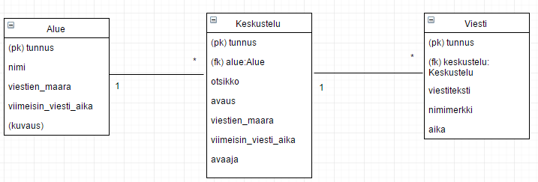

https://www.draw.io/#LUntitled%20Diagram.xml