Profanity Checker Service deploy to Azure using Visual Studio 2019

Here are introduced simple steps to deploy the ProfanityCheckerService to Azure using Visual Studio 2019. Other options to deploy are also possible, but I did it this way.

1) Open solution ProfanityCheckerService in Visual Studio 2019.

1) Right-click the project name ProfanityCheckerService in Solution Explorer, and in the pop up menu, select Publish…

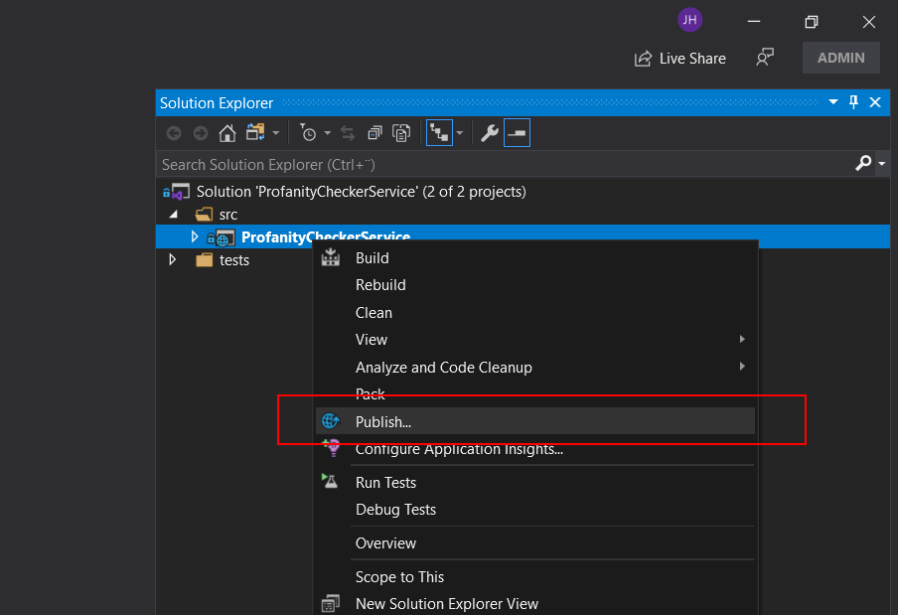

2) Select Azure as publish target and click Next.

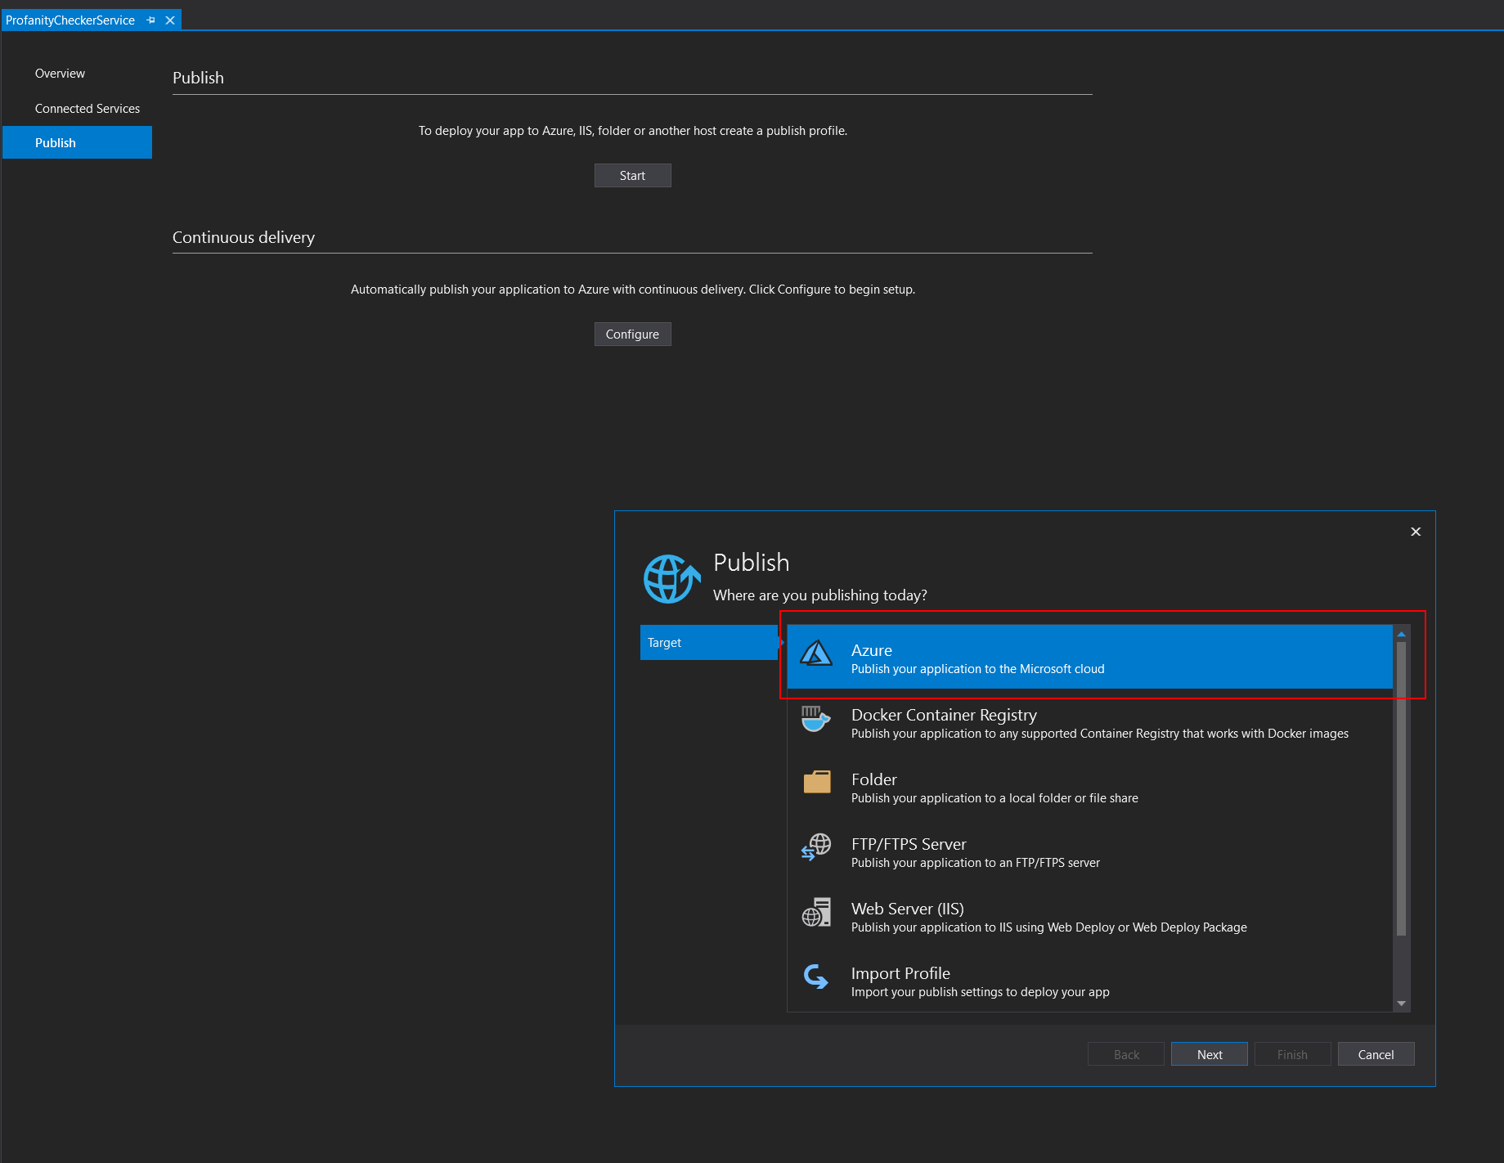

3) Select option Azure App Service (Windows) as Specific Target and press Next.

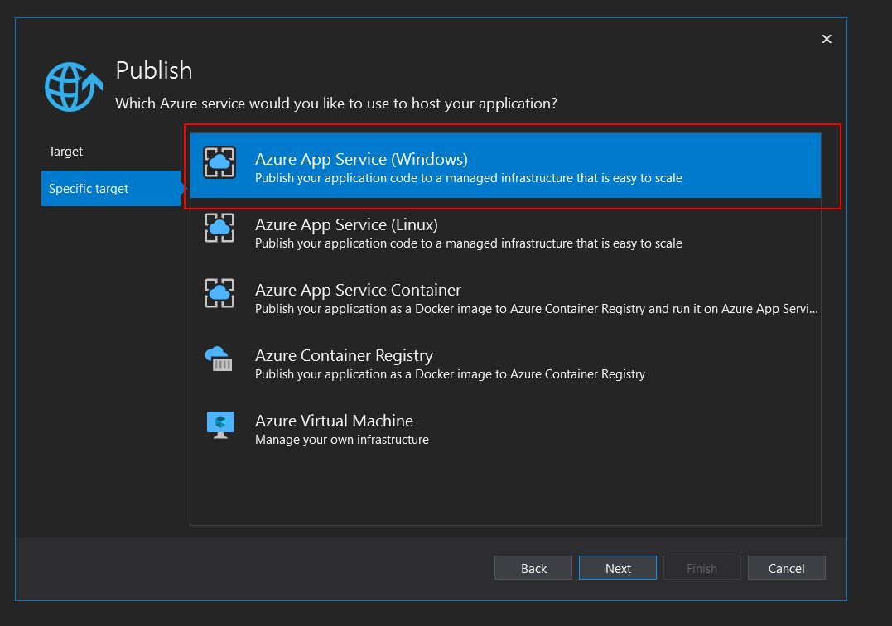

4) Either sign in and use an existing Azure Account or create a new account. I used my existing account and selected Sign in.

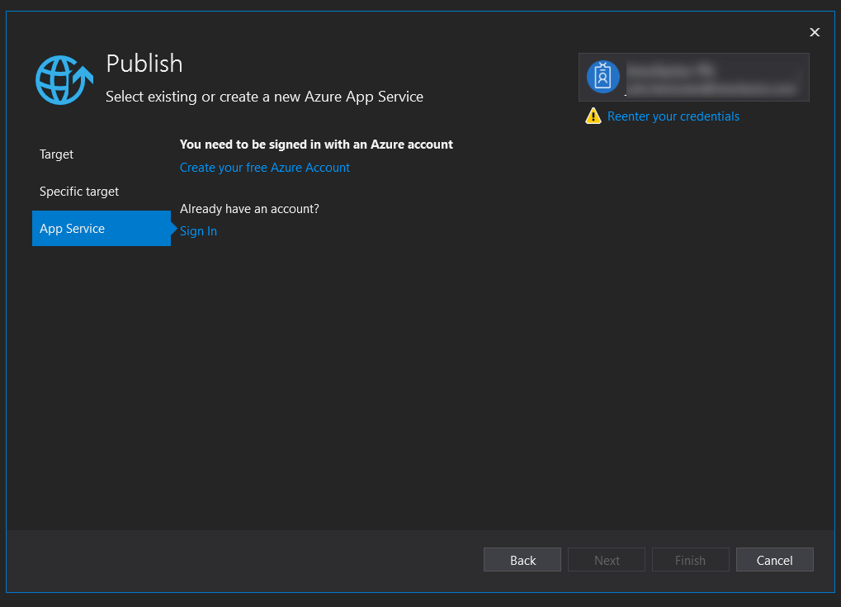

5) After signing in Azure Account, either create a new app service or use an existing one.

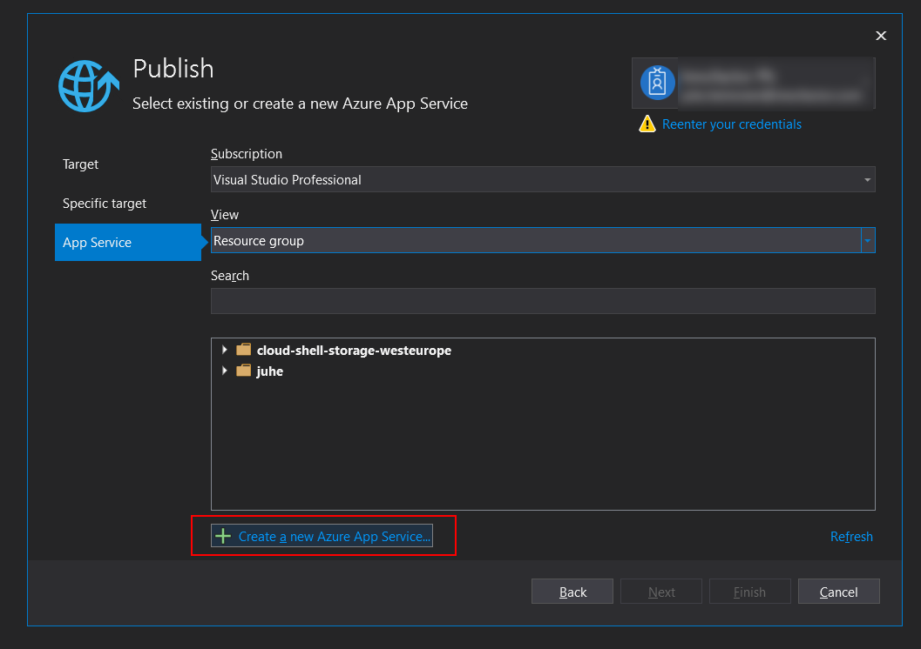

6) After creation of App Service (or selecting an existing app service), press Finish to proceed to confirmation of deploying the application (the Finish button is activated after selecting the App Service).

7) In the next screen you can see the URI of the service. Click Publish to finish the deploying of the application.

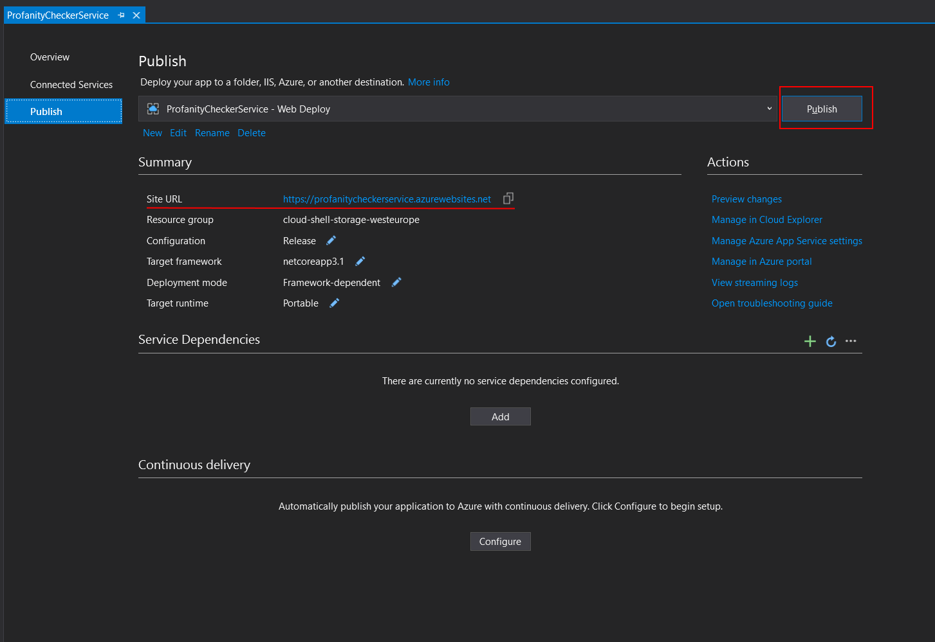

8) If publishing the application goes well, then, with default options, the a web browser will open and it will complain of 404 error. This is expected, as the site opens for root URI of the rest API, which does not have any functionality.

