Seamless Indoor-Outdoor Transition Detection Through Door Crossing Awareness Using Deep Learning

Group 11 – KSE801 “Data Analysis based on Deep Learning”

Juho Son  
 Industrial Engineering  
 Korea Advanced Institute of Science and Technology  
 Daejeon, South Korea  
 email@email.com

Keunchul Park  
 Civil & Environmental Engineering  
 Korea Advanced Institute of Science and Technology  
 Daejeon, South Korea  
 [email@email.com](mailto:email@email.com)

Joseph Berkner  
School of Computing  
 Korea Advanced Institute of Science and Technology  
 Daejeon, South Korea  
 josephberkner@kaist.ac.kr

ABSTRACT

∗Article Title Footnote needs to be captured as Title Note

†Author Footnote to be captured as Author Note

Permission to make digital or hard copies of part or all of this work for personal or classroom use is granted without fee provided that copies are not made or distributed for profit or commercial advantage and that copies bear this notice and the full citation on the first page. Copyrights for third-party components of this work must be honored. For all other uses, contact the owner/author(s).

*WOODSTOCK’18, June, 2018, El Paso, Texas USA*

Figure 1: Yearly trend of number of publications listed in *Google Scholar* using the keyword “Indoor Localization”

© 2018 Copyright held by the owner/author(s). 978-1-4503-0000-0/18/06...$15.00

https://doi.org/10.1145/1234567890

Indoor/outdoor detection provides essential information for mobile application. In indoor positioning systems, the seamless detection of environment changes (outdoor to indoor and vice versa) is a crucial part of setting up radio maps (the reference system in many such systems) and for a user-friendly experience. Different scanning strategies, whether indoors or outdoors, can achieve better performance. GNSS and Wi-Fi search provide better performance when scanning strategies vary between indoors and outdoors. Nevertheless, this field is still struggling with several challenges, especially regarding the time delay between the actual transition moment and the detected one. This paper tries to address this issue by introducing deep learning approaches using heterogeneous smartphone sensor data to detect indoor-outdoor transitions. The central assumption considered here is that we define a transition moment to be associated with the usage of a door. Therefore we focus our research on detecting door crossings with said sensor data. Our results show that...

CCS CONCEPTS

• **Computing methodologies ~ Neural networks** • Information systems ~ Mobile information processing systems

KEYWORDS

Indoor-Outdoor Transition Detection, Human Activity Detection, Indoor Localization, Deep Learning

ACM Reference format:

Joseph Berkner, Keunchul Park and Juho Son. 2020. Seamless indoor-outdoor transition detection through door crossing awareness using deep learning. In *Proceedings of ACM Woodstock conference (WOODSTOCK’18). ACM, New York, NY, USA, 2 pages.* https://doi.org/10.1145/1234567890

1 Introduction

Nowadays, indoor localization receives more attention among scientists than ever before (see figure 1). This is not to any surprise, because, for one thing, people are living more than 87% of their life in indoor environments (office, home, shopping center, etc.) [1] and, for another, in recent years smartphones became an essential part of our daily life and with them the ability to directly measure the position and activity of a person. Thus, the demand and technology are ready to be explored for indoor localization, which is not a trivial task due to the absence of sufficient GPS signal coverage inside buildings. In fact, many studies and techniques exist to locate a person in indoor environments, utilizing a wide range of sensor data from mobile phones and pre-existing infrastructure [2]. Here, one of the most promising methods is a Wi-Fi signal-based approach using received signal strengths (RSS). This is mostly due to the capability of every modern smartphone to detect such signals and a pre-established constellation of WiFi access points in many publically accessible buildings, which serve as a reference system for the positioning of a person the same way satellites do in GPS. This reference system is fed with so-called fingerprints, each one of them being a vector of RSS values from different AP's corresponding to a specific position in the indoor environment. The term referred to such a set of fingerprints representing a whole indoor environment is a radio map. The construction of such radio maps was very labor-intensive in the past, as people had to visit the buildings themselves beforehand to collect fingerprint data. Hence, it was also very inflexible in its ability to adapt to changes in the environment. With the emergence of smartphones, this becomes an unpopular approach because data can be directly collected using implicit crowdsourcing [3]. Besides the increasing success of such simultaneous localization and mapping (SLAM) methods [4-7], several challenges remain up to now, one of them being seamless indoor-outdoor transition detection (IOTD). Positioning systems in general struggle with the identification of the exact moment a user enters or exits a building. However, this is crucial for SLAM-based methods to simultaneously construct an accurate radio map as well as to provide a user-friendly navigation system.

In this paper, we discuss the idea of implementing an IOTD system based on the assumption that a person uses a door of some kind to transfer between indoor and outdoor. By using human activity detection strategies with smartphone sensor data and a deep learning algorithm, we try to detect the moment a person walks through a door and, thus, the point in time of building entrance or exit.

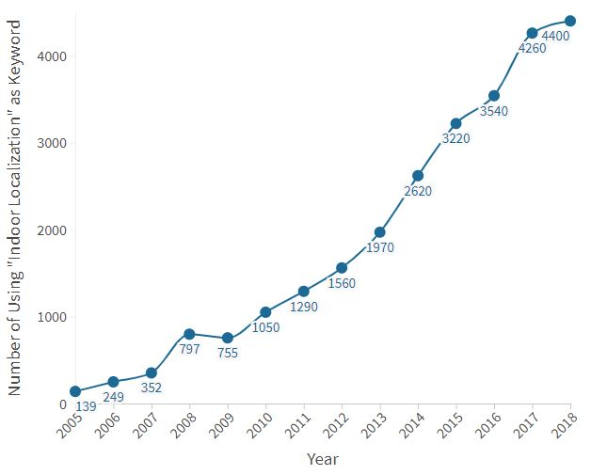

Figure 1: Yearly trend of number of publications listed in *Google Scholar* using the keyword “Indoor Localization”

2 Related Work

2.1 Indoor-Outdoor Transition Detection

IOTD is subject to extensive research in recent years. One of the earlier systems of leveraging smartphone sensor data to distinguish between outdoor and indoor environments was *IODetector* using a Hidden Markov Model (HMM) and reached a recognition accuracy of 96.2% [8]. Due to its dependence on cellular towers, it may not be a desirable approach nowadays as smartphones do not always record RSS of all neighboring towers [9]. Another multi-modal system is *SenseIO*, which used fixed detection rules from numerous sensors to reach an accuracy of over 92% [10]. However, because utilizing many sensors at the same time leads to high power consumption, other techniques exist to limit their number. Considering the fact of loss of GPS signal in indoor environments, a system may also solely use this information for IOTD [11,12]. This comes at a cost for accuracy, which may not reach the mark of 90%.

Machine learning also plays a more significant role in the field of IOTD. This includes stacking schemes [9,14] as well as semi-supervised deep learning-based methods [15].

However, only two other studies were found that did not exclusively concentrate their evaluation on the accuracy but also tried to decrease the transition time, meaning the time delay a system requires for IOTD. Sung et al. [13] proposed a sound-based IOTD system analyzing reverberation patterns of a special chirp sound probe. They achieved a detection accuracy of roughly 95%, with an average transition time of 3.81s. Zhu et al. [9] introduced a solution that accounted for all, a fast transition time (probability of switching delay within 3 s exceeding 80%) with a high detection accuracy (97.02% for new environments) for a set of environments with different levels of complexity.

2.2 Door Crossing Detection

As mentioned earlier, our approach to improving IOTD systems is to incorporate door crossing detection (DCD) as our assumption is that in most cases, a person enters/exits a building through a door. As an important note: This, however, will not account for so-called hybrid environments, in which the GPS signal is also week due to complex structures such as an open hall which do not have doors. Until now, DCD algorithms are usually vision- or infrastructure-based and mostly applied in the field of robotics. Currently, leveraging smartphone sensors for DCD has not a high demand in research yet, with only two papers addressing this strategy. Zhao et al. [16] concentrated their work on creating a lightweight solution with the primary data source coming from the magnetometer. The addition of other sensors is then based on a fusion method with a majority-voting model. The system leads to a DCD accuracy of 90% on average. However, their focus on magnetic sensor data leads to challenges in situations of noisy environments (e.g., metal doors) and due to the low quality of smartphones' magnetic sensors. Furthermore, the system was solely tested on indoor environments and thus not applied to perform IOTD. Racko et al. [17] did address this task to improve their pedestrian dead reckoning algorithm and reached an IOTD accuracy of 82.7%. However, they did not evaluate their system on transition time and mainly used accelerometer data in combination with positioning information to detect door crossing moments.

In contrast to the above two studies, we are applying deep learning methods on heterogeneous sensor data to enhance IOTD. To the best of our knowledge, the approach of combining DCD with deep learning methods for IOTD is novel and has the potential of notably decreasing the transition time.

3 Methodology

3.1 Data Acquisition

Nowadays most smartphones have several sensors built in. These sensors provide a navigation service. We were able to collect Accelerometer, GNSS, Gyroscope, Magnetic Field, Pressure and WifiRSS data, among which we used Accelerometer, GNSS (GPS) and WifiRSS data. We collected samples of sensor data from the university campus. The transition was labeled with 9 types, 3 types of indoor/outdoor directions and 3 types of doors.

**Figure 2. Type of Label**

As you can see in Fig 2, the Automatic and Automatic Button doors are significantly smaller numbers than Manual doors, so we classified them according to the indoor/outdoor transition type without distinguishing the type of door. The accelerometer data repre-sentting the change was mainly used to detect door opening motion, and the RSS data was analyzed by dividing it into 2GHz and 5GHz bandwidths.

3.2 Data Preprocessing

3.2.1. *Low Pass Filter on Accelerometer data (Moving average filter)*

Accelerometer data is data that represents change and plays a major role in recognizing human behavior. However, accelerometer data tends to include white noise which in turn disturb the extraction of meaningful information. It is important to remove white noise from the accelerometer data.

We used a moving average filter, the most commonly used filter in digital signal processing among low pass filters. It works best as a smoothing filter to reduce random white noise while maintaining step response in the time domain. In addition, when averaging signals, the dynamic variation is ignored. In the case of a moving average filter, the dynamic variation can be reflected because the average is moved by one point.

The moving average filter produces an output signal at each point by averaging the input signals.

$${\overline{p}}_{SM}=\frac{p_{M}+p_{M-1}+⋯+p_{M-(n-1)}}{n}$$

where $p_{i}$  is signal at time i, ${\overline{p}}_{SM}$  is the mean of the previous n data. As the above equation, moving average filter is a convolution using a simple filter kernel.

3.2.2. *Fast Fourier transform*

The change in the signal is caused by certain actions when opening the door and noise. Certain behaviors mean to move aside the body sideways, twist it or wait a moment when opening the door. It cannot be predicted and concluded all of these things. Analysis of signal changes is important to detect these actions. We use Fourier transform that decomposes data over time into frequencies.

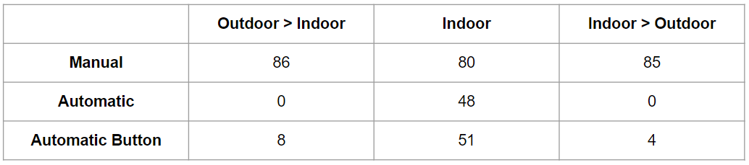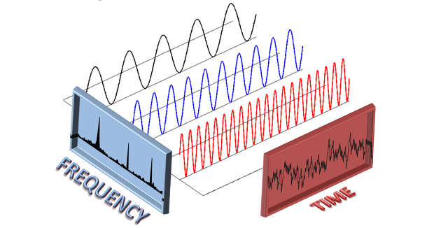

**Figure 3. Fourier transform**

In signal processing, these Fourier transforms are used throughout the industry. The Fast-Fourier-transform(FFT) we use is an algorithm that reduces the computational complexity of the Discrete Fourier transform. Fast Fourier transform bring the data constantly changing in the time domain into the frequency domain and tell them what frequencies they consist of. New signals generated by certain actions when opening the door are converted to certain frequency by FFT. Using this property of FFT, we apply FFT to IOTD for detecting certain actions.

3.2.3. *Sliding Window Algorithm*

In this study, we want to detect the transition point by the behavior of opening the door. The behavior of opening the door is a continuous operation that makes it difficult to achieve the desired result with a single signal of data. The sensor data is changing continuously while users pass through door, we need to know how the signal changes over a certain time interval. The sliding window technique analyzes a window of a certain size(window size) moving at a constant rate. With this sliding window technique, we detect specific patterns that occur during the opening operation. In addition, the sliding window technique reduces the time complexity of the algorithm and can be used efficiently for dynamic data. It can reduce the time complexity by making the most of what it have already calculated so it can quickly find the next one. The problem that needs to be solved above O (N2) is solved by linear time O (N) with sliding window technique.

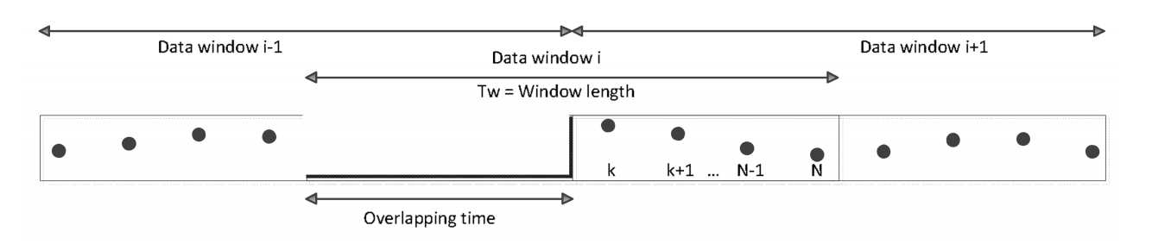

**Figure 4. Sliding window Approach (Each window consists of N data with overlap ratio of 50%)**

When using the sliding window technique, two values must be set. The first is how many signal data to use in a single process at window size. Smaller sizes tend to detect what happens for a shorter time, while larger sizes tend to detect what happens for a longer time. Therefore, we need to change the window size according to the nature of what we want to detect. As a result of proceeding with different window sizes, it has the highest accuracy when set to 1 seconds. When people pass through the door, the behavior change time of the visible is approximately 1 seconds. Considering these things, we set the window size to 1 seconds. Another value we need to determine is the overlap ratio. In many studies, the overlap ratio is set to 50%, so in this study the overlap ratio is set to 50%.

3.2.4. *Labeling & Sampling*

Our labeled data is more than 95% non-transtion case, and less than 5% is transition case. As the difference in class ratio becomes larger, the accuracy of the model which simply selects the dominant class becomes higher, which makes it difficult to determine the performance of the model. This may cause a phenomenon in which the recall rate of a class having a small number of data decreases rapidly even though the accuracy is high. The problems caused by the difference in the number of data belonging to each class are called an imbalanced data problem.

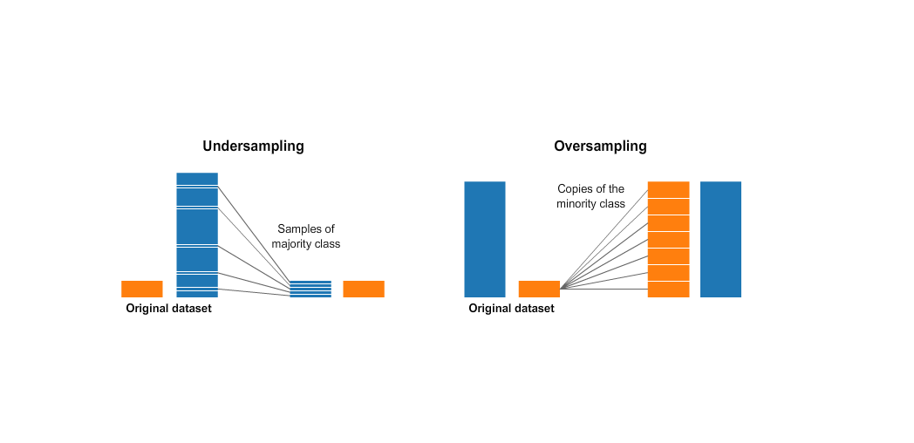

**Figure 5. Undersampling**

To overcome the asymmetric data problem, we use under-sampling. Under-sampling balances class data by using only some part of the majority of class data. We use Undersampling to the samples with non-transition to prevent the ratio between labels do not exceed 0.55(A meaningful information of non-transition data may be lost due to undersampling. However, since we just want to detect the transition point, it is not a big problem to lose information of non-transition data.)

4. Model Design

In this study, we chose a model with a small number of possible parameters because this study just has limited number of samples. We have implemented these models and studied each one. The models we picked are RNN, LSTM, and GRU.

4.1. *Model Overview*

RNN, LSTM, and GRU are all many-to-one models that take multiple inputs and produce one output. Receive 10 input data and train separately with each model. After that, we go through the Batch Normalization process and then create an output layer using sigmoid as an activation function. The output value has a value between 0 and 1, where 0.5 or more is 1 and the rest is 0. 0 means non-transition point and 1 means transition point.

4.2. *Specifications*

During training, we assigned the trainset to 70% (It means test set is 30%). At this time, we set the validation ratio to 0.2. The optimizer set the SGD With learning rate is 0.01. The goal of this study is to find the transition point, which is a binary problem whose output consists only of 0 and 1. Therefore, Binary cross entropy is used as the loss function. We used accuracy and F1-score as the metric, and set Epoch to 1000.

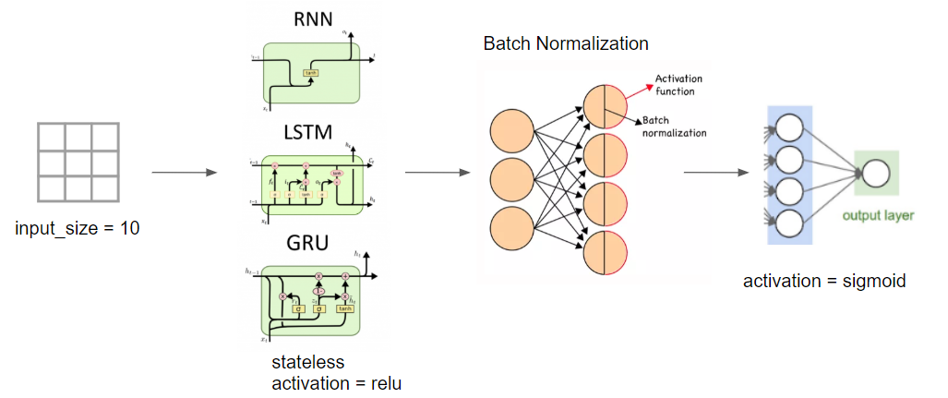

**Figure 6. Model Overview**

5. Results

The accuracy of our method is compared with the Baseline (Majority Vote). We compare the three models to the base line with the accuracy and the F1-score. All three had higher accuracy than the baseline, and especially LSTM and GRU models showed better performance. GRU showed the best performance for validation dataset and LSTM showed the best performance for test dataset.

|  |  |  |  |  |
| --- | --- | --- | --- | --- |
| Model | Val | | Test | |
| acc | F1 | acc | F1 |
| Baseline(Majority Vote) | 0.517 | 0.682 | 0.517 | 0.682 |
| RNN | 0.791 | 0.772 | 0.812 | 0.771 |
| LSTM | 0.806 | 0.781 | 0.821 | 0.791 |
| GRU | 0.821 | 0.813 | 0.816 | 0.790 |

**Figure 7. ~~~**

We trained the LSTM model on several input sizes to find the appropriate input size. The best performance was obtained when input size was 10. So we set input size to 10.

|  |  |  |  |  |  |
| --- | --- | --- | --- | --- | --- |
| Input_size | Detection scope(s) | Val | | Test | |
| Acc | F1-score | Acc | F1-score |
| 3 | 2 | 0.750 | 0.727 | 0.770 | 0.785 |
| 4 | 2.5 | 0.711 | 0.723 | 0.756 | 0.713 |
| 6 | 3.5 | 0.758 | 0.705 | 0.776 | 0.757 |
| 8 | 4.5 | 0.715 | 0.750 | 0.750 | 0.780 |
| 10 | 5.5 | 0.806 | 0.781 | 0.821 | 0.791 |

**Figure 8.~~~**

We used a sliding window algorithm to preprocess the model. When using this technique, we had to set the window size, so we had to find the optimal window size. We thought that the time that the behavior of opening door affects the signal is about 1 second, so we assumed that we should set the window size to around 1 second(0.5s, 1s, 2s). In the LSTM model, f1-score was best when the window size was 0.5s,

|  |  |  |  |  |  |
| --- | --- | --- | --- | --- | --- |
| Window size(ms) | Detection scope(s) | Val | | Test | |
| Acc | F1-score | Acc | F1-score |
| 500 | 2.75 | 0.767 | 0.797 | 0.793 | 0.793 |
| 1000 | 5.5 | 0.806 | 0.781 | 0.821 | 0.791 |
| 2000 | 11 | 0.805 | 0.733 | 0.808 | 0.782 |

but the accuracy was the best when the window size was 1s. In the case of F1-score, 'the window size = 0.5s' is a little better, and in the case of accuracy, 'the window size = 1s' is much better, so we set the window size to 1s.

**Figure 9. ~~~**

6. Discussion and Future Work

In this study, data collection was conducted in only three buildings on university campus. In three buildings, about 20 doors were used for data collection. Depending on the location and structure of the door, the behavior of opening the door was similar, but somewhat different. Some doors had to be pulled, some doors had to be pushed, and some doors had to be pulled or pushed with strong. Some automatic doors responded fast while others responded late. As such, the characteristics of the doors affected the user's behavior a lot. In addition, the behavior of each user who performed data collection apart from the types of door differed slightly. People's own behavior may also have influenced the signal of the behavior of opening the door(some people open the door with their hands and some with their bodies). Considering these things, it is expected that better results will be generated by more diverse people performing data collection on many doors in different buildings.

In this study, only about indoor/outdoor-direction detection (Indoor to outdoor, outdoor to indoor, indoor to indoor) was performed. If more data is collected, it will be developed into an IOTD capable of door type classification.

Data preprocessing was done using a low pass filter on the accelerometer, but adding various features, such as the Kalman filter, to the model will give better results. We used only Accelerometer, GNSS and Wifi-RSS data from the six kinds of data we collected. Using magnetic field data will make more accurate indoor / outdoor transition detector. Magnetic field data is good for detecting human behavior in response to movement. However, magnetic field data has a disadvantage of including a lot of white noise due to the influence of the surrounding environment. Denoising must be done before using magnetic data. Denoising can eliminate white noise by applying Edge Preserving Algorithm. Edge Preserving Algorithm is an algorithm that gives weight to magnetic data by multiplying Gaussian for space and Gaussian for range.

By giving Gaussian values ​​for the range to the weights, if the magnetic field sensor strength shows a large difference, it will play a role of removing white noise by lowering the value by reducing the weight. By giving the gaussian weights and standardization within the window size range, it plays a role in smoothly catching those whose values ​​change rapidly due to noise. As a result, the signal fluctuation of the magnetic signal due to the behavior of opening the door is clearer by eliminating random measurement noise.

Applying Kalman filter algorithm to our research will yield better accuracy. Kalman filters are used to estimate the state of a system that is difficult to measure directly. The state of the system to be estimated is information such as position, speed, direction, and behavior. Kalman filters are used to find signals from noise so that a system properly predicts changes over time. Because the data of this study contains a lot of white noise, it was inconvenient to deal with it. But Kalman filter can be used to eliminate the problems related to white noise. Kalman filter is a filter whose main purpose is estimation. It is estimated based on the values ​​of several sensors and is mainly used in when there is a lot of noise. The main areas of use for Kalman filters are navigation, control systems, computer vision and signal processing. This Kalman filter is consist of two stages. In the state prediction step, the state of the system is estimated linearly, and next measurement update step, more accurate prediction is made through the values ​​included from the state prediction to the measured measurement. It is a recursive algorithm that performs these two steps repeatedly to estimate the state. (The output produced by Kalman filter algorithm is then used for the next step calculation.) The advantage of these filters will further increase our IOTD accuracy.

If some model uses a lot of sensor data, the accuracy will increase. However, the more sensors, the more battery usage will be used, which will cause battery shortage problems. So if we make an IOTD with only a few data that are sensitive to human behavior, we'll get good results in terms of battery efficiency.

7. Conclusion

ACKNOWLEDGMENTS

Insert paragraph text here. Insert paragraph text here. Insert paragraph text here. Insert paragraph text here. Insert paragraph text here. Insert paragraph text here. Insert paragraph text here. Insert paragraph text here. Insert paragraph text here. Insert paragraph text here. Insert paragraph text here.

REFERENCES

[1] Neil Klepeis, William Nelson, Wayne Ott and John Robinson. 2001. The National Human Activity Pattern Survey (NHAPS): A Resource for Assessing Exposure to Environmental Pollutants. Journal of Exposure Analysis and Environmental Epidemiology 11, 3. LBNL Report #: LBNL-47713.

[2] Hui Liu, Houshang Darabi, Pat Banerjee and Jing Liu. 2007. Survey of Wireless Indoor Positioning Techniques and Systems. IEEE Transactions on Systems, Man, and Cybernetics, Part C (Applications and Reviews) 37, 6 (Nov. 2007), 1067-1080. DOI: 10.1109/TSMCC.2007.905750

[3] Baharesh Lashkari, Javad Rezazadeh, Reza Farahbakhsh and Kumbesan Sandrasegaran. 2018. Crowdsourcing and sensing for indoor localization in iot: a review. *IEEE Sensors Journal* 19, 7 (Apr. 2019), 2408-2434. DOI: 10.1109/JSEN.2018.2880180

[4] Han Zou, Ming Jin, Hao Jiang, Lihua Xie and Costas Spanos. 2017. WinIPS: wifi-based non-intrusive indoor positioning system with online radio map construction and adaptation. *IEEE Transactions on Wireless Communications* 16, 12 (Dec. 2017), 8118-8130. DOI: 10.1109/TWC.2017.2757472

[5] Suk-Hoon Jung, Byung-chul Moon and Dongsoo Han. 2015. Unsupervised learning for crowdsourced indoor localization in wireless networks. IEEE Transactions on Mobile Computing 15, 11 (Nov. 2016), 2892-2906. DOI: 10.1109/TMC.2015.2506585

[6] Anshul Rai, Krishna Chintalapudi, Venkata Padmanabhan, Rijurekha Sen. 2012. Zee: zero-effort crowdsourcing for indoor localization. In Proceedings of the 18th annual international conference on Mobile computing and networking *(Mobicom '12)*. ACM, New York, NY, USA, 293-304. DOI: https://doi.org/10.1145/2348543.2348580

[7] Min Zhang, Ling Pei and Xiaotie Deng. 2016. GraphSLAM-based crowdsourcing framework for indoor wi-fi fingerprinting. In 2016 Fourth International Conference on Ubiquitous Positioning, Indoor Navigation and Location Based Services (UPINLBS). Shanghai, 61-67. DOI: 10.1109/UPINLBS.2016.7809951

[8] Pengfei Zhou, Yuanqing Zheng, Zhenjiang Li and Guobin Shen. 2012. IODetector: A generic service for indoor outdoor detection. In *Proceedings of the 10th ACM Conference on Embedded Networked Sensor Systems (SenSys ‘12)*. ACM, New York, NY, USA, 113-126. DOI: 10.1145/2426656.2426668.

[9] Yida Zhu, Haiyong Luo, Qu Wang, Fang Zhao, Bokun Ning, Qixue Ke and Chen Zhang. 2019. A fast indoor/outdoor transition detection algorithm based on machine learning. *Sensors (Basel, Switzerland)* 19, 4 (Feb. 2019), 786. DOI: 10.3390/s19040786

[10] Mohsen Ali, Moustafa Youssef and Tamer El Batt. 2018. SenseIO: Realistic ubiquitous indoor outdoor detection system using smartphones. *IEEE Sensors Journal* 18, 9 (May 2018), 3684–3693. DOI: 10.1109/JSEN.2018.2810193

[11] Kongyang Chen and Guang Tan. 2017. SatProbe: Low-energy and fast indoor/outdoor detection based on raw GPS processing. In *Proceedings of the IEEE INFOCOM 2017—IEEE Conference on Computer Communications*. Atlanta, GA, USA, 1–9. DOI: 10.1109/INFOCOM.2017.8057095

[12] Han Gao and Paul D. Groves. 2018. Environmental context detection for adaptive navigation using gnss measurements from a smartphone. *J. Inst. Navig* 65, 99–116. DOI: 10.1002/navi.221

[13] Rakmin Sung, Suk-hoon Jung and Dongsoo Han. 2015. Sound based indoor and outdoor environment detection for seamless positioning handover. *ICT Express* 1, 3, 106–109. DOI: https://doi.org/10.1016/j.icte.2016.02.001

[14] Imran Ashraf, Soojung Hur and Yongwan Park. 2018. MagIO: Magnetic field strength based indoor- outdoor detection with a commercial smartphone. *Micromachines* 9, 10 (Oct. 2018), 534. DOI: 10.3390/mi9100534

[15] Illyyne Saffar, Marie L. A. Morel, Kamal D. Singh and Cesar Viho. 2019. Semi-supervised deep learning-based methods for indoor outdoor detection. In ICC 2019 - 2019 IEEE International Conference on Communications (ICC). Shanghai, China, 1-7. DOI: 10.1109/ICC.2019.8761297

[16] Liangyi Gong, Yiyang Zhao, Chaocan Xiang, Zhenhua Li, Chen Qian and Panlong Yang. 2019. Robust light-weight magnetic-based door event detection

with smartphones. IEEE Transactions on Mobile Computing 18, 11 (Nov. 2019), 2631-2646. DOI: 10.1109/TMC.2018.2876841

[17] Jan Racko, Juraj Machaj and Peter Brida. 2018. Ubiquitous smartphone based localization with door crossing detection. *Engineering Applications of Artificial Intelligence* 75, 88-93. DOI: <https://doi.org/10.1016/j.engappai.2018.08.001>

[18] Lu, Shixian & Qu, Daiming & He, Yejun. (2012). Sliding Window Tone Reservation Technique for the Peak-to-Average Power Ratio Reduction of

[19] FBMC-OQAM Signals. Wireless Communications Letters, IEEE. 1. 268-271. 10.1109/WCL.2012.062512.120360.

[20] Houtekamer, P.L. and H.L. Mitchell, 1998: [Data Assimilation Using an Ensemble Kalman Filter Technique.](https://journals.ametsoc.org/doi/abs/10.1175/1520-0493%281998%29126%3C0796%3ADAUAEK%3E2.0.CO%3B2) Mon. Wea. Rev., 126, 796–811, [https://doi.org/10.1175/1520-0493(1998)126<0796:DAUAEK>2.0.CO;2](https://doi.org/10.1175/1520-0493(1998)126%3C0796:DAUAEK%3E2.0.CO;2)

Edge preserving detection

IOTD관련 찾아본거 하나

Conference Name:ACM Woodstock conference

Conference Short Name:WOODSTOCK’18

Conference Location:El Paso, Texas USA

ISBN:978-1-4503-0000-0/18/06

Year:2018

Date:June

Copyright Year:2018

Copyright Statement:rightsretained

DOI:10.1145/1234567890

RRH: F. Surname et al.

Price:$15.00