With Optimazion Flag 01:

Vectorlength 50



Vectorlength 20



Vectorlength 10:



Without Optimaion Flag:

Vectorlength 50



Vectorlength 20



Vectorlength 10:



As you can see the optimization flag helps a lot.

With Flag:

-ftree-vectorize WITHOUT O1 Flag

In the Internet there was that this command only also makes O3 optimization. So if you extra give the Flag O1 plus the vectorize Flag so you have ( mostly ) only vectorizing, like required. Only Vectorizing is not possible as I saw in the internet.

Vectorlength 50



Vectorlength 20



Vectorlength 10:



With Flag:

-ftree-vectorize AND O1 Flag

Vectorlength 50



Vectorlength 20



Vectorlength 10:



So as you can see the best results you have are with ONLY ( mostly ) Vectorizing.This you can archieve with the vector flag and the O1 Flag.

When you don’t do this vector makes automatically O3 and this is worse. Next best results would be simply O1 flag.

**False Results ?**

No I get the right results, I checked it everytime with the Output of Every Vector Input. Stays the same.

**Change Problem Size?**

No not really , maybe a little bit it changes the calculation , but nothing special because the number is already very high.

Using Perf:

I decided to look deeper into the difference between the vectorization with and without O1.

So I compared both of them with perf tools.



This event counts the number of Streaming SIMD Extensions (SSE) packed-single instructions retired.



Retired Streaming SIMD Extensions 2 (SSE2) vector instructions.

Vectorization WITH O1



Ein Bild, das Text enthält.



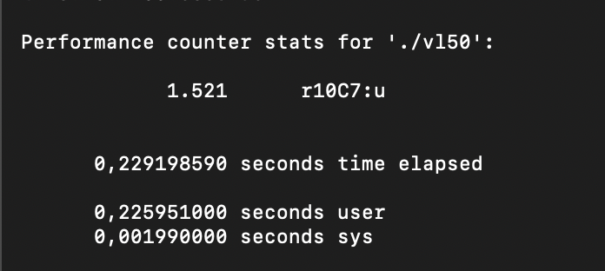

WITHOUT O1 ( O3 ) automatically )



Ein Bild, das Text enthält.



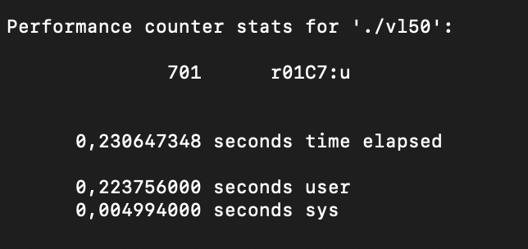

LL2 Measures:

Only with vector flag -



With Vector Flag O1 extra ( only vectorizing )

