**Exercise 1**

Team: Summit

**Consider the following individual code snippets, and analyze them regarding dependencies.**

**Regarding each snippet**

**- What are the data dependencies?**

**- Parallelize and optimize the code**

Snippet 1:

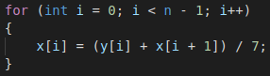

[**Anti - dependence**,](https://en.wikipedia.org/wiki/Dependence_analysis) the location in memory is read before that same location is written to. Paralyzed: by privatization

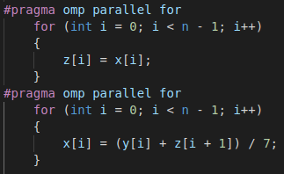

Snippet 2:

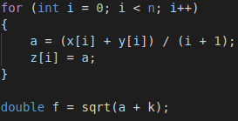

[**True - dependence**](https://en.wikipedia.org/wiki/Dependence_analysis)**,**memory is written to before it is read.

Paralyzed by eliminating a[n], and use of #pragma.

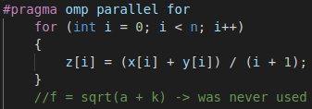

Snippet 3:

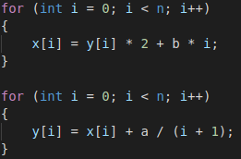

[**True - dependence**](https://en.wikipedia.org/wiki/Dependence_analysis)**,**memory is written to before it is read, but there’re its own loops.

Paralyzed by use of #pragma.

