Exercise 1

Team: Summit

Assume that during testing of your program on a scalar architecture, you found that the execution time is too slow, and you have to optimize it. You suppose that the following extracts significantly impact the execution time of your program.

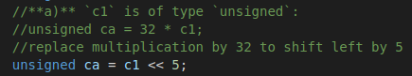

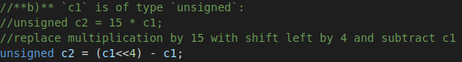

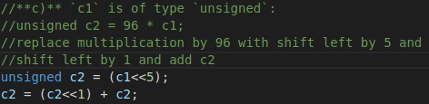

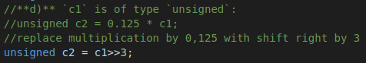

1. Djdjdjjd