Output:



What happens ?

-ftree-vectorize

Turns on autovectorization, but default is O3, but here O2.

Ein Bild, das Text enthält.

Ein Bild, das Text enthält.

Ein Bild, das Text enthält.

Ein Bild, das Text enthält.

And so on…

**What Informations about dependencies?**

Dependencies is a relationship between 2 computations.

Ein Bild, das Text enthält.

Here for example are Informations about dependencies.

* Dependence Distance = 4
* Here you have distance vectors
* Describe dependencies among iterations (not among array elements )
* For each dimension of an iteration space the distance is the number of iterations between accesses to the same memory location.
* Dependence Direction is negative
* So the after iteration needs the previous
* You can see this in a dependency graph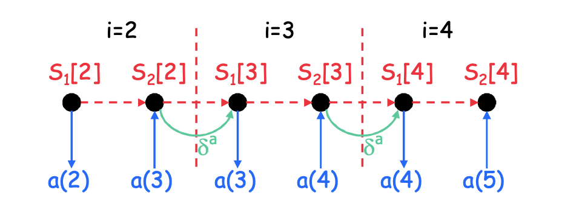
* Would be the opposite direction, this is a positive one.

**Any Information about successful / unsuccessful vectorization?**

Unsuccessful:

**Ein Bild, das Text enthält.
**



* Gather is a kind of vector addressing. And the load from this addressing is not suited
* Function calls which can be not vectorized for different reason ( function calls are critical for vectorisations ( lecture said ) ).

Successful:

Ein Bild, das Text enthält.

* If successful the vectors gets made ( get vectype … )

**Does the compiler perform any analysis beyond checking for dependencies and semantic correctness?**

**Ein Bild, das Text enthält.
**

* The compiler examines statements
* Calculates phi
* Checks if accesses have the same alignment. Maybe for optimization?!
* Checks if Stmt relevant ( statements ) , but this can mean anything according to the internet.