**Exercise 3**

Team: Summit

**Description:** Investigate the following given code examples along with their task.

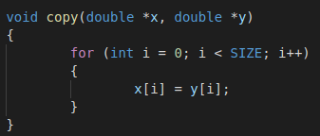

1. **Can this code be safely parallelized manually?**

Yes, for example with

#pragma omp for

**Can this code be safely parallelized by the compiler?**

Yes, there’s no problem. I tried it with the compiler flag -O1 and -O3 and got a very good speedup.

1. Normalize the following loop nest.

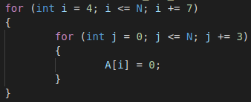

Normalized:

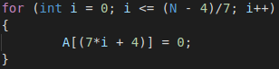

The speedup is enormous from 16sec. to 0,008 sec. But we must be aware that (N – 5)/7 results in an Integer, otherwise we can become conflicts due segmentation fault.

1. Does the following code excerpt hold any dependencies?

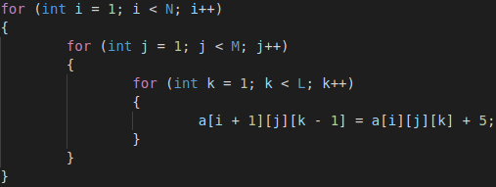

Yes. The nested loops use the overlaying variables.

If not, how would you parallelize it?

If yes, what are the distance and direction vectors?

**Distance vectors**: captures the “shape” of dependences, but not the particular source and sink. **Direction vectors**: captures the “direction” of dependences, but not the particular shape.

S1 has a true dependence on itself.

e.g S1[1,1,2] & S1[2,1,1] for a(2,1,1)

Distance Vector = (1,0,-1)

Direction Vector = (<,=,>)