Parallel:

Values with the parallel region in the main and with single region

Ein Bild, das Text enthält.

Values with the parallel function in the function itself with single region

Ein Bild, das Text enthält.

Then I tried to sum the variables up before returning but these also got us just a few miliseconds improvement.

Ein Bild, das Text enthält.

It is better but not even as good as the serial version.

Serial:

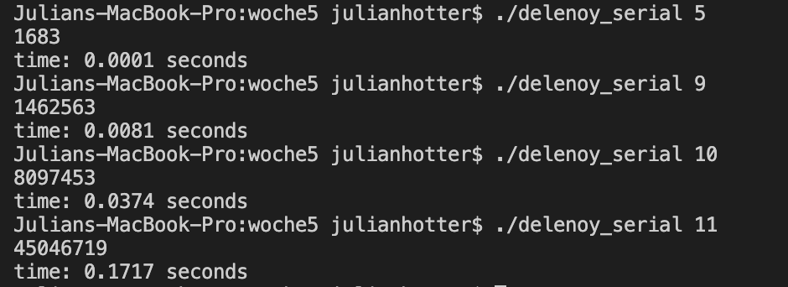

On my local computer the serial version is way faster than the tasked version, I have trief many different approaches , but it never gets faster than the sequential version.

Now on the LCC2.

SERIAL :

N = 12

With 1 and 8 threads

Ein Bild, das Text enthält.

Parallel

N = 12

With 1 and 8 threads

Ein Bild, das Text enthält.

So again, de serial version is way better. But with 8 Threads there is a big improvement on the parallel version.

**Main Bottleneck:**

The main bottleneck could be that the threads have to share the variables and have to wait ( taskwait ) , when one task is slow the others also get slow. Therefore, you don`t have that good times as you expect. We tried very much different OMP variation ( see above ) but nothing did the big thing for better times.

**Improve?:**

We tried much to improve but I think that would not be possible unless it changes the underlying algorithm.

Maybe don`t make the taskwait , but then you have synchronization problems und false results get here sometimes.

Maybe tasks are not the best idea for that kind of task ?