attrition

Autogenerated data summary from dataMaid

2019-08-14 15:31:54

# Data report overview

The dataset examined has the following dimensions:

|  |  |
| --- | --- |
| Feature | Result |
| Number of observations | 870 |
| Number of variables | 31 |

### Checks performed

The following variable checks were performed, depending on the data type of each variable:

|  |  |  |  |  |  |  |  |  |
| --- | --- | --- | --- | --- | --- | --- | --- | --- |
|  | character | factor | labelled | haven labelled | numeric | integer | logical | Date |
| Identify miscoded missing values | × | × | × | × | × | × |  | × |
| Identify prefixed and suffixed whitespace | × | × | × | × |  |  |  |  |
| Identify levels with < 6 obs. | × | × | × | × |  |  |  |  |
| Identify case issues | × | × | × | × |  |  |  |  |
| Identify misclassified numeric or integer variables | × | × | × | × |  |  |  |  |
| Identify outliers |  |  |  |  | × | × |  | × |

Please note that all numerical values in the following have been rounded to 2 decimals.

# Summary table

|  |  |  |  |  |
| --- | --- | --- | --- | --- |
|  | Variable class | # unique values | Missing observations | Any problems? |
| Age | integer | 43 | 0.00 % | × |
| Attrition | factor | 2 | 0.00 % |  |
| BusinessTravel | factor | 3 | 0.00 % |  |
| DailyRate | integer | 627 | 0.00 % |  |
| Department | factor | 3 | 0.00 % |  |
| DistanceFromHome | integer | 29 | 0.00 % |  |
| Education | integer | 5 | 0.00 % |  |
| EducationField | factor | 6 | 0.00 % |  |
| EnvironmentSatisfaction | integer | 4 | 0.00 % |  |
| Gender | factor | 2 | 0.00 % |  |
| HourlyRate | integer | 71 | 0.00 % |  |
| JobInvolvement | integer | 4 | 0.00 % |  |
| JobLevel | integer | 5 | 0.00 % |  |
| JobRole | factor | 9 | 0.00 % |  |
| JobSatisfaction | integer | 4 | 0.00 % |  |
| MaritalStatus | factor | 3 | 0.00 % |  |
| MonthlyIncome | integer | 826 | 0.00 % |  |
| MonthlyRate | integer | 852 | 0.00 % |  |
| NumCompaniesWorked | integer | 10 | 0.00 % |  |
| OverTime | factor | 2 | 0.00 % |  |
| PercentSalaryHike | integer | 15 | 0.00 % |  |
| PerformanceRating | integer | 2 | 0.00 % |  |
| RelationshipSatisfaction | integer | 4 | 0.00 % |  |
| StockOptionLevel | integer | 4 | 0.00 % |  |
| TotalWorkingYears | integer | 39 | 0.00 % | × |
| TrainingTimesLastYear | integer | 7 | 0.00 % | × |
| WorkLifeBalance | integer | 4 | 0.00 % |  |
| YearsAtCompany | integer | 32 | 0.00 % | × |
| YearsInCurrentRole | integer | 19 | 0.00 % | × |
| YearsSinceLastPromotion | integer | 16 | 0.00 % |  |
| YearsWithCurrManager | integer | 17 | 0.00 % | × |

# Variable list

## Age

|  |  |
| --- | --- |
| Feature | Result |
| Variable type | integer |
| Number of missing obs. | 0 (0 %) |
| Number of unique values | 43 |
| Median | 35 |
| 1st and 3rd quartiles | 30; 43 |
| Min. and max. | 18; 60 |

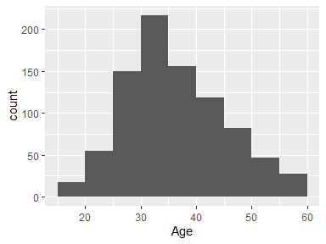

* Note that the following possible outlier values were detected: "18", "19", "20", "21".

## Attrition

|  |  |
| --- | --- |
| Feature | Result |
| Variable type | factor |
| Number of missing obs. | 0 (0 %) |
| Number of unique values | 2 |
| Mode | “No” |
| Reference category | No |

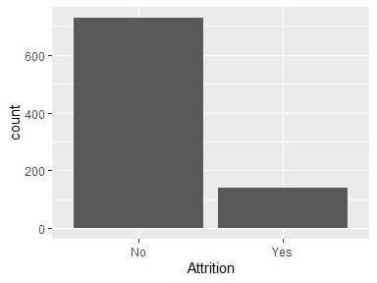

## BusinessTravel

|  |  |
| --- | --- |
| Feature | Result |
| Variable type | factor |
| Number of missing obs. | 0 (0 %) |
| Number of unique values | 3 |
| Mode | “Travel_Rarely” |
| Reference category | Non-Travel |

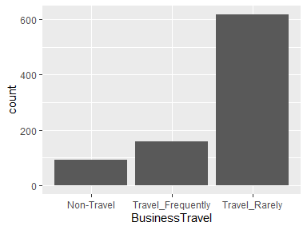

## DailyRate

|  |  |
| --- | --- |
| Feature | Result |
| Variable type | integer |
| Number of missing obs. | 0 (0 %) |
| Number of unique values | 627 |
| Median | 817.5 |
| 1st and 3rd quartiles | 472.5; 1165.75 |
| Min. and max. | 103; 1499 |

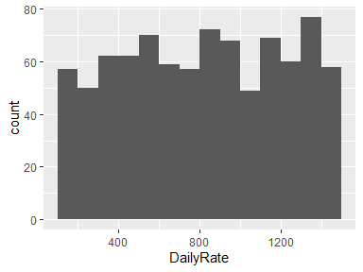

## Department

|  |  |
| --- | --- |
| Feature | Result |
| Variable type | factor |
| Number of missing obs. | 0 (0 %) |
| Number of unique values | 3 |
| Mode | “Research & Development” |
| Reference category | Human Resources |

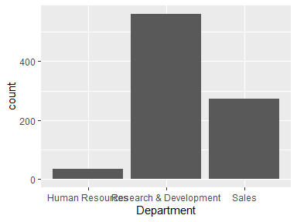

## DistanceFromHome

|  |  |
| --- | --- |
| Feature | Result |
| Variable type | integer |
| Number of missing obs. | 0 (0 %) |
| Number of unique values | 29 |
| Median | 7 |
| 1st and 3rd quartiles | 2; 14 |
| Min. and max. | 1; 29 |

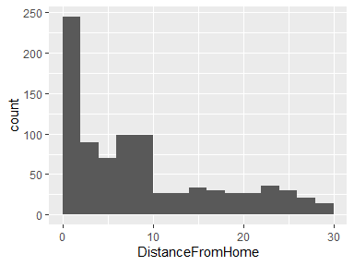

## Education

* Note that this variable is treated as a factor variable below, as it only takes a few unique values.

|  |  |
| --- | --- |
| Feature | Result |
| Variable type | integer |
| Number of missing obs. | 0 (0 %) |
| Number of unique values | 5 |
| Mode | “3” |
| Reference category | 1 |

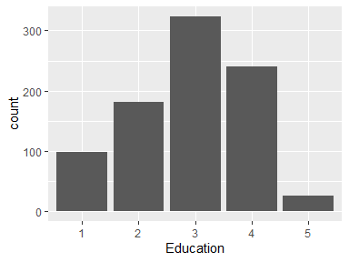

## EducationField

|  |  |
| --- | --- |
| Feature | Result |
| Variable type | factor |
| Number of missing obs. | 0 (0 %) |
| Number of unique values | 6 |
| Mode | “Life Sciences” |
| Reference category | Human Resources |

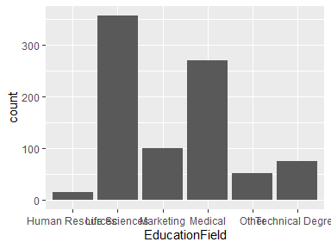

## EnvironmentSatisfaction

* Note that this variable is treated as a factor variable below, as it only takes a few unique values.

|  |  |
| --- | --- |
| Feature | Result |
| Variable type | integer |
| Number of missing obs. | 0 (0 %) |
| Number of unique values | 4 |
| Mode | “4” |
| Reference category | 1 |

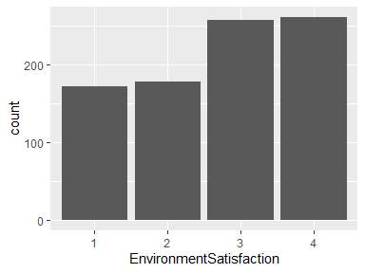

## Gender

|  |  |
| --- | --- |
| Feature | Result |
| Variable type | factor |
| Number of missing obs. | 0 (0 %) |
| Number of unique values | 2 |
| Mode | “Male” |
| Reference category | Female |

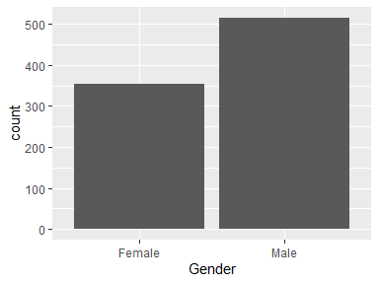

## HourlyRate

|  |  |
| --- | --- |
| Feature | Result |
| Variable type | integer |
| Number of missing obs. | 0 (0 %) |
| Number of unique values | 71 |
| Median | 66 |
| 1st and 3rd quartiles | 48; 83 |
| Min. and max. | 30; 100 |

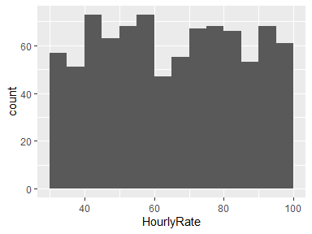

## JobInvolvement

* Note that this variable is treated as a factor variable below, as it only takes a few unique values.

|  |  |
| --- | --- |
| Feature | Result |
| Variable type | integer |
| Number of missing obs. | 0 (0 %) |
| Number of unique values | 4 |
| Mode | “3” |
| Reference category | 1 |

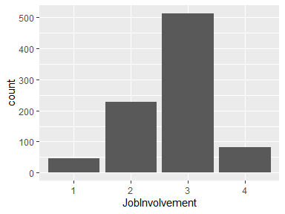

## JobLevel

* Note that this variable is treated as a factor variable below, as it only takes a few unique values.

|  |  |
| --- | --- |
| Feature | Result |
| Variable type | integer |
| Number of missing obs. | 0 (0 %) |
| Number of unique values | 5 |
| Mode | “1” |
| Reference category | 1 |

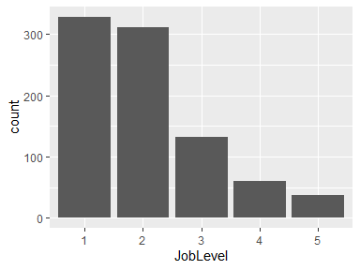

## JobRole

|  |  |
| --- | --- |
| Feature | Result |
| Variable type | factor |
| Number of missing obs. | 0 (0 %) |
| Number of unique values | 9 |
| Mode | “Sales Executive” |
| Reference category | Healthcare Representative |

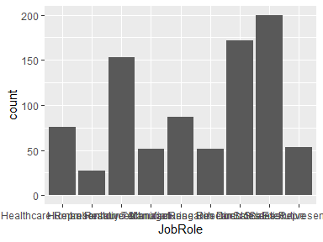

## JobSatisfaction

* Note that this variable is treated as a factor variable below, as it only takes a few unique values.

|  |  |
| --- | --- |
| Feature | Result |
| Variable type | integer |
| Number of missing obs. | 0 (0 %) |
| Number of unique values | 4 |
| Mode | “4” |
| Reference category | 1 |

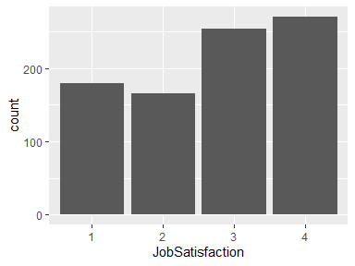

## MaritalStatus

|  |  |
| --- | --- |
| Feature | Result |
| Variable type | factor |
| Number of missing obs. | 0 (0 %) |
| Number of unique values | 3 |
| Mode | “Married” |
| Reference category | Divorced |

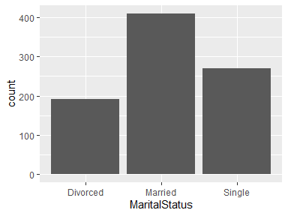

## MonthlyIncome

|  |  |
| --- | --- |
| Feature | Result |
| Variable type | integer |
| Number of missing obs. | 0 (0 %) |
| Number of unique values | 826 |
| Median | 4945.5 |
| 1st and 3rd quartiles | 2839.5; 8182 |
| Min. and max. | 1081; 19999 |

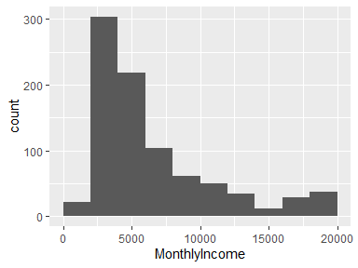

## MonthlyRate

|  |  |
| --- | --- |
| Feature | Result |
| Variable type | integer |
| Number of missing obs. | 0 (0 %) |
| Number of unique values | 852 |
| Median | 14074.5 |
| 1st and 3rd quartiles | 8092; 20456.25 |
| Min. and max. | 2094; 26997 |

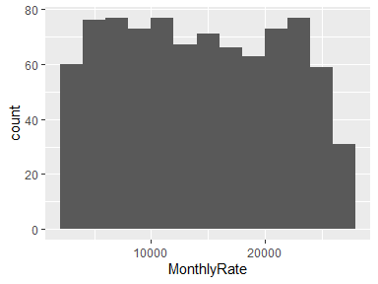

## NumCompaniesWorked

|  |  |
| --- | --- |
| Feature | Result |
| Variable type | integer |
| Number of missing obs. | 0 (0 %) |
| Number of unique values | 10 |
| Median | 2 |
| 1st and 3rd quartiles | 1; 4 |
| Min. and max. | 0; 9 |

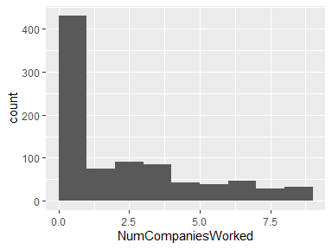

## OverTime

|  |  |
| --- | --- |
| Feature | Result |
| Variable type | factor |
| Number of missing obs. | 0 (0 %) |
| Number of unique values | 2 |
| Mode | “No” |
| Reference category | No |

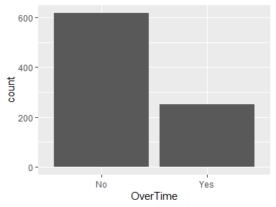

## PercentSalaryHike

|  |  |
| --- | --- |
| Feature | Result |
| Variable type | integer |
| Number of missing obs. | 0 (0 %) |
| Number of unique values | 15 |
| Median | 14 |
| 1st and 3rd quartiles | 12; 18 |
| Min. and max. | 11; 25 |

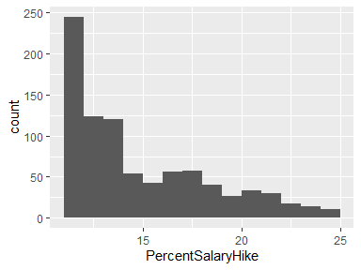

## PerformanceRating

* Note that this variable is treated as a factor variable below, as it only takes a few unique values.

|  |  |
| --- | --- |
| Feature | Result |
| Variable type | integer |
| Number of missing obs. | 0 (0 %) |
| Number of unique values | 2 |
| Mode | “3” |
| Reference category | 3 |

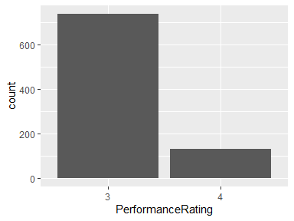

## RelationshipSatisfaction

* Note that this variable is treated as a factor variable below, as it only takes a few unique values.

|  |  |
| --- | --- |
| Feature | Result |
| Variable type | integer |
| Number of missing obs. | 0 (0 %) |
| Number of unique values | 4 |
| Mode | “4” |
| Reference category | 1 |

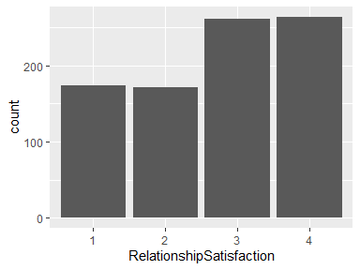

## StockOptionLevel

* Note that this variable is treated as a factor variable below, as it only takes a few unique values.

|  |  |
| --- | --- |
| Feature | Result |
| Variable type | integer |
| Number of missing obs. | 0 (0 %) |
| Number of unique values | 4 |
| Mode | “0” |
| Reference category | 0 |

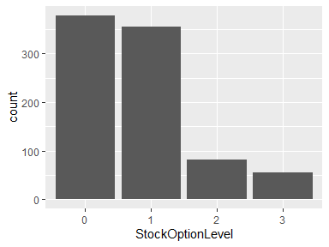

## TotalWorkingYears

|  |  |
| --- | --- |
| Feature | Result |
| Variable type | integer |
| Number of missing obs. | 0 (0 %) |
| Number of unique values | 39 |
| Median | 10 |
| 1st and 3rd quartiles | 6; 15 |
| Min. and max. | 0; 40 |

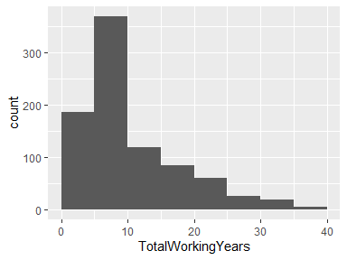

* Note that the following possible outlier values were detected: "0".

## TrainingTimesLastYear

|  |  |
| --- | --- |
| Feature | Result |
| Variable type | integer |
| Number of missing obs. | 0 (0 %) |
| Number of unique values | 7 |
| Median | 3 |
| 1st and 3rd quartiles | 2; 3 |
| Min. and max. | 0; 6 |

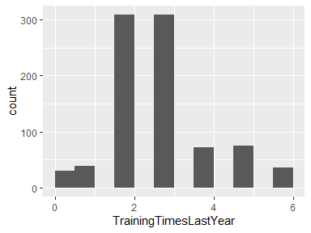

* Note that the following possible outlier values were detected: "4", "5", "6".

## WorkLifeBalance

* Note that this variable is treated as a factor variable below, as it only takes a few unique values.

|  |  |
| --- | --- |
| Feature | Result |
| Variable type | integer |
| Number of missing obs. | 0 (0 %) |
| Number of unique values | 4 |
| Mode | “3” |
| Reference category | 1 |

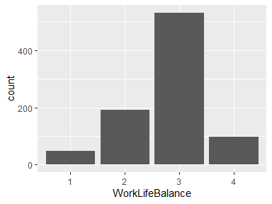

## YearsAtCompany

|  |  |
| --- | --- |
| Feature | Result |
| Variable type | integer |
| Number of missing obs. | 0 (0 %) |
| Number of unique values | 32 |
| Median | 5 |
| 1st and 3rd quartiles | 3; 10 |
| Min. and max. | 0; 40 |

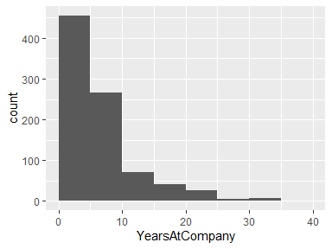

* Note that the following possible outlier values were detected: "0", "40".

## YearsInCurrentRole

|  |  |
| --- | --- |
| Feature | Result |
| Variable type | integer |
| Number of missing obs. | 0 (0 %) |
| Number of unique values | 19 |
| Median | 3 |
| 1st and 3rd quartiles | 2; 7 |
| Min. and max. | 0; 18 |

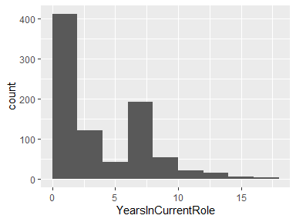

* Note that the following possible outlier values were detected: "0".

## YearsSinceLastPromotion

|  |  |
| --- | --- |
| Feature | Result |
| Variable type | integer |
| Number of missing obs. | 0 (0 %) |
| Number of unique values | 16 |
| Median | 1 |
| 1st and 3rd quartiles | 0; 3 |
| Min. and max. | 0; 15 |

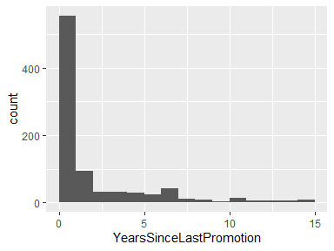

## YearsWithCurrManager

|  |  |
| --- | --- |
| Feature | Result |
| Variable type | integer |
| Number of missing obs. | 0 (0 %) |
| Number of unique values | 17 |
| Median | 3 |
| 1st and 3rd quartiles | 2; 7 |
| Min. and max. | 0; 17 |

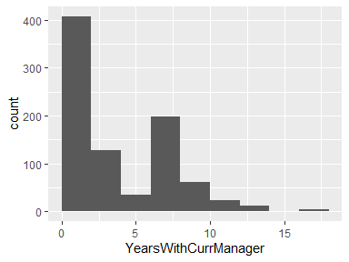

* Note that the following possible outlier values were detected: "0".

Report generation information:

* Created by Justin Howard (username: howar).
* Report creation time: Wed Aug 14 2019 15:31:56
* Report was run from directory: C:/Users/howar/Documents/R_WD/DDS/CaseStudy2DDS
* dataMaid v1.3.2 [Pkg: 2019-07-27 from CRAN (R 3.6.1)]
* R version 3.6.1 (2019-07-05).
* Platform: x86_64-w64-mingw32/x64 (64-bit)(Windows >= 8 x64 (build 9200)).
* Function call: makeDataReport(data = attrition)