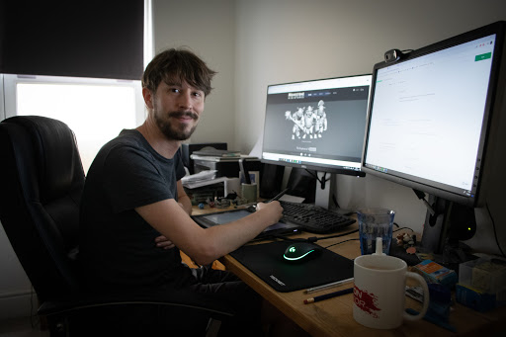

**Name:** Mark Barney

**Age:** 25 years old

**Sex:** Male

**Where they work:** 3D artist

**Hours of work:** 9:00AM – 5:00PM, 5 days/week

**Yearly income:** $46,000

**Marital Status:** Single

**Family:** Mom, Dad, No Siblings

**Education:** 3D Modelling and Visual Effects Production from Humber College

**Cultural Background:** Canadian

**Religion:** Agnostic

**Home:** Downtown Toronto, studio apartment

**How far to get to work:** 20 minutes bus and subway ride, can work from home

**What kind of vehicle:** Pre-owned Honda Civic

**Where they shop:** Amazon

**Sports, recreation:** No sports

**Internet habits:** ArtStation, YouTube,

**Hobbies:** Video games, board games, photography, drawing,

Mark Barney is a recent art grad from Humber, looking to show off his work online and make some cash while doing it. He wants to quit his current job making models for kid’s cartoons and go full time as a 3D game artist in the AAA game industry.