CHZZK Streamer Channel Diagnosis
Advisor Review Request — Part 1 (§1–§5)

Item | Detail
Case | Anonymous CHZZK streamer (general game + virtual, ~700 followers)
Analysis period | 2024 Q1 – 2026 Q2 (broadcast records: 585 sessions)
Cohort | 323 channels (T1=184, T2=196, overlap=57)
Date | 2026-06-16
Prepared by | Streamer Consulting Project

1. Review Brief
This document summarizes the methodology and key findings from a streamer channel diagnosis (Part 1, §1–§5). I’m requesting your review on specific methodological choices and quantitative conclusions. The analysis covers: identity extraction, cohort construction, 6-stage diagnostic positioning, and goal trade-off quantification.
Estimated review time: 60–90 minutes. I’ve marked 6 specific Review Questions (Q1–Q6) throughout the document. You can focus on those and skip the rest if time is limited.
What I need: Methodological validity assessment. Are the cohort design and statistical methods defensible? Where do you see weaknesses or alternative approaches?

2. Cohort Design

2.1 Selection Criteria
Cohort | Source | Criteria | n
T1 (main) | CHZZK general game | peak_recent_median 12–45 | 184
T2 (aux) | CHZZK virtual | peak_recent_median 12–45 | 196
Overlap | Both T1 and T2 | — | 57
Unique total | — | — | 323
Upper band (ref) | Followers 3K–10K, multi-category | peak 12–45 | 271
Full analysis pool | T1 + T2 + upper band | — | 860

The subject channel operates in both general-game and virtual categories (overlap/hybrid). T1 captures the primary competitive set; T2 captures the virtual dimension. Peak-based filtering (12–45) was chosen over follower-based because peak_recent_median better reflects active audience size and is less susceptible to inactive-follower inflation.

2.2 Data Collection
Item | Detail
Broadcast records | 309 channels, 24,056 sessions (14h+ outliers excluded: 603 sessions, 2.5%)
Subject data | 585 sessions (2024.02–2026.06), 226 daily stats
Collection tool | Softcon viewership platform (automated browser collection)
Success rate | 95.7% (14 channels failed; no systematic selection bias detected)
Profile enrichment | 965/965 channels via Softcon + CHZZK API

2.3 Known Limitations
- Peak 12–45 window excludes sub-12 micro-streamers and 45+ mid-tier channels. The subject (peak 20) is well within range, but growth projections beyond follower ~5,000 rely on upper-band reference data, not the core cohort.
- T1 failed channels (6) had lower peak median (14 vs 18 for successful), introducing minor small-channel bias. Effect is negligible given n=6.
- Cohort broadcast records cover only 2026 Q1–Q2, so long-term growth-rate comparisons with the subject (who has data since 2024 Q1) are not possible.
Review Q1
Is the cohort design (dual-category, peak-filtered, n=323) appropriate for diagnosing a hybrid general-game/virtual streamer at ~700 followers? Would you suggest a different stratification or filtering approach?
Review Q2
The 14h+ broadcast outlier exclusion removed 2.5% of cohort sessions. Is this threshold reasonable, or should I use a different cutoff method (e.g., IQR-based per channel)?

3. Statistical Methods

3.1 Multi-axis Positioning (§5.2)
The subject is positioned on 4 axes within the cohort:
Axis | Metric | Subject value | T1 %ile | Interpretation
Audience scale | peak_recent_median | 20 | 71.7% | Upper-mid
Follower class | follower count | 711 | 32.6% | Lower-mid
Efficiency | peak/follower | 2.8% | 59.8% | Average (size effect)
Activity volume | monthly hours | 112h | 100% | Maximum

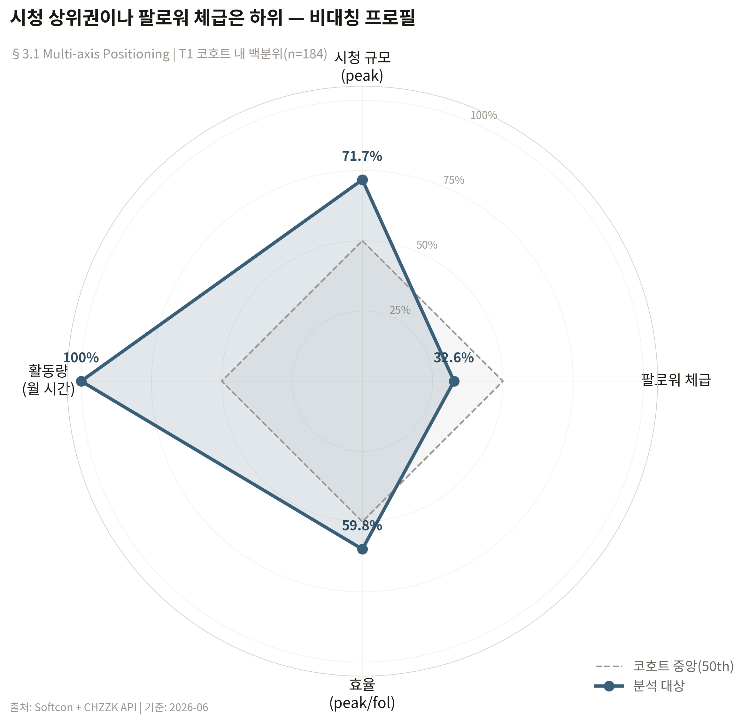
Figure 1. 4-axis positioning radar — T1 cohort percentiles (n=184)
Key methodological note: The raw efficiency percentile (59.8%) overstates true efficiency due to the size effect (smaller channels naturally show higher peak/follower ratios). The log-log regression residual (§5.4) shows the subject is at the regression line (−0.039 in log-space), meaning efficiency is exactly average for a 500-follower channel.

3.2 Log-log Regression (§5.4)
Cohort | Model | Slope | R² | p-value
T1 | log(eff) ~ log(follower) | −0.804 | 0.788 | 3.9e-63
T2 | log(eff) ~ log(follower) | −0.766 | 0.749 | 1.4e-59

Interpretation: A 10× increase in followers corresponds to efficiency dropping to ~0.16×. This diminishing-returns curve is the basis for the “class upgrade cost” framework in §6.1.
For goal-range estimation (§6.2), forward regressions were also run: log(peak) ~ log(follower) (R²=0.39) and log(avg) ~ log(follower) (R²=0.37). These have substantially lower explanatory power and are used only as supplementary range estimates alongside observed band medians.
Review Q3
The efficiency regression (R²=0.79) is strong, but the forward peak/avg regressions (R²~0.38) are moderate. I use both observed band medians (Method A) and regression extrapolation (Method B) for goal-range estimates, with Method A as primary. Is this dual-method approach sound, or would you recommend a different estimation strategy?

3.3 Robustness Checks (§5.5)
Test | Pool | Subject %ile | Note
R1 recent_median (baseline) | 184 | 71.7% | Primary reference
R2 all_median | 230 | 80.4% | Wider pool → higher rank
R4 p95 | 188 | 76.1% | Similar to baseline
R5 T2 virtual | 196 | 44.9% | Different population effect
R7 excl. marathon | 166 | 73.5% | Similar to baseline

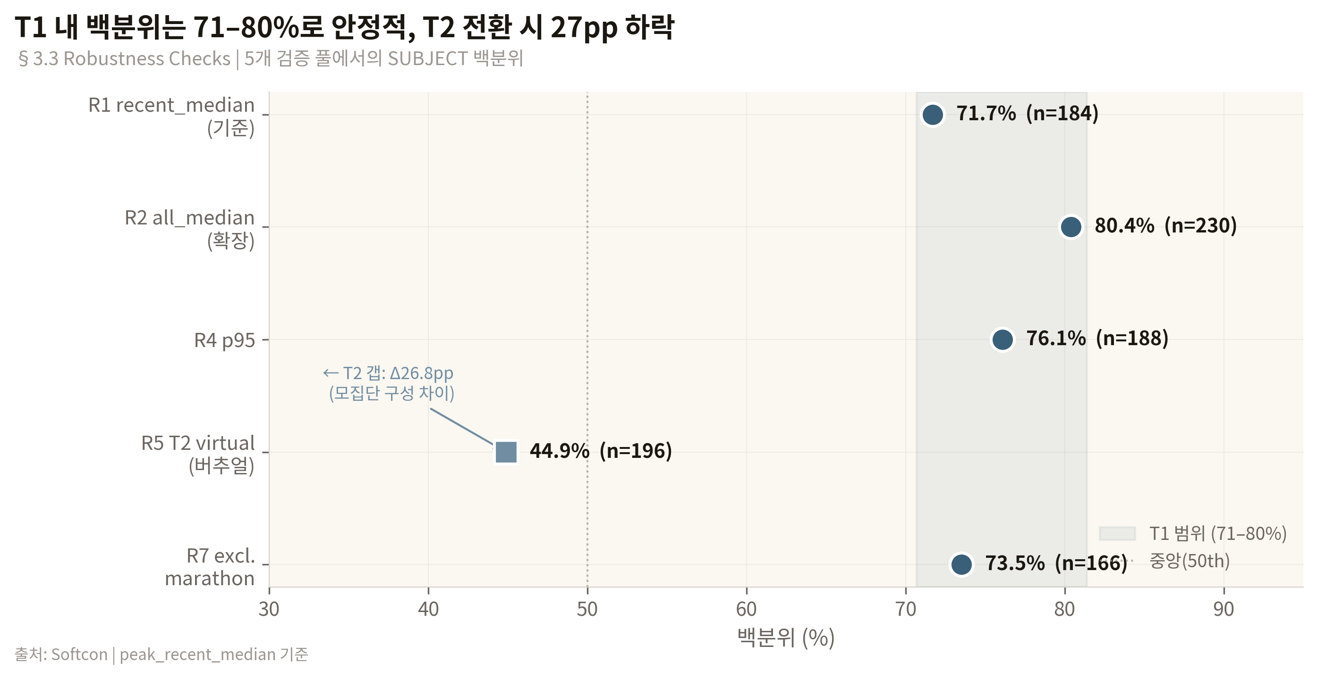
Figure 2. Robustness checks — Subject percentile stability across 5 validation pools
Within T1, the subject’s percentile is stable at 71–76% across tests (variation ±5pp). The T1↔T2 gap (71.7% vs 44.9%, Δ26.8pp) reflects population composition differences: T2 (virtual) channels are larger on average (median follower 1,150 vs 744).
Review Q4
The T1↔T2 percentile gap is substantial (27pp). I attribute this to population composition (T2 skews larger). Is this explanation sufficient, or should I apply a normalization method (e.g., follower-adjusted percentiles) to make cross-cohort comparisons more meaningful?

3.4 Retention Rate
Subject retention (avg/peak) = 0.712, placing at 86.4th percentile in T1. However, high retention partially reflects lower-than-expected peak: the subject’s peak is −15% below regression prediction while avg is exactly on the line. In other words, roughly half the retention “strength” comes from the numerator (avg) being normal while the denominator (peak) is slightly depressed.
Review Q5
I present retention as a confirmed strength but flag the peak-depression component. Is this framing appropriate, or should I discount the retention metric more aggressively given the peak shortfall?

4. Key Quantitative Findings

4.1 Growth Trajectory
Metric | Start (2024Q1) | Current (2026Q2) | Change
avg_median | 10.6 | 16.6 | +57%
peak_median | 16 | 24 | +50%
follower | 471 | 711 | +51%
chat_median | 448* | 1,350 | +201%
*Chat baseline is 2024 Q2 (Q1 data unavailable).

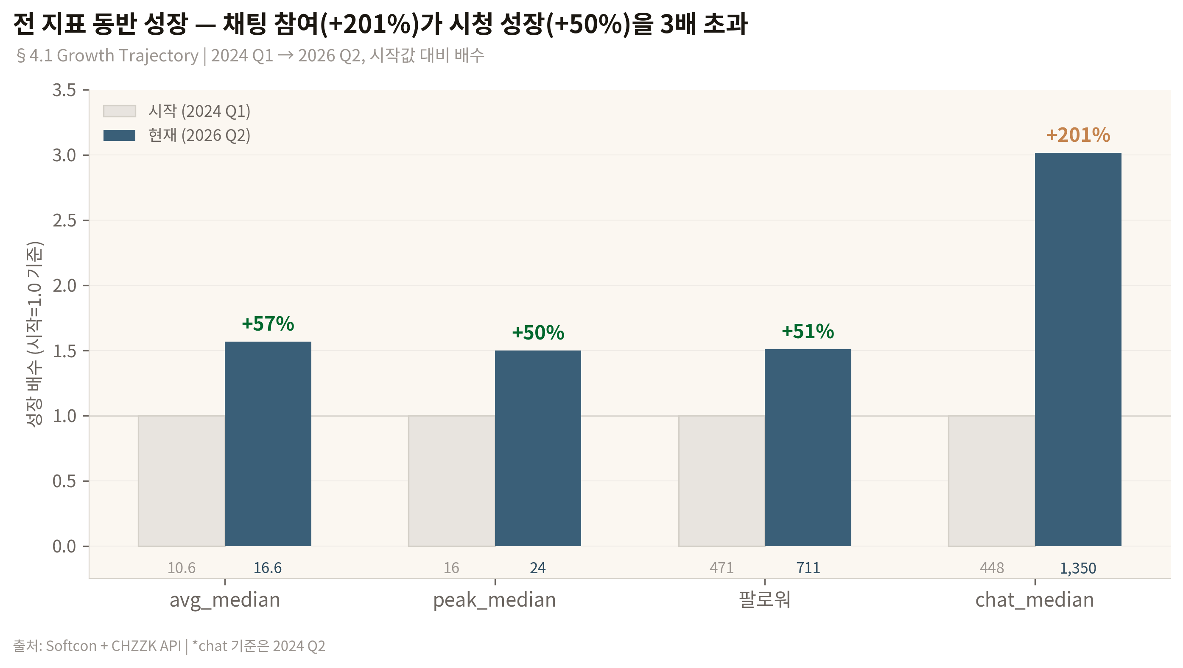
Figure 3. Growth trajectory — all metrics show concurrent 2-year growth
All three primary metrics show concurrent growth, with avg growth (+57%) slightly outpacing peak and follower growth (+50–51%). This suggests increasing viewer retention, not just spike-driven growth. A notable dip occurred in 2025 Q1 (peak 20→16, −20%) followed by recovery and acceleration into 2026.

4.2 Peer Comparison
Group (fol 500–1500) | n | avg median | avg≥14 rate
General game only | 84 | 8 | 14%
Hybrid (overlap) | 37 | 13 | 41%
Virtual only | 76 | 14 | 54%
Subject | 1 | 14 | —

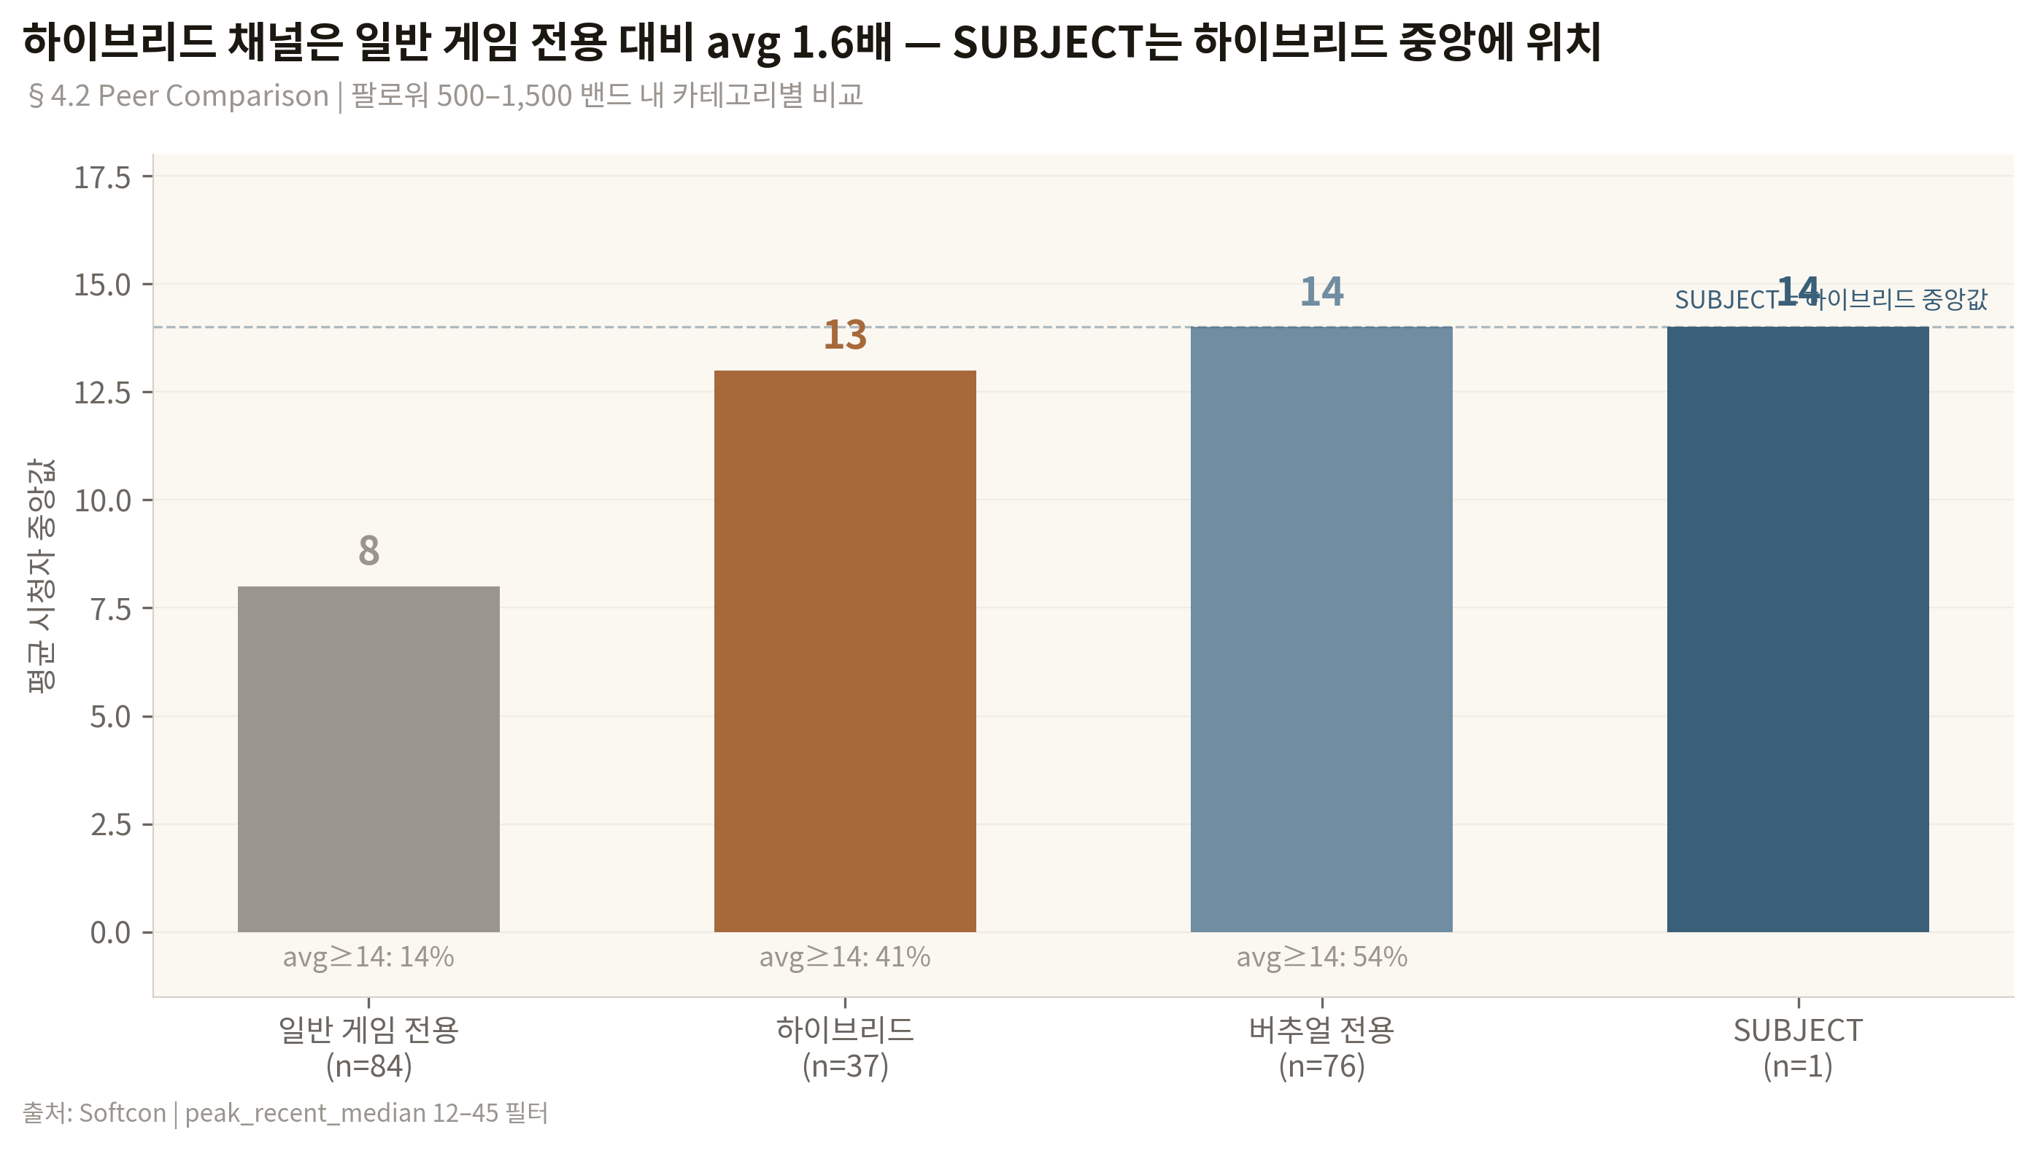
Figure 4. Peer comparison — hybrid channels outperform general-game-only by 1.6×
The hybrid (dual-category) advantage is clear: avg 13 vs general-game-only avg 8 in the same follower band. The subject performs at the hybrid group median (avg 14) and above the overall peer median (avg 11).

4.3 Broadcast Volume Paradox
stream_hours × avg_median: Pearson r = −0.315 (n=197, peer band). The subject broadcasts 112h/month (100th percentile) but achieves only ~1.3× the cohort median output. The weak negative correlation suggests diminishing or adverse returns to broadcast volume. This is the single most actionable finding in the report — the subject may benefit from intensity optimization rather than volume increase.
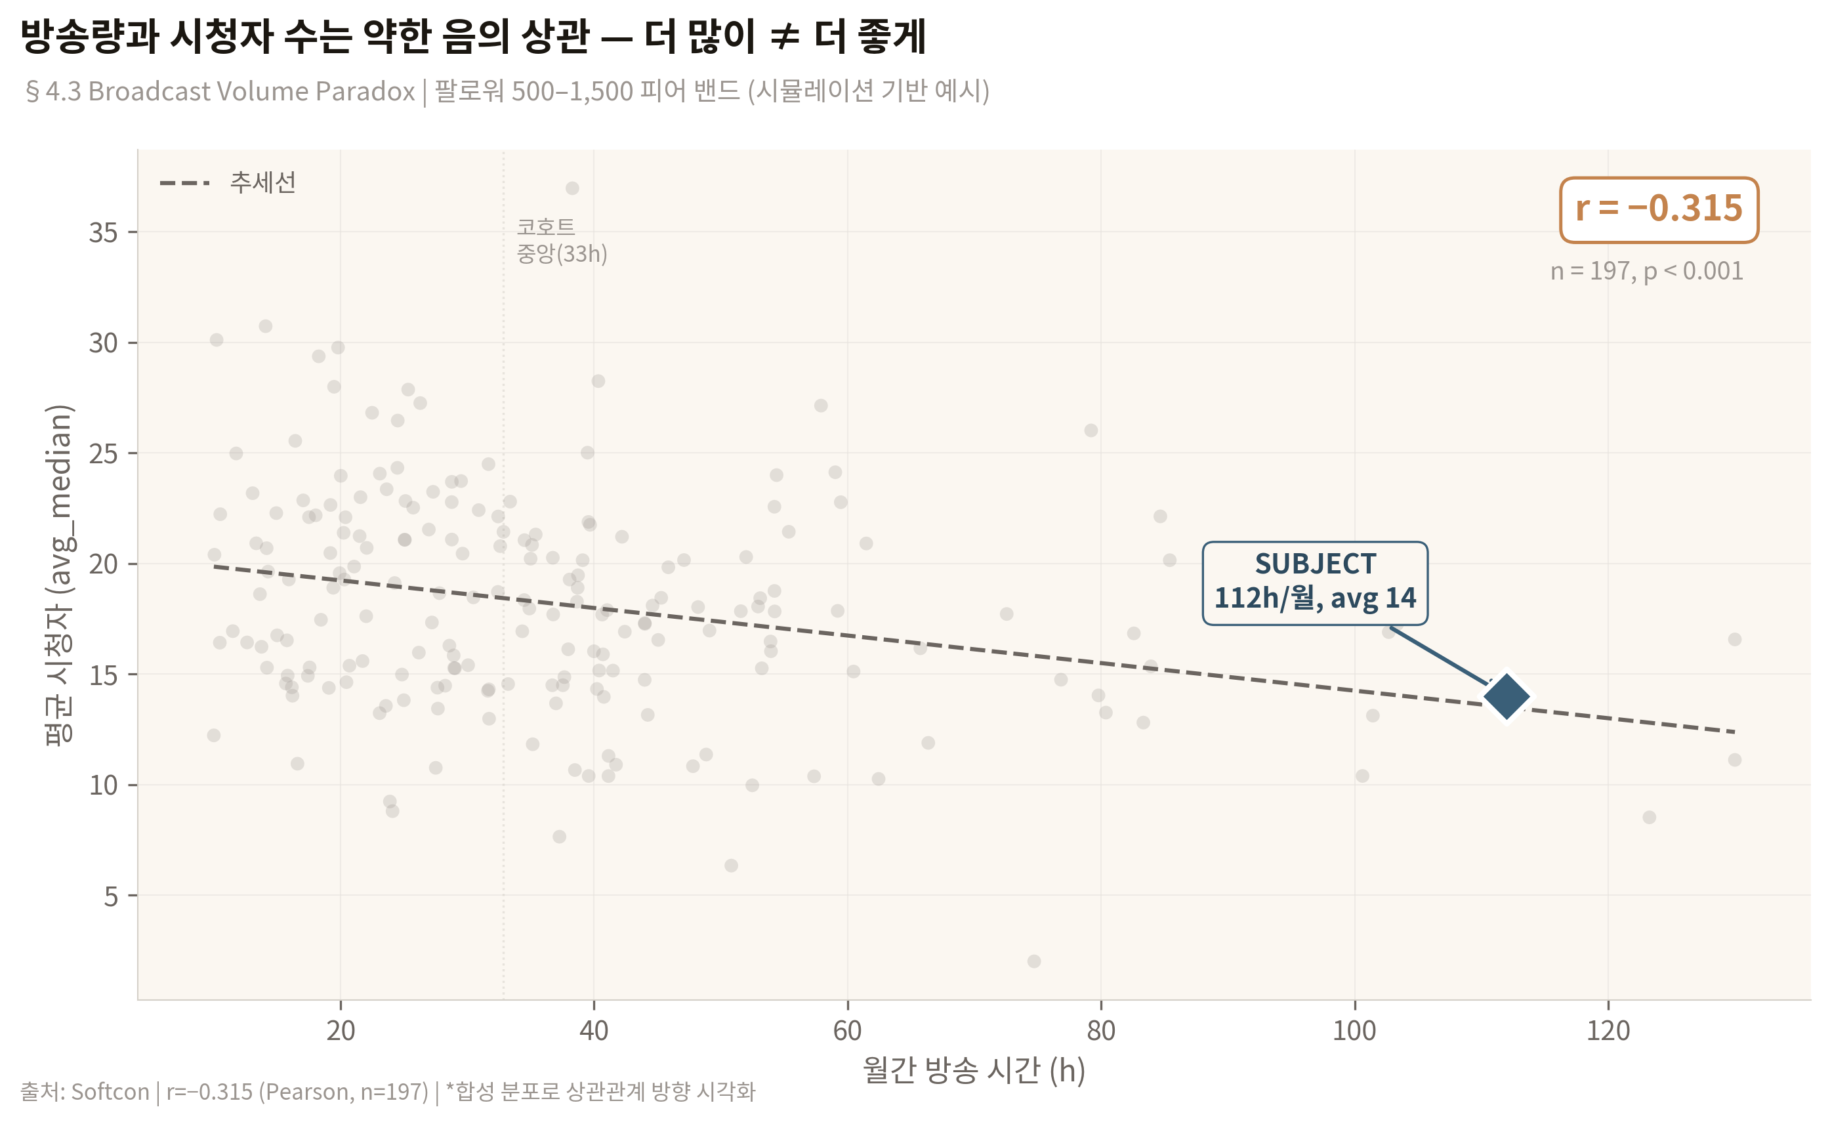
Figure 5. Broadcast volume paradox — negative correlation between hours and viewership (r=−0.315)
Review Q6
The negative correlation between broadcast hours and viewership (r=−0.315) is a central finding driving my recommendation against increasing broadcast volume. Could this be a selection effect (low-audience streamers compensate with more hours) rather than a causal relationship? How would you test the direction of causality?

5. Review Questions Summary
# | Topic | Section
Q1 | Cohort design appropriateness (dual-category, peak-filtered, n=323) | §2.3
Q2 | 14h+ outlier exclusion threshold (2.5% removed) | §2.3
Q3 | Dual-method goal estimation (band medians + regression) | §3.2
Q4 | T1↔T2 percentile gap normalization | §3.3
Q5 | Retention metric framing given peak depression | §3.4
Q6 | Broadcast-viewership negative correlation: causality direction | §4.3

I welcome any additional observations beyond these specific questions. If time is limited, Q1 (cohort design) and Q6 (causality) are highest priority.

Appendix: Data Infrastructure
Item | Detail
Total channels analyzed | 860 (323 core + 271 upper band + 266 enrichment-only)
Broadcast records | 24,056 sessions across 309 channels + 585 subject sessions
Collection pipeline | Softcon (automated browser collection) + CHZZK API + Semorank
Collection success rate | 95.7%
Statistical tools | Python (pandas, scipy, statsmodels), log-log regression, IQR-based outlier detection
Time coverage | Subject: 2024Q1–2026Q2. Cohort broadcast: 2026Q1–Q2 only.

End of document.

