HIBO EnergyPlus Building Model
Model Inputs and Simulation Results
Juhyun Bak | University of Nebraska–Lincoln
Model: 28 September 2026 | EnergyPlus 22.2.0

1. Model Overview
The Human-Centered Integrated Building Operation (HIBO) laboratory in Omaha, Nebraska, is modeled with three directly served thermal zones, a separate MEP zone, and a common return plenum. Lab A and Lab B are separate zones; the Lobby, Restroom, and Control rooms form one combined zone. One common air loop provides two-speed direct-expansion (DX) cooling and central electric heat, with a variable-air-volume (VAV) terminal and electric reheater for each served zone. [1,3]
Table 1-1. HIBO model summary
Characteristic | Value / representation
Modeled total floor area | 67.782 m², including MEP; derived from floor polygons
Directly served floor area | 61.325 m² across three main zones
Stories / thermal zones | One occupied level plus plenum / five thermal zones
Typical occupied ceiling height | 3.048 m; restroom portion 2.7432 m
Main / rear roof elevations | 4.7244–4.5212 m / 4.0640–3.9624 m
Exterior walls | Metal-panel and CMU-veneer assemblies
Roof / floor | EPDM with insulation above metal deck / ground-contact concrete slab
Glazing | SN54 simple-glazing reference externally; 6.35 mm clear glass internally
Air system | One common VAV air loop with central DX cooling and electric heat
Terminal systems | Three VAV terminals, each with electric reheat
Shading / internal mass | Five parapet shading polygons / four central-zone mass objects
Airflows and most coil capacities remain Autosize; the central electric heater is specified at 15 kW. The model combines drawing-based geometry, reference material properties, and operating assumptions; it has not been field-calibrated. [1,3,4]

2. Simulation Settings and Weather

2.1 Simulation Settings
The input specifies EnergyPlus version 22.2 and the supplied output identifies EnergyPlus 22.2.0-c249759bad. Zone and system sizing are enabled, plant sizing is disabled, and the annual weather-file run is enabled. Although separate design-day reporting is disabled, the seven SizingPeriod:DesignDay objects remain sizing inputs. [1,5]
Table 2-1. Simulation settings
Setting | Input | IDF object
EnergyPlus version | 22.2.0 (IDF version 22.2) | Version
Run period | January 1–December 31; year fields blank | RunPeriod
Start day / calendar | January 1 = Monday; weather-file holidays and daylight saving disabled | RunPeriod
Weather-file rain / snow indicators | Yes / Yes | RunPeriod
Zone / system / plant sizing | Yes / Yes / No | SimulationControl
Separate sizing-period simulation | No | SimulationControl
Weather-file annual simulation | Yes | SimulationControl
HVAC sizing simulation | No; maximum passes field = 3 | SimulationControl
Zone timestep | 6 per hour (10 minutes) | Timestep
Minimum HVAC timestep | 1 minute | ConvergenceLimits
Maximum HVAC iterations | 100 | ConvergenceLimits
Plant iteration limits | Minimum 2; maximum 8 | ConvergenceLimits
Warmup days | Minimum 6; maximum 25 | Building
Loads / temperature convergence tolerance | 0.04 / 0.4°C | Building
Envelope heat balance | ConductionTransferFunction | HeatBalanceAlgorithm
Surface-temperature upper limit | 200°C | HeatBalanceAlgorithm
Inside / outside convection | TARP / TARP | SurfaceConvectionAlgorithm:*
Solar distribution | FullExterior | Building
Shadow calculation | PolygonClipping; SutherlandHodgman | ShadowCalculation
Shadow update | Periodic; every 20 days | ShadowCalculation
Shadow overlap maximum | 15,000 figures | ShadowCalculation
Diffuse-sky treatment | SimpleSkyDiffuseModeling | ShadowCalculation
Source: [1, L20–L95, L323–L336]. The shadow-calculation Pixel Counting Resolution is 512 although the selected method is PolygonClipping; all three external-shadow/self-shading disable flags are No.

2.2 Weather File and Site
Table 2-2. Weather and site inputs
Input | Value | Source
EPW | USA_NE_Omaha-Eppley.Airfield.725500_TMY3.epw | Supplied file [2]
Station / data set | Omaha Eppley Airfield, NE, USA / TMY3 | EPW LOCATION header
WMO / latitude / longitude | 725500 / 41.32° / −95.90° | EPW LOCATION; Site:Location
Time zone / elevation | UTC−6 / 299 m | EPW LOCATION; Site:Location
Weather records | 8,760 hourly records | Counted in supplied EPW
Header data period | January 1–December 31; Sunday | EPW DATA PERIODS
Simulation calendar | January 1 = Monday; year fields blank | RunPeriod in IDF
Holidays / daylight saving | Disabled for the annual run | RunPeriod in IDF
Data provenance | NREL TMY Data Set (2008); generally 1973–2005 period of record | EPW COMMENTS 1
The RunPeriod calendar is the model input governing day-type schedules; it is not replaced here by the EPW header’s Sunday start-day label. TMY monthly records retain their source-year values. The filename date identifies the model snapshot, not the meteorological year. The weather file is selected directly in EP-Launch. [1,2]

2.3 Sizing Design Days
Table 2-3. Sizing design-day inputs
Condition | Date | Max dry bulb [°C] | Daily range [°C] | Humidity input | Wind [m/s / °] | Source
Ann Clg .4% Condns DB=>MWB | 7/21 | 35 | 11 | Wetbulb 24.5°C | 6.1 / 180 | [1, L110–L138]
Ann Clg .4% Condns DP=>MDB | 7/21 | 29.7 | 11 | Dewpoint 24.5°C | 6.1 / 180 | [1, L140–L168]
Ann Clg .4% Condns Enth=>MDB | 7/21 | 32 | 11 | Enthalpy 82600 J/kg | 6.1 / 180 | [1, L170–L198]
Ann Clg .4% Condns WB=>MDB | 7/21 | 32 | 11 | Wetbulb 26.1°C | 6.1 / 180 | [1, L200–L228]
Ann Htg 99.6% Condns DB | 1/21 | -21.3 | 0 | Wetbulb -21.3°C | 4.5 / 340 | [1, L230–L258]
Ann Htg Wind 99.6% Condns WS=>MCDB | 1/21 | -8.6 | 0 | Wetbulb -8.6°C | 13.8 / 340 | [1, L260–L288]
Ann Hum_n 99.6% Condns DP=>MCDB | 1/21 | -20.6 | 0 | Dewpoint -25.4°C | 4.5 / 340 | [1, L290–L318]
All seven design days use 97,784 Pa and DefaultMultipliers; rain, snow, and daylight saving are No. The four summer records use ASHRAETau with beam/diffuse optical depths 0.421 / 2.196. The three winter records use ASHRAEClearSky and sky clearness 0. The remaining blank solar and humidity schedules remain empty. [1, L110–L318]

3. Geometry and Zoning
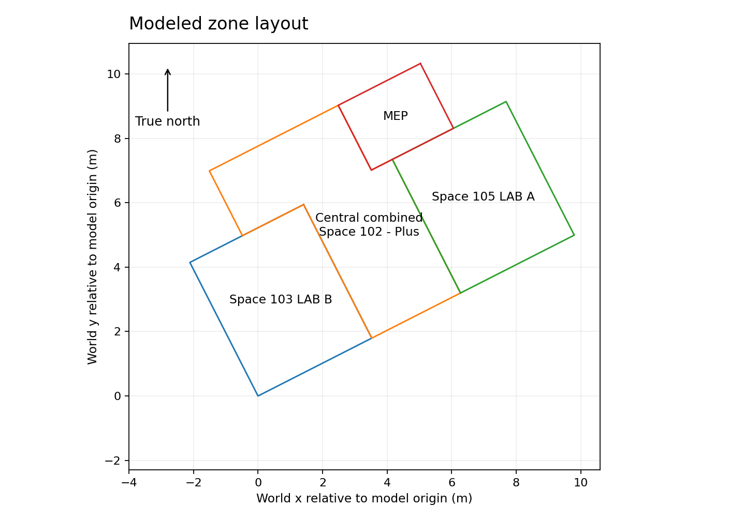
Figure 3-1. Modeled zone layout derived from the current IDF floor vertices. The common plenum is above the occupied plan. [1]
Table 3-1. Zone and architectural-room correspondence
IDF zone | Drawing room(s) | Floor/footprint area [m²] | Volume [m³] | Representation
Thermal Zone: Space 103 LAB B | Lab B / room 103 | 18.414 | 56.13 | Dedicated VAV + reheat
Thermal Zone: Space 102 - Plus | Lobby 101 + Restroom 102 + Control 104 | 24.497 | 72.81 | One combined zone; VAV + reheat
Thermal Zone: Space 105 LAB A | Lab A / room 105 | 18.414 | 56.13 | Dedicated VAV + reheat
MEP | MEP / room 106 | 6.457 | 19.68 | No dedicated terminal
Thermal Zone: Plenum | Common return plenum | 67.782 | 98.50 | Above the rooms; not counted in floor-area total
Lab B is modeled as Thermal Zone: Space 103 LAB B, and Lab A as Thermal Zone: Space 105 LAB A. Lobby 101, Restroom 102, and Control 104 share the central zone’s simulated air temperature. The plenum footprint is not added again to building floor area. The MEP room has no dedicated air terminal. Model polygon area is not the same quantity as the architectural cover sheet’s gross building area. [1,3]
Table 3-2. Zone extents and enclosed volumes calculated from surface vertices
Zone | Model-coordinate extent x × y [m] | Vertical extent [m] | Modeled volume [m³]
MEP | 6.312–9.171 × 4.654–6.913 | 0.000–3.048 | 19.682
Thermal Zone: Plenum | 0.000–11.000 × 0.000–6.913 | 2.743–4.724 | 98.495
Thermal Zone: Space 103 LAB B | 0.000–3.956 × 0.000–4.654 | 0.000–3.048 | 56.125
Thermal Zone: Space 102 - Plus | 1.829–7.044 × 0.000–6.913 | 0.000–3.048 | 72.806
Thermal Zone: Space 105 LAB A | 7.044–11.000 × 0.000–4.654 | 0.000–3.048 | 56.125
The central-zone extent is a bounding rectangle, not a statement that the zone itself is rectangular. Exact vertices, surface assignments, and reciprocal adjacent-surface names are supplied in the IDF and the complete input register. [1]
Table 3-3. Geometry conventions and boundaries
Geometry input | Value / treatment
Coordinate system | Relative; counterclockwise vertices; UpperLeftCorner
Zone origins / zone rotations | All zero
Building North Axis | 333°
Main occupied ceiling | 3.048 m; restroom portion 2.7432 m
Main roof elevations | 4.7244–4.5212 m
Rear roof elevations | 4.0640–3.9624 m
Building surfaces | 67 BuildingSurface:Detailed objects
Openings and opaque opening pieces | 108 FenestrationSurface:Detailed objects; includes doors, frames, mullions and spandrels
Shading | 5 Shading:Building:Detailed parapet objects
Internal mass | 4 InternalMass objects in the combined central zone
Outside surfaces | Outdoors boundary
Ground-contact slabs | Ground boundary; Section 4.3 temperatures
Interior partitions / ceilings | Paired Surface boundaries to adjacent zone or plenum
The listed zone origins and zone rotations are zero. Surface and opening names are retained from the IDF. Outdoors, Ground, and paired Surface boundaries are kept distinct. Ground-contact boundary temperatures are given in Section 4.3; construction assignments are given in Section 4. [1]

3.1 Openings, Frames, and Shading
The 108 FenestrationSurface:Detailed objects include transparent openings and explicit opaque opening pieces. They should not be counted as 108 transparent windows. Some exterior and interior frame strips, door pieces, and spandrels are represented as opaque Door-type subsurfaces. The two frame-and-divider objects are used for the principal south vision windows. [1]
Table 3-4. Principal south vision window polygons
Window object | Vertex polygon width × height [m] | Frame/divider object | Source
HIBO CWC LabB Vision | 3.5560 × 2.5400 | HIBO CWC Vision Frame | [1, L3194–L3215]
HIBO CWB Control Vision | 1.1176 × 2.5400 | HIBO CWB Vision Frame | [1, L3217–L3238]
HIBO CWC LabA Vision | 3.5560 × 2.5400 | HIBO CWC Vision Frame | [1, L3240–L3261]
The polygon dimensions are not interchangeable with clear-glass area or frame-inclusive opening area. The glazing, explicit frame-strip constructions, and FrameAndDivider inputs are documented separately in Section 4.5. The five Shading:Building:Detailed objects represent the South, West, East, Northwest Shoulder, and Northeast Shoulder upper parapets. Their transmittance-schedule fields are blank; the exact vertices are retained in the complete register. [1]

3.2 Internal Partitions and Same-Zone Mass
Interzone partitions and ceilings use paired Surface boundaries. Partitions and doors separating rooms that have been combined into the central thermal zone are instead represented by InternalMass objects with half-layer constructions and the entered exposed areas. These mass areas are not additional floor area. No explicit door-opening airflow is assigned. [1]
Table 3-5. Central-zone internal mass
Object | Construction | Entered surface area [m²]
HIBO Same-Zone Partition 104 | HIBO Internal Mass Half SA6 | 14.920228
HIBO Same-Zone Door 104 | HIBO Internal Mass Half HM Door | 3.901928
HIBO Same-Zone Partition 102 | HIBO Internal Mass Half SA6 | 11.650041
HIBO Same-Zone Door 102 | HIBO Internal Mass Half HM Door | 3.901928

4. Envelope Materials and Constructions
Opaque heat-transfer surfaces use layer-by-layer Construction definitions. The exterior surface film is not inserted as a material layer; the model selects TARP for both inside and outside surface convection. FullExterior solar distribution and the shading settings in Section 2.1 are used. Equivalent materials remain explicit model representations rather than implied product tests. [1]

4.1 Exterior Walls
The metal-panel exterior wall has six layers from exterior to interior: equivalent sheet-metal skin, continuous insulation, an air-barrier resistance, exterior gypsum sheathing, an effective steel-stud/batt cavity, and interior Type X gypsum. The CMU-veneer wall has seven layers, with equivalent hollow CMU and a drainage cavity outside the same insulated/sheathing/cavity/gypsum sequence. The assemblies follow the drawing descriptions while the thermal tuples and equivalents are those entered in the IDF. [1,3]

4.2 Roofs
The roof uses EPDM membrane, four-inch R-30-equivalent polyisocyanurate, a resistance-only vapor-retarder layer, and equivalent metal decking. The modeled roof is sloped using surface vertices; the roof insulation layer remains 0.1016 m in the material definition. Material thickness is therefore not inferred from the elevation difference. [1,3]

4.3 Slab-on-Grade Floors
Both slab constructions start at the ground side with 0.1016 m granular fill followed by 0.1016 m concrete. The carpeted slab adds a 0.005207 m carpet-tile equivalent on the room side. Sealed-concrete floors do not add a separate massive sealer layer. All slab exterior boundaries are Ground, using the twelve monthly temperatures below; no Foundation:Kiva object is present. [1,3]
Table 4-1. Prescribed ground-contact temperatures
Month | Ground temperature [°C]
January | 21.5
February | 21.4
March | 21.5
April | 21.5
May | 22
June | 22.9
July | 23
August | 23.1
September | 23.1
October | 22.2
November | 21.7
December | 21.6
These temperatures belong to Site:GroundTemperature:BuildingSurface in the IDF. The separate ground-temperature information at several depths in the EPW header is not substituted for them. The source records do not establish these monthly boundary values as field measurements. [1,2]

4.4 Interior Partitions, Ceilings, and Construction Totals
Interior partitions use gypsum layers around six-inch or eight-inch effective sound-batt cavities. The suspended acoustic ceiling is represented by an Armstrong ULTIMA High NRC 1940 reference material; this reference item is not asserted to be the installed SKU. A separate gypsum ceiling construction is also used. Doors, frame strips, spandrels and same-zone half constructions have their own records. [1,3]
Table 4-2. All 17 construction definitions
Construction | Layers: exterior / adjacent side → room side
EXT_Window_SN54 | SN54_1in_IGU
HIBO Metal Panel Exterior Wall | Metal Wall Panel 24ga Eq → Thermax CI R7.5 Eq → Air Barrier Eq → Exterior Gypsum Sheathing 5-8in → CFS Batt R13 6in Effective → Gypsum Board Type X 5-8in
HIBO CMU Veneer Exterior Wall | Burnished CMU Veneer 4in Eq → Exterior Drainage Cavity → Thermax CI R7.5 Eq → Air Barrier Eq → Exterior Gypsum Sheathing 5-8in → CFS Batt R13 6in Effective → Gypsum Board Type X 5-8in
HIBO EPDM Insulated Roof | EPDM Membrane 45mil → Roof Polyiso 4in R30 Eq → Roof Vapor Retarder Eq → Metal Roof Deck Eq
HIBO Slab Carpet | Granular Fill 4in Eq → Concrete Slab 4in → Carpet Tile CPT-1 Eq
HIBO Slab Sealed Concrete | Granular Fill 4in Eq → Concrete Slab 4in
HIBO APC-1 Ceiling | APC-1 Ultima High NRC 1940 Reference
HIBO GYP Ceiling | Gypsum Board Type X 5-8in
HIBO Interior Partition SA.6.20 | Gypsum Board Type X 5-8in → Interior Sound Batt Cavity 6in Eq → Gypsum Board Type X 5-8in
HIBO Interior Partition SA.8.21 | Gypsum Board Type X 5-8in → Interior Sound Batt Cavity 8in Eq → Gypsum Board Type X 5-8in
HIBO Interior CTG | Interior CTG 1-4in
HIBO HM Door 1-3-4in | HM Door Steel Skin Eq → HM Door Core Eq → HM Door Steel Skin Eq
HIBO Metal Frame Strip | Hollow Metal Frame Eq
HIBO Exterior Aluminum Frame Strip | Exterior Aluminum Frame Strip Eq
HIBO Internal Mass Half SA6 | Internal Mass Half Cavity SA6 Eq → Gypsum Board Type X 5-8in
HIBO Internal Mass Half HM Door | Internal Mass Half HM Core → HM Door Steel Skin Eq
HIBO ITSG Opaque Panel | ITSG Opaque Panel 1in Eq
Table 4-3. Calculated construction resistance and areal heat capacity
Opaque construction | R, no films [m² K/W] | C_A [kJ/(m² K)]
HIBO Metal Panel Exterior Wall | 2.576922 | 36.207
HIBO CMU Veneer Exterior Wall | 2.917107 | 101.279
HIBO EPDM Insulated Roof | 5.288905 | 9.126
HIBO Slab Carpet | 0.217755 | 338.816
HIBO Slab Sealed Concrete | 0.130972 | 336.746
HIBO APC-1 Ceiling | 0.390000 | 3.284
HIBO GYP Ceiling | 0.099219 | 13.843
HIBO Interior Partition SA.6.20 | 1.468437 | 31.953
HIBO Interior Partition SA.8.21 | 1.891771 | 33.376
HIBO HM Door 1-3-4in | 0.353794 | 11.220
HIBO Metal Frame Strip | 0.200000 | 5.556
HIBO Exterior Aluminum Frame Strip | 0.200000 | 16.459
HIBO Internal Mass Half SA6 | 0.734219 | 15.977
HIBO Internal Mass Half HM Door | 0.176897 | 5.610
HIBO ITSG Opaque Panel | 0.418235 | 8.534
Source: [1, L1296–L1387]. Calculations use R = Σ(t/k) plus resistance-only layers and C_A = Σ(tρcₚ)/1000. NoMass and AirGap layers add their entered resistance but no explicit material heat capacity to this calculation. Glazing is not treated as an opaque massive layer. For slabs, the listed heat capacity includes the modeled granular-fill layer. These construction totals are not a single whole-building equivalent R or C.

4.5 Glazing, Frames, Doors, and Spandrel
The exterior SN54 simple-glazing record specifies glazing performance; it is not the frame-inclusive whole-window result. Interior clear glass uses a detailed spectral-average optical record. The main CWB/CWC windows use FrameAndDivider objects, while many other frames are explicit opaque strips. Insulated spandrels are opaque panels, not solar-transmitting glass. [1]
Table 4-4. Glazing thermal and optical inputs
Glazing record | Property | Input | Source / basis
SN54_1in_IGU | U-factor [W/(m²K)] | 1.36 | Guardian SN54 on clear, double-glazed reference
SN54_1in_IGU | SHGC / visible transmittance | 0.28 / 0.54 | Guardian SN54 reference
HIBO Interior CTG 1-4in | Thickness [mm] | 6.35 | A0.1 §088000: 1/4 in clear tempered glass
HIBO Interior CTG 1-4in | Conductivity [W/(mK)] | 0.9 | EnergyPlus 22.2 WindowGlassMaterials: CLEAR 6MM reference
HIBO Interior CTG 1-4in | Solar transmittance / front and back reflectance | 0.775 / 0.071 / 0.071 | CLEAR 6MM reference
HIBO Interior CTG 1-4in | Visible transmittance / front and back reflectance | 0.881 / 0.08 / 0.08 | CLEAR 6MM reference
HIBO Interior CTG 1-4in | IR transmittance / front and back emissivity | 0 / 0.84 / 0.84 | CLEAR 6MM reference
HIBO Interior CTG 1-4in | Optical data / dirt factor / solar diffusing | SpectralAverage / 1 / No | IDF settings
Table 4-5. Main window frame and divider inputs
Input | CWB Vision Frame | CWC Vision Frame
Frame width | 0.0508 m | 0.0508 m
Frame conductance | 5.0 W/(m²K) | 5.0 W/(m²K)
Frame inside/outside projection | 0.0 / 0.0 m | 0.0 / 0.0 m
Frame edge-to-center conductance ratio | 1.3 | 1.3
Frame solar / visible absorptance / emissivity | 0.40 / 0.40 / 0.90 | 0.40 / 0.40 / 0.90
Divider type / width | DividedLite / 0.0508 m | DividedLite / 0.0508 m
Horizontal / vertical divider count | 2 / 0 | 2 / 3
Divider inside/outside projection | 0.0 / 0.0 m | 0.0 / 0.0 m
Divider conductance / edge ratio | 5.0 W/(m²K) / 1.3 | 5.0 W/(m²K) / 1.3
Divider solar / visible absorptance / emissivity | 0.40 / 0.40 / 0.90 | 0.40 / 0.40 / 0.90
Outside reveal solar absorptance | 0.50 | 0.50
Inside sill depth / solar absorptance | 0.0 m / 0.50 | 0.0 m / 0.50
Inside reveal depth / solar absorptance | 0.0 m / 0.50 | 0.0 m / 0.50
Sources: [1, L1266–L1291, L5681–L5735]. The 5 W/(m² K) frame/divider conductance, 1.3 edge ratios, and explicit strip equivalents are model inputs, not certified installed assembly performance. Opaque frame strips use their own assumed layer properties, while the detailed exterior simple-glazing model and internal glass are independent material records.

4.6 Material Properties and Sources
Tables 4-6 through 4-27 list material thickness, conductivity, density, specific heat, and surface properties with the source recorded for each value. Equivalent layers and generic reference properties are identified in the corresponding rows; they are not installed-product certifications. [1,3]
Table 4-6. HIBO Metal Wall Panel 24ga Eq
Property | Input | Unit | Source / basis
Thickness | 0.61 | mm | Equivalent skin thickness; not independently verified gauge
Conductivity | 45.28 | W/(m K) | ASHRAE HOF F08 generic steel
Density | 7824 | kg/m³ | ASHRAE HOF F08 generic steel
Specific heat | 500 | J/(kg K) | ASHRAE HOF F08 generic steel
Roughness | Smooth | — | IDF surface setting
Absorptance: thermal / solar / visible | 0.9 / 0.7 / 0.7 | — | IDF surface settings
[1, L685–L694].
Table 4-7. HIBO Burnished CMU Veneer 4in Eq
Property | Input | Unit | Source / basis
Thickness | 92.1 | mm | 4 in hollow-wall equivalent
Conductivity | 0.484229679367 | W/(m K) | CMHA TEK 06-02C, derived t/R without films
Density | 832.318730782 | kg/m³ | CMHA TEK 06-16A heat capacity, derived bulk-effective density
Specific heat | 880 | J/(kg K) | CMHA TEK 06-16A masonry reference
Roughness | MediumRough | — | IDF surface setting
Absorptance: thermal / solar / visible | 0.9 / 0.7 / 0.7 | — | IDF surface settings
[1, L718–L727].
Table 4-8. HIBO Thermax CI R7.5 Eq
Property | Input | Unit | Source / basis
Thickness | 27.2 | mm | A0.1 R-7.5 equivalent / DuPont THERMAX R-7 per inch
Conductivity | 0.0205931898624 | W/(m K) | Derived from A0.1 R-7.5 and modeled thickness
Density | 32 | kg/m³ | ASHRAE HOF faced-polyiso generic reference
Specific heat | 920 | J/(kg K) | ASHRAE HOF faced-polyiso generic reference
Roughness | MediumRough | — | IDF surface setting
Absorptance: thermal / solar / visible | 0.9 / 0.7 / 0.7 | — | IDF surface settings
[1, L745–L754].
Table 4-9. HIBO Exterior Gypsum Sheathing 5-8in
Property | Input | Unit | Source / basis
Thickness | 15.875 | mm | A1.1/A1.2: 5/8 in
Conductivity | 0.16 | W/(m K) | ASHRAE HOF G01/G01a generic gypsum
Density | 800 | kg/m³ | ASHRAE HOF G01/G01a generic gypsum
Specific heat | 1090 | J/(kg K) | ASHRAE HOF G01/G01a generic gypsum
Roughness | MediumSmooth | — | IDF surface setting
Absorptance: thermal / solar / visible | 0.9 / 0.4 / 0.4 | — | IDF surface settings
[1, L774–L783].
Table 4-10. HIBO CFS Batt R13 6in Effective
Property | Input | Unit | Source / basis
Thickness | 152.4 | mm | A1.2: 6 in framing
Conductivity | 0.14423 | W/(m K) | Assumed effective steel/batt cavity resistance ≈ R-6 (IP)
Density | 50 | kg/m³ | Assumed effective composite density
Specific heat | 700 | J/(kg K) | Assumed effective composite specific heat
Roughness | MediumRough | — | IDF surface setting
Absorptance: thermal / solar / visible | 0.9 / 0.5 / 0.5 | — | IDF surface settings
[1, L795–L804].
Table 4-11. HIBO Gypsum Board Type X 5-8in
Property | Input | Unit | Source / basis
Thickness | 15.875 | mm | A1.1/A1.2: 5/8 in Type X
Conductivity | 0.16 | W/(m K) | ASHRAE HOF G01/G01a generic gypsum
Density | 800 | kg/m³ | ASHRAE HOF G01/G01a generic gypsum
Specific heat | 1090 | J/(kg K) | ASHRAE HOF G01/G01a generic gypsum
Roughness | MediumSmooth | — | IDF surface setting
Absorptance: thermal / solar / visible | 0.9 / 0.4 / 0.4 | — | IDF surface settings
[1, L824–L833].
Table 4-12. HIBO EPDM Membrane 45mil
Property | Input | Unit | Source / basis
Thickness | 1.143 | mm | A0.1 §075323: 45 mil EPDM
Conductivity | 0.25 | W/(m K) | EN 12524:2000, Table 1 EPDM reference
Density | 1150 | kg/m³ | EN 12524:2000, Table 1 EPDM reference
Specific heat | 1000 | J/(kg K) | EN 12524:2000, Table 1 EPDM reference
Roughness | VeryRough | — | IDF surface setting
Absorptance: thermal / solar / visible | 0.9 / 0.7 / 0.7 | — | IDF surface settings
[1, L852–L861].
Table 4-13. HIBO Roof Polyiso 4in R30 Eq
Property | Input | Unit | Source / basis
Thickness | 101.6 | mm | A1.2: 4 in roof insulation
Conductivity | 0.0192304052391 | W/(m K) | Derived to preserve A0.1 R-30 target
Density | 32 | kg/m³ | ASHRAE HOF faced-polyiso generic reference
Specific heat | 920 | J/(kg K) | ASHRAE HOF faced-polyiso generic reference
Roughness | MediumRough | — | IDF surface setting
Absorptance: thermal / solar / visible | 0.9 / 0.7 / 0.7 | — | IDF surface settings
[1, L878–L887].
Table 4-14. HIBO Metal Roof Deck Eq
Property | Input | Unit | Source / basis
Thickness | 1.5 | mm | EnergyPlus 22.2 DOE reference: Metal Decking
Conductivity | 45.006 | W/(m K) | EnergyPlus 22.2 DOE reference: Metal Decking
Density | 7680 | kg/m³ | EnergyPlus 22.2 DOE reference: Metal Decking
Specific heat | 418.4 | J/(kg K) | EnergyPlus 22.2 DOE reference: Metal Decking
Roughness | MediumSmooth | — | IDF surface setting
Absorptance: thermal / solar / visible | 0.9 / 0.7 / 0.3 | — | IDF surface settings
[1, L908–L917].
Table 4-15. HIBO Concrete Slab 4in
Property | Input | Unit | Source / basis
Thickness | 101.6 | mm | A1.2: 4 in concrete slab
Conductivity | 1.311 | W/(m K) | EnergyPlus 22.2 DOE reference: MAT-CC05
Density | 2240 | kg/m³ | EnergyPlus 22.2 DOE reference: MAT-CC05
Specific heat | 836.8 | J/(kg K) | EnergyPlus 22.2 DOE reference: MAT-CC05
Roughness | Rough | — | IDF surface setting
Absorptance: thermal / solar / visible | 0.9 / 0.7 / 0.7 | — | IDF surface settings
[1, L937–L946].
Table 4-16. HIBO Granular Fill 4in Eq
Property | Input | Unit | Source / basis
Thickness | 101.6 | mm | A1.2: 4 in granular fill
Conductivity | 1.9 | W/(m K) | EnergyPlus 22.2 Basement material reference: gravel
Density | 2000 | kg/m³ | EnergyPlus 22.2 Basement material reference: gravel
Specific heat | 720 | J/(kg K) | EnergyPlus 22.2 Basement material reference: gravel
Roughness | Rough | — | IDF surface setting
Absorptance: thermal / solar / visible | 0.9 / 0.7 / 0.7 | — | IDF surface settings
[1, L965–L974].
Table 4-17. HIBO APC-1 Ultima High NRC 1940 Reference
Property | Input | Unit | Source / basis
Thickness | 22.225 | mm | Armstrong ULTIMA High NRC 1940 reference: 7/8 in
Conductivity | 0.0569871794872 | W/(m K) | Derived t/R from manufacturer reference R = 0.39 m²K/W
Density | 250.437233092 | kg/m³ | Derived from manufacturer reference areal weight
Specific heat | 590 | J/(kg K) | ASHRAE HOF F16 generic acoustic tile
Roughness | MediumSmooth | — | IDF surface setting
Absorptance: thermal / solar / visible | 0.9 / 0.3 / 0.13 | — | IDF surface settings
[1, L994–L1003].
Table 4-18. HIBO Interior Sound Batt Cavity 6in Eq
Property | Input | Unit | Source / basis
Thickness | 152.4 | mm | A1.1: SA.6.20 framing tag
Conductivity | 0.12 | W/(m K) | Assumed effective cavity
Density | 40 | kg/m³ | Assumed composite density
Specific heat | 700 | J/(kg K) | Assumed composite specific heat
Roughness | MediumRough | — | IDF surface setting
Absorptance: thermal / solar / visible | 0.9 / 0.5 / 0.5 | — | IDF surface settings
[1, L1015–L1024].
Table 4-19. HIBO Interior Sound Batt Cavity 8in Eq
Property | Input | Unit | Source / basis
Thickness | 203.2 | mm | A1.1: SA.8.21 tag interpretation; schedule thickness conflicts
Conductivity | 0.12 | W/(m K) | Assumed effective cavity
Density | 40 | kg/m³ | Assumed composite density
Specific heat | 700 | J/(kg K) | Assumed composite specific heat
Roughness | MediumRough | — | IDF surface setting
Absorptance: thermal / solar / visible | 0.9 / 0.5 / 0.5 | — | IDF surface settings
[1, L1036–L1045].
Table 4-20. HIBO HM Door Steel Skin Eq
Property | Input | Unit | Source / basis
Thickness | 1 | mm | Assumed 1 mm steel skin
Conductivity | 45.28 | W/(m K) | ASHRAE HOF F08 generic steel
Density | 7824 | kg/m³ | ASHRAE HOF F08 generic steel
Specific heat | 500 | J/(kg K) | ASHRAE HOF F08 generic steel
Roughness | Smooth | — | IDF surface setting
Absorptance: thermal / solar / visible | 0.9 / 0.7 / 0.7 | — | IDF surface settings
[1, L1065–L1074].
Table 4-21. HIBO HM Door Core Eq
Property | Input | Unit | Source / basis
Thickness | 42.45 | mm | 44.45 mm leaf minus two assumed 1 mm skins
Conductivity | 0.12 | W/(m K) | Assumed unknown door core
Density | 80 | kg/m³ | Assumed unknown door core
Specific heat | 1000 | J/(kg K) | Assumed unknown door core
Roughness | Smooth | — | IDF surface setting
Absorptance: thermal / solar / visible | 0.9 / 0.5 / 0.5 | — | IDF surface settings
[1, L1086–L1095].
Table 4-22. HIBO Hollow Metal Frame Eq
Property | Input | Unit | Source / basis
Thickness | 44.45 | mm | Assumed equivalent frame depth
Conductivity | 0.22225 | W/(m K) | Derived from assumed layer R = 0.20 m²K/W
Density | 250 | kg/m³ | Assumed hollow-section bulk density
Specific heat | 500 | J/(kg K) | Generic steel specific-heat proxy
Roughness | Smooth | — | IDF surface setting
Absorptance: thermal / solar / visible | 0.9 / 0.4 / 0.4 | — | IDF surface settings
[1, L1108–L1117].
Table 4-23. HIBO Exterior Aluminum Frame Strip Eq
Property | Input | Unit | Source / basis
Thickness | 152.4 | mm | A0.1: nominal 6 in storefront-equivalent depth
Conductivity | 0.762 | W/(m K) | Derived from assumed layer R = 0.20 m²K/W
Density | 120 | kg/m³ | Assumed hollow-section bulk density
Specific heat | 900 | J/(kg K) | NIST WebBook aluminum at 25°C; rounded
Roughness | Smooth | — | IDF surface setting
Absorptance: thermal / solar / visible | 0.9 / 0.4 / 0.4 | — | IDF surface settings
[1, L1130–L1139].
Table 4-24. HIBO Internal Mass Half Cavity SA6 Eq
Property | Input | Unit | Source / basis
Thickness | 76.2 | mm | Half SA6 cavity
Conductivity | 0.12 | W/(m K) | Same assumed SA6 cavity
Density | 40 | kg/m³ | Same assumed SA6 cavity
Specific heat | 700 | J/(kg K) | Same assumed SA6 cavity
Roughness | Smooth | — | IDF surface setting
Absorptance: thermal / solar / visible | 0.9 / 0.5 / 0.5 | — | IDF surface settings
[1, L1151–L1160].
Table 4-25. HIBO Internal Mass Half HM Core
Property | Input | Unit | Source / basis
Thickness | 21.225 | mm | Half HM core
Conductivity | 0.12 | W/(m K) | Same assumed HM core
Density | 80 | kg/m³ | Same assumed HM core
Specific heat | 1000 | J/(kg K) | Same assumed HM core
Roughness | Smooth | — | IDF surface setting
Absorptance: thermal / solar / visible | 0.9 / 0.5 / 0.5 | — | IDF surface settings
[1, L1172–L1181].
Table 4-26. HIBO ITSG Opaque Panel 1in Eq
Property | Input | Unit | Source / basis
Thickness | 25.4 | mm | A0.1 §088000: 1 in opaque spandrel
Conductivity | 0.0607313642757 | W/(m K) | Derived from assumed U = 1.70 W/(m²K) and film R = 0.17 m²K/W
Density | 400 | kg/m³ | Assumed spandrel composite
Specific heat | 840 | J/(kg K) | Assumed spandrel composite
Roughness | Smooth | — | IDF surface setting
Absorptance: thermal / solar / visible | 0.84 / 0.6 / 0.6 | — | IDF surface settings
[1, L1193–L1202].
Table 4-27. HIBO Carpet Tile CPT-1 Eq
Property | Input | Unit | Source / basis
Thickness | 5.207 | mm | J+J Kinetex 1840 reference: nominal 0.205 in
Conductivity | 0.06 | W/(m K) | ASHRAE HOF F17 generic carpet
Density | 288 | kg/m³ | ASHRAE HOF F17 generic carpet
Specific heat | 1380 | J/(kg K) | ASHRAE HOF F17 generic carpet
Roughness | MediumRough | — | IDF surface setting
Absorptance: thermal / solar / visible | 0.9 / 0.7 / 0.7 | — | IDF surface settings
[1, L1222–L1231].
The CFS/batt material’s name contains R13, but its entered conductivity represents an effective framed cavity rather than unbridged R-13 insulation. The CMU density is a bulk-effective hollow-assembly value. Interior batt cavities, door cores, frame strips, and spandrel composites retain their declared equivalent-property assumptions. These choices are not silently replaced by nominal material labels. [1]
Table 4-28. Resistance-only material inputs
Layer | R [m²K/W] | Roughness | Thermal / solar / visible absorptance | Source / basis
HIBO Air Barrier Eq | 0.001 | MediumSmooth | 0.90 / 0.50 / 0.50 | Thin-membrane modeling assumption; [1, L1237–L1243]
HIBO Roof Vapor Retarder Eq | 0.0010 | Smooth | 0.90 / 0.50 / 0.50 | Thin-membrane modeling assumption; [1, L1246–L1252]
HIBO Exterior Drainage Cavity | 0.15 | Not applicable | Not applicable | EnergyPlus 22.2 ASHRAE HOF F04 wall air space; [1, L1259–L1261]

5. Occupancy, Lighting, and Equipment

5.1 Occupancy
Each of the three main zones has one People object, using the same area-per-person method, people multiplier, and activity schedule. Neither MEP nor the plenum has a People object. The occupancy inputs are schedule assumptions in the model, not measured occupant counts. [1]
Table 5-1. People inputs common to the three main zones
Parameter | Input | Source / basis
Calculation method | Area/Person | [1, L5859–L5902]
Floor area per person | 18.580626 m²/person | IDF occupancy-density input
Number-of-people schedule | OCCUPY-1 | Schedule multiplier applied to area-based design count
Activity schedule | ActSchd | Activity level defined in Appendix A
Radiant fraction | 0.30 | IDF sensible-heat split input
Sensible heat fraction | Blank | Not assigned a constant value in the IDF
Mean radiant temperature calculation | ZoneAveraged | IDF setting
ASHRAE 55 comfort warnings | No | IDF setting
Table 5-2. Calculated design occupancy from area and activity inputs
Zone | Design people count | Full-schedule activity heat [W]
Thermal Zone: Space 103 LAB B | 0.991 | 116.19
Thermal Zone: Space 102 - Plus | 1.318 | 154.57
Thermal Zone: Space 105 LAB A | 0.991 | 116.19
The calculated count is fractional because an area-per-person density is used. The activity heat is total metabolic heat before the solver determines the sensible/latent split; it is not all convective sensible gain. ActSchd is 117.239998 W/person all day. The sensible-heat-fraction field is blank, and the CO₂ generation-rate field is also blank. [1]
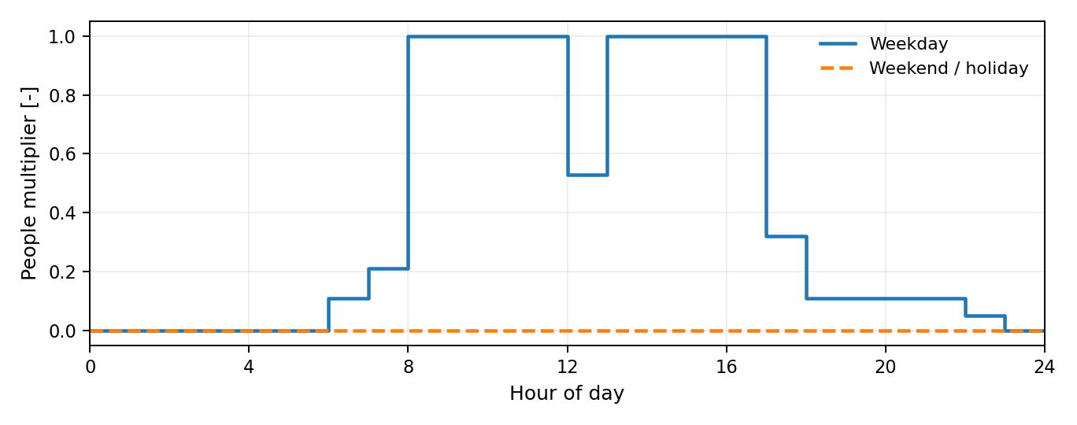
Figure 5-1. OCCUPY-1 weekday and weekend profiles. Exact day-type and design-day values are in Appendix A.1. [1]

5.2 Electric Lighting
The three main zones each contain a Lights object using Watts/Area. The lighting density is multiplied by ltg_sch_office. No Daylighting:Controls object is instantiated, so the daylight availability at the windows does not imply an active daylight-dimming control. The plenum and MEP have no Lights objects. [1]
Table 5-3. Interior lighting inputs
Parameter | Input | Source / basis
Design-level method | Watts/Area | [1, L5907–L5950]
Lighting power density | 6.181254 W/m² | IDF load input
Schedule | ltg_sch_office | Appendix A
Return-air / radiant / visible fractions | 0 / 0.70 / 0.20 | IDF fractions; remainder 0.10 is convective
Fraction replaceable | 1 | IDF setting
End-use subcategory | LightsWired | IDF setting
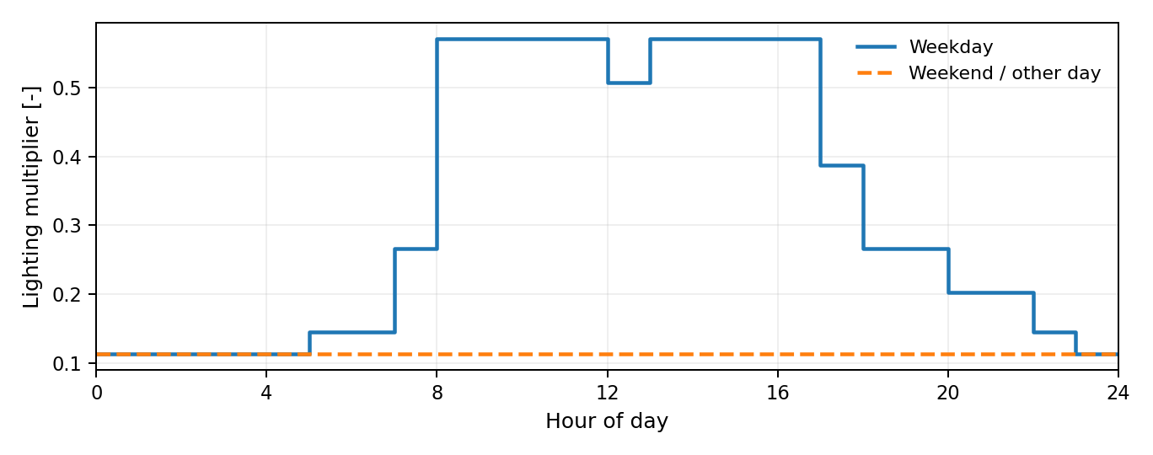
Figure 5-2. Interior lighting schedule. The entered weekday maximum is about 0.571 of design power, not 1.0. [1]
Table 5-4. Calculated zone design powers before schedule multipliers
Zone | Calculated design lighting [W] | Calculated design plug load [W]
Thermal Zone: Space 103 LAB B | 113.82 | 124.85
Thermal Zone: Space 102 - Plus | 151.42 | 166.09
Thermal Zone: Space 105 LAB A | 113.82 | 124.85
Exterior_Lights_a is a separate 88.49 W load. Its schedule is zero from 00:00–06:00 and one from 06:00–24:00 for AllDays. The Control Option field is blank. The exterior load is not applied as a zone internal heat gain. [1, L498–L506, L6056–L6061]

5.3 Plug and Process Loads
One ElectricEquipment object is assigned to each main zone. Each uses a 6.78 W/m² design power and the EQUIP-1 schedule. The source does not enumerate individual laboratory devices or provide a measured plug-load inventory. Latent, radiant and lost fraction fields are blank, so the report does not substitute a measured heat split. [1]
Table 5-5. Electric-equipment inputs
Parameter | Input | Source / basis
Design-level method | Watts/Area | [1, L5955–L5992]
Equipment power density | 6.78 W/m² | IDF load input
Schedule | EQUIP-1 | Appendix A
Latent / radiant / lost fractions | Blank / Blank / Blank | Fields are not explicitly entered; no measured heat split is asserted
End-use subcategory | MiscPlug | IDF setting
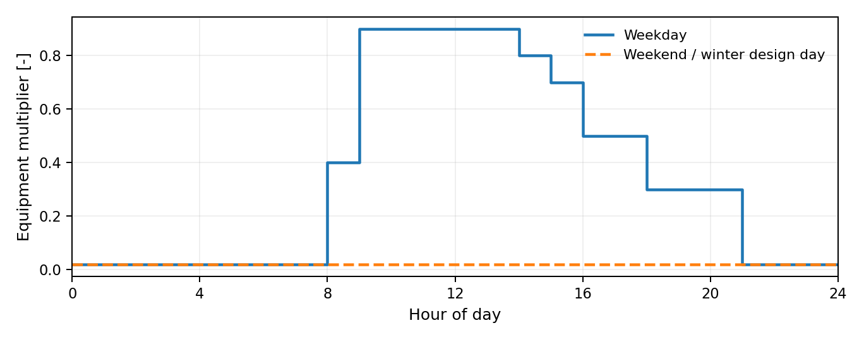
Figure 5-3. EQUIP-1 operating profile. Weekday, summer design-day and custom-day profiles share the plotted daytime curve. [1]

6. HVAC, Controls, and Air Exchange

6.1 System Arrangement
The air loop DXVAV Sys 1 serves all three main zones. Zone return nodes enter a common return plenum; air passes through a series return fan, outdoor/return-air mixer, DX cooling coil, central electric heater, supply fan, and zone splitter. Each branch then passes through a VAV damper and electric reheat coil before entering its zone. [1]
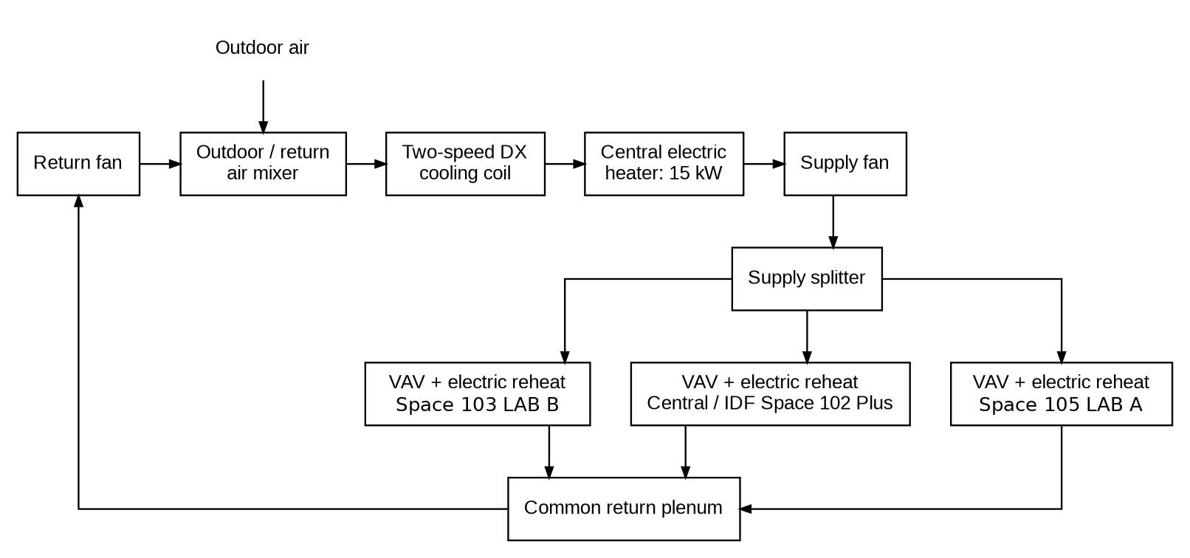
Figure 6-1. Implemented common air loop and three VAV/reheat branches. [1]
Table 6-1. Terminal-to-zone mapping
Zone | Terminal name | Terminal reheat coil
Thermal Zone:  Space 103 LAB B | Thermal Zone:  Space 103 LAB B VAV Reheat | Thermal Zone:  Space 103 LAB B Reheat Coil
Thermal Zone:  Space 102 - Plus | Thermal Zone:  Space 102 - Plus VAV Reheat | Thermal Zone:  Space 102 - Plus Reheat Coil
Thermal Zone:  Space 105 LAB A | Thermal Zone:  Space 105 LAB A VAV Reheat | Thermal Zone:  Space 105 LAB A Reheat Coil
SupplyPath, ReturnPath, Branch, BranchList, NodeList and ZoneHVAC equipment-connection objects implement this routing. Appendix B.1 gives the common node sequence and points to the full connection definitions. MEP has no dedicated supply terminal. [1]

6.2 Cooling and Electric Heating
Table 6-2. Cooling and heating component inputs
Component / parameter | Input | Source / basis
DX coil object | Coil:Cooling:DX:TwoSpeed / DXVAV Sys 1 Cooling Coil | [1, L6497–L6530]
High / low gross cooling capacity | Autosize / Autosize | Calculated by EnergyPlus; no fixed nameplate tonnage is entered
High / low rated airflow | Autosize / Autosize | IDF sizing inputs
High / low sensible heat ratio | Autosize / Autosize | IDF sizing inputs
High / low gross COP | 3.28 / 3.28 W/W | IDF performance inputs
Condenser type | AirCooled | IDF setting
Minimum compressor outdoor dry bulb | −25°C | IDF setting
DX coil availability schedule | Blank | No schedule name is entered in the coil object
Central electric heating coil | DXVAV Sys 1 Heating Coil | Coil:Heating:Electric
Central heating nominal capacity | 15,000 W | AAON RTU-1 nameplate: maximum electric heat 15 kW
Central heating efficiency / schedule | 1.0 / AvailSched_1 | IDF input
Terminal electric reheaters | One coil per main zone; nominal capacity = Autosize | [1, L6535–L6566]
Terminal reheat efficiency / schedule | 1.0 / AvailSched_1 | IDF input
The DX coil uses gross COP 3.28 at both speeds and AirCooled condenser type. Internal static pressure, condenser-air-inlet name, evaporative-condenser fields, water tank references and basin-heater capacity are blank; the basin-heater setpoint field is 2°C. The associated CoilSystem:Cooling:DX has an empty availability-schedule name and connects the mixed-air and cooling-coil-outlet nodes. Its sensor node is the cooling-coil outlet; Dehumidification Control Type is None, Run on Sensible Load is Yes, and Run on Latent Load is No. Additional explicitly entered and blank fields are preserved in the complete input register. [1, L6497–L6530, L6571–L6581]
Table 6-3. Equipment-source evidence versus implemented capacity inputs
Equipment evidence | Documented value | How it is used in this IDF
Installed AAON RTU electric heat | 15 kW maximum output | Central nominal heating capacity = 15,000 W
Installed RTU field note | Reconfigured from 6 ton to 4 ton | Not imposed as a fixed DX cooling capacity; DX capacity remains Autosize
Nameplate maximum outlet-air temperature | 200°F | Rating on the central unit; not entered as a terminal DAT control limit
M1.1 terminal schedule TB-1 / TB-2 / TB-3 | 8.9 / 4.4 / 8.9 kW; 800 / 400 / 800 CFM maximum | Design evidence, not the current autosized terminal inputs
M1.1 RTU basis of design | Daikin DPS005A | Different evidence from the installed AAON label
Sources: [1,3,4]. The central heater and the three terminal reheaters are separate components. A nameplate maximum is not continuous electric consumption. The source schedule’s approximately 90°F terminal leaving-air condition is not asserted as an active discharge-temperature ceiling.

6.3 Supply and Return Fans and Availability
Table 6-4. Supply and return fan inputs
Parameter | Supply fan | Return fan
Object type | Fan:VariableVolume | Fan:VariableVolume
Maximum flow rate | Autosize | Autosize
Pressure rise | 1,389.42 Pa | 1,389.42 Pa
Total efficiency | 0.43 | 0.30
Motor efficiency | 0.815 | 0.85
Motor-in-airstream fraction | 1 | 1
Power minimum-flow method / fraction | Fraction / 0.40 | Fraction / 0.40
Availability schedule | AvailSched_1 | AvailSched_1
Power coefficients c1…c5 | 0.0408, 0.088, −0.0729, 0.9437, 0 | Same
The fan polynomial uses the listed coefficients in the entered order. The 0.40 minimum-flow fraction belongs to the fan-power model and is separate from the terminal minimum-airflow fraction. Both fan availability schedules are AvailSched_1, whose profiles are one throughout the year. The model therefore does not implement the drawing’s normal unoccupied fan-off sequence through this schedule. [1,3]
Table 6-5. Availability-manager inputs
Availability-manager input | Value
Object | DXVAV Sys 1 Availability
Applicability schedule | HVACTemplate-Always 1
Fan schedule | AvailSched_1
Night-cycle control | StayOff
Thermostat tolerance | 1°C
Cycling control / run time | FixedRunTime / 1,800 s
Source: [1, L6456–L6492, L6773–L6788]. The NightCycle manager’s Control Type is StayOff; it is not described as an optimum-start controller. The nominal cycling tolerance and time are retained as input fields, but no additional night-cycle behavior is inferred from their presence alone.
No dedicated bathroom-exhaust Fan:ZoneExhaust object is connected. The M1.1 design schedule lists EF-1 at 125 CFM and 42.4 W; that device is not a separate load in this model. The series return fan is not an established equivalent of the installed RTU power-exhaust motor. [1,3,4]

6.4 VAV Terminals
Table 6-6. VAV terminal inputs common to all three zones
Parameter | Input
Maximum airflow | Autosize
Minimum-airflow input method | Constant
Constant minimum-airflow fraction | Autosize
Fixed minimum flow / minimum-fraction schedule | Blank / Blank
Terminal availability schedule | Blank
Reheat coil type | Coil:Heating:Electric
Damper Heating Action | Reverse
Maximum flow per zone floor area during reheat | Autocalculate
Maximum flow fraction during reheat | Blank
Maximum Reheat Air Temperature | Blank; no value entered
Convergence tolerance | 0.001
Outdoor-air object | Matching SZ DSOA for each zone
Source: [1, L6306–L6370]. The entered maximum reheat-air-temperature field is blank. The 40°C heating design supply temperature in Sizing:Zone is a sizing condition, not a terminal operating ceiling. Damper Heating Action is reported literally as Reverse; it is not used here to assert an independently verified BAS sequence for the electric reheaters.

6.5 Supply-Air Temperature Control
Table 6-7. Temperature-control inputs
Control input | Value | Source
AHU setpoint manager | SetpointManager:Warmest / DXVAV Sys 1 SAT Reset Manager | [1, L6812–L6819]
Minimum / maximum SAT target | 12.0 / 17.7°C | IDF setpoint bounds
Reset strategy | MaximumTemperature | IDF strategy
Fan-heat compensation | SetpointManager:MixedAir objects assign upstream coil-node targets | [1, L6793–L6807]
Zone thermostat | ThermostatSetpoint:DualSetpoint / Dual SP Control | [1, L6298–L6301]
Heating / cooling schedule | HTGSETP_SCH_NO_OPTIMUM / CLGSETP_SCH_NO_OPTIMUM | Schedule values are given in Appendix A
Thermostat control schedule | HVACTemplate-Always 4 | [1, L6274–L6293]
The warmest-zone manager resets the AHU supply-air target within 12.0–17.7°C. The two MixedAir managers connect that reference to upstream coil nodes with the supply-fan inlet and outlet specified for compensation. Zone thermostat schedules are given once in Section 6.6 and Appendix A.2. [1]

6.6 Zone Thermostat Set Points
All three main zones use ThermostatSetpoint:DualSetpoint through the constant control selector HVACTemplate-Always 4. The heating and cooling schedules have different transition times: weekday heating remains at 21.11°C until 19:00, while weekday cooling returns to 29.44°C at 18:00. These are implemented schedules, not a statement of the present BAS operating program. [1]
Table 6-8. Thermostat schedule summary
Control | Schedule | Weekday daytime | Other periods
Heating | HTGSETP_SCH_NO_OPTIMUM | 21.11°C, 06:00–19:00 | 15.56°C
Cooling | CLGSETP_SCH_NO_OPTIMUM | 23.89°C, 06:00–18:00 | 29.44°C
Control type | HVACTemplate-Always 4 | 4, all day | 4, all day
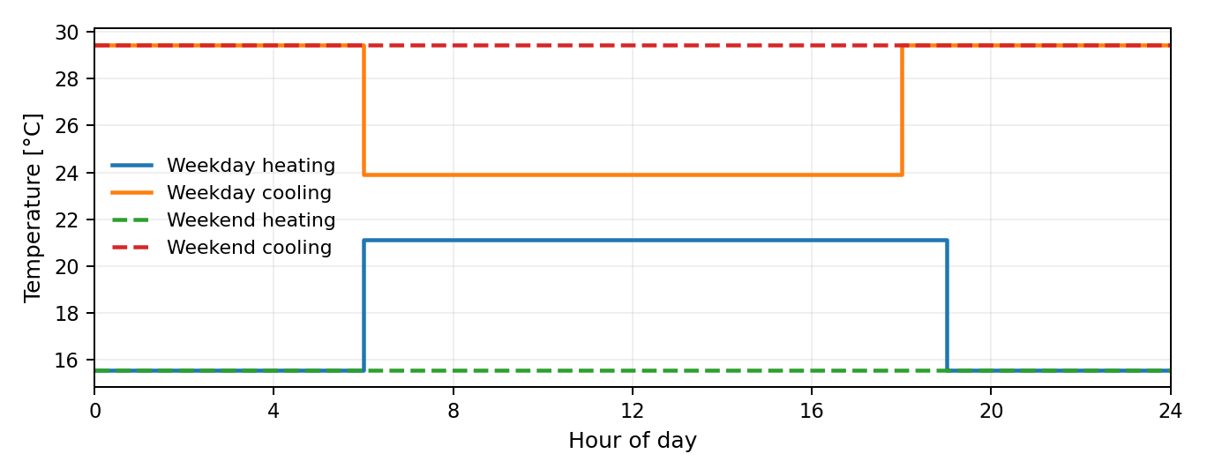
Figure 6-2. Zone thermostat schedules. Design-day and custom-day cases are tabulated in Appendix A.2. [1]
There is no separate humidity setpoint or humidification controller. The common AHU supply-air reset is a different control from the zone thermostat and is described in Section 6.5. [1]

6.7 Ventilation and Total Airflow
Mechanical ventilation is requested through three DesignSpecification:OutdoorAir objects and the connected Controller:MechanicalVentilation. The per-person and per-area components use the Sum method. These outdoor-air requests are different from the total recirculating supply flow, which is autosized at the system and terminal levels. [1]
Table 6-9. Ventilation and total-flow inputs
Input | Value
Zone outdoor-air method | Sum
Outdoor air per person | 0.0025 m³/(s·person)
Outdoor air per floor area | 0.0003 m³/(s·m²)
Fixed flow / ACH component | 0 / 0
Outdoor-air rate schedule | Min OA Sched; Appendix A.5
Cooling / heating air-distribution effectiveness | 1 / 1
Secondary recirculation fraction | Blank
System method | Standard62.1VentilationRateProcedure
Demand controlled ventilation | No
Zone maximum outdoor-air fraction | 1.0
AirLoopHVAC design supply airflow | Autosize
Terminal maximum flow / constant minimum fraction | Autosize / Autosize
Sources: [1, L6611–L6625]; [1, L6066–L6109, L6306–L6370, L6638–L6648]. Min OA Sched is 1 from 06:00–23:00 on its weekday/custom-day profile and 0 on weekends/holidays; both design-day profiles are 1. This outdoor-air schedule does not turn the supply and return fans off. The zero fixed minimum in Controller:OutdoorAir is not a substitute for the connected zone ventilation requests.

6.8 Economizer
Table 6-10. Outdoor-air controller and economizer inputs
Parameter | Entered value
Controller | DXVAV Sys 1 OA Controller
Economizer type / action | FixedDryBulb / ModulateFlow
Dry-bulb lower / upper limits | 4.0 / 12.7778°C
Lockout type | NoLockout
Minimum / maximum outdoor-air flow | 0.0 m³/s / Autosize
Minimum limit type | FixedMinimum
Minimum / maximum fraction schedule | Blank / Blank
Enthalpy / dewpoint high limits | Blank / Blank
Time-of-day economizer schedule | Blank
Source: [1, L6586–L6606]. The outdoor-air system contains one mixer and uses the mechanical-ventilation controller described in Section 6.7. A refrigerant compressor minimum outdoor dry-bulb input of −25°C is part of the DX coil; it is not the economizer limit. [1]

6.9 Infiltration
Four ZoneInfiltration:DesignFlowRate objects serve Lab B, the central zone, Lab A, and MEP. No plenum infiltration object is present. Flow is specified per exterior wall area and modified by a schedule and the entered environmental coefficients, so it should not be described as a constant whole-zone ACH input. [1]
Table 6-11. Infiltration inputs
Parameter | Input
Method | Flow/ExteriorWallArea
Rate per exterior wall area | 0.000199350288 m³/(s·m²)
Schedule | INFIL-SCH
Constant / temperature / wind / wind² coefficients | 0 / 0 / 0.224 / 0
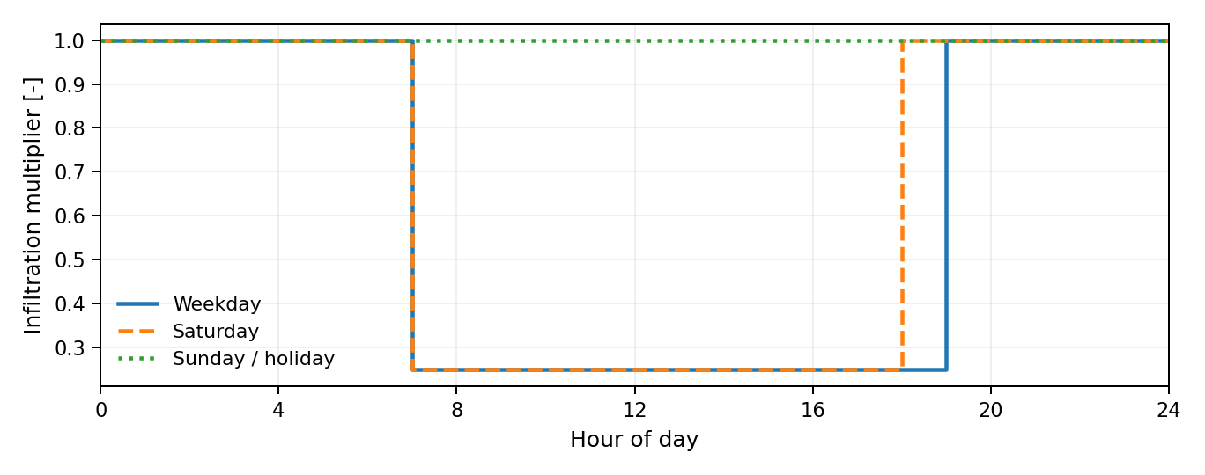
Figure 6-3. INFIL-SCH weekday, Saturday and Sunday profiles; the design-flow coefficients are separate from this multiplier. [1]
Source: [1, L5997–L6051]. The coefficient tuple is constant = 0, temperature = 0, wind = 0.224, and wind² = 0. The mechanical-ventilation outdoor-air request in Section 6.7 is an additional, different input. The exact INFIL-SCH day-type profiles appear in Appendix A.5.

6.10 HVAC Sizing and Performance Curves
Table 6-12. HVAC sizing inputs
Sizing input | Value | IDF location
Global heating / cooling factors | 1.2 / 2.0 | Sizing:Parameters
Explicit zone heating / cooling factors | 1.2 / 1.2 in each of the three zone objects | Sizing:Zone
Zone cooling / heating supply-temperature method | SupplyAirTemperature / SupplyAirTemperature | Sizing:Zone
Zone cooling / heating design supply temperature | 12.8 / 40°C | Sizing:Zone
Zone cooling / heating design supply humidity ratio | 0.0085 / 0.008 kg/kg | Sizing:Zone
Zone dedicated outdoor-air system | No | Sizing:Zone
Zone load sizing method | Sensible Load Only No Latent Load | Sizing:Zone
Central load type / zone-sum method | Sensible / NonCoincident | Sizing:System
Central heating maximum airflow ratio | 1.0 | Sizing:System
Preheat design temperature / humidity ratio | 7°C / 0.008 kg/kg | Sizing:System
Precool design temperature / humidity ratio | 12.8°C / 0.008 kg/kg | Sizing:System
Central cooling / heating design supply temperature | 12.8 / 17.7°C | Sizing:System
Central cooling / heating design humidity ratio | 0.0085 / 0.008 kg/kg | Sizing:System
100% outdoor air: cooling / heating | No / No | Sizing:System
System design outdoor airflow | Autosize | Sizing:System
Cooling / heating design capacity | Autosize / Autosize | Sizing:System
Cooling / heating capacity method | CoolingDesignCapacity / HeatingDesignCapacity | Sizing:System
Central cooling capacity control | OnOff | Sizing:System
Global factors and explicit zone factors are separate inputs and are not multiplied together in this documentation. Alternative airflow/capacity sizing fields that are empty remain blank; the exact fields are listed in the register. The seven design-day definitions appear in Section 2.3. Reported capacity and airflow results are not substituted into Autosize fields. [1]
Table 6-13. The seven connected DX performance curves
Curve suffix | Form | Coefficients in entered order | Input domains
PLF | Quadratic | 0.85, 0.15, 0 | min x: 0; max x: 1
Cap-FF | Cubic | 0.47278589, 1.2433415, -1.0387055, 0.32257813 | min x: 0.5; max x: 1.5
EIR-FF | Cubic | 1.0079484, 0.34544129, -.6922891, 0.33889943 | min x: 0.5; max x: 1.5
Cap-FT | Biquadratic | 0.476428, 0.0401147, 0.000226411, -.000827136, -.0000073224, -.000446278 | min x: 12.77778; max x: 23.88889; min y: 23.88889; max y: 46.11111
EIR-FT | Biquadratic | 0.632475, -.0121321, 0.000507773, 0.0155377, 0.00027284, -.000679201 | min x: 12.77778; max x: 23.88889; min y: 23.88889; max y: 46.11111
Low Cap-FT | Biquadratic | 0.476428, 0.0401147, 0.000226411, -.000827136, -.0000073224, -.000446278 | min x: 12.77778; max x: 23.88889; min y: 23.88889; max y: 46.11111
Low EIR-FT | Biquadratic | 0.774645, -.0343731, 0.000783173, 0.0146596, 0.000488851, -.000752036 | min x: 12.77778; max x: 23.88889; min y: 23.88889; max y: 46.11111
Source: [1, L6824–L6934]. The cubic records use Dimensionless input/output types; the biquadratic records use Temperature for x and y and Dimensionless output. Their minimum/maximum output-limit fields are blank. The quadratic record ends after its x bounds. Curve use is specified by the coil’s name references. The fitted provenance of these curves is not established as measured HIBO equipment performance.
Four additional Battery-named curve records remain in the IDF but no battery or generation system references them. Their numerical definitions are retained in Appendix B.2 as unconnected input records; their presence does not mean battery operation is modeled. [1]

7. Simulation Results
The annual results cover 8,760 hours of the Omaha TMY3 simulation. Table 7-1 lists electricity by end use; Figure 7-1 shows the corresponding energy-use intensity (EUI). [5]
EUI is annual site energy divided by the modeled floor area of 67.78217 m², including MEP and excluding the duplicate plenum footprint. All reported end uses are electric. Values are shown in kWh/year, kWh/(m² yr), and kBtu/(ft² yr). [1,5]
Table 7-1. Annual simulation results - HIBO, Omaha TMY3
End use | Annual electricity  [kWh/yr] | Site EUI  [kWh/(m² yr)] | Site EUI  [kBtu/(ft² yr)]
Interior equipment (electric) | 944 | 13.93 | 4.42
Interior lighting (electric) | 878 | 12.95 | 4.11
Exterior lighting (electric) | 581 | 8.57 | 2.72
Heating incl. terminal reheat (electric) | 2,092 | 30.86 | 9.78
Cooling (electric) | 2,039 | 30.08 | 9.54
Fans (electric) | 4,831 | 71.27 | 22.59
Total | 11,366 | 167.69 | 53.16
Source: [1,5]. End-use values are read from the annual report at 0.01 GJ precision; total electricity is reported at 0.001 GJ. Converted kWh and EUI are approximate, and independently rounded entries may not sum exactly to the total.
Heating includes both the central electric heater and terminal electric reheat. No gas, elevator, hydronic-pump, service-water-heating, humidification, or dedicated refrigeration load is modeled. [1,5]
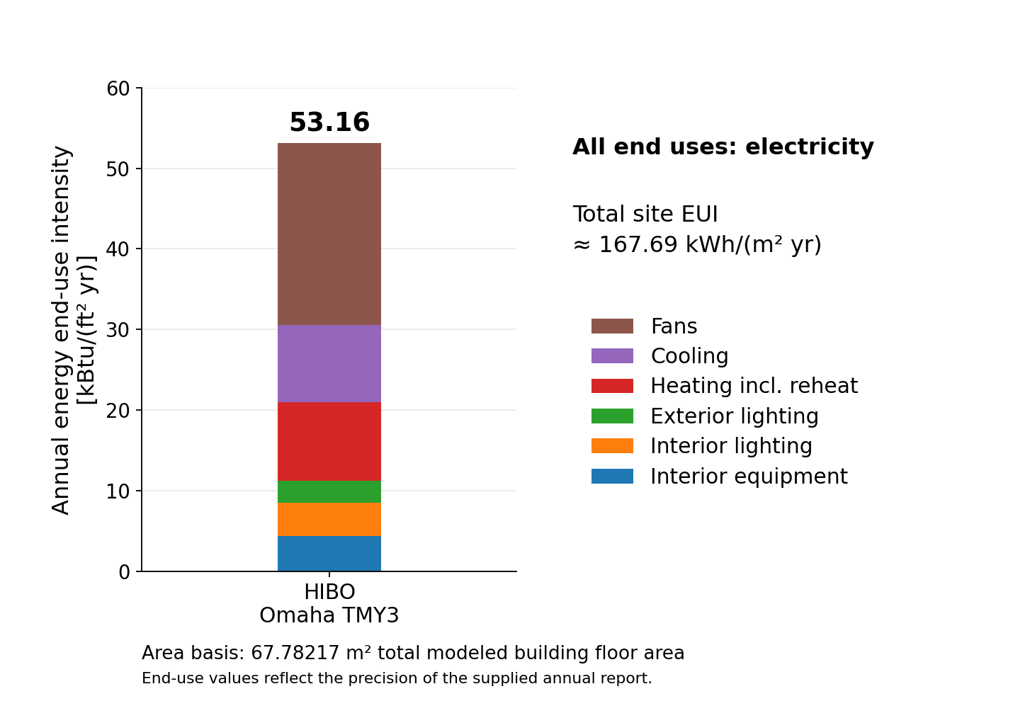
Figure 7-1. Annual site-energy end-use intensity for HIBO, Omaha TMY3. [5]
Fans are the largest end use, accounting for approximately 42.5% of annual electricity. Cooling accounts for 17.9%, and central heating plus terminal reheat for 18.4%. Heating, cooling, and fans together account for approximately 78.8%; interior equipment and interior/exterior lighting account for the remaining 21.2%. [5]
Total site electricity is approximately 11,366 kWh/year. Total site EUI is approximately 167.69 kWh/(m² yr), equivalent to 53.16 kBtu/(ft² yr). The supplied annual table does not separate central-heater and terminal-reheat electricity. [5]
The supplied run completed with three warnings and no severe errors. Occupied heating setpoint-not-met time is 53.83 facility-hours; occupied cooling setpoint-not-met time is 0.00 hours. These are simulated results, not measured-building performance. [5,6]

8. References
[1] Bak, J. HIBO_09282026_JB.idf. User-supplied EnergyPlus input snapshot, 28 September 2026. Canonical file in model/. All input line references in this report refer to this unchanged file.
[2] USA_NE_Omaha-Eppley.Airfield.725500_TMY3.epw. User-supplied weather file. LOCATION: Omaha Eppley Airfield; TMY3; WMO 725500. Header identifies NREL TMY Data Set (2008), generally 1973–2005 period of record. Included in weather/.
[3] DLR Group / University of Nebraska–Omaha. Human-Centered Integrated Building Operation Lab, 95% Review Package, 24 February 2022. File: UNO-HCIBO-Lab_95%CheckSet_220223 - UNOReview.pdf. Principal sheets: A0.1, A1.1, A1.2, M1.1. This is design-intent evidence; reproduction restrictions are stated on the drawing sheets.
[4] AAON, Inc. RTU-1 nameplate photograph, IMG_4634.jpeg, supplied by the user. Electric heat maximum 15 kW; field note reconfiguring unit from 6 ton to 4 ton; maximum outlet-air temperature 200°F. Photograph is equipment-rating evidence, not a full control-sequence document.
[5] EnergyPlus. HIBO_09282026_JBTable.html and HIBO_09282026_JBZsz.csv. Supplied outputs from EnergyPlus 22.2.0-c249759bad, simulation timestamp 28 September 2026, 14:03:43. Table.html contains annual summaries; Zsz.csv contains zone-sizing design-day profiles. Both are included in reference/.
[6] EnergyPlus. HIBO_09282026_JB.err. Supplied error log for the same run. A local-path-redacted copy is included in reference/.
[7] Bonnema, E.; Leach, M.; Pless, S. Technical Support Document: Development of the Advanced Energy Design Guide for Large Hospitals – 50% Energy Savings. NREL/TP-5500-52588, June 2013. Sections 3.2–3.3 and Appendix C provide the model-description example; Section 3.3.8, pp. 57–58, provides the annual end-use table and stacked EUI format.
Material-property references recorded in the IDF:
• ASHRAE HOF F08 generic steel.
• CMHA TEK 06-02C, derived t/R without films.
• CMHA TEK 06-16A heat capacity, derived bulk-effective density.
• A0.1 R-7.5 equivalent / DuPont THERMAX R-7 per inch.
• EN 12524:2000, Table 1 EPDM reference.
• EnergyPlus 22.2 DOE reference: Metal Decking.
• EnergyPlus 22.2 Basement material reference: gravel.
• Armstrong ULTIMA High NRC 1940 reference: 7/8 in.
• NIST WebBook aluminum at 25°C; rounded.
• J+J Kinetex 1840 reference: nominal 0.205 in.

Appendix A. Schedule Tables
All twelve Schedule:Compact objects are shown below. They apply through December 31. Each row gives the value in the interval ending at the stated Until time; identical adjacent intervals and identical day-type profiles may be combined for readability. Full-precision fields and original selectors remain in the complete input register. The schedules are inputs, not measured BAS trends. [1]

A.1 Occupancy Schedules
Table A-1. OCCUPY-1
Day type(s) | Interval | Value [fraction]
Weekdays | 00:00–06:00 | 0
Weekdays | 06:00–07:00 | 0.11
Weekdays | 07:00–08:00 | 0.21
Weekdays | 08:00–12:00 | 1
Weekdays | 12:00–13:00 | 0.53
Weekdays | 13:00–17:00 | 1
Weekdays | 17:00–18:00 | 0.32
Weekdays | 18:00–22:00 | 0.11
Weekdays | 22:00–23:00 | 0.05
Weekdays | 23:00–24:00 | 0
Weekends; Holiday; WinterDesignDay; CustomDay1; CustomDay2 | 00:00–24:00 | 0
SummerDesignDay | 00:00–24:00 | 1
Type limits: Fraction. [1, L508–L550].
Table A-2. ActSchd
Day type(s) | Interval | Value [W/person]
AllDays | 00:00–24:00 | 117.239998
Type limits: Any Number. [1, L602–L608].

A.2 Thermostat Set Point Schedules
Table A-3. HTGSETP_SCH_NO_OPTIMUM
Day type(s) | Interval | Value [°C]
WeekDays | 00:00–06:00 | 15.56
WeekDays | 06:00–19:00 | 21.11
WeekDays | 19:00–24:00 | 15.56
Weekends; Holiday; SummerDesignDay; CustomDay1; CustomDay2 | 00:00–24:00 | 15.56
WinterDesignDay | 00:00–24:00 | 21.11
Type limits: Temperature. [1, L394–L424].
Table A-4. CLGSETP_SCH_NO_OPTIMUM
Day type(s) | Interval | Value [°C]
WeekDays | 00:00–06:00 | 29.44
WeekDays | 06:00–18:00 | 23.89
WeekDays | 18:00–24:00 | 29.44
Weekends; Holiday; WinterDesignDay; CustomDay1; CustomDay2 | 00:00–24:00 | 29.44
SummerDesignDay | 00:00–24:00 | 23.89
Type limits: Temperature. [1, L426–L456].

A.3 Lighting Schedules
Table A-5. ltg_sch_office
Day type(s) | Interval | Value [fraction]
SummerDesignDay | 00:00–24:00 | 1
WinterDesignDay | 00:00–24:00 | 0
Weekdays | 00:00–05:00 | 0.114132
Weekdays | 05:00–07:00 | 0.145835
Weekdays | 07:00–08:00 | 0.266306
Weekdays | 08:00–12:00 | 0.570652
Weekdays | 12:00–13:00 | 0.507247
Weekdays | 13:00–17:00 | 0.570652
Weekdays | 17:00–18:00 | 0.386777
Weekdays | 18:00–20:00 | 0.266306
Weekdays | 20:00–22:00 | 0.202901
Weekdays | 22:00–23:00 | 0.145835
Weekdays | 23:00–24:00 | 0.114132
Saturday; AllOtherDays | 00:00–24:00 | 0.114132
Type limits: Fraction. [1, L458–L496].
Table A-6. Exterior_lighting_schedule_a
Day type(s) | Interval | Value [fraction]
AllDays | 00:00–06:00 | 0
AllDays | 06:00–24:00 | 1
Type limits: fraction. [1, L498–L506].

A.4 Plug and Process Load Schedules
Table A-7. EQUIP-1
Day type(s) | Interval | Value [fraction]
WeekDays SummerDesignDay CustomDay1 CustomDay2 | 00:00–08:00 | 0.02
WeekDays SummerDesignDay CustomDay1 CustomDay2 | 08:00–09:00 | 0.4
WeekDays SummerDesignDay CustomDay1 CustomDay2 | 09:00–14:00 | 0.9
WeekDays SummerDesignDay CustomDay1 CustomDay2 | 14:00–15:00 | 0.8
WeekDays SummerDesignDay CustomDay1 CustomDay2 | 15:00–16:00 | 0.7
WeekDays SummerDesignDay CustomDay1 CustomDay2 | 16:00–18:00 | 0.5
WeekDays SummerDesignDay CustomDay1 CustomDay2 | 18:00–21:00 | 0.3
WeekDays SummerDesignDay CustomDay1 CustomDay2 | 21:00–24:00 | 0.02
Weekends WinterDesignDay Holiday | 00:00–24:00 | 0.02
Type limits: Fraction. [1, L552–L575].

A.5 Infiltration and Outdoor-Air Schedules
Table A-8. INFIL-SCH
Day type(s) | Interval | Value [fraction]
Weekdays | 00:00–07:00 | 1
Weekdays | 07:00–19:00 | 0.25
Weekdays | 19:00–24:00 | 1
Saturday | 00:00–07:00 | 1
Saturday | 07:00–18:00 | 0.25
Saturday | 18:00–24:00 | 1
WinterDesignDay SummerDesignDay; Sunday Holidays AllOtherDays | 00:00–24:00 | 1
Type limits: Fraction. [1, L577–L600].
Table A-9. Min OA Sched
Day type(s) | Interval | Value [fraction]
WeekDays CustomDay1 CustomDay2 | 00:00–06:00 | 0
WeekDays CustomDay1 CustomDay2 | 06:00–23:00 | 1
WeekDays CustomDay1 CustomDay2 | 23:00–24:00 | 0
WeekEnds Holiday | 00:00–24:00 | 0
SummerDesignDay; WinterDesignDay | 00:00–24:00 | 1
Type limits: Fraction. [1, L627–L646].

A.6 Availability and Constant Control Schedules
Table A-10. AvailSched_1
Day type(s) | Interval | Value [on/off]
WeekDays CustomDay1 CustomDay2; WeekEnds Holiday; SummerDesignDay; WinterDesignDay | 00:00–24:00 | 1
Type limits: On/Off. [1, L610–L625].
Table A-11. HVACTemplate-Always 4
Day type(s) | Interval | Value [control code]
AllDays | 00:00–24:00 | 4
Type limits: Any Number. [1, L648–L654].
Table A-12. HVACTemplate-Always 1
Day type(s) | Interval | Value [availability value]
AllDays | 00:00–24:00 | 1
Type limits: Any Number. [1, L656–L662].

A.7 Schedule Type Limits
Table A-13. All six ScheduleTypeLimits records
Name | Lower bound | Upper bound | Numeric type | Unit type field
Any Number | Not entered | Not entered | Not entered | Not entered
Fraction | 0 | 1 | Continuous | Not entered
Temperature | -60 | 200 | Continuous | Not entered
Control Type | 0 | 4 | Discrete | Not entered
On/Off | 0 | 1 | Discrete | Not entered
FlowRate | 0 | 10 | Continuous | Not entered
Source: [1, L358–L389]. FlowRate is retained as a type-limit record even though none of the twelve Schedule:Compact objects uses it. The six unit-type fields are omitted in the entered records; the quantity meanings used in this report follow each schedule’s consuming object, not an invented unit-type entry.

Appendix B. Additional Input Settings

B.1 Air-System Connections
Table B-1. Common HVAC connection sequence
Position / object | Inlet → outlet / reference
Common return plenum | Three main-zone return nodes → DXVAV Sys 1 Return Air Outlet
Return fan | DXVAV Sys 1 Air Loop Inlet → DXVAV Sys 1 Return Fan Outlet
Outdoor/return mixer | Return Fan Outlet plus outdoor-air node → DXVAV Sys 1 Mixed Air Outlet; relief node separate
Two-speed DX coil | Mixed Air Outlet → DXVAV Sys 1 Cooling Coil Outlet
Central heater | Cooling Coil Outlet → DXVAV Sys 1 Heating Coil Outlet
Supply fan | Heating Coil Outlet → DXVAV Sys 1 Supply Fan Outlet
Supply path and splitter | DXVAV Sys 1 Supply Path Inlet → each zone Zone Equip Inlet
Each terminal | Zone Equip Inlet → Damper Outlet → Supply Inlet
Each zone equipment connection | Supply Inlet / Zone Air Node / Return Outlet
Source: [1, L6306–L6819]. Connection labels in this table abbreviate repeated prefixes. The field register preserves full node names, side-specific AirLoopHVAC nodes, equipment sequence numbers, and the fan and mixed-air setpoint-manager references.
Table B-2. Air-loop support-object settings
Support object | Entered settings
ZoneHVAC:EquipmentList | SequentialLoad; one AirDistributionUnit per main zone; heating and cooling sequence = 1
ZoneHVAC:AirDistributionUnit | One VAV terminal reference per zone; additional leakage fields omitted
OutdoorAir:Node | DXVAV Sys 1 Outside Air Inlet; height and trailing fields omitted
AirLoopHVAC:ControllerList | One Controller:OutdoorAir entry in the OA system
AirLoopHVAC:OutdoorAirSystem:EquipmentList | One OutdoorAir:Mixer entry
SupplyPath / ReturnPath | One ZoneSplitter / one ReturnPlenum
NodeList | SAT Setpoint Nodes: supply-path inlet and supply-fan outlet; Mixed Air Nodes: cooling-coil outlet and mixed-air outlet
SetpointManager:MixedAir | Cooling manager reference = supply-fan outlet; heating manager reference = supply-path inlet. Both use fan inlet = heating-coil outlet and fan outlet = supply-fan outlet.
The exact fields, including omitted availability-manager lists and controller-list blanks, appear in the complete register. No connector, plant loop, air-distribution leakage model, humidity controller, or separate external control interface is inferred merely from a generic HVAC object name. [1]

B.2 Unconnected Curve Records
Table B-3. BatteryChargeCurve (Curve:RectangularHyperbola2)
Field | Entered value
Coefficient1 C1 | -.2765
Coefficient2 C2 | -93.27
Coefficient3 C3 | 0.0068
Minimum Value of x | 0
Maximum Value of x | 1
Minimum Curve Output | -100
Maximum Curve Output | 100
Source: [1, L6939–L6947]. No active battery or generator object references this record.
Table B-4. BatteryDischargeCurve (Curve:RectangularHyperbola2)
Field | Entered value
Coefficient1 C1 | 0.0899
Coefficient2 C2 | -98.24
Coefficient3 C3 | -.0082
Minimum Value of x | 0
Maximum Value of x | 1
Minimum Curve Output | -100
Maximum Curve Output | 100
Source: [1, L6949–L6957]. No active battery or generator object references this record.
Table B-5. old_BatteryCycleCurve (Curve:DoubleExponentialDecay)
Field | Entered value
Coefficient1 C1 | 1380
Coefficient2 C2 | 6834
Coefficient3 C3 | -8.75
Coefficient4 C4 | 6747
Coefficient5 C5 | -6.22
Minimum Value of x | 0
Maximum Value of x | 1
Source: [1, L6962–L6970]. No active battery or generator object references this record.
Table B-6. new_BatteryCycleCurve (Curve:DoubleExponentialDecay)
Field | Entered value
Coefficient1 C1 | 1380
Coefficient2 C2 | 34170
Coefficient3 C3 | -1.75
Coefficient4 C4 | 33735
Coefficient5 C5 | -1.244
Minimum Value of x | 0
Maximum Value of x | 1
Source: [1, L6972–L6980]. No active battery or generator object references this record.

B.3 Reporting and Diagnostic Inputs
The IDF requests the following summary reports, diagnostic dictionaries, and time-series outputs. [1]
Table B-7. Summary, dictionary, drawing, database and diagnostic requests
Class | Entered request
Output:VariableDictionary | Key Field: regular
Output:Surfaces:List | Report Type: Lines
Output:Surfaces:Drawing | Report Type: DXF
Output:Schedules | Key Field: Timestep
Output:Constructions | Details Type 1: Constructions; Details Type 2: Materials
Output:EnergyManagementSystem | Actuator Availability Dictionary Reporting: Verbose; Internal Variable Availability Dictionary Reporting: Verbose; EMS Runtime Language Debug Output Level: ErrorsOnly
Output:Table:SummaryReports | Report 1 Name: AllSummary
OutputControl:Table:Style | Column Separator: HTML
Output:SQLite | Option Type: SimpleAndTabular
Output:Diagnostics | Key 1: DisplayExtraWarnings; Key 2: DisplayAdvancedReportVariables
There are 127 Output:Variable records and 14 Output:Meter:MeterFileOnly records. Repeated requests are retained in the register instead of being silently deleted. Requesting a variable does not guarantee a populated physical output for every key; for example, a system node without a setpoint can report an unset marker. No separate measured-temperature record is implied. [1]
Table B-8. All meter-file-only requests
Meter name | Frequency
Electricity:Facility | Hourly
Electricity:Building | Hourly
InteriorLights:Electricity | Hourly
Electricity:HVAC | Hourly
Electricity:Facility | runperiod
Electricity:Building | runperiod
InteriorLights:Electricity | runperiod
Electricity:HVAC | runperiod
Heating:Electricity | Hourly
Cooling:Electricity | Hourly
Electricity:Zone:THERMAL ZONE: SPACE 103 LAB B | Hourly
Electricity:Zone:THERMAL ZONE: SPACE 102 - PLUS | Hourly
Electricity:Zone:THERMAL ZONE: SPACE 105 LAB A | Hourly
ElectricityNet:Facility | Hourly
Table B-9. All requested variable/key/frequency combinations (duplicate counts preserved)
Requested variable | Key / scope | Frequency / count
Zone Air Temperature | * | Timestep
Site Outdoor Air Relative Humidity | * | Timestep
Facility Total Electricity Demand Rate | Whole Building | Timestep
Site Outdoor Air Drybulb Temperature | * | Timestep
Zone Air Relative Humidity | * | Timestep
System Node Temperature | * | Timestep × 2
System Node Setpoint Temperature | * | Timestep × 2
Site Direct Solar Radiation Rate per Area | * | Timestep
Facility Net Purchased Electricity Rate | * | Timestep
Cooling Coil Total Cooling Rate | DXVAV Sys 1 Cooling Coil | TimeStep
Cooling Coil Electricity Rate | DXVAV Sys 1 Cooling Coil | TimeStep
Heating Coil Heating Rate | DXVAV Sys 1 Heating Coil | TimeStep
Heating Coil Electricity Rate | DXVAV Sys 1 Heating Coil | TimeStep
Heating Coil Heating Rate | Thermal Zone:  Space 103 LAB B Reheat Coil | TimeStep
Heating Coil Heating Rate | Thermal Zone:  Space 102 - Plus Reheat Coil | TimeStep
Heating Coil Heating Rate | Thermal Zone:  Space 105 LAB A Reheat Coil | TimeStep
Fan Electricity Rate | DXVAV Sys 1 Supply Fan | TimeStep
Fan Air Mass Flow Rate | DXVAV Sys 1 Supply Fan | TimeStep
Fan Electricity Rate | DXVAV Sys 1 Return Fan | TimeStep
System Node Temperature | DXVAV Sys 1 Mixed Air Outlet | TimeStep
System Node Temperature | DXVAV Sys 1 Cooling Coil Outlet | TimeStep
System Node Temperature | DXVAV Sys 1 Heating Coil Outlet | TimeStep
System Node Temperature | DXVAV Sys 1 Supply Fan Outlet | TimeStep
System Node Temperature | Thermal Zone:  Space 103 LAB B Zone Equip Inlet | TimeStep
System Node Temperature | Thermal Zone:  Space 102 - Plus Zone Equip Inlet | TimeStep
System Node Temperature | Thermal Zone:  Space 105 LAB A Zone Equip Inlet | TimeStep
Air System Outdoor Air Economizer Status | DXVAV Sys 1 | TimeStep
Air System Outdoor Air Flow Fraction | DXVAV Sys 1 | TimeStep
Cooling Coil Sensible Cooling Rate | DXVAV Sys 1 Cooling Coil | TimeStep
Cooling Coil Latent Cooling Rate | DXVAV Sys 1 Cooling Coil | TimeStep
Cooling Coil Runtime Fraction | DXVAV Sys 1 Cooling Coil | TimeStep
System Node Mass Flow Rate | DXVAV Sys 1 Mixed Air Outlet | TimeStep
System Node Mass Flow Rate | DXVAV Sys 1 Supply Fan Outlet | TimeStep
System Node Humidity Ratio | DXVAV Sys 1 Mixed Air Outlet | TimeStep
System Node Humidity Ratio | DXVAV Sys 1 Supply Fan Outlet | TimeStep
System Node Setpoint Temperature | DXVAV Sys 1 Supply Fan Outlet | TimeStep
Zone Thermostat Heating Setpoint Temperature | Thermal Zone: Space 103 LAB B | TimeStep
Zone Thermostat Cooling Setpoint Temperature | Thermal Zone: Space 103 LAB B | TimeStep
Zone Predicted Sensible Load to Heating Setpoint Heat Transfer Rate | Thermal Zone: Space 103 LAB B | TimeStep
Zone Predicted Sensible Load to Cooling Setpoint Heat Transfer Rate | Thermal Zone: Space 103 LAB B | TimeStep
Zone Air Terminal VAV Damper Position | Thermal Zone:  Space 103 LAB B VAV Reheat | TimeStep
Zone Thermostat Heating Setpoint Temperature | Thermal Zone: Space 102 - Plus | TimeStep
Zone Thermostat Cooling Setpoint Temperature | Thermal Zone: Space 102 - Plus | TimeStep
Zone Predicted Sensible Load to Heating Setpoint Heat Transfer Rate | Thermal Zone: Space 102 - Plus | TimeStep
Zone Predicted Sensible Load to Cooling Setpoint Heat Transfer Rate | Thermal Zone: Space 102 - Plus | TimeStep
Zone Air Terminal VAV Damper Position | Thermal Zone:  Space 102 - Plus VAV Reheat | TimeStep
Zone Thermostat Heating Setpoint Temperature | Thermal Zone: Space 105 LAB A | TimeStep
Zone Thermostat Cooling Setpoint Temperature | Thermal Zone: Space 105 LAB A | TimeStep
Zone Predicted Sensible Load to Heating Setpoint Heat Transfer Rate | Thermal Zone: Space 105 LAB A | TimeStep
Zone Predicted Sensible Load to Cooling Setpoint Heat Transfer Rate | Thermal Zone: Space 105 LAB A | TimeStep
Zone Air Terminal VAV Damper Position | Thermal Zone:  Space 105 LAB A VAV Reheat | TimeStep
Site Day Type Index | * | Timestep
Zone Windows Total Transmitted Solar Radiation Rate | * | Timestep
Zone Exterior Windows Total Transmitted Beam Solar Radiation Rate | * | Timestep
Zone Exterior Windows Total Transmitted Diffuse Solar Radiation Rate | * | Timestep
Zone Total Internal Convective Heating Rate | * | Timestep
Zone Total Internal Radiant Heating Rate | * | Timestep
Zone Total Internal Visible Radiation Heating Rate | * | Timestep
Zone Total Internal Latent Gain Rate | * | Timestep
Zone Total Internal Total Heating Rate | * | Timestep
Zone People Occupant Count | * | Timestep
Zone People Convective Heating Rate | * | Timestep
Zone People Radiant Heating Rate | * | Timestep
Zone People Sensible Heating Rate | * | Timestep
Zone People Latent Gain Rate | * | Timestep
Zone People Total Heating Rate | * | Timestep
Zone Electric Equipment Radiant Heating Rate | * | Timestep
Zone Electric Equipment Convective Heating Rate | * | Timestep
Zone Electric Equipment Latent Gain Rate | * | Timestep
Zone Electric Equipment Lost Heat Rate | * | Timestep
Zone Electric Equipment Total Heating Rate | * | Timestep
Zone Infiltration Sensible Heat Gain Energy | * | Timestep
Zone Infiltration Sensible Heat Loss Energy | * | Timestep
Zone Infiltration Latent Heat Gain Energy | * | Timestep
Zone Infiltration Latent Heat Loss Energy | * | Timestep
Zone Infiltration Total Heat Gain Energy | * | Timestep
Zone Infiltration Total Heat Loss Energy | * | Timestep
Zone Infiltration Mass Flow Rate | * | Timestep
Zone Infiltration Current Density Volume Flow Rate | * | Timestep
Zone Infiltration Air Change Rate | * | Timestep
HVAC System Solver Iteration Count | * | Timestep
Air System Solver Iteration Count | * | Timestep
Air System Outdoor Air Mass Flow Rate | DXVAV Sys 1 | Timestep
Air System Mixed Air Mass Flow Rate | DXVAV Sys 1 | Timestep
Air System Outdoor Air Minimum Flow Fraction | DXVAV Sys 1 | Timestep
Zone Air Terminal Outdoor Air Volume Flow Rate | * | Timestep
Zone Air Terminal Minimum Air Flow Fraction | * | Timestep
Schedule Value | Min OA Sched | Timestep
System Node Mass Flow Rate | Thermal Zone:  Space 103 LAB B Supply Inlet | Timestep
System Node Mass Flow Rate | Thermal Zone:  Space 102 - Plus Supply Inlet | Timestep
System Node Mass Flow Rate | Thermal Zone:  Space 105 LAB A Supply Inlet | Timestep
Zone Heating Setpoint Not Met Time | * | Timestep
Zone Cooling Setpoint Not Met Time | * | Timestep
Zone Heating Setpoint Not Met While Occupied Time | * | Timestep
Zone Cooling Setpoint Not Met While Occupied Time | * | Timestep
Air System Outdoor Air Mechanical Ventilation Requested Mass Flow Rate | DXVAV Sys 1 | Timestep
System Node Standard Density Volume Flow Rate | Thermal Zone:  Space 103 LAB B Supply Inlet | Timestep
System Node Standard Density Volume Flow Rate | Thermal Zone:  Space 102 - Plus Supply Inlet | Timestep
System Node Standard Density Volume Flow Rate | Thermal Zone:  Space 105 LAB A Supply Inlet | Timestep
System Node Standard Density Volume Flow Rate | DXVAV Sys 1 Supply Fan Outlet | Timestep
Site Ground Temperature | * | Timestep
Surface Inside Face Temperature | Surface 1 | Timestep
Surface Outside Face Temperature | Surface 1 | Timestep
Surface Inside Face Conduction Heat Transfer Rate | Surface 1 | Timestep
Surface Inside Face Convection Heat Gain Rate | Surface 1 | Timestep
Surface Inside Face Temperature | Surface 9 | Timestep
Surface Outside Face Temperature | Surface 9 | Timestep
Surface Inside Face Conduction Heat Transfer Rate | Surface 9 | Timestep
Surface Inside Face Convection Heat Gain Rate | Surface 9 | Timestep
Surface Inside Face Temperature | Surface 15 | Timestep
Surface Outside Face Temperature | Surface 15 | Timestep
Surface Inside Face Conduction Heat Transfer Rate | Surface 15 | Timestep
Surface Inside Face Convection Heat Gain Rate | Surface 15 | Timestep
Surface Inside Face Temperature | Surface 23 | Timestep
Surface Outside Face Temperature | Surface 23 | Timestep
Surface Inside Face Conduction Heat Transfer Rate | Surface 23 | Timestep
Surface Inside Face Convection Heat Gain Rate | Surface 23 | Timestep
Surface Inside Face Temperature | Surface 33 | Timestep
Surface Outside Face Temperature | Surface 33 | Timestep
Surface Inside Face Conduction Heat Transfer Rate | Surface 33 | Timestep
Surface Inside Face Convection Heat Gain Rate | Surface 33 | Timestep
Surface Inside Face Temperature | Surface 40 | Timestep
Surface Outside Face Temperature | Surface 40 | Timestep
Surface Inside Face Conduction Heat Transfer Rate | Surface 40 | Timestep
Surface Inside Face Convection Heat Gain Rate | Surface 40 | Timestep

Appendix C. Abbreviations and Symbols
Term | Meaning
AHU / RTU | Air-handling unit / rooftop unit
BAS / BMS | Building automation system / building management system
CFS / CMU | Cold-formed steel / concrete masonry unit
COP | Coefficient of performance
CTF | Conduction transfer function
CTG / CTIG / ITSG | Clear tempered glass / clear tempered insulating glass / insulated tempered spandrel glass
DAT / SAT | Discharge-air temperature / supply-air temperature
DX | Direct expansion
EPW / IDF | EnergyPlus weather file / input data file
HVAC | Heating, ventilation, and air conditioning
OA / RA / SA | Outdoor / return / supply air
TMY3 | Typical Meteorological Year, third-generation data set
VAV | Variable air volume
R / C_A | Layer thermal resistance [m² K/W] / areal heat capacity [kJ/(m² K)]
t / k / ρ / cₚ | Thickness / thermal conductivity / density / specific heat
Autosize / Autocalculate | Literal sizing or calculation directives retained in the input
Blank | An explicitly empty field; not a numeric zero and not a measured value
EUI | Energy-use intensity; annual site energy per unit floor area

