TASK 2:

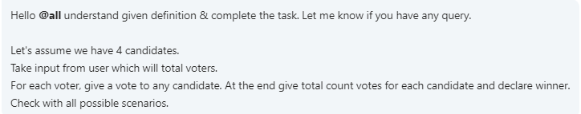

#include <stdio.h>

#define Candidate_count

#define Candidate1 "Jui"

#define Candidate2 "Zeel"

#define Candidate3 "Krishna"

#define Candidate4 "Parita"

int main()

{

int voteCount1 =0 , voteCount2=0 , voteCount3=0 , voteCount4 =0 , votesSpoiled=0;

int t,i,choice;

printf("Enter the total number of voters");

scanf("%d",&t);

printf("\n\n Please choose your Candidate \n\n");

for(i=0;i<t;i++)

{

printf("\n 1. %s", Candidate1);

printf("\n 2. %s", Candidate2);

printf("\n 3. %s", Candidate3);

printf("\n 4. %s", Candidate4);

printf("\n 5. %s", "None of These");

printf("\n\n Input your choice (1 - 4) : ");

scanf("%d",&choice);

switch(choice){

case 1: voteCount1++; break;

case 2: voteCount2++; break;

case 3: voteCount3++; break;

case 4: voteCount4++; break;

case 5: votesSpoiled++; break;

default: printf("\n Error: Wrong Choice !! Please retry");

//hold the screen

getchar();

}

printf("\n thanks for vote !!");

}

}