TASK 3:

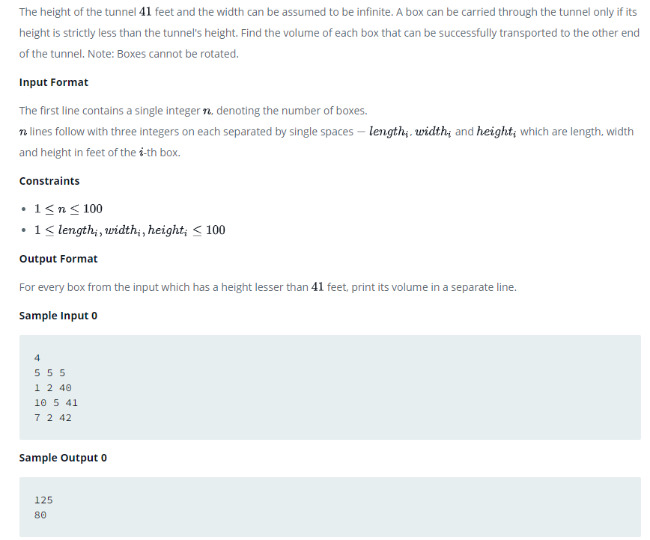

PROGRAM:

#include <stdio.h>

struct Box

{

int length, width, height;

};

int volume(struct Box box)

{

return box.length\*box.width\*box.height;

}

int lower(struct Box box, int maxHeight)

{

return box.height < maxHeight;

}

int main()

{

int n;

scanf("%d", &n);

struct Box boxes[100];

for (int i = 0; i < n; i++)

scanf("%d%d%d", &boxes[i].length, &boxes[i].width, &boxes[i].height);

for (int i = 0; i < n; i++)

if (lower(boxes[i], 41))

printf("%d\n", volume(boxes[i]));

return 0;

}