TASK 4:

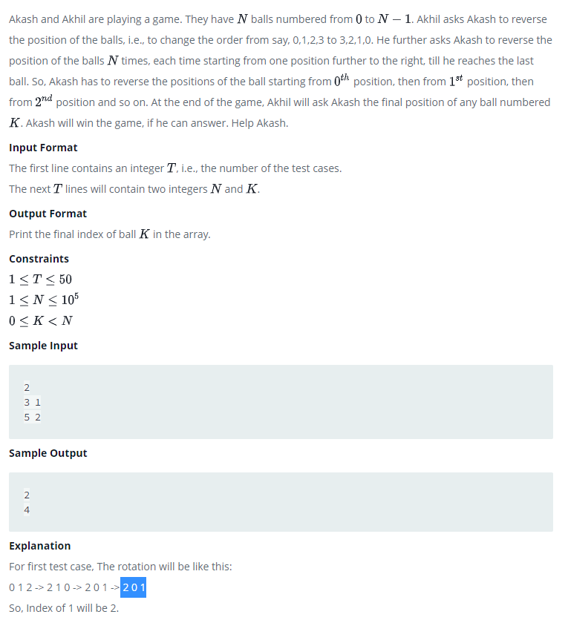

#include <stdio.h>

int main() {

int i,T;

int N,K;

scanf("%d\n",&T);

for(i=0;i<T;i++)

{

scanf("%d%d",&N,&K);

if(K < (N/2))

printf("%d\n",(2\*K + 1));

else{

printf("%d\n",2\*((N-1)-K));

}

}

return 0;

}

Another way without formula :

#include <stdio.h>

int main()

{

int n,count,find;

int a[100],b[100];

printf("Enter The Total Number Of Balls: ");

scanf("%d",&n);

printf("Enter The Number You want to find: ");

scanf("%d",&find);

for(int i=0;i<n;i++)

{

a[i] = i;

//printf("%d",a[i]);

}

for(int k=0;k<n;k++)

{

int i=k;

for(int j=n-1;j>=k;j--)

{

b[i]=a[j];

i++;

count=j;

}

for(int i=0;i<n;i++)

{

a[i] = b[i];

// printf("\n");

}

}

for(int i=0;i<n;i++)

{

// printf("%d",c[i]);

printf("%d",b[i]);

if(b[i]==find)

{

printf("\n%d is available at %d positions ",find,i+1);

}

}

return 0;

}