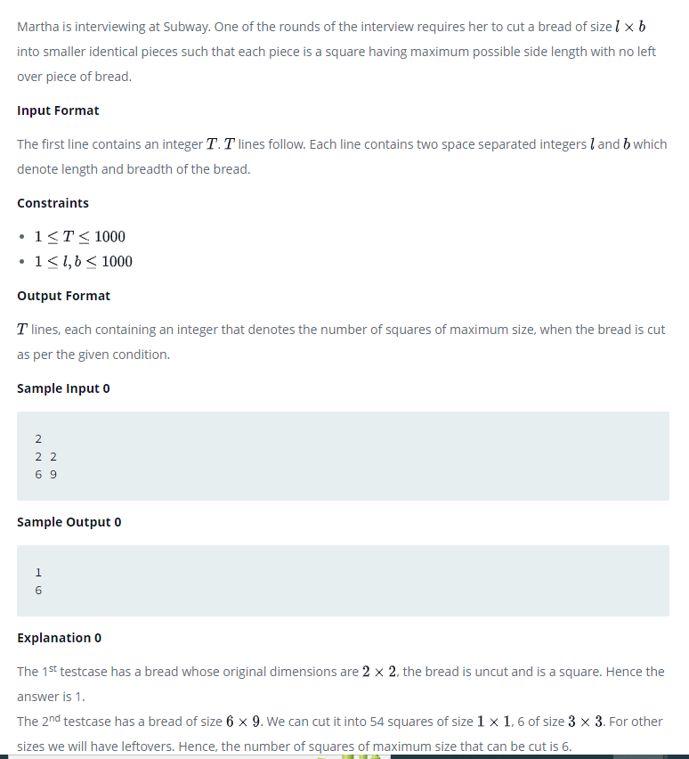

#include<stdio.h>

int main()

{

int T,i,j;

int gcd;

printf("Enter the number of test case ");

scanf("%d",&T);

for(i=0;i<T;i++)

{

int l,b;

printf("Enter the number of lenght and breadth\n");

scanf("%d %d",&l,&b);

for(int i = 1; i <= l && i <= b; i++) {

if(l % i == 0 && b % i == 0)

gcd = i;

}

int v=(l/gcd)\*(b/gcd);

printf("the total number of slices %d",v);

}

return 0;

}