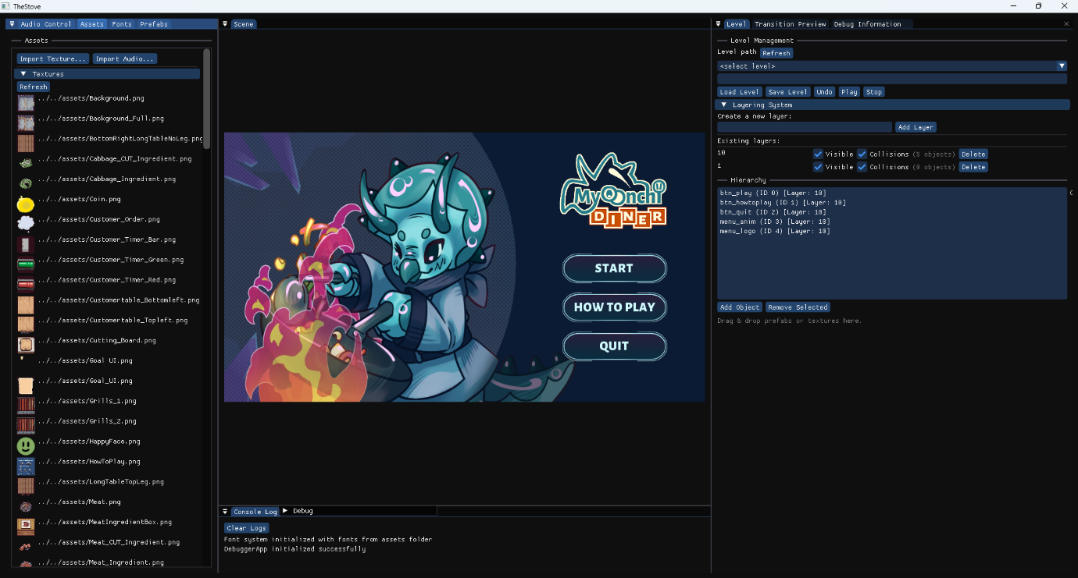
This is the updated version of our level editor.
The Level Editor is composed of multiple panels working together to support level creation, editing, previewing, and testing. Each panel focuses on a specific aspect of the workflow while remaining tightly integrated with the others.
The Audio Control Panel allows designers to preview, adjust, and manage audio assets directly within the level editor.
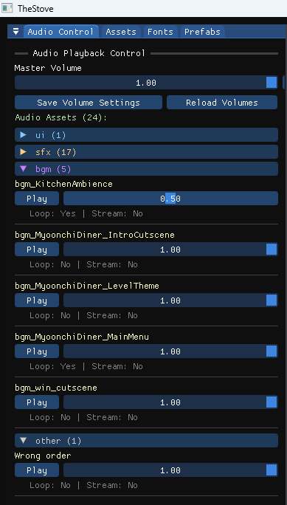
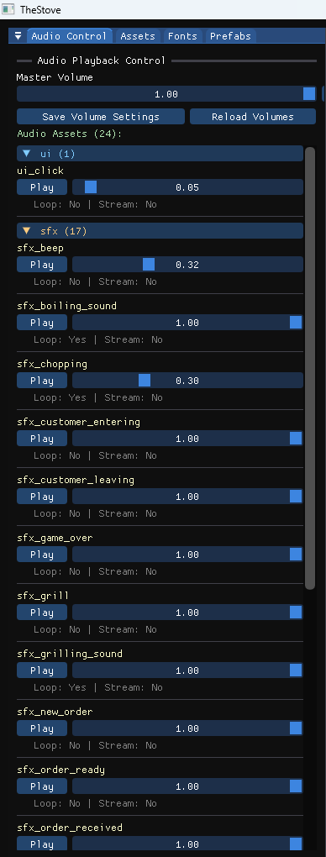

Main Functions
- Master Volume Control
Adjusts the overall game audio volume in real time and allows saving the value as the default configuration.
- Per-Audio Asset Volume Editing
Enables individual volume tuning for each audio asset loaded in the project.
- Audio Preview (Play / Stop)
Allows designers to play and stop audio assets directly in the editor for quick verification.
- Save and Reload Audio Settings
Supports saving edited audio volumes to the audio catalog and reloading them from file.
- Audio Categorization
Audio assets are grouped by category (e.g. UI, SFX, BGM) for easier browsing and organization.
- Drag-and-Drop Support
Audio assets can be dragged from the panel and assigned to other editor components.

The Assets Panel displays all project assets and provides tools for browsing, previewing, and assigning them within the level editor.
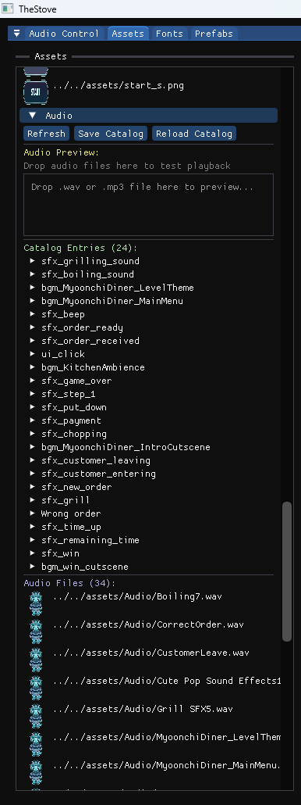
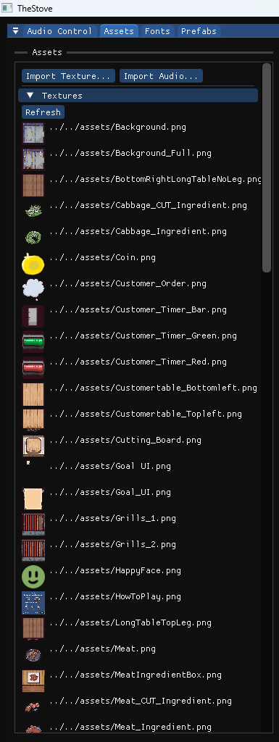

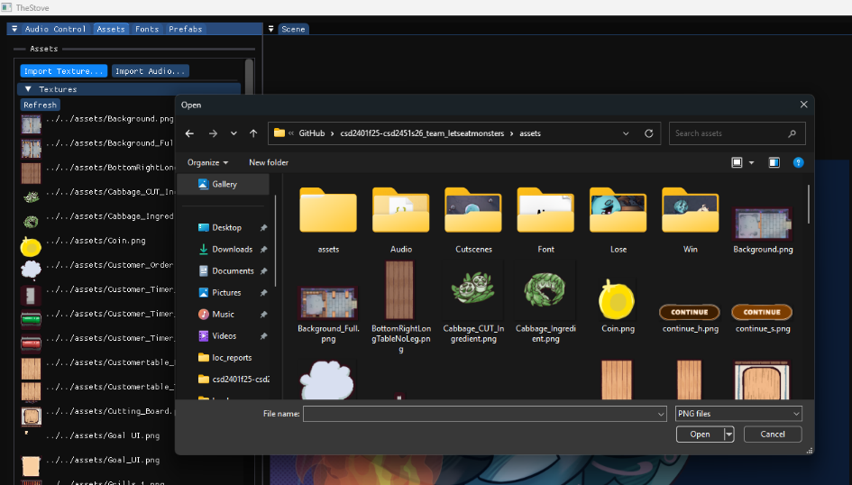

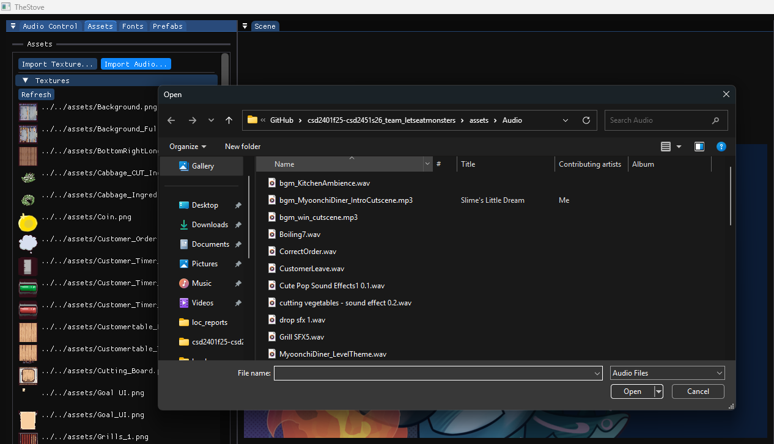

Assets Panel
The Assets Panel provides access to all loaded project assets.
Features
- Displays assets grouped by type (textures, audio, fonts, etc.).
- Supports drag-and-drop:
  - Dropping assets onto objects applies them when valid.
- Enables fast asset reuse without manual file handling.
The Fonts Panel allows designers to view, manage, and assign font assets used for text rendering in the game.
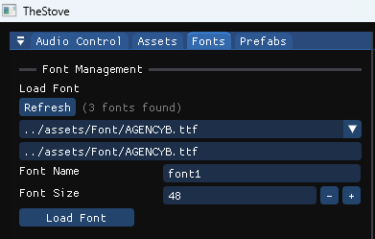

Features
- Lists all loaded fonts.
- Supports drag-and-drop assignment to text/UI objects.
- Enables font switching without code changes.

The Prefabs Panel provides access to all prefab templates used in the project, allowing designers to quickly instantiate predefined objects in the level.
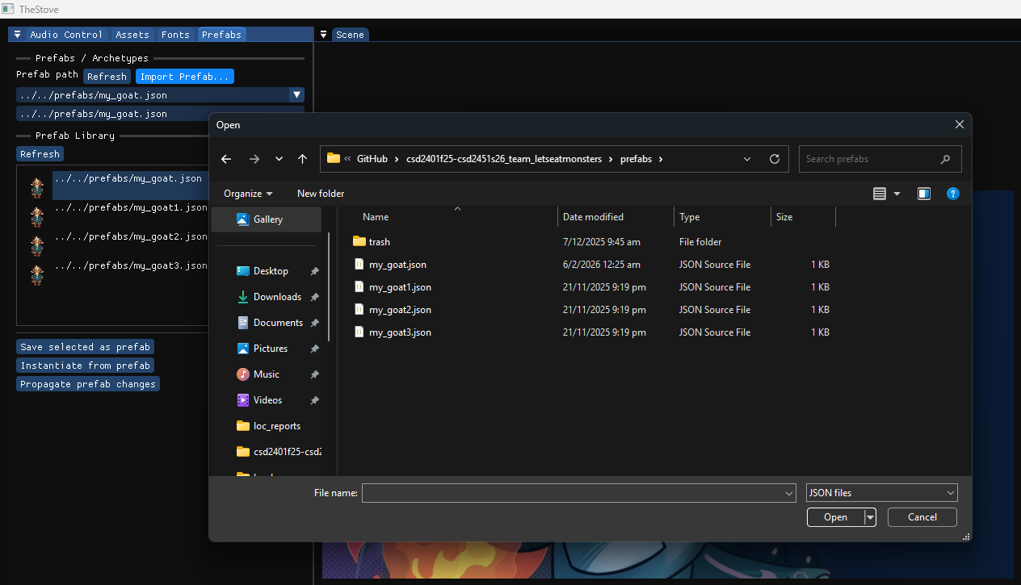
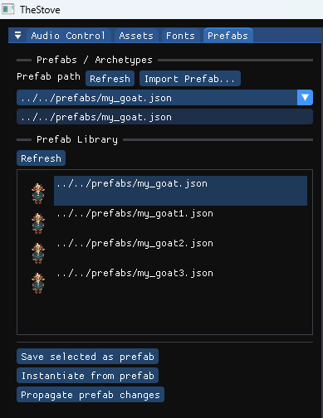
Prefabs Panel
The Prefabs Panel manages reusable object templates.
Features
- Lists all available prefabs.
- Dragging a prefab into the scene:
  - Instantiates a new GameObject.
  - Applies predefined components and properties.

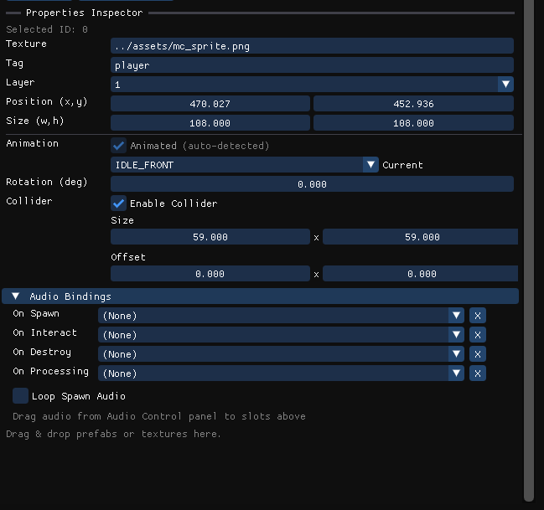
The Level Panel is the central control hub of the editor.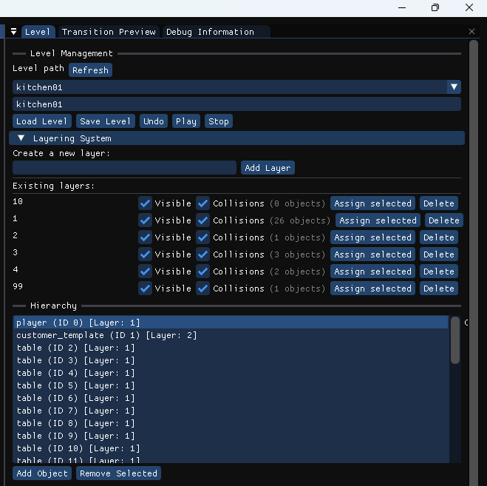
Responsibilities
- Load and save level files (.json format).
- Control play and stop simulation.
- Maintain the active scene state.
Key Functions
- Level Path Input & Dropdown
Allows selecting or manually entering a level file path.
- Load Level
Parses JSON level data and rebuilds the scene.
- Save Level
Serializes the current scene state back into JSON.
- Play / Stop
  - Play: Creates a snapshot, clears editor state, and runs the level with gameplay logic and physics enabled.
  - Stop: Restores the snapshot and returns to edit mode.

Scene View (Viewport)
The Scene View displays the current level visually.
Features
- Shows all GameObjects in the scene.
- Updates in real time as objects are moved or edited.
- Acts as the primary drop target for drag-and-drop operations.
Interaction
- Clicking objects selects them.
- Dragging prefabs into the view instantiates new objects.
- Dragging assets applies them to selected objects when supported.

Object Hierarchy Panel
The Hierarchy Panel lists all GameObjects currently in the level.
Features
- Displays GameObject name, ID, and layer.
- Clicking an object selects it and synchronizes with:
  - Scene View
  - Properties Inspector

Properties Inspector Panel
The Properties Inspector allows detailed editing of the selected GameObject.
Editable Properties
- Texture Path
Updates the sprite or animation automatically.
- Tag
Used for gameplay logic (e.g. player, npc).
- Layer
Read-only; determines rendering and collision behavior.
- Position / Size
Editable numerically or via dragging; supports “Reset to Default”.
- Rotation
Stored and displayed in degrees.
- Collider Size / Offset
Updates collision bounds immediately.
- Velocity
Used for NPC movement testing.
- Animation
  - Automatically detected for animated objects.
  - Dropdown for selecting available clips.

The Transition Preview Panel allows testing screen fade transitions.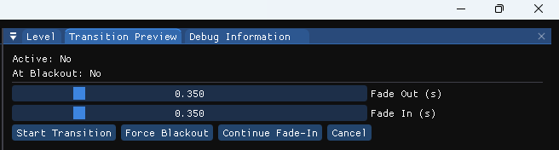
Features
- Displays transition state (active / blackout).
- Adjustable fade-out and fade-in durations.
- Controls to:
  - Start transition
  - Force blackout
  - Continue fade-in
  - Cancel transition

